Guildford Borough Council

Budget Survey 2021

Report (V02)
January 2021

Contents
Headline Findings 3
Introduction 4
Background 4
Report structure 4
Sample / Methodology 5
Telephone Methodology – Breakdown 5
Online Methodology – Breakdown 6
Main Findings 8
Concerns and support 8
Council Services 12
Appendices 19
Questionnaire 19
Quota Targets – Telephone Consultation 25
Confidence level and interval overview 26

Headline Findings

As local authorities and people respond and adapt to the current Coronavirus pandemic, residents across Guildford are most concerned about its impact on the wider economy. More than 9 in every 10 residents responding to a telephone consultation, representative of the Borough, stated they are worried to some degree about this impact together with 8 in every 10 respondents who responded to an online consultation, open to all residents across Guildford.

Residents revealed they are also worried about the impact of the pandemic on the health and wellbeing of family and friends with more than two-thirds of telephone respondents (71%) and 65% of online respondents showing concern for this aspect. Residents also harbour anxieties about the effect on the local community; a concern shared by more than three-fifths (63%) of telephone respondents and three-quarters (79%) of online respondents.

Residents across both cohorts tended to be less worried, overall, about the personal impact of the pandemic with less than a fifth (17%) of telephone respondents and a third (36%) of online respondents stating they were worried about their own mental health and wellbeing.

When taking into account all residents who responded to the consultation, 4% said that either themselves or their family had accessed support provided by Guildford Borough Council during the pandemic (3% telephone respondents and 5% online respondents). Residents who accessed support tended to be older or identified as having a disability; the main form of support accessed tended to be food parcels and deliveries, advice and financial support.

When asked to consider council services in terms of importance, priority and spending, residents across both consultations were almost unanimous in rating services to the elderly and vulnerable highest for each aspect. On average, telephone respondents attributed a score of 8.90 out of 10 to this service in terms of importance whereas online respondents agreed on an average of 8.33, placing environmental services as slightly more important (8.90). Both cohorts rated services to the elderly and vulnerable their highest priority on average when scoring on a scale of ten (telephone 9.10, online 8.68) and also felt funding for this service area should be most protected when scoring on a scale of ten (telephone 9.24, online 8.68).

Other services that scored highly in terms of the three aspects of importance, priority and spending were public health and safety, economic services and environmental services, the latter being more prevalent amongst online respondents.

Arts and heritage and tourism services were consistently attributed the lowest scores on average by respondents who participated in the survey, the two provisions making up the lowest ranked services for each aspect of importance, priority and spending within both strands of the consultation. Transport and parking and public facilities were also perceived as less important services by residents across both consultations.

Introduction

Background

Guildford Borough Council are committed to providing high quality and good value services to meet the needs of the local community.

Guildford Borough Council have been working for some years to make sure they deliver these services in the most cost-effective way. This has already resulted in efficiency savings of £9million and £6.8 million of additional income since 2013-14 and further efforts will continue to reduce the cost of services. However, reductions in central government funding and the coronavirus pandemic have had a major impact on the Council's finances and will continue to do so.

Guildford Borough Council are currently working on the basis that another £3 million needs to be saved next year, rising to £4.2 million by 2023-24. As part of that process, the Council would like to understand residents’ views on where they think savings should be made and what the Council’s priorities for spending should be. Guildford Borough Council wants to find out which services are important to residents and which are not so important.

The Council would also like to understand how the coronavirus pandemic has impacted on residents, so that they can continue to support those in need and plan for the recovery of the local community and economy.

In addition to an online consultation, hosted on the council’s website, SMSR Ltd, an independent research company was commissioned to undertake a telephone survey with residents to help the Council understand their views.

Report structure

This report includes headline findings for each question combined with insight on differences between the two strands of the consultation – telephone and online. It should be noted that when the results are discussed within the report, often percentages will be rounded up or down to the nearest one per cent. Therefore, occasionally figures may add up to 101% or 99%. Due to multiple responses being allowed for the question, some results may exceed the sum of 100%.

Trends identified in the reporting are statistically significant at a 95% confidence level. This means that there is only 5% probability that the difference has occurred by chance (a commonly accepted level of probability), rather than being a ‘real’ difference. Unless otherwise stated, statistically significant trends have been reported on.

Sample / Methodology

It was important that the methodological approach to the consultation was robust and wide-reaching and therefore it was decided that a combination of methodologies would be utilised to ensure representation and inclusivity.

An interviewer led, CATI telephone questionnaire was designed by SMSR in conjunction with staff from Guildford Borough Council. The survey script was mirrored and adapted for an online consultation open to all residents in the Borough via an online link located on the council’s website. A copy of the survey can be found in the appendices.

A total of 1,100 residents participated by telephone; a further 381 residents completed the questionnaire online. The breakdown for each sample is as follows:

Telephone Methodology – Breakdown

To ensure the research was robust and reflected the profile of the local community, a representative sample of 1100 residents was completed via telephone methodology which included members of the Guildford Borough Council Citizens’ Panel. This representative sample provides a confidence level of 95% with a confidence interval of +/- 3%. An explanation of confidence intervals can be found in the appendices.

Telephone interviews were conducted using random quota sampling to maximise representation across the borough. Sample data was drawn from several, GDPR compliant sources, including the Council’s Citizens’ Panel, to extend the scope of potential participants as much as possible. Target quotas for age, gender and ethnicity were set using the most recent ONS figures available and the sample included representation from each of the wards within the borough. Telephone interviewing took place between November 2020 and January 2021. The full breakdown of the sample is set out below:

Gender | Number | Percentage
Male | 535 | 49%
Female | 565 | 51%
Transgender | 0 | 0%
Other | 0 | 0%

Age | Number | Percentage
16-24 | 164 | 15%
25-34 | 191 | 17%
35-44 | 187 | 17%
45-54 | 195 | 18%
55-64 | 156 | 14%
65+ | 207 | 19%

Ethnicity | Number | Percentage
White | 1053 | 96%
BAME | 45 | 4%
Prefer not to say | 2 | 0%

Disability | Number | Percentage
Yes | 108 | 10%
No | 990 | 90%
Prefer not to say | 2 | 0%

Online Methodology – Breakdown

An online version of the questionnaire was also made available to local residents, with the council promoting the link via its website and various social media platforms. A total of 381 residents participated in the online consultation, this sample provides an overall confidence level of 95% with a confidence interval of +/- 5%. However, the consultation was open to all residents and is less robust statistically and representative of the Borough than the telephone consultation. The results of the online consultation have been presented separately in the report. The online survey link was open from November 2020 to January 2021. The full breakdown of the sample is set out below:

Gender | Number | Percentage
Male | 190 | 50%
Female | 172 | 45%
Transgender | 2 | 1%
Other | 1 | 0%
Prefer not to say | 16 | 4%

Age | Number | Percentage
16-24 | 7 | 2%
25-34 | 28 | 7%
35-44 | 78 | 20%
45-54 | 66 | 17%
55-64 | 79 | 21%
65+ | 105 | 28%
Prefer not to say | 18 | 5%

Ethnicity | Number | Percentage
White | 334 | 88%
BAME | 6 | 2%
Prefer not to say | 41 | 11%

Disability | Number | Percentage
Yes | 54 | 14%
No | 303 | 80%
Prefer not to say | 24 | 6%

Main Findings

Concerns and support

Respondents were initially asked to state how worried they feel personally about the coronavirus pandemic and its ongoing impact upon a number of important issues.

Those interviewed as part of the representative telephone survey felt most worried about the wider economy with 9 in every 10 stating they were worried to some degree and three-fifths (60%) revealing they were very worried. More than two-thirds (71%) admitted they were worried about the health, safety and wellbeing of family and friends and more than three-fifths (63%) had concerns about their local community.

Despite concerns about family and friends, less than a fifth (17%) said they were worried about their own mental health and wellbeing. A slightly higher percentage (29%) felt worried about their own physical health and safety and two-fifths (41%) had fears about their economic wellbeing. In general, residents tended to show more concern for the wider community and family and friends as opposed to personally.

Similar findings were extracted from the sample of residents who responded online:

The vast majority of those who responded to the online consultation said they were worried about the impact of Coronavirus on the wider economy with more than 8 in every 10 sharing these concerns. More emphasis on concerns about the impact on the local community was recorded amongst this cohort with more than three quarters (79%) stating they were worried about this aspect.

Moreover, personal concerns were again outweighed by fears for the wider impact of the pandemic and family and friends amongst online respondents. However, slightly higher levels of concern were recorded for mental health and wellbeing (36%), economic wellbeing (42%) and physical health and safety (45%) amongst this group.

Respondents were asked if they had accessed any support provided by Guildford Borough Council during the pandemic:

Just 3% of those who participated in the representative telephone survey confirmed they or their family had accessed support provided by the Council during the pandemic; the vast majority stating they had not accessed help.

A slightly higher percentage of online participants said they had sought support from Guildford Borough Council during the pandemic, however, access was still low at just 5%.

The two samples were compiled to view any relationships between specific demographics and accessing support:

Although the overall sample of those accessing support was relatively low, it was found that older residents were more inclined to have accessed support from the Council during the pandemic (65+, 8%) together with respondents who identified as having a disability (10%).

Prevalent sources of support from the Council included food parcels and deliveries, advice, financial support, and prescription deliveries.

Council Services

Respondents were then asked look at a series of council services and to use a scale to rate each service in terms of importance, priority, and spending, starting with importance:

On average, respondents who participated in the representative telephone consultation valued services to the elderly and vulnerable (8.81), public health and safety (8.55) and economic development (8.47) as most important. Furthermore, environmental and housing services also scored higher than 8 (8.33 and 8.27 respectively). The levels of value placed on the top three services are, perhaps, foreseeable in light of the current pandemic and do seem to mirror concerns expressed earlier in the questionnaire around the economy and wellbeing.

The least value was placed upon arts and heritage (5.99) and tourism services (6.05), which perhaps could be considered less pertinent provisions amidst the current circumstances, together with public facilities (6.72) and transport and parking (6.81).

When observing results from the online consultation, services to the elderly and vulnerable (8.33) and public health (8.09) also scored highly, however, most importance was placed on environmental services (8.90). The provision of parks and open spaces also scored highly (8.29) at the expense of economic services (7.66).

Tourism services (5.10) together with arts and heritage services (5.98) were seen to be the least important by online respondents as also seen in the representative sample.

Respondents were then asked to prioritise the same list of services, using a similar scale of 1 to 10 with 10 being a high priority:

Services for the elderly and vulnerable were again deemed paramount, being the highest rated priority amongst the representative sample (9.10). Public health (8.41), economic services (8.36), housing services (8.25) and environmental services (8.25) were all perceived to be high priority services amongst residents.

Arts and heritage (5.75) and tourism services (5.89) were again rated lowest for this aspect (priority) compared with the previous question with public facilities (6.63) and transport and parking (6.65) also thought to be lower priorities.

The ranking of services in terms of priority was seen to be almost identical to the order in which residents responding to the telephone surveys valued each service.

Services to the elderly and vulnerable were also deemed to be the top priority from the list by online respondents (8.68), reinforcing this provision as the highest priority amongst residents across the Borough. Environmental services (8.27) were also seen as a top priority amongst online respondents, reflecting the value placed on this issue amongst this cohort.

In line with previous trends, less emphasis was placed on tourism services (4.62), arts and heritage (5.47), transport and parking (6.18) and leisure centres and physical activity (6.50).

As found in the representative sample, the amount of value placed on each service amongst online respondents was reflected in the ranking of services as a priority. Online respondents tended to place more priority on services related to natural resources (environmental and open spaces) than residents responding via the telephone survey.

Lastly, residents were again asked to use a scale of 1 to 10 and rate to what extent, which services Guildford Borough Council should consider stopping or reducing spending on:

In keeping with lower levels of importance and prioritisation placed on arts and heritage and tourism services, residents responding to the representative consultation felt that spending could be retracted the most for these services. Where 10 represented fully funding a service, arts and heritage scored, on average, the lowest figure of 5.27, followed by tourist services (5.43). Public facilities (6.25) and transport and parking (6.38) also rated lower amongst this cluster of respondents.

Together with being ranked most important and the highest priority amongst telephone respondents, services to the elderly and vulnerable was rated highest in terms of funding, scoring 9.24 on average. Other services that residents felt deserved more funding protection were housing services (8.27), economic services (8.25), public health and safety (8.23) and environmental services (8.17).

The services that residents felt Guildford Borough Council could reduce spending on were largely reflective of earlier ratings attributed to services in terms of importance and priority.

Furthermore, online respondents further supported a reduction in spending on tourism services (4.33) and arts and heritage (5.17) together with transport and parking (5.95) and leisure centres and physical activities (6.39).

Services to the elderly and vulnerable were judged to be worthy or near full funding (8.68) with environmental services (8.15), public health and safety (7.81) and parks and open spaces (7.58) all receiving higher ratings.

When considering the overall sample of respondents, a clear steer emerges. Services to the elderly and vulnerable are considered vital by residents across the Borough for all aspects (importance, priority, spending) whereas arts and heritage and tourism services are perceived as least critical.

The table below sets out the combined results of the telephone and online consultation into rankings, based on the mean score provided for each service for each aspect. The services are ordered by the overall ranking – based on the total score in rank for each aspect. The lowest score being the highest ranked service, overall.

Service | Importance | Priority | Spending | OVR
Services to the elderly and vulnerable | 1 | 1 | 1 | 1
Environmental services | 2 | 3 | 2 | 2
Public health and safety | 3 | 2 | 3 | 3
Economic development, business, jobs, and unemployment | 4 | 4 | 5 | 4
Housing services | 5 | 5 | 4 | 5
Services for young people | 6 | 6 | 6 | 6
Parks and open spaces | 7 | 7 | 7 | 7
Leisure centres and physical activities | 8 | 8 | 8 | 8
Public facilities | 9 | 9 | 9 | 9
Transport and parking | 10 | 10 | 10 | 10
Arts and heritage | 11 | 11 | 11 | 11
Tourism services | 12 | 12 | 12 | 12

Appendices

Questionnaire

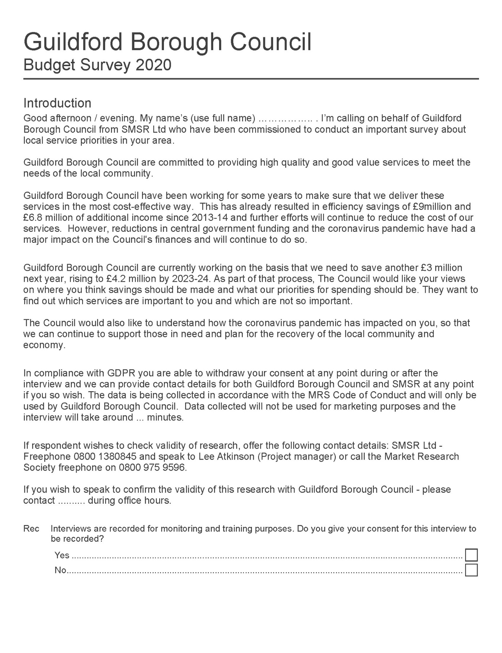

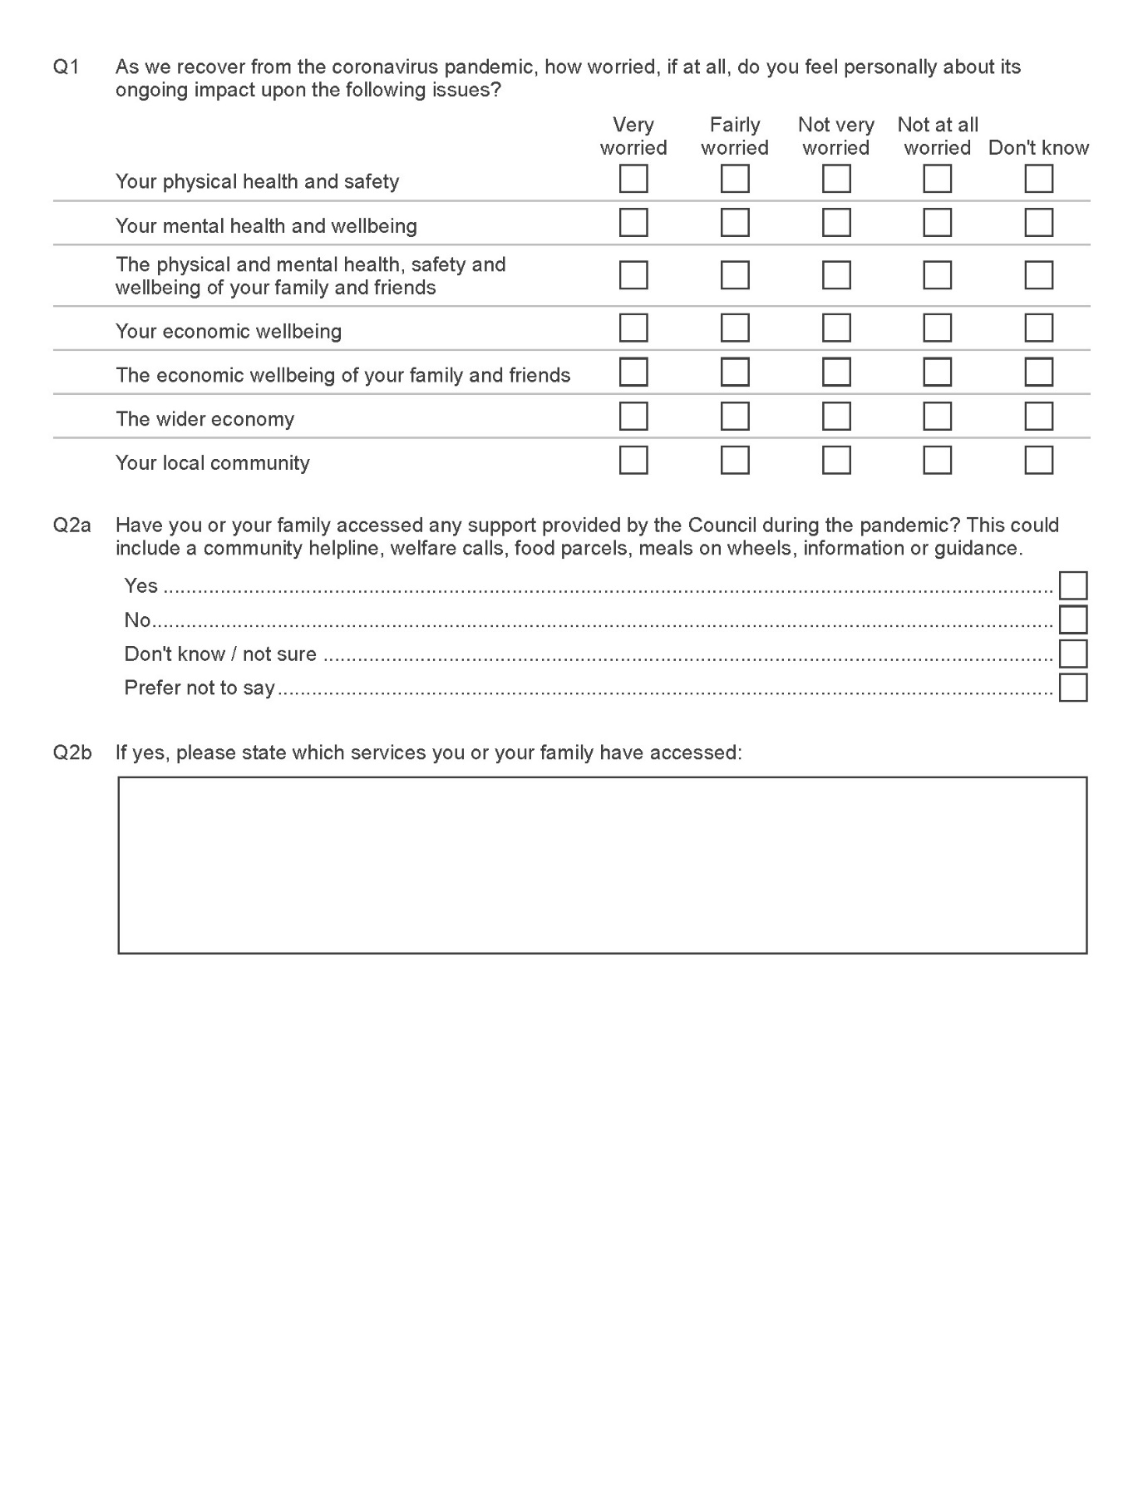

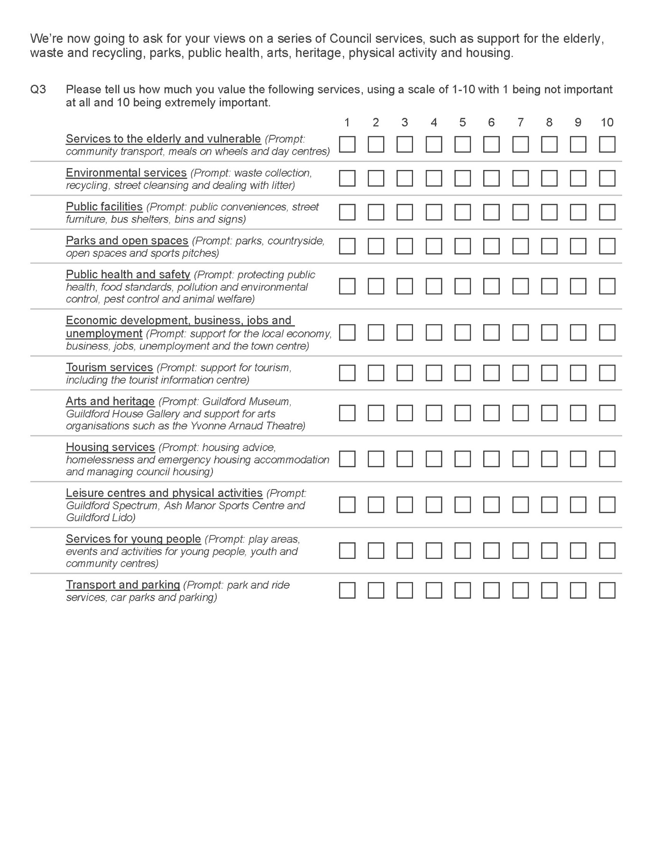

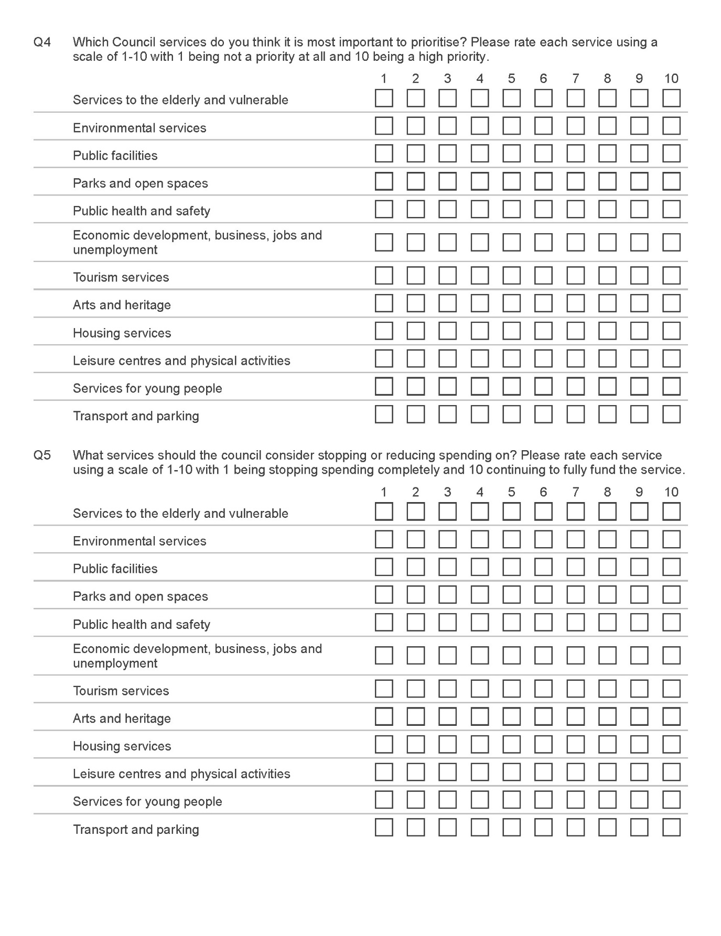

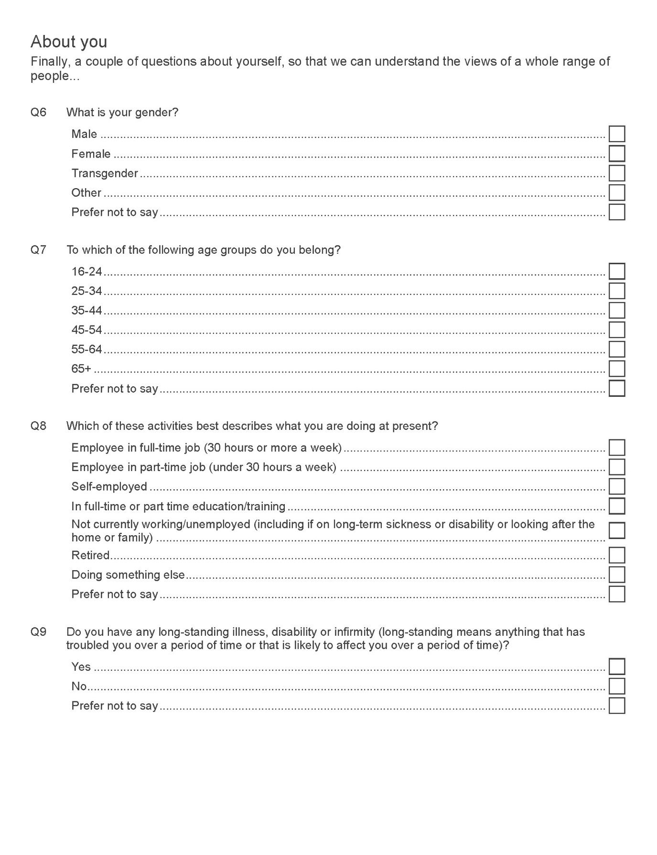

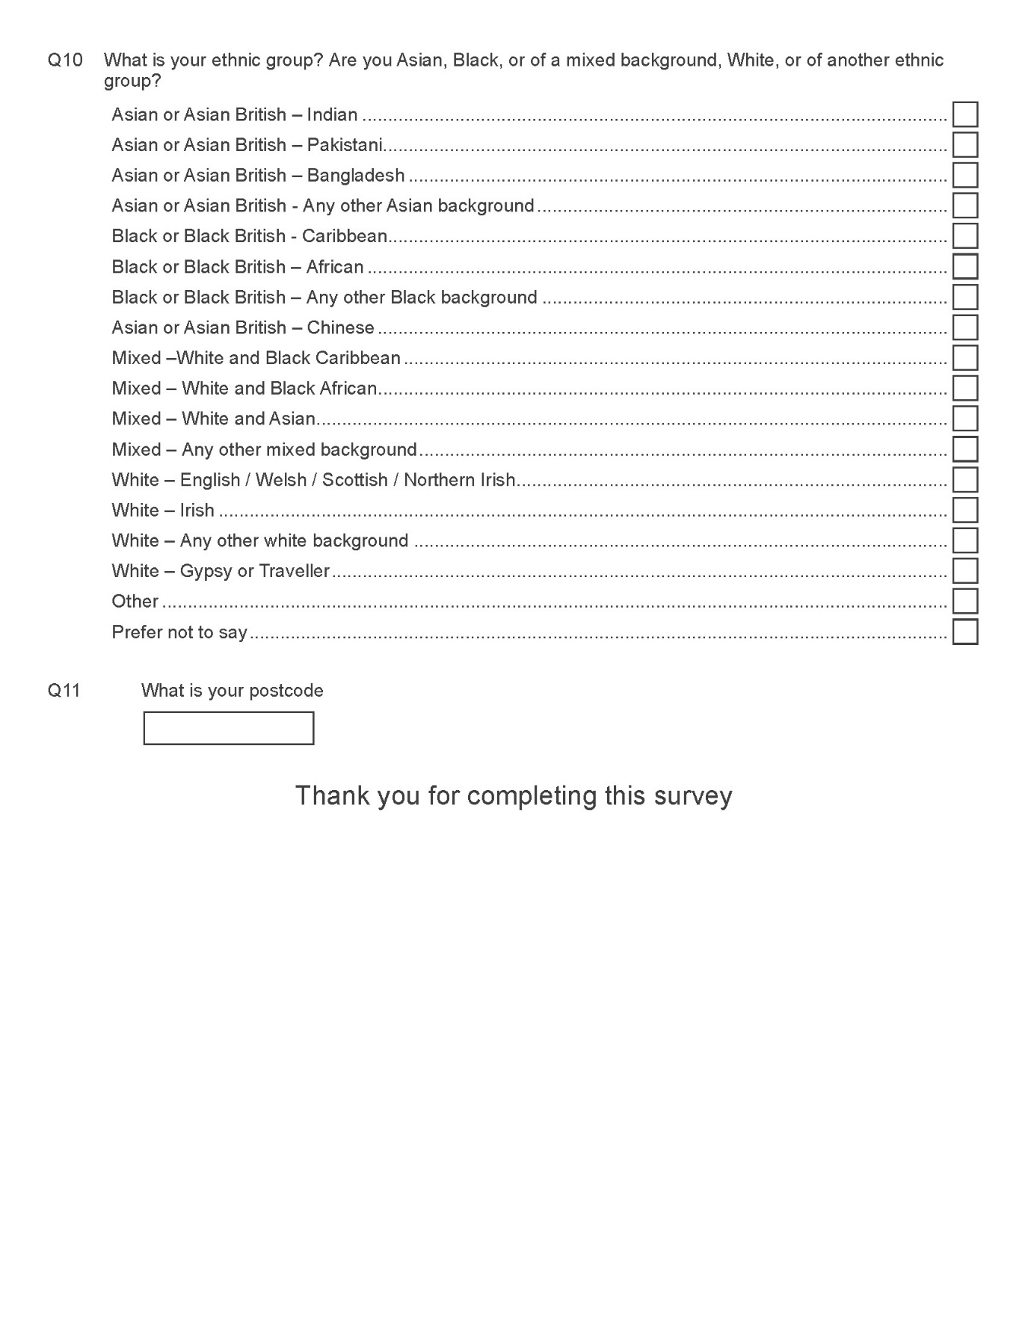

Quota Targets – Telephone Consultation

As part of the telephone consultation, quota targets were set, based on the latest Office of National Statistics data for the population of Guildford. Data for those aged 16 and under was removed before calculating the targets. Targets were set for Gender, Age and Ethnicity to ensure results were based on a sample, representative of the Borough.

The targets are set out below:

Gender | Number | Percentage
Male | 544 | 49%
Female | 556 | 51%

Age | Number | Percentage
16-24 | 180 | 17%
25-34 | 180 | 16%
35-44 | 191 | 17%
45-54 | 184 | 17%
55-64 | 152 | 14%
65+ | 210 | 19%

Ethnicity | Number | Percentage
White | 1000 | 91%
BAME | 100 | 9%

Respondents were selected by means of stratified random sampling alternatively known as random quota sampling. This method of sampling that involves the division of a population into smaller sub-groups known as strata. In stratified random sampling, or stratification, the strata are formed based on the population’s shared attributes. Sample data was drawn from several, GDPR compliant sources, including the Council’s Citizens’ Panel, and randomised in a telephone dialler system to ensure each potential respondent in the data had an equal chance of being selected for interviewing.

Confidence level and interval overview

The confidence interval (also called margin of error) is the plus-or-minus figure usually reported in newspaper or television opinion poll results. For example, if you use a confidence interval of 4 and 47% percent of your sample picks an answer you can be "sure" that if you had asked the question of the entire relevant population between 43% (47-4) and 51% (47+4) would have picked that answer.

The confidence level tells you how sure you can be. It is expressed as a percentage and represents how often the true percentage of the population who would pick an answer lies within the confidence interval. The 95% confidence level means you can be 95% certain; the 99% confidence level means you can be 99% certain. Most researchers use the 95% confidence level.

When you put the confidence level and the confidence interval together, you can say that you are 95% sure that the true percentage of the population is between 43% and 51%. The wider the confidence interval you are willing to accept, the more certain you can be that the whole population answers would be within that range.

For example, if you asked a sample of 1000 people in a city which brand of cola they preferred, and 60% said Brand A, you can be very certain that between 40 and 80% of all the people in the city actually do prefer that brand, but you cannot be so sure that between 59 and 61% of the people in the city prefer the brand.

Social & Market Strategic Research
Wellington House
108 Beverley Road
Kingston-Upon-Hull
HU3 1XA
(01482) 211200

