Make and use your Template

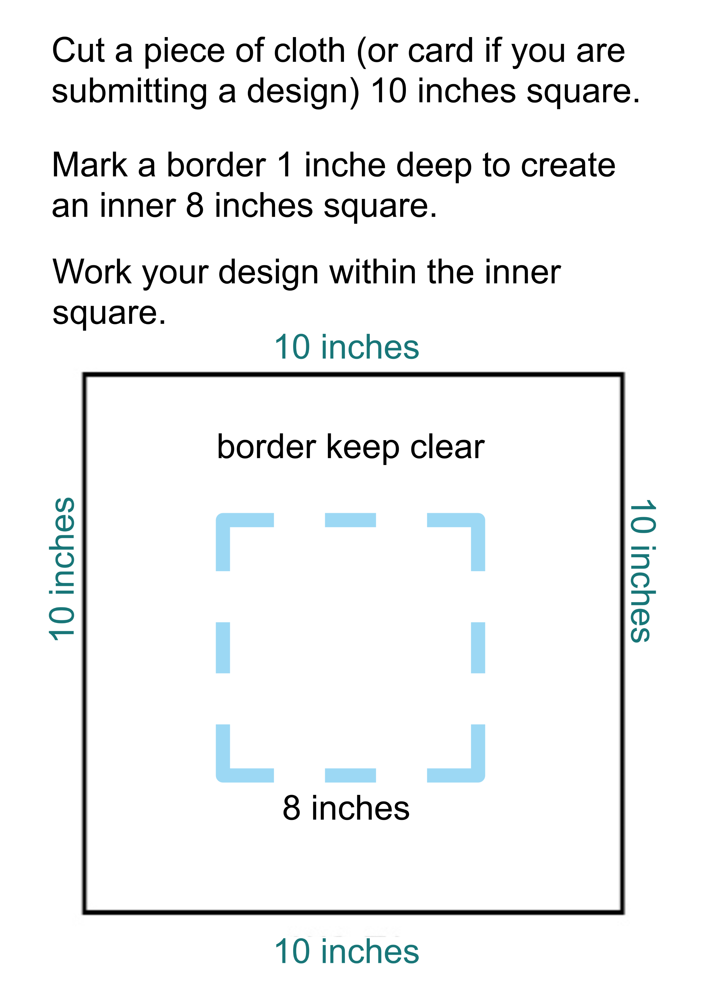

Guildford’s Quilt – Stitch yourself into History

Send your square or design with the following information by 1 September to

Guildford’s Quilt, Heritage Services, Guildford Museum, Castle Arch Quarry, Street Guildford GU13SX

Your Name
Address
telephone
email

Your age – if you want this recorded in the display and archive
Do you permit us to show your name alongside your square or design in the exhibition – circle your response YES NO

If you are aged under 13 please ask a parent or guardian to complete this section

Title or description of the act of kindness you have depicted. Does it show something you have experienced during Covid-19, or does it represent a wish for a kinder world. Tell us the story behind your square or design so that we can share this in the exhibition and preserve the information with the quilt.

Lots of people and visitors will enjoy seeing your work. The press and visitors may want to take photographs of it.

Please note that by participating in Guildford’s Quilt you are transferring ownership of the patch or design to Heritage Services.

Privacy Statement
When an object is acquired by Guildford Heritage Services we need to collect and retain evidence of the transfer of ownership. We will use the personal information you provide on this form (i.e your name and contact details) to send you the form transferring ownership, and one which requests permission to make and reproduce images of the patch. These will be processed in accordance with data protection legislation. Your personal contact details will not be passed on to any third parties without your consent. For further information, please see the Council’s website - Data protection and privacy - Guildford Borough Council – or contact the Data Protection Officer at dpo@guildford.gov.uk.

We look forward to seeing your fantastic patch or design.

