Guildford Borough Council
Guildford Town Centre
Draft Air Quality Action Plan

In fulfilment of Part IV of the
Environment Act 1995
Local Air Quality Management

May, 2022

- Local Authority Officer: Gary Durrant and Anjana Papnai
- Department: Regulatory Services
- Address: Guildford Borough Council, Millmead House, Millmead, GU2 4BB
- Telephone: 01483 505050
- E-mail: environmental.protection@guildford.gov.uk
- Report reference number: AQAP GBC 2022
- Date: 9 May 2022
Report Prepared By:

Chapel House, Barton Manor, Bristol, BS2 0RL
Tel: 01179 112434. Email: contact@airpollutionservices.co.uk

Quality Assurance
Reference: L1002_A_10
Status: Draft
Author: Katya Kaczmarczyk & Dr Austin Cogan
Date Published: 9 May 2022
Approver: Kieran Laxen
Date Approved: 9 May 2022
This report has been prepared by Air Pollution Services on behalf of the Local Authority, taking account of the agreed scope of works. In preparing this report, Air Pollution Services has exercised all reasonable skill and care, taking account of the objectives and the agreed scope of works. Air Pollution Services does not accept any liability in negligence for any matters arising outside of the agreed scope of works. Air Pollution Services shall not be liable for the use of or reliance on any information, advice, recommendations, and opinions in this document for any purpose by any person other than the Local Authority. Reliance may be granted to a third party only if Air Pollution Services and the third party have executed a reliance agreement or collateral warranty. Information, advice, recommendations, and opinions in this document should only be relied upon in the context of the whole document and any documents referenced explicitly herein and should then only be used within the context of the appointment. Air Pollution Services does not accept any responsibility for any unauthorised changes made by others.

Executive Summary
This Air Quality Action Plan (AQAP) has been produced as part of our statutory duties required by the Local Air Quality Management framework. It outlines the action we will take to improve air quality in Guildford Town Centre between 2022 and 2027.
Air pollution is associated with a number of adverse health impacts. It is recognised as a contributing factor in the onset of heart disease and cancer. Additionally, air pollution particularly affects the most vulnerable in society: children and older people, and those with heart and lung conditions. There is also often a strong correlation with equalities issues, because areas with poor air quality are also often the less affluent areas (Wheeler, 2005) (Defra, 2006) (Barnes, J., Chatterton, T., & Longhurst, J., 2019).
The annual health cost to society of the impacts of particulate matter alone in the UK is estimated to be around £16 billion (Defra, 2013). Guildford Borough Council is committed to reducing the exposure of people in Guildford Borough Council to poor air quality in order to improve health.
We have developed actions that can be considered under ten broad topics recommended by Defra:
- Alternatives to private vehicle use
- Freight and delivery management
- Improving air quality modelling and assessment
- Policy guidance and development control
- Promoting low emission transport
- Promoting travel alternatives
- Public information and education
- Traffic management
- Transport planning and infrastructure
- Vehicle fleet efficiency
Our priorities are to reduce congestion and emissions within Guildford Town Centre (including within the newly declared AQMA), improve vehicle fleet emissions where possible, educate the public about air quality, and to promote travel alternatives. In terms of measures within this plan, the following points have been taken into consideration:
- The majority of emissions arise from cars, with significant contributions also from Light Goods Vehicles (LGVs), Heavy Goods Vehicles (HGVs) and buses/coaches;
- There is no decipherable contribution from point sources or industry;
- Any measures which will take longer than 2027 to implement and have effect, are unlikely to bring forward compliance with the air quality objectives.
Because of the above points, it is going to be very difficult to implement a measure which will have a large enough impact in isolation to improve the situation in a short timescale; multiple measures will thus need to be implemented.
In this AQAP we outline how we plan to effectively tackle air quality issues within our control. However, we recognise that there are a large number of air quality policy areas that are outside of our influence (such as vehicle emissions standards agreed in Europe), but for which we may have useful evidence, and so we will continue to work with regional and central government on policies and issues beyond Guildford Borough Council’s direct influence.

Responsibilities and Commitment
This AQAP was prepared by Air Pollution Services on behalf of the Environment and Regulatory Services of Guildford Borough Council with the support and agreement of William Bryans of the Strategic Transport Team, Surrey County Council, as well as a wider steering group made up of Guildford Borough Council local authority officers.
This AQAP has been approved by:
[TBC]
This AQAP will be subject to review every five years with annual appraisal of progress and reporting to the Guildford Joint Committee (Surrey County Council and GBC). Progress each year will be reported in the Annual Status Reports (ASRs) produced by Guildford Borough Council, as part of our statutory Local Air Quality Management duties.
If you have any comments on this AQAP, please send them to:
Write to: Guildford Borough Council, Millmead House, Millmead, GU2 4BB
Telephone: 01483 505050
Email: regulatoryservices@guildford.gov.uk

Table of Contents
Executive Summary 3
Responsibilities and Commitment 4
1 Introduction 7
2 Summary of Current Air Quality in Guildford Town Centre 8
3 Guildford Borough Council’s Air Quality Priorities 10
3.1 Public Health Context 10
3.2 Planning and Policy Context 11
3.2.1 Local Plan 11
Guildford Transport Strategy 11
Sustainability 12
3.2.2 Guildford Town Regeneration Strategy 12
3.2.3 Local Transport Plan 12
3.2.4 Guildford Air Quality Strategy 14
3.3 National Policy Context 14
3.3.1 Air Quality Strategy 14
3.3.2 Clean Air Strategy 2019 14
3.3.3 Reducing Emissions from Road Transport: Road to Zero Strategy 15
3.3.4 The Decarbonisation Plan 15
3.3.5 The Industrial Strategy 15
3.3.6 The Clean Growth Strategy 16
3.3.7 The 25 Year Environment Plan 16
3.4 Source Apportionment 16
3.5 Required Reduction in Emissions 17
3.6 Year when objective is predicted to be achieved 18
3.7 WHO Guidelines 19
3.8 Key Priorities 20
4 Development and Implementation of Guildford Town Centre AQAP 21
4.1 Consultation and Stakeholder Engagement 21
4.2 Steering Group 21
4.3 Existing and Committed Measures 22
4.4 Development of AQAP Measures 23
5 AQAP Measures 33
Appendix A: Response to Consultation 34
Appendix B: Reasons for Not Pursuing Action Plan Measures 35
Appendix C: Further Measure Considerations 36
Reduction of speed limits, 20 mph zone 36
Possible HGV ban around the gyratory during peak and interpeak hours 37
EV deliveries, local delivery hubs 38
Potential CAZ/LEZ 39
Anti-vehicle idling 41
Appendix D: Glossary of Terms 43
Appendix E: References 44

Introduction

This report outlines the actions that Guildford Borough Council (GBC) will deliver between 2022 and 2027 in order to reduce concentrations of air pollutants and exposure to air pollution; thereby positively impacting on the health and quality of life of residents and visitors to the Guildford area.
It has been developed in recognition of the legal requirement on the local authority to work towards Air Quality Strategy (AQS) objectives under Part IV of the Environment Act 1995 (HMSO, 1995) and relevant regulations made under that part and to meet the requirements of the Local Air Quality Management (LAQM) statutory process.
This Plan will be reviewed every five years at the latest and progress on measures set out within this Plan will be reported on annually within GBC’s air quality report (ASR).
GBC, which is one of the local authorities in Surrey, faces a number of challenges in order to improve air quality. Surrey is a densely populated county and traffic flows on A roads are almost double the national average. In Guildford Town Centre, a combination of volume of vehicles, stop start traffic caused by congestion, and properties situated close to the carriageway (meaning that high concentrations don’t disperse as quickly as they would elsewhere) has led to high concentrations in a localised area. A number of options are included in this report, which have been evaluated by the AQAP steering group.

Summary of Current Air Quality in Guildford Town Centre
Under Part IV of the Environment Act 1995, Local Authorities are required to review and assess air quality in their areas and to report annually against air quality objectives for specified pollutants of concern, to Defra. For each air quality objective, local authorities have to consider whether the objective is likely to be achieved. Where it appears likely that an air quality objective is not being met, the authority must declare an AQMA. Following the declaration of an AQMA, the authority must then develop an AQAP which sets out the local measures to be implemented in pursuit of the air quality objectives.
Prompted by the Review and Assessment process, an AQMA was submitted to Defra for declaration in Guildford Town Centre in 2021 following the recommendations of the commissioned Detailed Assessment (APS, 2021). The Detailed Assessment suggested that there may be exceedances of the 1-hour mean and annual mean nitrogen dioxide (NO₂) air quality objectives in the centre of Guildford, along several roads. The AQMA has been proposed across many roads within the town centre, with the main source of emissions being from road traffic, which is exacerbated by the canyon nature of the roads (i.e. properties close to the carriageway resulting in reduced dispersion at the building facades). Figure 1 shows the extent of the proposed Guildford Town Centre AQMA (shaded in blue).
Figure 1 – Proposed Guildford AQMA
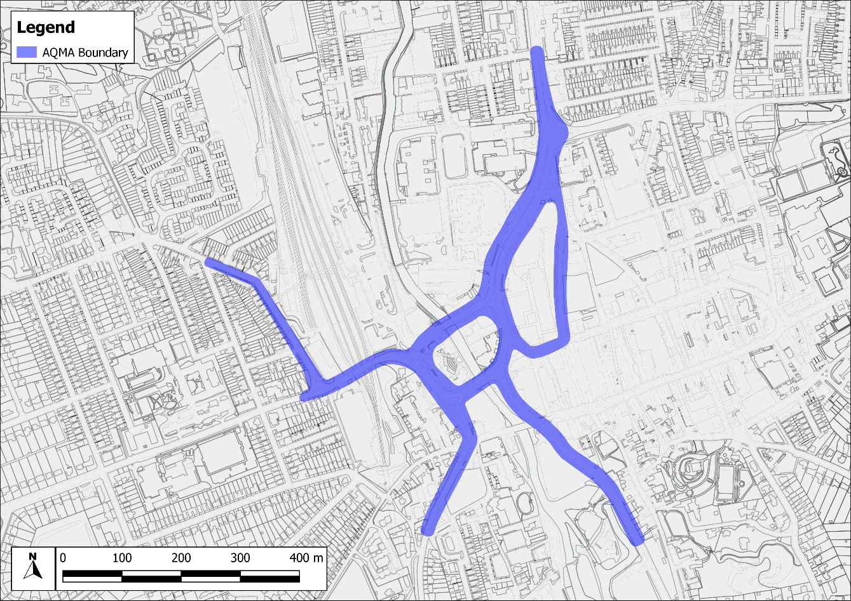
Contains OS data © Crown copyright and database right (2022).

Guildford Borough Council’s Air Quality Priorities

Public Health Context
Air pollution is a major public health risk ranking alongside cancer, heart disease and obesity. A review by the World Health Organization (WHO) concluded that long-term exposure to air pollution reduces life expectancy by increasing the incidence of lung, heart and circulatory conditions. The Department of Health and Social Care’s advisory Committee on the Medical Effects of Air Pollutants (COMEAP) have estimated that long-term exposure to man-made air pollution in the UK has an annual impact on shortening lifespans, equivalent to 28,000 to 36,000 deaths (COMEAP, 2018). Based on 2020 mid-year population estimates for the UK and Guildford, there is estimated to be the equivalent of 63-81 deaths in the borough. Poor air quality can affect health at all stages of life. Those most affected are the young and old. In the womb, maternal exposure to air pollution can result in low birth weight, premature birth, stillbirth or organ damage. In children there is evidence of reduced lung capacity, while impacts in adulthood can include diabetes, heart disease and stroke. In old age, a life-time of exposure to air pollution can result in reduced life-expectancy and reduced wellbeing at end of life. There is also emerging evidence for a link between air pollution and an acceleration of the decline in cognitive function (Defra, 2019).
The Public Health function aims not only to improve health, but also reduce health inequalities by using an evidence-based approach to make recommendations on the delivery of health and well-being services. The Guildford Health and Wellbeing Strategy recognises that “Air Pollution is a significant public health issue. In Guildford, the key pollutants are specifically nitrogen dioxide (NO₂) and fine particulates, these are principally from traffic emissions. Public Health England estimate that 5.7% of deaths in those over 25 years old are from long term exposure to anthropogenic particulate pollution”. Desired outcomes of the Strategy include identification of areas with high levels of pollution and introduce measures to improve air quality and encouraging the use of lower polluting transport options. As such, this action plan supports work underway within the public health arena.

Planning and Policy Context

Local Plan
The Guildford Borough Council Local Plan: Strategy and Sites which covers the period to 2034, was adopted on 25 April 2019. Air Quality is referred to in paragraph 4.6.31 of the Local Plan, which states:
“Well designed developments may actively help to enhance air quality and reduce overall emissions, therefore reducing possible health impacts”.
In relation to mitigation, air pollution is referred to under Policy ID3 (Sustainable transport for new developments):
“This mitigation: …. (b) will address otherwise adverse material impacts on communities and the environment including impacts on amenity and health, noise pollution and air pollution”.
Within the evidence base for the Local Plan, an investigation of the impacts of development plans on air quality has been undertaken. The air quality assessment considered the potential effect of the proposed plan at key receptor locations within GBC area. In summary, the findings of the assessment suggest that the effect of the Local Plan on annual mean NO₂ concentrations will be negligible and not a key constraint on development in the majority of the GBC area. The report advised that further detailed modelling would be advisable around roads where notable changes in traffic flows are predicted, including the A3 / A31 junction particularly Guildford and Godalming bypass and Farnham Road.

Guildford Transport Strategy
Guildford Borough Transport Strategy sets out a programme to address the historic infrastructure deficit and to mitigate the key transport impacts of proposed planned growth in the borough (and beyond). The Council is working closely with the key transport infrastructure and service providers to accelerate the development and delivery of appropriate improvements. These include Surrey County Council, as the Local Highway Authority; National Highways, who are responsible for the A3 trunk road and M25 motorway; Network Rail; and bus and community transport operators. There are a number of component strategies for specific issues, including transport and air quality, one of the outcomes of which is to ensure ‘No requirement for Air Quality Management Areas in Guildford borough’.

Sustainability
The Guildford Development Framework includes a Climate Change, Sustainable Design, Construction and Energy Supplementary Planning Document (SPD), in order to effectively implement Sustainable Development (including reducing emissions of climate change gases and adapting and mitigating climate change through a variety of measures). Some of the measures included in the SPD relate to transport and increasing the usage of alternative modes of transport to the private vehicle, such as walking and cycling through the provision of access for pedestrians and cyclists and implementation of car clubs.

Guildford Town Regeneration Strategy
The Guildford Town Centre Regeneration Strategy seeks to deliver a thriving and vibrant forward-looking town centre that embraces innovation to take best advantage of new and emerging technologies whilst respecting the town’s history and heritage and preserving what makes Guildford special. The strategy sets out a number of strategic priorities including aspirations to improve sustainable transport, improvements to the A3 and borough wide road network, high quality cycling and walking network, a reduction in air pollution and improving public health and wellbeing. The strategy builds on the town centre masterplan which aims to implement a number of place-making concepts including reducing the dominance of traffic, a healthy approach to movement which encourages a modal shift from the car to the other more sustainable forms of transport and a new riverside park.

Local Transport Plan
The Surrey Transport Plan is the third Local Transport Plan (LTP) for the county. It is a statutory plan (required by the Local Transport Act 2008 and Transport Act 2000), which replaced the second LTP on 1 April 2011. Like the previous Plans, the Surrey Transport Plan is partly an aspirational document with funding not secured/guaranteed in place for all the measures identified. The strategies look forward to 2026 and are reviewed as necessary. The Local Transport Strategies and Forward Programmes cover a three-year cycle and are updated and rolled forward regularly.
The vision of the LTP is:
“To help people to meet their transport and travel needs effectively, reliably, safely and sustainably within Surrey; in order to promote economic vibrancy, protect and enhance the environment and improve the quality of life”.
Based on this, one of the four objectives is to provide an integrated transport system that protects the environment, keeps people healthy and provides for lower carbon choices. As one of the most densely populated counties in the UK with traffic flows on A roads almost double the national average, transport related problems are a major concern for people living and working in Surrey. There are a number of strategies which form part of the Surrey Transport Plan including an Air Quality Strategy which uses a twin track approach, both focussing on AQMAs in the County and delivering Countywide improvements delivered through synergies with other Surrey Local Plan strategies, and other county council strategies to restrain traffic growth, reduce vehicle delay, reduce vehicle emissions and improve the provisions of travel information to people on the air quality impacts of their travel choices.
The Air Quality Strategy provides a toolkit of measures, based around infrastructure measures, management of infrastructure, promotional and behavioural measures, information provision and other measures including planning and taxi licensing etc. The Strategy acknowledges that:
“In future, infrastructure to support use of hybrid/electric vehicles could become a key measure for reducing air pollution in Surrey and the designated AQMAs, through a reduction in tailpipe emissions of such vehicles. The Climate Change Strategy is the main promoter of this measure. The county council will develop proposals and funding bids for electric vehicle recharging points, determining appropriate locations e.g. workplaces, public car parks and on-street, future-proofing infrastructure as far as possible and encouraging take-up through demonstration schemes and promotional campaigns”.

Guildford Air Quality Strategy
The Guildford Air Quality Strategy identifies key air quality issues within the Borough and sets out an approach to maintaining and improving air quality. A key aim of the strategy is to establish and maintain good working relationships with key stakeholders to achieve the air quality objectives. The priorities of the strategy are to set out a clear approach to air quality, monitor and report on air pollution, reduce vehicle emissions, work with other agencies, use the planning framework, reduce emissions at source and provide the public with information. There is overlap with the measures set out in the Air Quality Strategy with those in this AQAP for Guildford Town Centre.

National Policy Context

Air Quality Strategy
The Air Quality Strategy (Defra, 2007) published by the Department for Environment, Food, and Rural Affairs (Defra) and Devolved Administrations, provides the policy framework for air quality management and assessment in the UK. It provides air quality standards and objectives for key air pollutants, which are designed to protect human health and the environment. It also sets out how the different sectors: industry, transport and local government, can contribute to achieving the air quality objectives. Local authorities are seen to play a particularly important role. The strategy describes the Local Air Quality Management (LAQM) regime that has been established, whereby every authority has to carry out regular reviews and assessments of air quality in its area to identify whether the objectives have been, or will be, achieved at relevant locations, by the applicable date. If this is not the case, the authority must declare an Air Quality Management Area (AQMA) and prepare an action plan which identifies appropriate measures that will be introduced in pursuit of the objectives.

Clean Air Strategy 2019
The Clean Air Strategy (Defra, 2019a) sets out a wide range of actions by which the UK Government will seek to reduce pollutant emissions and improve air quality. Actions are targeted at four main sources of emissions: Transport, Domestic, Farming and Industry.

Reducing Emissions from Road Transport: Road to Zero Strategy
The Office for Low Emission Vehicles (OLEV) and Department for Transport (DfT) published a Policy Paper (DfT, 2018) in July 2018 outlining how the government will support the transition to zero tailpipe emission road transport and reduce tailpipe emissions from conventional vehicles during the transition. This paper affirms the Government’s pledge to end the sale of new conventional petrol and diesel cars and vans by 2040 [now 2030], and states that the Government expects the majority of new cars and vans sold to be 100% zero tailpipe emission and all new cars and vans to have significant zero tailpipe emission capability by this year, and that by 2050 almost every car and van should have zero tailpipe emissions. It states that the Government wants to see at least 50%, and as many as 70%, of new car sales, and up to 40% of new van sales, being ultra-low emission by 2030.
The paper sets out a number of measures by which Government will support this transition but is clear that Government expects this transition to be industry and consumer led. If these ambitions are realised, then road traffic-related NOx emissions can be expected to reduce significantly over the coming decades.

The Decarbonisation Plan
More recently, the Government published a Decarbonisation Plan in 2021, which states “new diesel and petrol cars and vans would no longer be sold from 2030, and that all new cars and vans must be fully zero emission at the tailpipe from 2035”, bringing the dates significantly forward from the DfT Policy Paper.

The Industrial Strategy
The Government has published a white paper that sets out a long-term ‘Industrial Strategy’ for the UK (HM Government, 2017). It includes a key policy to “support electric vehicles through a £400m charging infrastructure investment and an extra £100m to extend the plug-in car grant” and states “the UK’s road and rail network could dramatically reduce carbon emissions and other pollutants”. Unlike their fossil fuel counterparts, electric vehicles do not release nitrogen oxides (NOx) emissions; if the strategy is fulfilled then NOx emissions will reduce significantly over the coming decades.

The Clean Growth Strategy
An ambitious blueprint for Britain’s low carbon future was set out by the Government in a Policy paper (HM Government, 2018) in April 2018. Although this strategy focuses on reducing the UK’s carbon footprint, it contains several policies and proposals that relate to air quality. This includes ending the sale of new conventional petrol and diesel cars and vans by 2040, supporting the uptake of ultra-low emission vehicles (ULEVs), developing electric vehicle infrastructure, providing funds for ULEV taxis and low emission buses, investment in cycling and walking, and promoting the shift of freight from road to rail.

The 25 Year Environment Plan
The Government has published a Policy paper called the ’25 Year Environment Plan’ (HM Government, 2019) which set out what the Government will do to improve the environment within a generation. This includes the first goal ‘Clean air’ where the government states “we will achieve clean air by…meeting legally binding targets to reduce emissions of five damaging air pollutants. This should halve the effects of air pollution on health by 2030…Ending the sale of new conventional petrol and diesel cars and vans by 2040…Maintaining the continuous improvement in industrial emissions by building on existing good practice and the successful regulatory framework”.

Source Apportionment
The AQAP measures presented in this report are intended to be targeted towards the predominant sources of emissions within Guildford Town Centre, as these will have the most significant impacts and therefore value for money.
A source apportionment exercise was carried out by GBC in 2021 on modelled concentrations at relevant receptors in Guildford Town Centre. The total concentration of a pollutant comprises contributions from road traffic as well as other local sources and those that are transported into the area from further away. The key source of emissions in the town centre are emissions from road traffic, therefore the source apportionment focuses on the contributions from different vehicle types and backgrounds (i.e. all other sources).
Figure 2 shows the contribution from different vehicle types to NO₂ concentrations along with background contributions at those locations. At the key locations of exceedance in Guildford Town Centre, a large proportion of the resulting concentration is caused locally by emissions from cars. Heavy goods vehicles (HGVs), light goods vehicles (LGVs) and buses/coaches also contribute significant proportions, of approximately 10% each in general, with Park Street having a high contribution from buses/coaches (23%). Very little is contributed from motorcycles. Measures focusing on cars, HGVs, LGVs and buses/coaches would help to improve air quality. In particular, buses/coaches are clearly important at Park Street.
Figure 2: Contributions of Different Sources to Total Predicted Annual Mean Nitrogen Dioxide Concentration (µg/m³) at Each Location in 2021
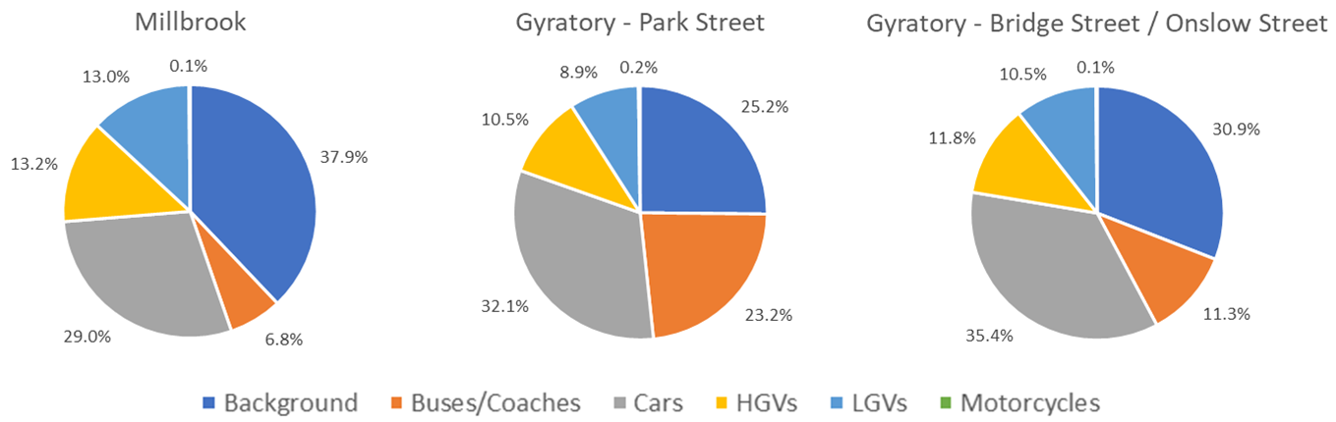

Required Reduction in Emissions
The degree of improvement needed in order for the annual mean NO₂ objective to be achieved is defined by the difference between the highest measured or predicted concentration and the objective level (40 μg/m³).
In terms of describing the reduction in emissions required, it is more useful to consider nitrogen oxides (NOx). The required reduction in local NOx emission has been calculated in line with guidance presented in LAQM.TG16 (Defra, 2018).
Table 3.1 sets out the required reduction in local emissions of NOx that would be required at the worst-case location where an exceedance is predicted, in order for the AQMA compliance level (38 μg/m³ for this AQMA) to be achieved.
The highest annual mean NO₂ concentration has been predicted at Park Street (60.9 μg/m³), requiring a reduction of 22.9 μg/m³ for the compliance level to be achieved. Table 3.1 shows that at this location a reduction of 56.6 µg/m³ in NOx emissions would be required in order to achieve the objective. This equates to a reduction of 57% in local road traffic emissions at this location.
Table 3.1 ‒ Improvements in Annual Mean NO₂ and NOx Concentrations Required in 2019 to Meet the Objective

Receptor | Required Reduction in Annual Mean NO₂ (µg/m³) | Required Reduction in Annual Mean NO₂ (% of total predicted NO₂) | Required Reduction in Road NOx Emissions (µg/m³) | Required Reduction in Road NOx Emissions (% reduction in road NOx)
Park St | 22.9 | 37.6 | 56.6 | 57.0

Year when objective is predicted to be achieved
A brief analysis has been undertaken to estimate when the objective may be achieved without any further intervention. It should be noted that this is not an accurate prediction but is based on factors provided by Defra for quantifying air quality concentrations in future years. The following graph shows reductions in concentrations at the worst-case modelled receptor within the AQMA, using two different methods; Defra’s roadside NO₂ projection factors and using the Emissions Factors Toolkit (EFT) published by Defra (assuming no traffic growth).
The graph indicates that, without intervention, the annual mean NO₂ concentrations may reduce below the compliance level (38 µg/m³ for this AQMA) at some time between 2025 and 2028.
Figure 3: Projected Concentrations in Future Years at Receptors Predicted to Exceed Air Quality Objectives
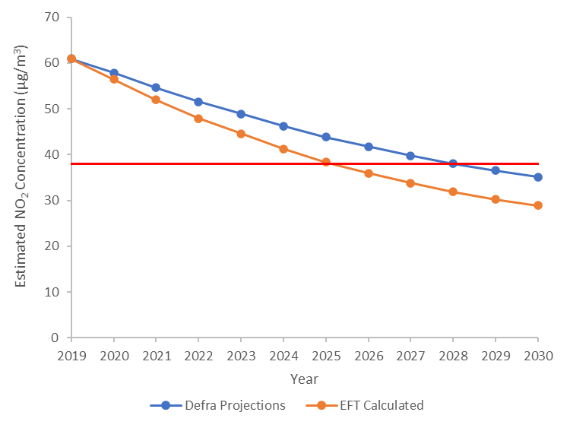
Predicting pollutant concentrations in a future year will always be subject to uncertainty. It is necessary to rely on a series of projections as to what will happen to traffic volumes, background pollutant concentrations and vehicle emissions. Although traffic volumes are generally increasing across the UK, background pollutant concentrations are expected to decrease into the future with cleaner technologies becoming available and increasing uptake of low emission vehicles.
Future year vehicle emission rates are based on a range of factors, such as expected vehicle fleet release dates, anticipated improvements in emission reduction technologies, expected uptake rates of different vehicles based on government policies, etc. It is therefore possible that the expected future emission rates in the EFT may differ from reality. Historically, evidence had suggested that Defra’s EFT exaggerated reductions in NOx emissions as expectations of reductions from diesel vehicles were included which were not seen in practice. However, analyses of recent NOx measurements now provide evidence that vehicle controls are working and as a result Defra’s EFT provides the current best reflection of the rate of reductions into the future. Due to the implications associated with the Covid-19 Pandemic upon vehicle fleet turnovers and low emission vehicle uptake, there remains uncertainty in predicting future compliance within the AQMA. GBC will continue to monitor and conduct modelling exercises over the forthcoming years to understand the real levels.

WHO Guidelines
The 2019 Clean Air Strategy (Defra, 2019) includes a commitment to set a “new, ambitious, long-term target to reduce people's exposure to PM_{2.5}” which the Environment Act 2021 commits the Secretary of State to setting. The World Health Organization (WHO) acknowledges that current evidence suggests no safe level for PM_{2.5} (particulate matter less than 2.5 micrometres in diameter). The WHO set a previous guideline, which was 10 µg/m³ as an annual mean and more stringent than the current air quality objectives, to reflect the level at which increased mortality from exposure to PM_{2.5} is likely. However, the WHO guidelines were updated in September 2021 and now include more stringent levels to reflect updated evidence of health effects (5 µg/m³ for PM_{2.5}), since the previous guidelines were published in 2005. Following the UK leaving the EU the Government have published the Environment Act 2021, which puts a duty on the Secretary of State to lay before Parliament an annual mean target for PM_{2.5} in ambient air before November 2022. The maximum annual mean PM_{2.5} concentration in the town centre has been predicted to be 16.9 µg/m³, below the air quality objective but above the WHO guideline level. Although the AQMA has not been declared for PM_{2.5}, GBC have a duty to work towards improving PM_{2.5} levels in the town centre. The new WHO guidelines also set a more stringent level of 10 µg/m³ for NO₂, which should be borne in mind when considering the level of ideal reductions to be achieved, particularly where there is highly sensitive exposure or a densely populated area of exposure.

Key Priorities
Based on the evidence provided above, the following issues need to be considered when deciding on which measures are likely to be effective:
- The majority of emissions arise from cars;
- There is a significant contribution of emissions from LGVs and HGVs;
- There is a significant contribution from buses, particularly at Park Street;
- There is no decipherable contribution from point sources or industry;
- Any measures which will take longer than 2027 to implement and have effect, are unlikely to bring forward compliance with the air quality objectives.
Because of the above points, it is going to be very difficult to implement a single measure in isolation which will have a large enough impact to improve the situation in a short timescale; multiple measures will therefore be required. A number of measures have been discussed within the Action Planning process, anything implemented will need to be proportionate to the issue which has been identified, which is a localised issue around the gyratory and arterial roads, and considered in terms of potential wider impacts outside of the town centre (i.e. to avoid creating another AQMA elsewhere). The following sections outline measures which are proposed to be implemented, and those which require further investigation. Appendix B includes measures which have been discussed and discounted (and the reasons for being discounted).

Development and Implementation of Guildford Town Centre AQAP

Consultation and Stakeholder Engagement
In developing this AQAP, GBC have worked with other local authorities, agencies, businesses and the local community to improve local air quality. Schedule 11 of the Environment Act 1995 requires local authorities to consult the bodies listed in Table 4.1.
The response to our consultation stakeholder engagement is given in Appendix A.
Table 4.1 ‒ Consultation Undertaken
Yes/No | Consultee
[TBC] | The Secretary of State
[TBC] | The Environment Agency
[TBC] | The highways authority
[TBC] | Neighbouring local authorities (Waverley)
[TBC] | Other public authorities as appropriate, such as Public Health officials
[TBC] | Bodies representing local business interests and other organisations as appropriate

Steering Group
The Air Quality Steering Group includes environmental health officers, planners (policy and transport), local highways officers (Surrey County Council), plus the GBC’s contracted air quality consultants Air Pollution Services (a trading name of KALACO Group Ltd).
Workshops were held on 21st October 2021 and 13th December 2021 to discuss measures for inclusion within the AQAP. Useful dialogues were had in relation to current and future practice, ideas for further measures and consultation as the AQAP is taken forward with a particular focus on the plans and visions for the town centre.
Matters relating to the Guildford Town Centre are also covered in the Consultation Shaping Guildford’s Future launched on the 8 December 2021.

Existing and Committed Measures
A number of measures and initiatives, which will improve air quality, or raise awareness, are already being implemented in the Guildford area. These are not focussed specifically on Guildford Town Centre but will assist in reducing emissions more generally and increasing awareness of air quality, travel choice and choice of vehicle. These existing measures include:
- easitGUILDFORD. This is a green travel network, which was launched in 2019, which currently has over 12 businesses signed up. There are benefits for employees to encourage car sharing and alternative travel to work, which include discounts on rail and bus travel, discounts on EV recharging, car sharing schemes, discounts on bikes and free car club membership.
- Electric buses. Guildford has introduced a fleet of nine electric buses for its park and ride service from car parks to the town centre to replace existing diesel buses on the routes. This is the first Park and Ride in the UK to operate using only electric buses.
- Surrey Air Alliance have delivered a Defra funded schools education project in AQMA areas. Around 40 schools in the County have taken part in the programme which included workshops on air quality, cycle training and an anti-idling campaign;
- GBC has introduced a Green Scheme, which enables owners of electric vehicles to apply for a Green Parking Permit free of charge, which gives discounted parking in car parks;
- Project Aspire, which aims to improve the health and well-being of Guildford residents and to reduce social inequality, is about providing leadership, encouragement and support to all communities. The projects include initiatives to reduce dependency on cars and educational programmes in schools;
- GBC and Surrey County Council are incrementally improving the existing cycle network in the borough. An example of this is the Guildford-Godalming Greenway, which links the two towns with a safe route suitable for people who are walking, cycling, using wheelchairs or families with children in pushchairs. The Guildford Local Committee, on 13 June 2018, adopted the Guildford-Godalming Greenway route into the Guildford Cycle Plan which is a Surrey County Council plan. At Guildford, the Greenway will link into the growing network of green routes around the town. The route exists and is being upgraded gradually. Surrey County Council currently have funding for a short section of it known as Dagley Lane, otherwise the route is not funded, but it is anticipated that developments would contribute to sections of the scheme.
- GBC is participating in iSCAPE (Improving the Smart Control of Air Pollution in Europe) which works on integrating and advancing the control of air quality and carbon emissions in European cities in the context of climate change through the development of sustainable and passive air pollution remediation strategies, policy interventions and behavioural change initiatives.
- Surrey County Council will begin a new one-way trial of Walnut Tree Close on the 29th May 2022 for a period of six months. This is part of the Town Centre Master plan which aims to create a more attractive pedestrian environment. If this one-way system proves beneficial to the impact of traffic on Walnut Tree Close and Guildford Town Centre, reduces queuing and conflicts along the road and gyratory, and improves the safety and environment, then it will be made permanent.
- An Electric Vehicle charging network pilot study is currently at construction stage.
Where feasible, and funding is available, these projects will be continued and enhanced.

Development of AQAP Measures
In relation to Guildford Town Centre specifically, the following groups of measures, as outlined by Defra and categorised for reporting to the EU, have been considered. A brief overview of this consideration is included in Table 4.2.
Table 4.2 ‒ EU Measure Categories Considered in Guildford
EU Measure Category | Current Practice in Guildford/ consideration for Guildford Town Centre
Alternatives to Private Vehicle Use | Bus based Park and Ride is already in place, and now fully electric. Additional services may be highly beneficial. GBC has adopted a policy to promote and facilitate home working, flexible start and finish times, compressed hours, mobile working and virtual meetings, and conference calls etc.
Environmental Permits | Not relevant at this location.
Freight and Delivery Management | Much freight and delivery is present in the town centre and contributes to elevated pollution levels. Measures to reduce emissions from these vehicles would be highly beneficial.
Policy Guidance and Development Control | Regional groups already operating in Surrey. An Air Quality Strategy for Guildford already adopted. GBC work within the planning system to request air quality assessments where relevant and ensure mitigation measures are implemented where necessary, although further improvements in local guidance would be highly beneficial.
Promoting Low Emission Plant | Not a major issue at this location.
Promoting Low Emission Transport | Green scheme parking fees for Electric vehicles in GBC car parks. Electric vehicles as part of GBC vehicle fleet.  Currently Environment and Regulatory al Health recommends conditions to the Planning Services on developments above 10 dwellings to have infrastructure for electric vehicle charging in each house or 10% EV spaces for unallocated car parking spaces.  Electric vehicle car parking standards for new development are also promoted through Surrey County Council’s Vehicular and Cycling Parking Guidance (as well as via GBC’s Environmental and Regulatory Health Team). The guidance’s standards will be increased due to match the standards contained in the emerging Local Plan: Development Management Policies and Parking SPD, to standards which, as a minimum, mirrors the Government’s proposals to be implemented via Building Regulations.  Discounted car parking facilities for electric and ultra-low emission vehicles.
Promoting Travel Alternatives | GBC implemented easitGuildford, a green travel network, to promote alternative transport, car sharing, bike to work scheme, provision of lockers, changing facilities, shows to support cyclists, runners, walkers, promote P&R scheme and non-car use.
Public Information | This is being delivered through other projects such as easitGuildford and Project Aspire as outlined above. Further provision would be beneficial.
Traffic Management | Traffic Management options are being discussed with Surrey County Council. There are several other schemes that may affect traffic in Guildford Town Centre in the near future that require further consideration. Any major changes to the road network would likely not be implemented within a short enough period to provide sufficient benefits in air quality within the AQMA. However, there may be minor changes that could be beneficial.
Transport Planning and Infrastructure | Cycle network improvements such as the Guildford to Godalming Greenway are proposed, but there is already a usable cycle route into Guildford so may not encourage much further modal shift of work trips.
Vehicle Fleet Efficiency | Although GBC is promoting low emission public transport (particularly for the electric bus fleet for P&R), for other vehicle types these measures would be difficult to target for vehicles specifically driving through Guildford Town Centre. Continued improvements in the bus fleet are therefore considered further for this Action Plan.
Table 4.3 presents a short-list of measures which have been considered for implementation within the AQAP.

Table 4.3 ‒ Proposed Measures
Measure No. | Measure | Comments
1 | New bus based park and ride | Four Park and Ride schemes exist at present, albeit Onslow is suspended due to the site being used as a Covid testing facility. There is a new planned site at Gosden Hill (LPSS site allocation requirement). Park and Ride sites are generally, and in the Guildford context highly successful, but an overall revenue cost. They currently comprise electric vehicles and have helped improve air quality in the borough. GBC have suggested that a new site at Horsham Road (existing site - Arlington on different road) could potentially be beneficial, helping to reduce the number of vehicles travelling through the AQMA.
2 | Road strategy schemes to tackle congestion on Strategic Road Network | KonSULT (the Knowledgebase on Sustainable Urban Land Use and Transport) includes a first principles assessment for the urban traffic control policy instrument which indicates that by increasing capacity congestion can be reduced so reducing air pollution however, it can also attract additional car users due to the reduction in travel times and increasing capacity. Taken in isolation, this would not be wholly consistent with GBC's Corporate Plan ambition to 'Work with partners to make travel more sustainable and reduce congestion'. http://www.konsult.leeds.ac.uk/pg/14/  GBC have several other schemes currently ongoing, including the A3 air quality consultation, A3 highways improvements consultation and Guildford Town Centre Masterplan. All of these are likely to affect the road network their cumulative effects considered. SCC have thus commented that this measure would need traffic operations buy-in and potentially input from the traffic signals contractor.
3 | Incident management and effective contingency planning to minimise traffic disruption and unnecessary congestion | This is a popular action and will be parallel to the A3 consultation and the Masterplan. Incidents on the A3 and the associated impacts upon the town could be assessed. Potentially access would be needed to live feed from providers such as TomTom, Waze, etc. Potential large revenue cost.
4 | Reduction of speed limits, 20 mph zones | It is noted within SCC and GBC that average speeds on congested roads within the AQMA are likely to be lower than 20 mph anyway. Therefore, this step may not help to improve air quality in isolation but could assist delivering the message about not driving into / through Guildford, especially when combined with other measures. Implementation of 20 mph zones along the arterial roads of Guildford could provide smoother through-flows of traffic in Guildford and potentially within the AQMA, and have the potential to be beneficial.  Of note, 20 mph zones are not enforceable by cameras in Surrey. In principle, SCC would be supportive of this measure, and it's likely to be a measure advocated in the forthcoming Local Transport Plan (LTP4).  Low traffic neighbourhoods/ 20 mph schemes could have a number of benefits, including help achieve modal shift.
5 | Traffic control centre monitoring of traffic movement and providing real time traffic control over many traffic control installations | A pre-requirement for this is measure 2, road strategy schemes to tackle congestion on Strategic Road Network, and is a revenue cost.
6 | Possible HGV ban around the gyratory during peak and interpeak hours. | GBC – Risk of potential noise issues during off-peak hours. A review of congestion and potential restrictions would be useful to inform this measure.  SCC - Possible to deliver, especially as an HGV ban has just been delivered in Farnham. Would need to consider impact on alternative routes as part of a study to help inform consultation.
7 | Improve website information – Educational resources for schools | SCC - Already undertaken at some schools: possible to do more but uncertain effect on town centre in short-term.
8 | Schools air quality programme - monitoring, student air quality committee, educational materials, presentations | Would be beneficial to help drive forward long-term improvements, but uncertain effect on town centre in short-term.
9 | Promotion of cycling travel route maps to public | SCC already have maps available, but a relaunch may be beneficial. It is noted that many routes may require improvement to be a realistic mode choice for many.
10 | Promotion of low pollution route maps to public (walking) | This is seen as a low-cost measure, and it is noted that added value would arise if coupled with other measures that affected the ability to drive to or through Guildford. However, it is also noted that although this could provide obvious health benefits, from a mode shift point of view this may highlight there are no alternatives, i.e. need to cross Onslow road would involve a convoluted detour.
11 | Postcode air quality checker | This can be done at a low cost with a professional service already sourced for the technical side (APS).
12 | Air Alert | Air quality monitoring station is recommended due to the AQMA, which would be a prerequisite for this service. While possible to do, this might impact on tourism economy on days with poor air quality (e.g. air alert issued based on readings from station and weather forecast might dissuade people from travelling into Guildford. Hence, might be good for air quality readings and local residents, but may have implications for the local economy).
13 | Air quality information - current conditions in Guildford - what residents can do to help | Put leaflet info on website, possibly email all Guildford residents with links to the pages, utilising contact data already held by the GBC. Hardcopies could be used if deemed more likely to drive involvement from residents, but is less sustainable.
14 | Indoor air quality information - what residents can do to improve their conditions | SCC note that this might aggravate local residents when they see the problem as through traffic, commuters and visitors.  As more people opt to work at home, promoting this measure will introduce a modal shift in thinking about air quality and that personal choices of local residents (both inside and outside the AQMA) can make big differences to their personal exposure to air pollutants overall. This may also encourage residents to have a modal shift away from home, towards more sustainable modes of transport.
15 | Tools to assess traffic management schemes prior to implementation | Main tool, SCC's Paramics model for Guildford Town Centre needs updating, but could be done fairly quickly (e.g. within 6 months). Any traffic management measures proposed would likely lead to changes in traffic on local roads, changing flows, speeds, queuing, and vehicle compositions, all of which can affect air quality. Keeping the model updated with the latest traffic on the roads in Guildford and assessing interventions within the model will help to ensure measures reduce concentrations.
16 | Tool to evaluate measures to reduce traffic emissions | As above, Paramics Discovery has an emissions module and can output traffic flows and speeds, allowing them to be inputted into an air quality dispersion model. The latter cannot be done by SCC but can be done by a professional service already sourced (APS). Evaluating the air quality impacts of measures is an important step in implementing measures to ensure measures will reduce concentrations prior to any financial actions.
17 | Parking App to direct users to closest and cheapest spaces | An investigation would be needed to check whether this measure is already available in some form (GBC believes here is an existing third party app). Potentially could be used to allow EV vehicle owners to book parking spaces in central car parks. Something more practical might be a new improved on-street parking guidance system. There was some concern regarding this making it easier for car use as it could increase total traffic volumes and decrease frustration in searching for a space, that users might end up paying more, and that it could facilitate more parking in Guildford Town Centre.
18 | Facilitate and promote home, mobile, remote and flexible working within the Council | Ongoing, new Agile Working Policy, and related to measure at 14 (indoor air quality information).
19 | EV deliveries, local delivery hubs | Guildford is possibly not large enough to support a depot of size that would be needed. This measure might be possible with couriers or might achieve better results with a Clean Air Zone (CAZ) or Low Emission Zone (LEZ).
20 | Potential CAZ/LEZ (Buses + HGVs) | Buses and HGVs combined contribute a significant proportion of pollution in the town centre. While cars have the largest effect, there are potential implications on deprivation. Similarly, LGVs also have a contribution, largely relating to small businesses. Targeting buses and HGVs, which are typically produce the highest emissions per vehicle, could provide a considerable air quality benefit. Will need to consider which buses could meet criteria and impact on operators and alternative routes. Could also consider a more stringent CAZ, involving more vehicle types or stricter emission standards.
21 | Anti-vehicle idling e.g. At level crossings, taxi ranks, the station, bus stops and outside schools. | There not any level crossings or schools within the AQMA boundary. Focus would be on bus station and taxi rank, most of the area is covered by parking restrictions.
22 | Bus stop clearways - further clearways will only be considered if vehicles parking in bus stops impede traffic flows | GBC mentioned the possibility for this on Portsmouth and Millbrook, and SCC highlighted that this may only be practical should there be enough services using the route. Additionally, there are other issues to consider such as sufficient road space, potential conflict with cycling measures, residential parking, etc.
23 | Development of Air quality supplementary planning guidance for developers | The following should be included; habitats, personalised travel plan, Construction vehicles (low emission) / Non-Road Mobile Machinery (NRMM) database, EV deliveries.  SPD/guidance for developers would be intended to build upon draft Policy P11: Air Quality and Air Quality Management Areas in the Local Plan Development Management Policies (LPDMP), which is not likely to be adopted until March 2023 at the earliest. Any SPD (should this be the form the guidance takes) would need to supplement this policy and could only be adopted after the LPDMP in 2023.  Informal guidance could be utilised sooner. It would have no planning weight but may be useful as a form of ‘operational advice’. Resource would be required for preparation of SPD, consultation, committee process, and would be competing against other corporate priorities for new Planning Policy documentation, such as Review of Local Plan, town centre Area Action Plan, new SPD’s already signalled in adopted and emerging Local Plans, etc.
24 | Improving modelling predictions of NO₂ concentrations | Popular with all councils, SCC mentioning that this could be done now. Existing predictions are based upon limited traffic information. Newer traffic data is now available and could be used to improve the air quality modelling.
25 | Promotion of Travel Choices | Possible to do easily, but unlikely to have much of an impact. However, targeted leaflets, social media and distribution would be good combined with other measures such as if improvements made to cycle network in a specific area or along a specific route/ infrastructure improvements to promote.
26 | Taxi licencing conditions - Emission standard in the new policy | GBC have funding through a Defra grant for electric vehicle trials for taxis. Should the trial prove beneficial then it may be beneficial to update the taxi licencing conditions with a new emission standard (i.e. low or zero emission) within a new policy.
27 | Electric cycle/scooter hire scheme | The cycle scheme is in operation at the main station, and there will be an on-going revenue cost. An opportunity could be electric scooter hire based at the main railway station to encourage commuters to travel by train and then pick-up scooter for last part of journey to workplace. But depends in part on location of facility, ease of access, hire rates acknowledging that commuters will want to retain scooter for return journey at end of the day, etc. Likely to have limited effect in town centre but could help as part of a package.  Significant work undertaken on delivery of an electric bike scheme, however deferred and budget removed in 2020. Corporate Programmes are leading new discussions with the University to introduce a new scheme to start following the end of the University's current scheme. Electric scooters only permitted as part of an approved Government trial, which are currently running elsewhere. So may need to wait until decision made on outcome of the trials.  Existing bike hire schemes (non-electric) at the station are managed by third parties, rather than GBC. There is a potential for GBC to encourage the third parties to work towards providing electric bikes.
28 | Sustainable Procurement Guidance | Worth reviewing – potentially already exists.
29 | Incentivise retrofitting scheme or upgrading of buses to low emission fuels | Currently there is a long lead time on such schemes, but worth reviewing again.

Each measure above has been scored 1 – 5 (going from worst to best, respectively) for a series of parameters, including cost to implement, timescale to implement, practical feasibility, deliverability, value for money, public buy-in, political buy-in and potential reductions to NO₂. In addition, GBC has a duty to work towards improving PM_{2.5} emissions and the potential reductions to PM_{2.5} for the measures have also been considered. An overall score was then calculated to enable the proposed measures to be ranked, in order to focus on the most useful measures to implement. The ranking and scores are set out in Table 4.4.
Table 4.4 ‒ Options Matrix
Measure No. | Measure | Cost | Timescale | Practical Feasibility | Deliverability | Value for Money | Public Buy-in | Political Buy-in | NO₂ Reduction | PM Reduction | Overall Score
1 | New bus based park and ride | 2 | 5 | 5 | 5 | 5 | 5 | 3 | 4 | 4 | 38
2 | Road strategy schemes to tackle congestion on Strategic Road Network | 5 | 4 | 2 | 3 | 3 | 5 | 5 | 3 | 3 | 33
3 | Incident management and effective contingency planning to minimise traffic disruption and unnecessary congestion | 4 | 3 | 2 | 3 | 3 | 5 | 5 | 4 | 4 | 33
4 | Reduction of speed limits, 20 mph zones | 5 | 5 | 3 | 5 | 2 | 4 | 5 | 2 | 2 | 33
5 | Traffic control centre monitors traffic movement and provides real time traffic control over many traffic control installations | 4 | 3 | 2 | 3 | 3 | 5 | 5 | 3 | 3 | 31
6 | Possible HGV ban around the gyratory during peak and interpeak hours. | 4 | 4 | 2 | 4 | 3 | 3 | 3 | 4 | 4 | 31
7 | Improve website information – Educational resources for schools | 5 | 4 | 5 | 5 | 1 | 3 | 3 | 2 | 2 | 30
8 | Schools air quality programme - monitoring, student air quality committee, educational materials, presentations | 5 | 4 | 5 | 5 | 1 | 3 | 3 | 2 | 2 | 30
9 | Promotion of cycling travel route maps to public | 5 | 5 | 4 | 4 | 2 | 2 | 2 | 2 | 2 | 28
10 | Promotion of low pollution route maps to public (walking) | 5 | 5 | 4 | 4 | 2 | 2 | 2 | 2 | 2 | 28
11 | Postcode air quality checker | 5 | 5 | 5 | 5 | 2 | 1 | 3 | 1 | 1 | 28
12 | Air Alert | 3 | 4 | 5 | 5 | 2 | 3 | 4 | 1 | 1 | 28
13 | Air quality information - current conditions in Guildford - what residents can do to help | 5 | 5 | 5 | 5 | 1 | 1 | 2 | 2 | 2 | 28
14 | Indoor air quality information - what residents can do to improve their conditions | 5 | 5 | 5 | 5 | 1 | 1 | 2 | 2 | 2 | 28
15 | Tools to assess traffic management schemes prior to implementation | 3 | 3 | 3 | 3 | 3 | 3 | 3 | 4 | 3 | 28
16 | Tool to evaluate measures to reduce traffic emissions | 3 | 3 | 3 | 3 | 3 | 3 | 3 | 4 | 3 | 28
17 | Parking App to direct users to closest and cheapest spaces | 4 | 4 | 2 | 4 | 1 | 4 | 4 | 2 | 2 | 27
18 | Facilitate and promote home, mobile, remote and flexible working within the Council | 5 | 5 | 4 | 4 | 3 | 1 | 3 | 1 | 1 | 27
19 | EV deliveries, local delivery hubs | 2 | 2 | 3 | 2 | 3 | 3 | 3 | 5 | 4 | 27
20 | Potential CAZ/LEZ | 2 | 2 | 3 | 3 | 2 | 4 | 4 | 4 | 3 | 27
21 | Anti-vehicle idling e.g. At level crossings, taxi ranks, the station, bus stops and outside schools. | 5 | 4 | 2 | 2 | 2 | 4 | 5 | 1 | 1 | 26
22 | Bus stop clearways -further clearways will only be considered if vehicles parking in bus stops impede traffic flows | 4 | 2 | 3 | 2 | 3 | 3 | 3 | 3 | 3 | 26
23 | Development of Air quality supplementary planning guidance for developers | 4 | 2 | 3 | 2 | 1 | 3 | 3 | 4 | 4 | 26
24 | Improving modelling predictions of NO₂ concentrations | 3 | 4 | 4 | 5 | 2 | 2 | 2 | 3 | 1 | 26
25 | Promotion of Travel Choices | 5 | 5 | 3 | 4 | 1 | 1 | 2 | 2 | 2 | 25
26 | Taxi licencing conditions - Emission standard in the new policy* | 4 | 3 | 3 | 1 | 4 | 1 | 3 | 4 | 2 | 25
27 | Electric cycle/scooter hire scheme | 3 | 3 | 2 | 3 | 2 | 2 | 2 | 4 | 3 | 24
28 | Sustainable Procurement Guidance | 5 | 5 | 5 | 3 | 1 | 1 | 2 | 1 | 1 | 24
29 | Incentivise retrofitting scheme or upgrading of buses to low emission fuels | 3 | 2 | 3 | 2 | 2 | 3 | 3 | 3 | 3 | 24

When considering which to implement, it is important to take into account whether they are likely to be viable economically within the timescales of achieving improvements. If measures will not have any effect until after 2027 then they will not help to revoke the AQMA. Table 4.5 sets out which authority would be responsible for each measure, the potential funding that may be utilised to implement each measure and the overall viability of achievement of each measure taking account of when each measure could lead to improvements within the AQMA. The measures that are not achievable have not been taken forward for further consultation (see Appendix B for further details).
Table 4.5 ‒ Viability of Measures
Measure No. | Measure | Responsible Authority | Funding Potential | Viability of Achievement
1 | New bus based park and ride | GBC own the land of existing sites. SCC setup and operate park and ride sites | Likely to be over £10 million to be confirmed. Land may need to be purchased. | Not achievable within time period due to funding, planning constraints, and physical constraints as old landfill site
2 | Road strategy schemes to tackle congestion on Strategic Road Network | SCC and National Highways. GBC as part of Town Centre Masterplan | Not able to estimate | Not achievable within the time period. The Masterplan is unlikely to be in place before 2025
3 | Incident management and effective contingency planning to minimise traffic disruption and unnecessary congestion | SCC and National Highways | Not able to estimate but likely viable | Potentially achievable
4 | Reduction of speed limits, 20 mph zones | SCC | Not able to estimate | Potentially achievable
5 | Traffic control centre monitors traffic movement and provides real time traffic control over many traffic control installations | SCC | Not able to estimate | Not achievable within the time period. The Masterplan is unlikely to be in place before 2025
6 | Possible HGV ban around the gyratory during peak and interpeak hours. | SCC | Not able to estimate | Potentially achievable
7 | Improve website information – Educational resources for schools | SCC and Private Sector | Likely to be less than £5,000 | Potentially achievable
8 | Schools air quality programme - monitoring, student air quality committee, educational materials, presentations | SCC and Private Sector. Four schools close to town centre, three colleges and the university. | Likely to be less than £10,000 intially | Potentially achievable
9 | Promotion of cycling travel route maps to public | SCC and GBC | Likely to be less than £5,000 | Potentially achievable
10 | Promotion of low pollution route maps to public (walking) | SCC and GBC | Likely to be less than £5,000 | Potentially achievable
11 | Postcode air quality checker | GBC | Likely to be less than £5,000 | Potentially achievable
12 | Air Alert | GBC | Not likely unless part of long-term monitoring of AQAP | Not achievable as unlikely to resource an automatic monitoring station
13 | Air quality information - current conditions in Guildford - what residents can do to help | GBC | Likely to be less than £5,000. Might need extra officer resource | Potentially achievable
14 | Indoor air quality information - what residents can do to improve their conditions | GBC | Likely to be less than £5,000. Might need extra officer resource | Potentially achievable
15 | Tools to assess traffic management schemes prior to implementation | SCC | Not able to estimate | Potentially achievable
16 | Tool to evaluate measures to reduce traffic emissions | SCC | Not able to estimate | Potentially achievable
17 | Parking App to direct users to closest and cheapest spaces | GBC | Not able to estimate | Potentially achievable
18 | Facilitate and promote home, mobile, remote and flexible working within the Council | GBC | Likely to be less than £5,000 | Potentially achievable
19 | EV deliveries, local delivery hubs | GBC, SCC and National Highways | Not able to estimate | Potentially achievable
20 | Potential CAZ/LEZ | SCC | Likely to be more than £5,000,000 | Potentially achievable
21 | Anti-vehicle idling e.g. At level crossings, taxi ranks, the station, bus stops and outside schools. | GBC and SCC | Not able to estimate | Potentially achievable
22 | Bus stop clearways -further clearways will only be considered if vehicles parking in bus stops impede traffic flows | SCC | Not able to estimate | Potentially achievable
23 | Development of Air quality supplementary planning guidance for developers | GBC | From GBC policy | Potentially achievable
24 | Improving modelling predictions of NO₂ concentrations | GBC and SCC | Likely to be less than £10,000 | Potentially achievable
25 | Promotion of Travel Choices | GBC and SCC | Not able to estimate | Not achievable as unlikely to provide much benefit within time period
26 | Taxi licencing conditions - Emission standard in the new policy | GBC, SCC, and other authorities | From Defra but has been revised | Potentially achievable
27 | Electric cycle/scooter hire scheme | GBC and Private Companies | Corporate programmes. May be opportunity in near future for Government scheme | Potentially achievable
28 | Sustainable Procurement Guidance | GBC | No additional funding required | Achievable
29 | Incentivise retrofitting scheme or upgrading of buses to low emission fuels | SCC | May be ex state funding | Potentially achievable

AQAP Measures
Following consultation, a number of measures have been considered by all relevant authorities, stakeholders and consultees as being appropriate for taking forward to assist with revoking the AQMA. These measures are set out in Table 5.1. The measures that have been considered and not pursued further are set out in Appendix B.
Table 5.1 ‒ Air Quality Action Plan Measures
Measure No. | Measure | EU Category | EU Classifi-cation | Lead Authority | Planning Phase | Implementation Phase | Key Performance Indicator | Target Pollution Reduction in the AQMA | Progress to Date | Estimated Completion Date | Comments
[TBC] | [TBC] | [TBC] | [TBC] | [TBC] | [TBC] | [TBC] | [TBC] | [TBC] | [TBC] | [TBC] | [TBC]
[TBC] | [TBC] | [TBC] | [TBC] | [TBC] | [TBC] | [TBC] | [TBC] | [TBC] | [TBC] | [TBC] | [TBC]
[TBC] | [TBC] | [TBC] | [TBC] | [TBC] | [TBC] | [TBC] | [TBC] | [TBC] | [TBC] | [TBC] | [TBC]

- Response to Consultation
Table A1: Summary of Responses to Consultation and Stakeholder Engagement on the AQAP
Consultee | Category | Response
[TBC] | [TBC] | [TBC]
[TBC] | [TBC] | [TBC]

- Reasons for Not Pursuing Action Plan Measures
Table B1: Action Plan Measures Not Pursued and the Reasons for that Decision
Action category | Action description | Reason action is not being pursued (including Stakeholder views)
Alternatives to Private Vehicle Use | Bus based park and ride | The bus-based park and ride is not seen as an achievable action that will be completed by 2025. It will require over £10 million of funding to be completed, it will likely encounter planning constraints during the planning process and the site previous use was a landfill site that will offer physical constraints to the site.
Traffic Management | Road strategy schemes to tackle congestion on Strategic Road Network | The Town Centre Masterplan is unlikely to be implemented before 2025. The implementation of a changing road strategy will not likely be achievable by 2025 as the Masterplan will be required.
Traffic Management | Traffic control centre monitors traffic movement and provides real time traffic control over many traffic control installations | The Town Centre Masterplan is unlikely to be implemented before 2025. The implementation of a changing road strategy will not likely be achievable by 2025 as the Masterplan will be required.
Public Information | Air Alert | GBC do not have the resources for a network of automatic monitoring stations for the period up to 2025.
Promoting Travel Alternatives | Promotion of Travel Choices | The action of promoting travel choices is seen as unlikely to make a significant impact within the administrative area of GBC within the relevant time period. The impact of other suggested measures compared to promoting travel choices will likely be greater.

- Further Measure Considerations
This section sets out some of the important preliminary details of measures proposed, which incorporate a geographical element, provided to the consultees to carefully consider when responding to the consultation.
When considering the measures, it is important to acknowledge that the AQAP is the first step in the process of progressing any measure. All measures taken forward by the AQAP will need to have feasibility studies undertaken to demonstrate their effectiveness and cost benefit, also taking account of other factors such as deprivation.
For the measures set out below, the feasibility studies would, for example, require detailed modelling of traffic and air quality, which could take several months to year to complete. The studies would need to consider the economic and social impacts, as well as consideration of the practicalities of implementation (e.g. locations for sign posts, turnaround points, databases and software for implementing fines, etc.).

Reduction of speed limits, 20 mph zone
The use of a 20 mph zone could have a number of benefits, including improving the throughflow of traffic across the town centre and helping to achieve a model shift; both of which may help to reduce vehicle emissions. The implementation could also assist delivering the message about avoiding driving to/through the town centre. For illustrative purposes only, an example 20 mph zone is presented in Figure 4. Any zone proposed would need to account for a wide range of factors, all of which would be addressed at a later stage with feasibility studies.
Figure 4 – Example 20 mph zone
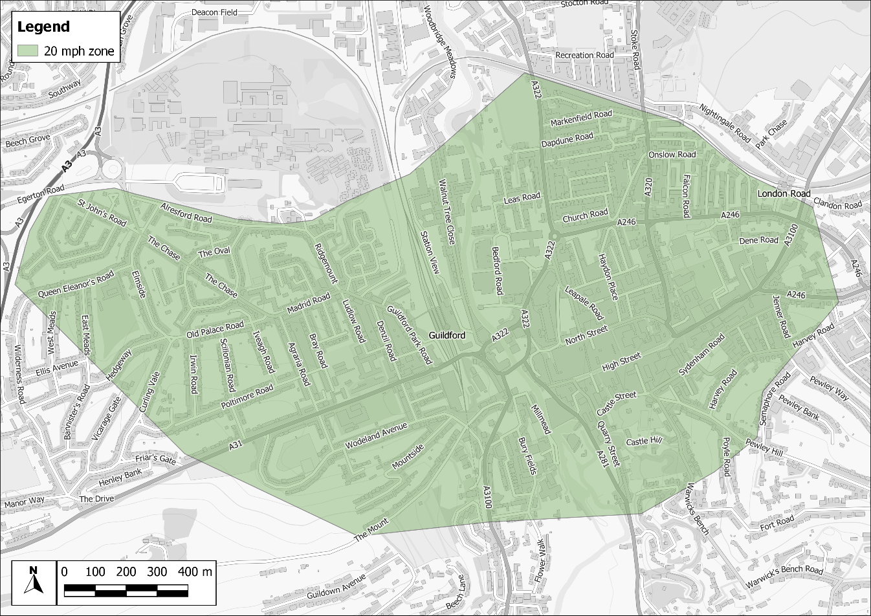
Contains OS data © Crown copyright and database right (2022).
The lower speeds would not be enforceable by cameras, nor traffic calming measures which would lead to episodes of acceleration resulting in higher emissions. Nevertheless, it is likely that a large proportion of road users would adhere to the speed limit, especially where congestion already occurs.

Possible HGV ban around the gyratory during peak and interpeak hours
Banning heavy goods vehicles (HGVs) from travelling through the gyratory and adjacent roads during peak and interpeak hours (7:30 am to 6:30 pm) could help reduce emissions from HGVs in the town centre, which currently account for approximately 10% of all emissions. For illustrative purposes only, an example ban boundary is presented in Figure 5. Any zone proposed would need to account for a wide range of factors, such as turnaround locations, all of which would be addressed at a later stage with feasibility studies.
Figure 5 – Example HGV ban boundary
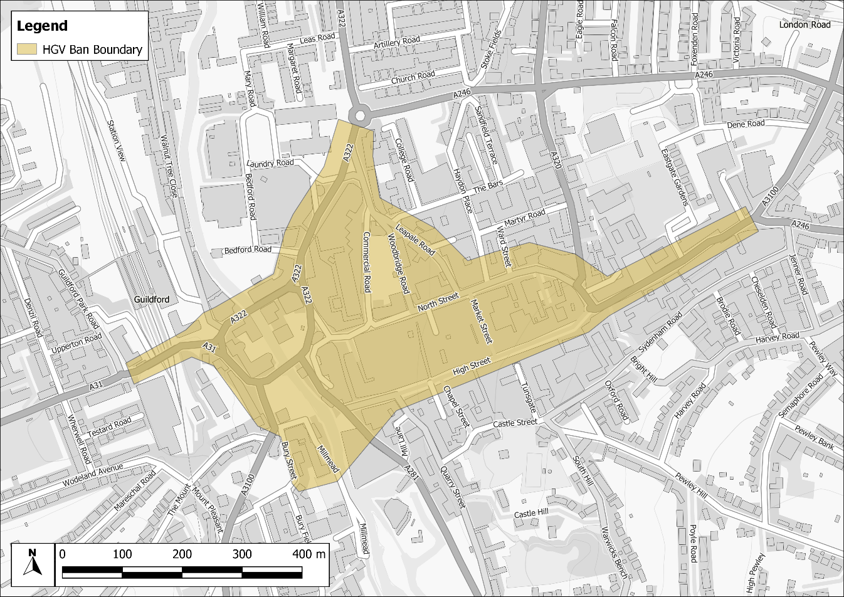
Contains OS data © Crown copyright and database right (2022).

EV deliveries, local delivery hubs
Light goods vehicles (LGVs) accounts for approximately 10% of all emissions in the town centre. One option to reduce these emissions could be to introduce electric LGVs, which depending on the uptake could achieve a significant reduction in pollution. To make this viable electric charging hubs would be needed along the key arterial routes in Guildford, including near the A3. In addition, it could be beneficial to have local delivery hubs that include electric charging infrastructure. These hubs would enable large HGV deliveries to be transferred to electric LGVs, for cleaner deliveries within the town centre. The proposed locations which could potentially be utilised for electric charging hubs or delivery hubs are presented in Figure 6.
Figure 6 – Example local delivery hub location options
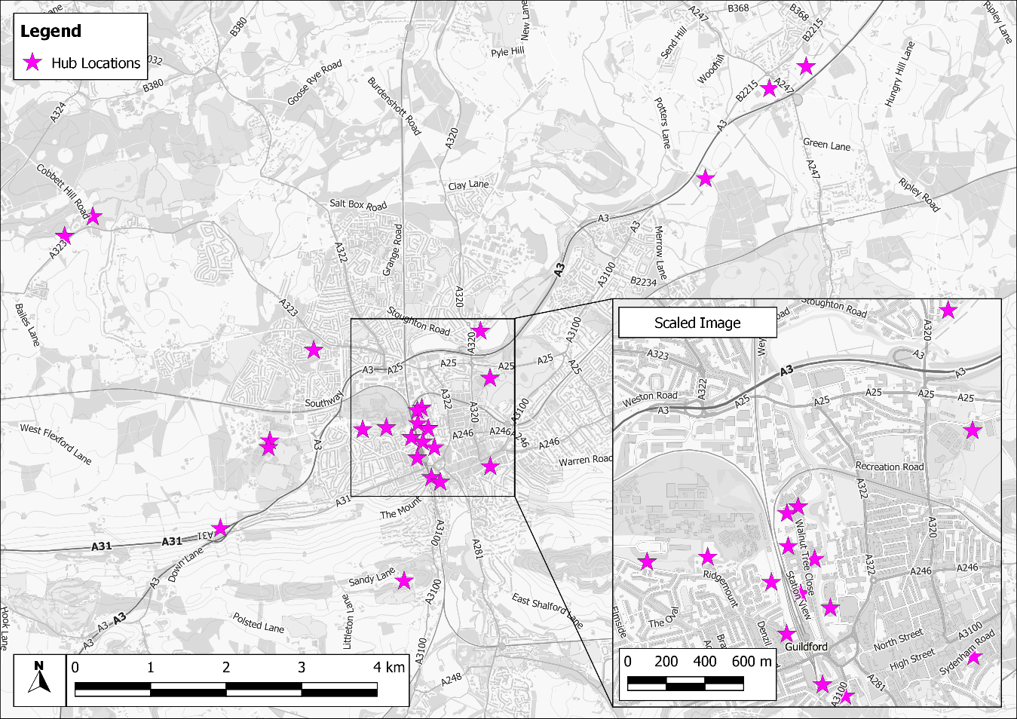
Contains OS data © Crown copyright and database right (2022).

Potential CAZ/LEZ
Clean Air Zones (CAZs) have been implemented in several cities recently (Bath, Birmingham, and Portsmouth) and proposed for many more. Although they have been established in response to the air quality limit values being exceeded (as opposed to the national air quality objectives for which the AQMA is declared), a CAZ could be utilised to achieve improvements in the town centre in relation to the objectives for the AQMA.
There are four types of CAZs that could be adopted:
- Class A – Buses, coaches, taxis and private hire vehicles
- Class B – Buses, coaches, taxis, private hire vehicles and HGVs
- Class C – Buses, coaches, taxis, private hire vehicles, HGVs, vans and minibuses
- Class D – Buses, coaches, taxis, private hire vehicles, HGVs, vans, minibuses, cars and GBC has the option to include motorcycles
Equally, another type of zone could be implemented, targeting specific vehicle types. The naming of the zone could also be termed differently, e.g. a Low Emission Zone (LEZ).
A CAZ would involve vehicles being charged to enter the zone, promoting drivers to avoid travelling through the town centre. It is important to consider how traffic may redistribute on the road network. Not all vehicles would be charged, only those that do not adhere to certain emission standards, i.e. newer vehicles with lower emissions would not be charged, only those that are likely to be more polluting. The minimum emission standards to avoid being charged in the CAZ would be:
- Buses, coaches and HGVs – Euro VI
- Vans, minibuses, taxis, private hire vehicles and cars – Euro 6 (diesel) and Euro 4 (petrol)
- Motorcycles – Euro 3
The key focus of a zone would be to limit high emission vehicles travelling through the gyratory, where the worst exceedances within the AQMA occur. Around the gyratory buses/coaches and HGVs account for about 22-33% of emissions and taxis for less than 5%. It is understood that the existing bus/coach fleet in the town centre is old and likely has high emission rates. Similarly, HGVs typically have high emission rates. The taxis are also understood to be fairly old. It is therefore proposed that CAZ B may provide a significant reduction in emissions.
Vans and minibuses (i.e. LGVs) also account for around 10% of emissions and would be useful to include. A CAZ C would be beneficial and worth consideration.
The key difference with a CAZ D is the inclusion of private cars. These account for approximately 30-35% of emissions alone and a CAZ D could therefore lead to a large improvement in air quality. Charging private cars would, however, have economic impacts on those more deprived and would need further consideration of the wider impacts.
For illustrative purposes only, an example CAZ boundary is presented in Figure 7. Any zone proposed would need to account for a wide range of factors, such as turnaround locations, all of which would be addressed at a later stage with feasibility studies.
Figure 7 – Example CAZ boundary
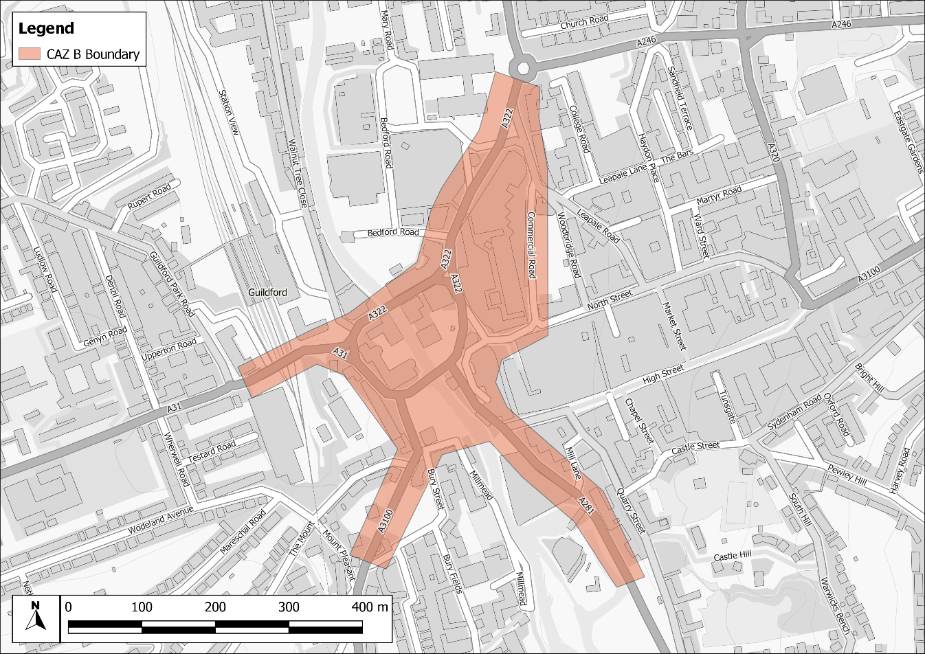
Contains OS data © Crown copyright and database right (2022).

Anti-vehicle idling
Stationary vehicles can unnecessarily cause emissions through idling of engines and also cause congestion if parked inappropriately. A simple solution to avoid excess emissions is to promote anti-vehicle idling, especially in locations close to those most at risk, such as schools, hospitals, care homes, etc.
There are not any level crossings or schools within the AQMA boundary. The focus would therefore be on the bus station, taxi rank and locations of queuing, for which most of the area is already covered by parking restrictions. Buses, taxis, and queuing traffic could reduce idling emissions though, as well as any temporarily idling parked cars.
Vehicle idling is an offence against the Road Traffic (Vehicle Emissions) (Fixed Penalty) (England) Regulations 2002. The law states that is an offence to idle your engine unnecessarily when stationary. If members of the public fail to turn their engines off after being spoken to, then they may be issued with a fixed penalty notice of £20. This would be difficult to enforce, and the emphasis should be on highlighting the issue of air quality and promoting anti-vehicle idling through signage.
The locations which could benefit from anti-vehicle idling are presented in Figure 8. The proposed focus is on the bus station, taxi rank and queuing traffic locations, where drivers could turn off their engines temporarily to reduce emissions, as well as at car parks, the bus station and taxi rank.
Figure 8 – Example anti-vehicle idling signage locations
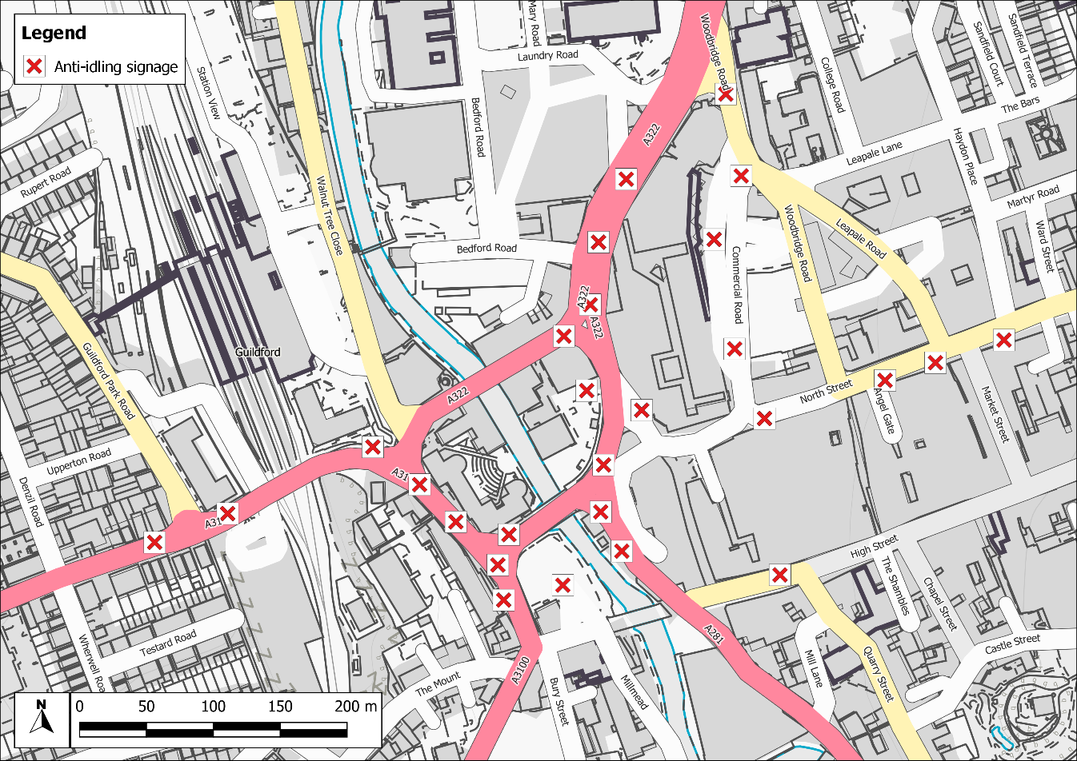
Contains OS data © Crown copyright and database right (2022).

- Glossary of Terms
Abbreviation | Description
APS | Air Pollution Services
AQAP | Air Quality Action Plan - A detailed description of measures, outcomes, achievement dates and implementation methods, showing how the local authority intends to achieve air quality limit values’
AQMA | Air Quality Management Area – An area where air pollutant concentrations exceed / are likely to exceed the relevant air quality objectives. AQMAs are declared for specific pollutants and objectives
AQS | Air Quality Strategy
ASR | Air quality Annual Status Report
CAZ | Clean Air Zone
Defra | Department for Environment, Food and Rural Affairs
EU | European Union
HGV | Heavy Goods Vehicle
LAQM | Local Air Quality Management
LGV | Light Goods Vehicle
NO₂ | Nitrogen Dioxide
NO_{x} | Nitrogen Oxides
PM_{2.5} | Fine particulate matter of less than 2.5 micrometres in diameter

- References
APS. (2021). Guildford Borough Council: Air Quality Detailed Assessment, Report Reference: L1002_A_5.
Barnes, J., Chatterton, T., & Longhurst, J. (2019). Emissions vs exposure: Increasing injustice from road traffic-related air pollution in the United Kingdom. Transportation Research Part D: Transport and Environment, 73, 56-66. https://doi.org/10.1016/j.
COMEAP. (2018). Associations of long-term average concentrations of nitrogen dioxide with mortality. Retrieved from https://www.gov.uk/government/publications/nitrogen-dioxide-effects-on-mortality
Defra. (2006). Air Quality and Social Deprivation in the UK: an environmental inequalities analysis.
Defra. (2013). Abatement cost guidance for valuing changes in air quality.
Defra. (2019). Clean Air Stratetgy. Retrieved from https://www.gov.uk/government/publications/clean-air-strategy-2019
HM Government. (2017). Industrial Strategy: Building a Britain fit for the future.
HM Government. (2018). The Clean Growth Strategy: Leading the way to a low carbon future.
HM Government. (2019). A Green Future: Our 25 Year Plan to Improve the Environment.
HMSO. (1995). Environment Act. HMSO.
Wheeler, B. W.-S. (2005). Environmental equity, air quality, socioeconomic status, and respiratory health: a linkage analysis of routine data from the Health Survey for England. J Epidemiol Community Health, 59:948–954. doi: 10.1136/jech.2005.036418.

Available at Health and Wellbeing Guildford Council
Available at New Local Plan Guildford Council
Available at Guildford Borough Transport Strategy 2017 PDF
Available at Climate Change SPD Guildford Council
Available at Shaping Guildford website
Available at Surrey County Council Transport Plan
Available at Guildford Council Air Quality Strategy 2017-2022 PDF
See Shaping Guildford's Future website for more details.
See the easitGuildford website for more details.
See What is Green Scheme Guildford Council for more details.
See Aspire projects and future events Guildford Council for more details,
See Guildford Godalming Greenway website for more details.
iSCAPE website
Proposed Submission Local Plan
Parking Strategy Guildford Council

