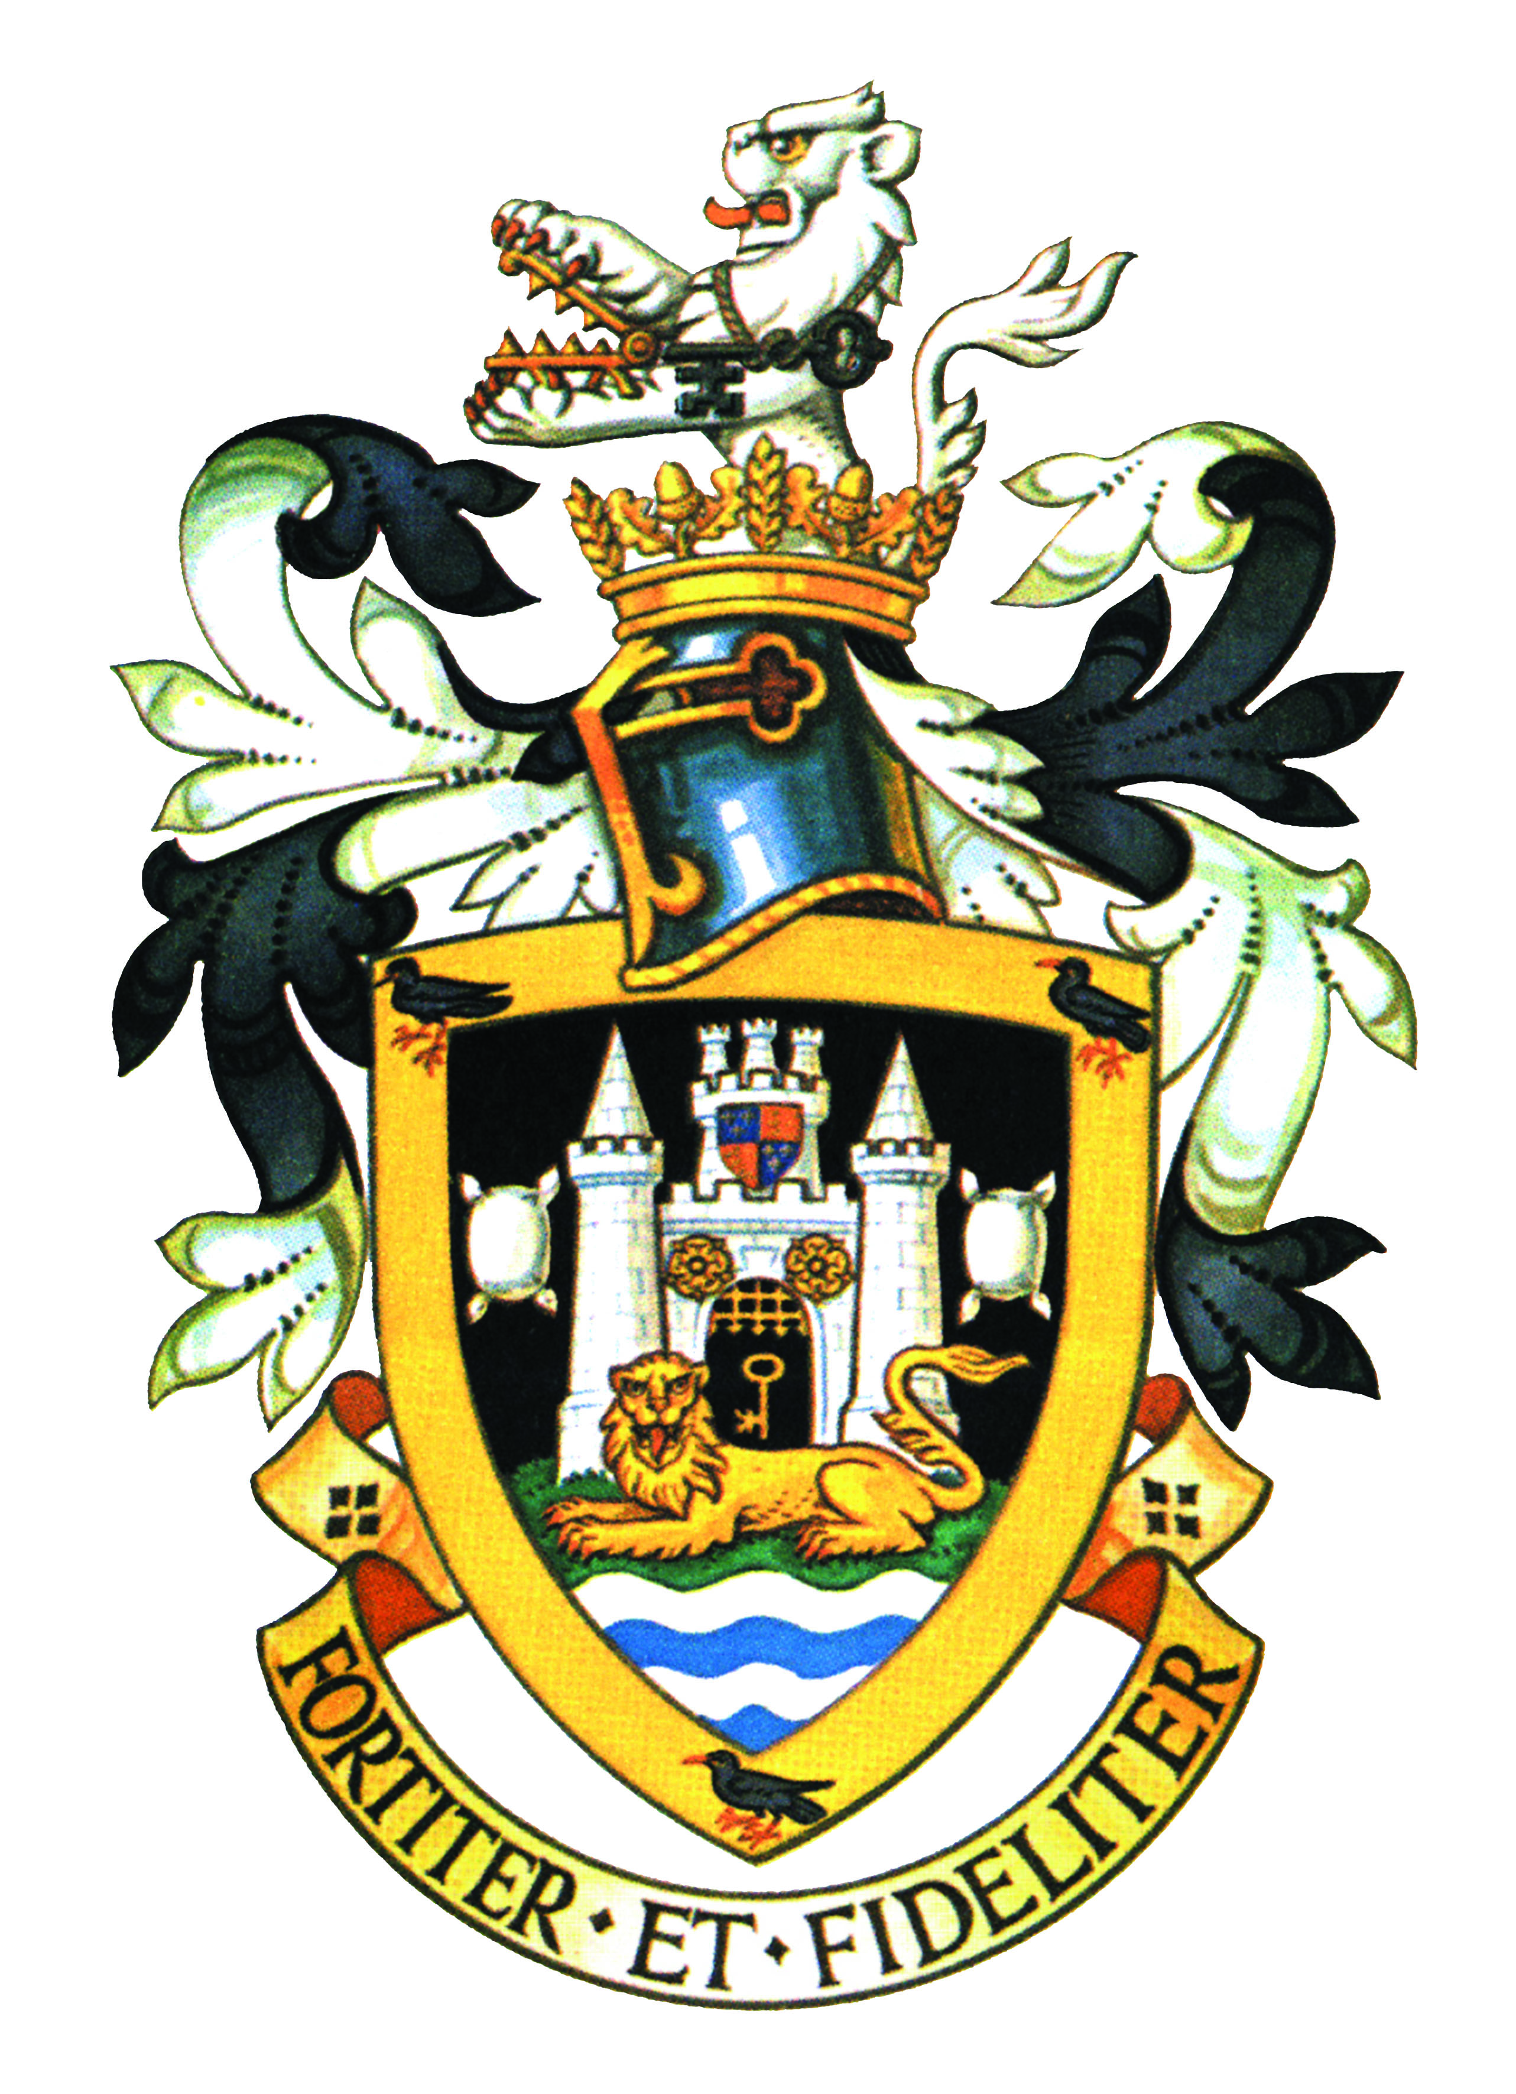

THE MAYOR OF GUILDFORD
Councillor Dennis Booth

Invites you to attend

a reading of the Proclamation of the Accession

on the steps of Holy Trinity Church, High Street, Guildford

at 3pm on Sunday, 11 September 2022

Following the passing of our late Sovereign, Queen Elizabeth the Second. Our sadness at this time is shared by people across the globe, as we remember with affection and gratitude the lifetime of service given by our longest-reigning Monarch.

But the basis on which our monarchy is built has ensured that through the centuries the Crown has passed in an unbroken line of succession. This ceremony will mark the formal Proclamation to the people of Guildford of the beginning of our new King’s reign.

The Accession Council will meet at St. James’s Palace to proclaim our new Sovereign. Flags which have flown at half-mast since The Queen’s death will be raised briefly to their full height to mark the start of His Majesty’s reign.

Following the reading of the Proclamation by the High Sheriff at Guildford Cathedral at 1pm, it will be my humble duty to read the Proclamation to the people of Guildford at 3pm.

The council will be robed and will process from the Guildhall to the steps of Holy Trinity at 2.50pm.

RSVP: please confirm your attendance by email to: civicsecretary@guildford.gov.uk

TIMETABLE

2.30pm Council guests to arrive at Guildhall to robe and prepare for the procession.

2.50pm Procession, led by the Town Crier and Mace Bearers leaves the Guildhall

2.55pm Welcome

The Mayor reads the Proclamation of the Accession
Assembled guests sing the first verse of the National Anthem

3.15pm Event ends – Civic procession returns to the Guildhall

DRESS CODE

LADIES: Sombre Day Dress

GENTLEMEN: Lounge Suit with Black Tie
*Items of mourning dress will be available for those robing

