2022 Air Quality Annual Status Report (ASR)
In fulfilment of Part IV of the Environment Act 1995 Local Air Quality Management

Date: May 2023

Information | Guildford Borough Council
Local Authority Officer | Anjana Papnai  Gary Durrant
Department | Environment and Regulatory Services
Address | Guildford Borough Council, Millmead House, Millmead, GU2 4BB
Telephone | 01483 444373
E-mail | regulatoryservices@guildford.gov.uk
Report Reference Number | ASR GBC 2022
Date | May 2023

Executive Summary: Air Quality in Our Area

This annual status report updates on the 2021 monitoring data and key actions in the year 2021 and part of 2022.
Guildford Borough Council continued monitoring of its diffusion tubes monitoring network across the borough as per the DEFRA diffusion tube monitoring calendar. The diffusion tubes network monitored at 48 locations, focussing on the relevant receptor locations (residential properties, schools) near busy roads.
The Council completed a detailed air quality assessment for wider town centre area including the town centre gyratory and major roads feeding into the gyratory. As a result of this study, the Town Centre Air Quality Management Area (AQMA) was adopted in October 2021. Map D.2 in Appendix D shows the AQMA boundary.
Guildford now has three AQMAs declared for exceedance of the annual average air quality objective level for nitrogen dioxide (NO₂). The Compton and Shalford AQMA were declared in January 2018 and May 2019 respectively and still remain in place.
We worked collaboratively with National Highways on the A3 PCM link which according to their report has worst nitrogen dioxide pollution in the country. The National Highways are the responsible authority for improving air quality along their strategic road network. The Council commissioned a high-level option analysis study for National Highways to understand measures that could be delivered in the next few years to improve air quality along the A3 stretch passing through Guildford. The study was completed in March 2021 and discussed in the section 2.2, Key Completed Measures. We also expanded our monitoring network to include the A3 roadside locations to assist in this study and any future air quality works on the A3.
We worked with the Planning Policy at Guildford Borough Council to develop the Local Plan: Development Management Policies, which includes Policy P11 for Air Quality and Air Quality Management Areas.
Air quality improvement is a collaborative work between local authorities and other stakeholders. We hope that through this ASR we can get progressive involvement of residents and local communities in various ways. Choosing sustainable mode of transports, supporting local businesses, using cleaner smokeless fuel for wood burners, low NO₂ emission boilers are only few of the suggestions listed here. The residents and interested parties can contact us with their concern or suggestions using the online webform: https://www.guildford.gov.uk/article/18932/Report-an-issue-with-air-quality.

Air Quality in Guildford Borough
Air pollution is associated with a number of adverse health impacts. It is recognised as a contributing factor in the onset of heart disease and cancer. Additionally, air pollution particularly affects the most vulnerable in society: children, the elderly, and those with existing heart and lung conditions. There is also often a strong correlation with equalities issues because areas with poor air quality are also often less affluent areas,.
The mortality burden of air pollution within the UK is equivalent to 28,000 to 36,000 deaths at typical ages, with a total estimated healthcare cost to the NHS and social care of £157 million in 2017.
The main source of emissions in Guildford Borough is from motor vehicles. The Borough of Guildford, centred on the town of Guildford, has a population of around 150,000, approximately half of which live within the urban area. Its location 32 miles to Central London (35 minutes by direct train), coupled with being almost equidistant of both Heathrow and Gatwick airports, makes it the ideal to work and commute from. Being a popular regional shopping and leisure destination, Guildford’s High Street and three shopping centres attract a lot of visitors and road traffic.
Four major roads pass through the Borough. The M25 enters the Borough briefly at Junction 10 (Wisley), which links to the A3 London to Portsmouth trunk road. The A3 runs from north to south through the Borough, linking with the A31, which joins the A331 Blackwater Valley Road. A high proportion of traffic in Guildford comprises of through-traffic on these strategic roads. The A3 Guildford origin destination study concluded that 60% of trips on A3 are external trips with neither origin or destination within Guildford Borough.
Whilst the land use is predominantly residential, there are several light industrial sites. The authority has 31 permitted processes under the Pollution Prevention and Control Act 1999. To date there is no record of any significant air quality impact from these premises. No new major point source of emission has been introduced in the Borough during 2021. In December 2019 the cremators at Guildford Crematorium were renewed to an up-to-date facility with mercury and NO₂ abatement. In September 2020 the flue height of the crematorium was increased by one metre following a variation to the permit.
Smoke Control Areas were set up in the 1960’s covering approximately 12 square kilometres of the urban area (See the Figure 1). These areas are still operational and subject to statutory control. The interactive smoke control areas map is available on GBC’s website for the residents: https://www.guildford.gov.uk/article/25093/What-are-smoke-control-areas
.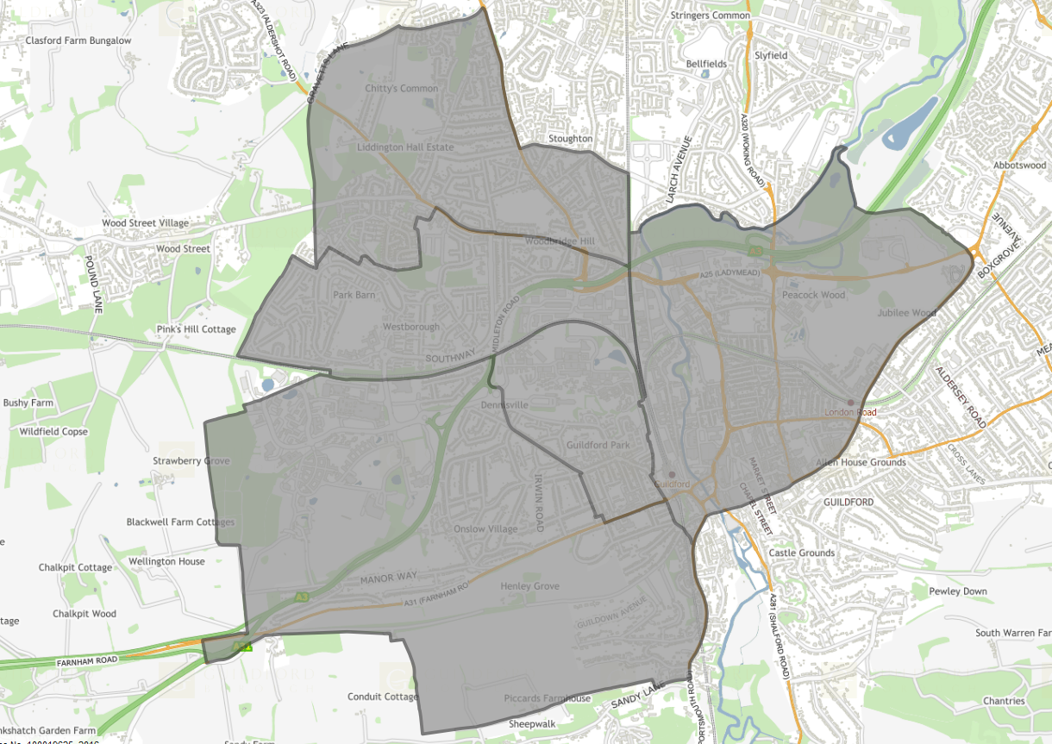
Figure 1: Map of Guildford Smoke Control Area

Nitrogen dioxide (NO₂) is the main pollutant of concern in Guildford Borough and is routinely monitored under the local air quality monitoring regime. In 2021, our diffusion tubes network monitored at 48 locations, primarily focussing the Air Quality Management areas and areas of know air quality concerns.

Monitoring Trends and comparison with national trend
The long term monitoring of urban and rural background in Guildford compares with the national trend (https://www.gov.uk/government/statistics/air-quality-statistics/ntrogen-dioxide).
Emissions of nitrogen oxides in the UK have continued to decrease as newer road vehicles subject to stricter emission standards enter the fleet.
In 2021, the coronavirus pandemic continued with third national lockdown across the country between January – March 2021 followed by phased exit from lockdown until July 2021. This is reflected in the NO₂ levels measured for the period. There has been a change in driving pattern, post covid and monitoring over next few years will help understand the impact on local air quality.
In 2020, the annual mean NO2 concentration at urban background sites reduced by 20%. It is likely that a reduction in traffic as a result of COVID-19 restrictions was a contributing factor to this relatively large decrease. In 2021, we can see a 4-5% increase in the background levels from the 2020 data.

Figure 2 10 year trend - Urban and Rural Background

Air Quality Management Areas:
Guildford Borough Council currently has three AQMAs for NO₂ :
- A small section of The Street, B3000 passing through Compton and where three properties are in close proximity to the road;
- A section of A281, The Street, Shalford affecting seven properties;
- The Guildford Town Centre AQMA encompassing Millbrook, Commercial Road, and the Park Street, Bridge Street/Onslow Road sections of the Guildford Gyratory.

Further information on the AQMAs in Guildford can be found at: https://www.guildford.gov.uk/article/21335/Find-out-about-Guildford-air-quality-management-areas

A monitoring summary is as follows:
Compton AQMA, although the monitored NO₂ levels were below the annual average air quality objective levels 0f 40µg/m³, the levels were within 10% of the objective level. Similarly, in Shalford AQMA, the monitored level for annual average NO₂ was within 10% of the objective level.
One location in Park Street, (Guildford), exceeded the air quality objective level. This location is within the Guildford town centre AQMA declared in 2022. There are some roadside exceedances near the A3 monitoring locations which are approximately more than 20m from the residential façade. The results are discussed in section 3.1 of the report.
There are no other identified areas of concern in Guildford Borough Council.

Actions to Improve Air Quality
Whilst air quality has improved significantly in recent decades and will continue to improve due to national policy decisions, there are some areas where local action is needed to improve air quality further.
The 2019 Clean Air Strategy sets out the case for action, with goals to reduce exposure to harmful pollutants. The Road to Zero sets out the approach to reduce exhaust emissions from road transport through a number of mechanisms; this is extremely important given that the majority of Air Quality Management Areas (AQMAs) are designated due to elevated concentrations heavily influenced by transport emissions.
The Council is committed at identifying areas where air quality could potentially be of concern and implementing local measures to provide opportunities for further local air quality improvements.
In 2021, NO₂ diffusion tube monitoring was carried out at 48 locations. Except for a few longstanding roadside and background monitors, locations are added or removed based on evidence from previous year’s monitoring. The focus is primarily on the locations where relevant receptors (e.g. residential façade) are very close to a busy road, as previous monitoring in the Borough has indicated that these areas are likely to exceed the air quality objectives for annual average NO₂ levels. The COVID restriction remained in place at varying degree till July 2021 and reflects in the monitoring data. It is likely to have impact on the long-term working/travelling pattern depending on the nature of business.
In addition, a Detailed Air Quality Assessment in the Guildford town centre area was commissioned and the town centre AQMA was declared on 22 October 2021 (https://www.guildford.gov.uk/article/21335/Find-out-about-Guildford-air-quality-management-areas).
A draft Air Quality Action Plan was submitted to DEFRA on the 26th October 2022 following a full public consultation on the proposed measures and adoption of the draft AQAP by the Guildford Joint Committee.
We continue to work closely with Surrey County Council on development of AQAPs, any other local initiatives. The other important partners are town centre AQMA Steering Group, Surrey Air Alliance (SAA, an alliance of 11 borough/district councils and SCC officers representing Public Health, Transport, Planning and Highways). The SAA is a valuable information sharing forum however has taken initiatives such as county wide air quality modelling and joint DEFRA grant bids benefitting the member authorities.
Surrey County Council has delivered 20 EV on-street fast (up to 22 kilowatts) charging points in Guildford under the two-year pilot scheme, from November 2019 to November 2021, that was funded by Enterprise M3 Local Enterprise Partnership (EM3 LEP).
The A3 trunk road, runs north to south through the Borough, GBC commissioned a report for National Highways on exceedances of the nitrogen dioxide annual air quality objective on public areas within the Guildford section. The study was completed in 2021 and aimed at identifying option measures, with a potential to reduce NO₂ levels on A3, which can be implemented in shortest possible timescale. The Council has since been working closely with the National Highways on development of project aimed at assisting, through grants and other schemes, to encourage businesses/users of A3 Guildford, to transform their fleet to cleaner electric vehicles. The project is currently in the planning stage.
The Guildford Local Plan was adopted in April 2019 which sets out the overall planning strategy for the Borough. The Air Quality Review, part of the Local Plan evidence base, assessed the impact of proposed growth on air quality. This advises further detailed modelling in certain areas but concludes that air quality issues are compatible with the growth proposed in the Local Plan. One area that has been a focus in particular air quality and habitats interaction, which although not LAQM is within the remit of GBC.
Following this, the new Local Plan: Development Management Policies (LPDMP) (https://www.guildford.gov.uk/guildfordlocalplan) were adopted following examination in and will be used with the Local Plan: Strategies and Sites (2015—2034). The LPDMP has detailed policies which will be used for determination of a planning application. The Policy 11 of LPDMP covers Air Quality and Air Quality Management Areas. It sets out the requirement of air quality improvement and reducing the effects of poor air quality from any development proposals and that the development proposal should not result in adverse impact on the sensitive receptors. It also sets out the requirement of detailed air quality assessment from major developments or developments around known air quality issues.
Several projects were completed such as implementation of the Sustainable Movement Corridor (SMC) to provide a priority pathway through the urban area of Guildford for buses, pedestrians, and cyclists, including serving the new communities at Blackwell Farm, SARP (Slyfield Area Regeneration Project) and Gosden Hill Farm; the replacement Walnut Bridge providing enhanced links between the railway station and the retail centre for pedestrians and cyclists.
Finally, several transport related actions, which are aimed at tackling air quality issues from the Guildford Borough Transport Strategy, December 2017 have been implemented and are included in table 2.2.

Conclusions and Priorities
We will continue to assess and review our monitoring network and continue the monitoring survey in the following year. Our draft town centre Air Quality Action Plan has been submitted for approval to DEFRA. The action plans are ambitious and challenging and will be subject to a feasibility study. The full process will require working closely with the local highway authorities and other partners.
The implementation of only identified measure in Compton AQAP of right turn ban to Down Lane was implemented in March 2020. The NO₂ levels have not shown any exceedance since 2019. However, this is due to COVID restrictions in place. In 2021, although not exceeding the levels are within 10% of the air quality objective level. Reviewing the AQAP for Compton is one of the Council’s priorities for the year 2023.
In Shalford AQAP, a number of soft measures were identified which are unlikely to bring compliance in the AQMA in the shortest possible timescale before natural compliance could be achieved through national interventions. We have prioritised a review of Shalford AQAP, using the new evidence obtained through the ANPR study (automated number plate recognition) on A281, which will compliment both the Shalford AQAP review and the town centre AQAP feasibility study. This will be reported in subsequent ASRs.
The Surrey Air Alliance of which, GBC is a member, successfully bid for a DEFRA air quality grant for £265k between 7 local authorities. The grant will fund an EV taxi project which will allow taxi operators to trial electric taxis. In October 2021, an online seminar was delivered for taxi drivers covering all the key issues associated with EVs, such as EV range, costs, and recharging. This was followed by 2 days of road test drive of electric vehicles suitable for taxi and private hire work. The course and test drives were delivered by the Energy Savings Trust.
In addition to above, working with the National Highways and supporting them with the implementation of air quality measure on A3, Guildford will remain the priority for 2022-2023. This work will be implemented in collaboration with the Surrey County Council.
The Council with identify air quality projects from the town centre AQAP that will bring benefits to local communities and will apply for government grants in 2022-23.
There are challenges expected which will affect the shape and form in which town centre AQAP can be implemented:
- The vibrancy of the town centre is important for Guildford’s economic growth and the AQAP should therefore not have negative impact on the economy.
- The increased cost of living will have impact on various national and local initiatives such as heating homes by burning solid fuels, delay in fleet renewal, etc.
- There are capacity and air quality issues on A3 in Guildford. The delivery of new Guildford West Station which will serve the residential are of Park Barn and economically active area of Guildford (including Royal Surrey Hospital, University of Surrey campuses including Surrey Sports Park and Surrey Research Park) will relieve some pressure off the A3. However, these are long term projects.
- Council has a priority to meet the need and welfare demands of its residents and often the resources must be matched to meet those demands.
- Funding and resources constraints
- To get more people to use sustainable mode of transport, there is a need for improved cycle network and safe cycling infrastructure, adequate bus transport and economical park and ride facility etc.

Local Engagement and How to get Involved
There is considerable interest from the residents, member of public and local action groups on the air quality issues in Guildford. We have information available on local air quality and how we monitor on our website: (https://www.guildford.gov.uk/article/19807/Find-out-how-we-monitor-air-quality-and-pollution).
In July 2022, we ran a full consultation on our proposed AQAP for the town centre AQMA and received over 400 responses to the action plan. The full result and analysis have been reported as part of AQAP submission. The details will be included in 2023 report.
We welcome and support any individual requests relating to local air quality concerns, monitoring requests in an area.
We engage with the Planning Services on any development, where air quality is likely to be of concern.
Most of the air quality concerns in Guildford are related to road traffic. Preventative measures include avoiding getting exposed to emissions by choosing alternative routes. Everyone has a role and can contribute to air quality improvement in many of the following ways:
- Are there alternatives to use of personal car? Consider alternatives to using the car. There are now several car free cycle routes, and you can you journey planner on Cycle Travel to plan your journey. Google maps are very handy to plan journeys by train, on foot or bike.
- Are you aware of Guildford car club? Guildford has 8 cars in the club with designated parking bays in a convenient location. Club cars are accessible to members 24 hours a day, 365 days a year. You can book them online, via a smart phone app or over the phone. The club cars either low or ultra-low emission vehicles. The residents in Guildford can benefit from the discount offer which gives annual membership of £10 and a 2-hour driving credit (Guildford car club - Guildford Borough Council).
- Is car sharing possible for school drop offs and pickups. Often, more than one car has same origin – destination from home to school or other activity clubs.
- Potential and existing green travellers can join the easitGuildford the green travel network www.easit.org.uk/network/easitGUILDFORD-23
- Turn off the car engine when stationary. Leaving an engine idling causes unnecessary emission into the air. The children and parents walking along the path near parked cars are the recipient to any emission from cars idling near schools.
- By choosing smokeless woodburning stoves and using seasoned woods or buy fuels certified as ‘Ready to Burn’ (Ready to Burn | A look at the regulations in more detail - HETAS).

Local Responsibilities and Commitment
This ASR was prepared by the Regulatory Service of Guildford Borough Council with the support and agreement of the following officers and departments:
Anjana Papnai, Compliance Officer, Regulatory Services
Gary Durrant, Senior Specialist-Environment Control (Noise and Pollution)
Justine Fuller, Head of Environment and Regulatory Services
Kimberley Ewan, Policy Officer – Planning Policy (Transport)
Donald Yell, Principal Strategic Transport Officer
This ASR is a late submission, as the Council had to prioritise work related to town centre AQMA and AQAP and has not been circulated for approval to any high-level Council member. We are committed to submit our 2023 within the deadline of 30 June 2023.
This ASR has not been signed off by a Director of Public Health. However, the council actively works with public health colleagues on actions to improve air quality via the Surrey Air Alliance.
If you have any comments on this ASR please send them to Gary Durrant, Senior Environmental Protection Specialist at:
Guildford Borough Council, Millmead House, Millmead, Guildford, Surrey GU2 4BB
01483 444373
regulatoryservices@guildford.gov.uk

Table of Contents
Executive Summary: Air Quality in Our Area i
Air Quality in Guildford Borough ii
Actions to Improve Air Quality vi
Conclusions and Priorities viii
Local Engagement and How to get Involved x
Local Responsibilities and Commitment xi
1 Local Air Quality Management 1
2 Actions to Improve Air Quality 2
2.1 Air Quality Management Areas 2
2.2 Progress and Impact of Measures to address Air Quality in Guildford Borough Council 5
2.3 PM_{2.5} – Local Authority Approach to Reducing Emissions and/or Concentrations 26
3 Air Quality Monitoring Data and Comparison with Air Quality Objectives and National Compliance 29
3.1 Summary of Monitoring Undertaken 29
3.1.1 Automatic Monitoring Sites 29
3.1.2 Non-Automatic Monitoring Sites 29
3.2 Individual Pollutants 29
3.2.1 Nitrogen Dioxide (NO₂) 29
Appendix A: Monitoring Results 31
Appendix B: Full Monthly Diffusion Tube Results for 2021 48
Appendix C: Supporting Technical Information / Air Quality Monitoring Data QA/QC 54
New or Changed Sources Identified Within Guildford Borough During 2021 54
Additional Air Quality Works Undertaken by Guildford Borough Council During 2021 54
QA/QC of Diffusion Tube Monitoring 54
Diffusion Tube Annualisation 55
Diffusion Tube Bias Adjustment Factors 55
NO₂ Fall-off with Distance from the Road 56
NO₂ Fall-off with Distance from the Road 57
Appendix D: Map(s) of Monitoring Locations and AQMAs 61
Appendix E: Summary of Air Quality Objectives in England 74
Glossary of Terms 75
References 77

Figures
Figure A.1 – Trends in Annual Mean NO₂ Concentrations – Town centre 44
Figure D.1 – Map of Non-Automatic Monitoring Site 61
Tables
Table 2.1 – Declared Air Quality Management Areas 3
Table 2.2 – Progress on Measures to Improve Air Quality 17

Table A.1 – Details of Non-Automatic Monitoring Sites 31
Table A.2 – Annual Mean NO₂ Monitoring Results: Non-Automatic Monitoring (µg/m³) 39
Table B.1 – NO₂ 2021 Diffusion Tube Results (µg/m³) 48

Table C.1 – Bias Adjustment Factor 56
Table C.2 – Annualisation Summary (concentrations presented in µg/m³) 59
Table C.3 – NO₂ Fall off With Distance Calculations (concentrations presented in µg/m³) 60
Table E.1 – Air Quality Objectives in England 74

Local Air Quality Management
This report provides an overview of air quality in Guildford Borough Council during 2021 and part of 2022. It fulfils the requirements of Local Air Quality Management (LAQM) as set out in Part IV of the Environment Act (1995) and the relevant Policy and Technical Guidance documents.
The LAQM process places an obligation on all local authorities to regularly review and assess air quality in their areas, and to determine whether or not the air quality objectives are likely to be achieved. Where an exceedance is considered likely the local authority must declare an Air Quality Management Area (AQMA) and prepare an Air Quality Action Plan (AQAP) setting out the measures it intends to put in place in pursuit of the objectives. This Annual Status Report (ASR) is an annual requirement showing the strategies employed by Guildford Borough Council to improve air quality and any progress that has been made.
The statutory air quality objectives applicable to LAQM in England are presented in Table E.1.

Actions to Improve Air Quality

Air Quality Management Areas
Air Quality Management Areas (AQMAs) are declared when there is an exceedance or likely exceedance of an air quality objective. After declaration, the authority should prepare an Air Quality Action Plan (AQAP) within 12 months setting out measures it intends to put in place in pursuit of compliance with the objectives.
Air Quality Management Areas (AQMAs) are declared when there is an exceedance or likely exceedance of an air quality objective. After declaration, the authority should prepare an Air Quality Action Plan (AQAP) within 12 months setting out measures it intends to put in place in pursuit of compliance with the objectives.
A summary of AQMAs declared by Guildford Borough Council can be found in Table 2.1. The table presents a description of the three AQMAs that are currently designated within Guildford Borough Council.
Appendix D: Map(s) of Monitoring Locations and AQMAs provides maps of AQMAs and also the air quality monitoring locations in relation to the AQMAs. The air quality objectives pertinent to the current AQMA designations are as follows:
- NO₂ annual mean

Table 2.1 – Declared Air Quality Management Areas
AQMA Name | Date of Declaration | Pollutants and Air Quality Objectives | One Line Description | Is air quality in the AQMA influenced by roads controlled by National Highways? | Level of Exceedance: Declaration | Level of Exceedance: Current Year | Name and Date of AQAP Publication | Web Link to AQAP
Guildford Borough Council AQMA Order (No. 1) 2018 | 02/01/2018 | NO2 Annual Mean | Section of B3000 to its northern end, encompassing 3 residential properties in Compton | NO | 43.8 µg/m3 | 37.3 | Guildford Borough Council Air Quality Action Plan - Compton Village, 05/07/2019 | https://www.guildford.gov.uk/article/21335/Guildford-air-quality-management-areas
Guildford Borough Council AQMA Order (No. 2) 2019 | 07/05/2019 | NO2 Annual Mean | Section of A281, The Street, Shalford | NO | 50 µg/m3 | 37.2 | Guildford Borough Council Shalford Air Quality Action Plan, 01/09/2019 | https://www.guildford.gov.uk/media/30621/Shalford-Draft-Air-Quality-Consultation/pdf/Draft_Air_Quality_Report_for_consultation_-_19.9.2019.pdf?m=637044877947270000
Guildford Borough Council Air Quality  Management Area (No 3) 2021 | 22/10/2021 | NO2 Annual Mean | incorporates section of A281 Millbrook, A31 Farnham Road, A3100 Portsmouth Road; Onslow Street,  Park Street, North Street, Commercial Road, Guildford Park Road and Woodbridge Road | YES | 41.3 µg/m3 | 50.5 | draft AQAP currently submitted to DEFRA for approval | https://www.guildford.gov.uk/media/34555/Draft-Air-Quality-Action-Plan/doc/Draft_Air_Quality_Action_Plan.docx?m=637921975406600000
☒ Guildford Borough Council confirm the information on UK-Air regarding their AQMA(s) is up to date.
☒ Guildford Borough Council confirm that all current AQAPs have been submitted to Defra.

Progress and Impact of Measures to address Air Quality in Guildford Borough Council
Defra’s appraisal of last year’s ASR concluded
No | Comment from Defra October 2021 | Actions
1 | There are discrepancies between Tables 2.1 and 2.2 in the ASR word document and the excel template; Table 2.1 – concentrations within current year not included Table 2.2 – no information for measures 28-31 presented. For future submissions consistency between the two documents should be checked. | Noted, We realised that it was due to further updates to the ASR word document directly without amending the table in excel sheet first. It has been addressed in this report.
2 | Table A.3 within the excel template has incorrectly been completed. This table is for automatic NO₂ monitoring results only. The tables specific to the Council, due to no automatic monitoring having been completed, are only tables 2.1 and 2.2. | The table A.3 in excel template was filled in error and was ignored. We however used the Diffusion Tube Data Processing Tool for this table and to update the ASR word document.
3 | A number of the tables have been adapted within the ASR template. It is recommended that the tables from the template are utilised if the Council is to publish the report as the template conforms with Accessibility Regulations; | Used Diffusion Tubes Data Processing Tool to avoid this error.
4 | Within Section 3.2.1 reference is made to monitoring sites FRH2, FRH4 and FRH6. Within Table A.2/Table A.4/Figure D.4 there is not an FRH4 listed or presented. Please ensure that there is consistency throughout the document when referring to monitoring sites; | Error accepted. Section 3.2.1 should have made reference to FRH2, FRH5 and FRH6. FRH4 was only monitored in 2019.
5 | For a number of monitoring sites within Table A.4 there is a difference between the valid data capture for the monitoring period and the valid data capture for 2020. Aside from monitoring sites SEND3 and SEND4, as presented within Table B.1, all monitoring within the borough commenced in January for 2020 therefore it would be expected that the two data captures would be the same; | Error noted
6 | It is stated by the Council that they are to declare a new AQMA within the Town Centre but there were no exceedances of the NO₂ annual mean objective within 2020. A study of the Town Centre area is currently being completed, it would be beneficial for this study to be appended to the 2022 ASR and a detailed summary provided within the ASR. Once the study has been completed, please contact the LAQM Helpdesk if you wish to discuss the results of the study in terms of AQMA declaration. | Addressed in this report. AQAP was submitted in October 2022 fir approval.

Guildford Borough Council has taken forward a number of direct measures during the current reporting year of 2021 in pursuit of improving local air quality. Details of all measures completed, in progress or planned are set out in Table 2.2. Thirty one measures are included within Table 2.2, with the type of measure and the progress Guildford Borough Council have made during the reporting year of 2021 presented.
Guildford Borough Council worked to implement these measures in partnership with the following stakeholders during 2021:
- Surrey County Council – Highways
- SCC – Travel Planning Team
- Guildford Borough Council’s Planning Policy
- Neighbouring LAs in particularly Waverley Borough Council
- Other Surrey Local Authorities through Surrey Air Alliance (SAA)
- The National Highways

Where there have been, or continue to be, barriers restricting the implementation of the measure, these are also presented within Table 2.2. Guildford Borough Council has taken forward a number of direct and indirect measures during the current reporting year of 2020 in pursuit of improving local air quality. Details of all measures Guildford Borough Council and partners have completed, in progress or planned are set out in Table 2.2. Where there have been, or continue to be, barriers restricting the implementation of the measure, these are also presented within Table 2.2.
More detail on these measures can be found in their respective Action Plans.
- Guildford Borough Council Air Quality Strategy 2017-2022
- Air Quality Action Plans for AQMAs in Shalford and Compton
Whilst the measures stated above and in Table 2.2 will help to contribute towards compliance, Guildford Borough Council anticipates that further additional measures not yet prescribed will be required in subsequent years to achieve compliance in the three AQMAs.

A summary of key completed measures from table 2.2 is as follows:

- Measure 15: Improve Sustainable transport opportunities:
Progress with respect to delivering schemes providing capacity or quality improvements for rail, public transport and active modes, 2016/17-2020/21: -
Schemes completed/ operational:
• Improvement of River Wey towpath around Parsonage Water meadows. This is a 1.24km traffic-free cycling and walking route along the River Wey and Godalming Navigations linking the A25 Woodbridge Road to the A320 Woking Road.
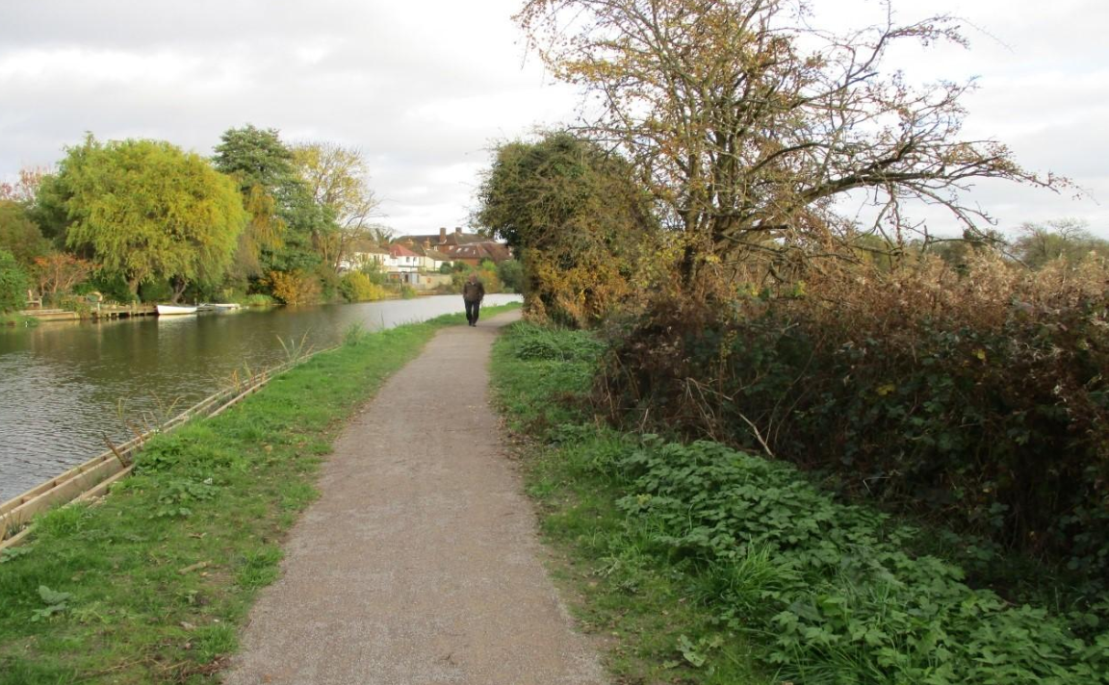
• North Downs Line (Great Western Railway) service frequency and timetable improvements (scheme NR6)
• Tunsgate public realm scheme:
The scheme made Tunsgate a gated pedestrianised road from the junction with
Castle Street. The existing pay and display and disabled parking is removed. The intention of this scheme is to provide enhanced public realm in the area, with improved connections between the castle, its grounds with the rest of the town centre through enhancement of Tunsgate.

• Electric bus fleet operating on the Guildford Park and Ride network – part of Guildford Quality Bus Corridors project, itself part of Unlocking Guildford Package
This project included set of measures to improve bus journey time reliability, on-street infrastructure and on-board experience to encourage sustainable travel. This involved addressing bus congestion points, installing bus priority signal technologies, new electric buses and improving bus stop facilities and accessibility.
• Majority of A25 cycle corridor scheme – part of Guildford town Centre Transport Package (TCTP)
The existing A25 cycle and pedestrian facility which was improved in 2014-15 had few gaps which could not be upgraded to a desirable standard at the time. As part of TCTP most of these upgrades are completed in the following locations:
- South side of the A25 Midleton Road between Midleton Industrial Estate and Surrey Way
- South side of A25 Woodbridge Road between A322 and Woodbridge Meadows
- South side of A25 Parkway between Stoke Crossroads and Boxgrove Roundabout.

• Sustainable Movement Corridor: West – phase 1 Pedestrian/ cycle route across Bannisters Field and phase 2a Pedestrian/ cycle route between Ashenden Road and Guildford Park Road – part of Unlocking Guildford Package

Schemes in development
- New Guildford town centre bus facilities – planning application yet to be determined (part of wider North Street regeneration proposals)

- Walnut Tree Close experimental one-way closure (retrial undertaken between May and November 2022) – part of Guildford Town Centre Transport Package. Final decision on permanent scheme yet to be taken.

- Sustainable Movement Corridor: West – phase 2b - pedestrian and bus lane improvements in Guildford Park Road at the back of Guildford Train station – part of Unlocking Guildford Package

- Measure 27, Policy ID11: Achieving a Comprehensive Guildford Borough Cycle Network in the emerging Local Plan: Development Management Policies.
Guilford Borough Council commissioned a Cycle Route Assessments Report (2020, https://www.guildford.gov.uk/article/25508/Guildford-Cycle-Route-Assessments-Report). The outputs from this report have been used to develop draft Policy ID11. The mapped network is the starting point for the identification of improvements which could be funded and/or provided by new development. They will also be used as a basis for the forthcoming Local Cycling and Walking Infrastructure Plan, which will be developed by Surrey County Council, with input from Guildford Borough Council.

- Measure 21: Detailed air quality study in the town centre and road gyratory system and declaration of the town centre AQMA
A decision for detailed air quality assessment was made when the GBC’s 2019 report on 2018 data identified risk of exceedance of annual mean Air Quality Objective (AQO) for NO₂ along the A3100, Portsmouth Road. A different monitoring location on A281 was found exceeding in 2020 ASR. This was despite of 25-30% reduction in measured annual mean NO₂ concentrations within the town of Guildford in 2020, compared to 2019.
It was considered possible that further hotspots are likely to be present and a detailed modelling study will be able to identify such hotspots.
The study predicted potential exceedances of the AQO at the following five roads:
- Millbrook
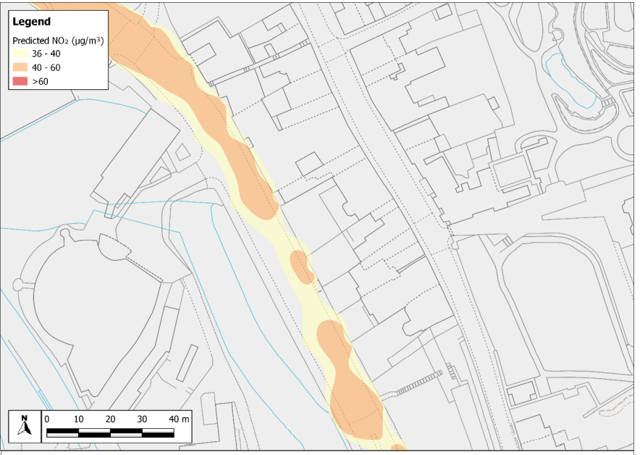
Figure 3 Risk of Exceedance Contour Plot for Millbrook

- Commercial Road
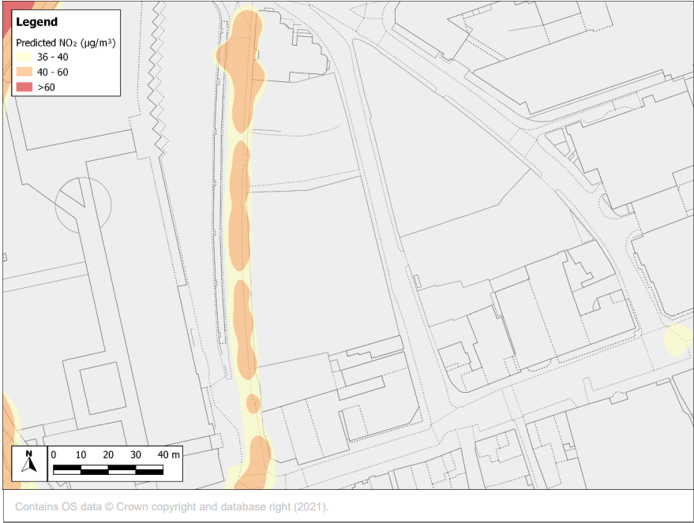
Figure 4 Risk of Exceedance Contour Plot at Commercial Road

- Onslow Street
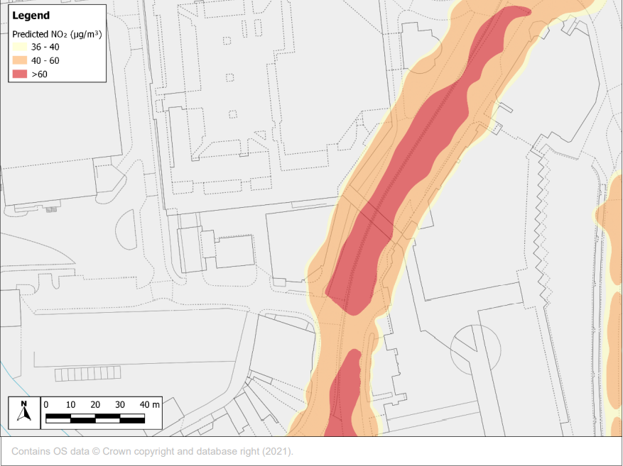
Figure 5 Risk of Exceedance Contour Plot at Onslow Street

- Gyratory – Bridge Street/Onslow Street
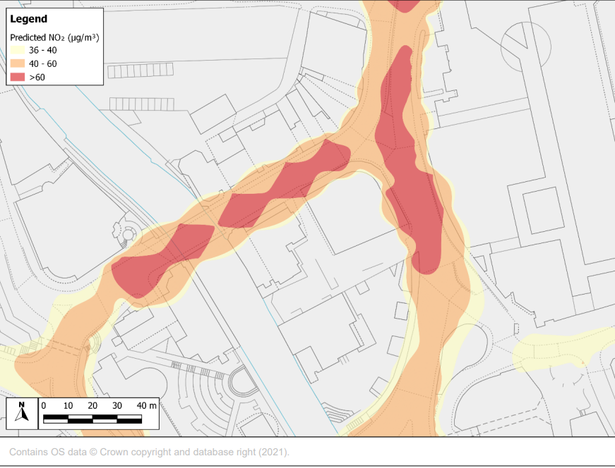
Figure 6 Risk of Exceedance Contour Plot at Bridge Street/Onslow Street

- Gyratory – Park Street
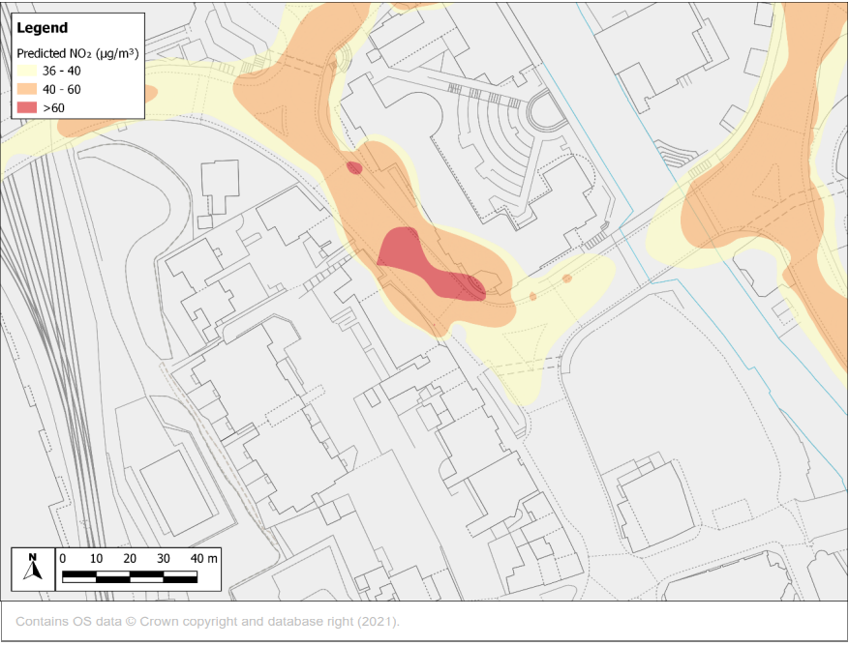
Figure 7 Risk of Exceedance Contour Plot at Park Street

The following single Town Centre AQMA was therefore adopted on 22 October 2021: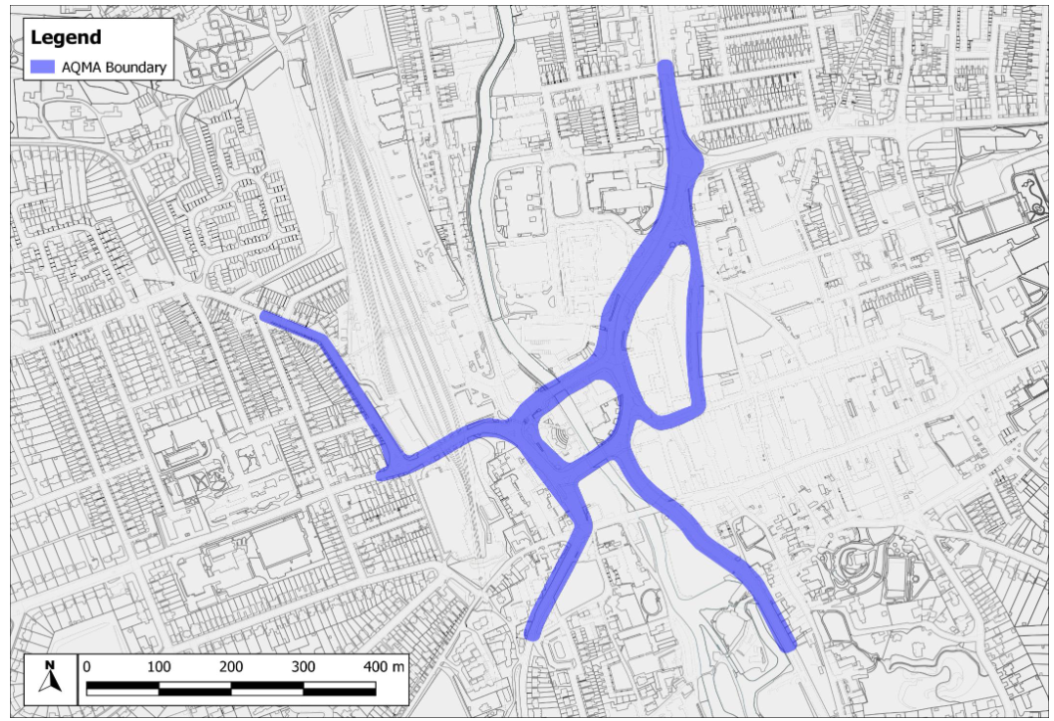Figure 8 Guildford Town Centre AQMA Boundary

The Air Quality Detailed Assessment Report, AQMA Order and site plan are available on our website: https://www.guildford.gov.uk/article/21335/Guildford-air-quality-management-areas

- A3 – Guildford

The section of the A3 to the west of Guilford Town Centre is part of the Government’s pollution climate mapping (PCM) modelled road network (PCM ID 17736). Modelled concentrations of nitrogen dioxide (NO2) close to the roadside are predicted to exceed the European Limit Values for this pollutant.
Guildford Borough Council worked with National Highways (who are responsible for improving air quality along the A3) to conduct a high-level analysis to understand levels of NO2 along the corridor. AECOM conducted a review to consider what, if any, measures could be delivered in the next few years to improve air quality along this section of road.

As a follow up to this study, GBC have commissioned AECOM to conduct a modelling study to further consider NO2 concentrations close to the A3, focusing on areas of relevant exposure for LAQM.

The main aims of this study were to:
  - Identify potentially sensitive receptor locations (such as houses and schools) close to the A3;
  - Predict annual mean NO2 concentrations for the baseline year (2020) at selected receptors and;
  - Determine if there are any exceedances of the annual mean or hourly mean NO2 objective values and if so, make recommendations to declare an AQMA.
Annual mean NO2 concentrations were modelled at 35 selected sensitive receptors close to the A3. All the 35 selected receptors were predicted to have annual mean NO2 concentrations below the annual mean 40 µg/m³ objective. Unadjusted modelled NO2 concentrations ranged from to 16.8 µg/m³ to 36.1 µg/m³. Sensitive receptors around Westborough area close to the A3 generally had the highest NO2 annual mean concentrations. With a concentration of 34.7 µg/m3 predicted at a residential property at 73A Beckingham Road. • The highest value modelled value of 36.1 µg/m3 was predicted within the garden of 119 Raymond Crescent closest to the A3.
The council has since instated monitoring locations in the Onslow Infant School, rear garden of 119 Raymond Crescent and a location representative of distance of residential garden of 73A Beckingham Road from A3.

- Partnership working
- The Council and our partner authorities have taken a number of steps to try to reduce vehicle emissions and traffic congestion by linking car use with the promotion of public and alternative means of transport. This remains central to reducing pollution from vehicle exhaust emissions in Guildford. Park and Ride schemes, car share schemes, car clubs, green scheme for parking electric vehicles, bus lanes, cycling and walking strategies and integrated transport plans, all form part of the overall approach.

- Guildford Borough Council has taken the following actions to reduce vehicle emissions within existing duties and responsibilities:

- Emissions are a prominent factor in procurement of the Council’s vehicle fleet.
- The diffusion tubes swaps are carried out using electric GBC company cars.
- Guildford Borough Council encourage internal lease car users to consider low emission vehicles by highlighting the tax benefits and setting a limit on the carbon dioxide (CO2) emissions.
- Guildford town centre car clubs have expanded and utilise more vehicles that are electric.
- The information on the electric charging spaces and cost of charging in public car parks is available on Guildford’s website: https://www.guildford.gov.uk/article/25314/Electric-vehicle-charging-points
- Where practicable, procurement of ultra-low emission fleet vehicles is encouraged. Progress has been covered in table 2.2.
- The Council continues to provide internal and external meetings to be conducted virtually on Teams saving unessential car journeys.
- GBC is member of Easit Network (Easit Guildford) providing the opportunity of discounted rail and bus tickets for Council employees and also participate in the car share scheme.

6. Electric Towns and Cities Initiative (ETCI)
National Highways has agreed to award a grant to GBC/SCC from the Environment and Wellbeing fund for the implementation of the Electric Town & Cities Initiative: Guildford (ETCI).
The ETCI has been developed by National Highways, GBC and SCC to help improve air quality alongside the A3 in Guildford by incentivising owners of diesel vans to switch to an electric alternative through:
  - the offer of a grant
  - the provision of more charging points.
The ETCI scheme also supports a salary sacrifice scheme to encourage car drivers using the A3 to swap to an electric vehicle.
The scheme will be delivered by an ETCI team which will be recruited and managed by SCC with funding provided by National Highways.

Table 2.2 – Progress on Measures to Improve Air Quality
Measure No. | Measure | Category | Classification | Year Measure Introduced | Estimated / Actual Completion Year | Organisations Involved | Funding Source | Defra AQ Grant Funding | Funding Status | Estimated Cost of Measure | Measure Status | Reduction in Pollutant / Emission from Measure | Key Performance Indicator | Progress to Date | Comments / Barriers to Implementation
1 | Air quality is a consideration at pre- application and application stage to allow effective use of planning conditions | Policy Guidance and Development Control | Air Quality Planning and Policy Guidance | 2018 | 2023 | Guildford Borough Council | Guildford Borough Council | NO | Not Funded | < £10k | Implementation | Reduced vehicle emissions | Number of developments where air quality has been assessed and actioned | Service Level Agreement between Planning Development and Environmental Health with quarterly monitoring meetings. | For medium and large-scale development, the Council recommends air quality assessment as pre-requisite emphasising on consideration of good design practices, mitigation measures and travel plan; Developers are made aware of the Institute of Air Quality Management Guidance: https://iaqm.co.uk/text/guidance/air-quality-planning-guidance.pdf
2 | Development management policies | Policy Guidance and Development Control | Air Quality Planning and Policy Guidance | 2021 | 2023 | Guildford Borough Council | Guildford Borough Council | NO | Funded | < £10k | Planning | Reduction in Emission | Number of developments where these apply | In areas where air quality is a concern Regulatory Services recommend an air quality assessment as a pre-application condition.  Across the borough electric charging points in every residential development with parking facility is now a standard condition. | The inspector's decision on the Policies will be reported in 2023 ASR
3 | Green scheme parking fees for  electric vehicles in  GBC car parks | Promoting Low Emission Transport | Priority parking for LEV's | 2018 | 2023 | Guildford Borough Council | Guildford Borough Council | NO | Funded | £10k - 50k | Implementation | Reduction in Emission | uptake of Green Parking Scheme | Implementation on-going | number of electric car users; better advertisement of the scheme
4 | Parking App to direct users to closest and cheapest spaces | Public Information | Via the Internet | 2019 | 2023 | Guildford Borough Council | Guildford Borough Council | NO | Funded | < £10k | Implementation | Reduction in vehicles in town centre area | App usage by the motorists | Implementation on-going | The Official Guildford App is available for residents and visitors. The parking function of the App utilises the latest GEOmii real-time parking technology, making parking efficient by directing cars to vacant space.
5 | Education in communities to change behaviours | Promoting Travel Alternatives | Promotion of cycling | 2017 | 2023 | Guildford Borough Council and Surrey County Council | Surrey County Council | NO | Not Funded | £10k - 50k | Implementation | Project Aspire encouraging partners  to increase use of local facilities within  communities to reduce | Resident’s participation | Implementation on-going | No allocated funding at the moment
6 | Electric buses for all Park and Ride | Promoting Low Emission Transport | Public Vehicle Procurement -Prioritising uptake of low emission vehicles | 2019 | 2023 | Defra and SCC | Defra and Surrey County Council | YES | Partially Funded | £500k - £1 million | Completed | Less emissions | Number of buses | Assessment of improvements required | Expanding to all buses operating within the borough. It is a long-term objective
7 | Easit Campaign | Promoting Travel Alternatives | Workplace Travel Planning | 2018 | 2024 | Guildford Borough Council | Guildford Borough Council | NO | Funded | £10k - 50k | Implementation | Reduced vehicle emissions | uptake of Easit initiatives | Implementation on-going | Due to pandemic, the Easit scheme has had to be updated as many of the target businesses withdrew from the scheme; progress to be reported in 2023 ASR.
8 | Schools Initiative | Promoting Travel Alternatives | School Travel Plans | 2017 | 2023 | Guildford Borough Council and Surrey County Council | Surrey County Council | YES | Partially Funded | £10k - 50k | Implementation | Reduced vehicle emissions | Take up by schools | Implementation on-going | SCC are leading on delivering the project. No activity in 2021.
9 | Bringing Services to communities to reduce car journeys | Promoting Travel Alternatives | Other | 2019 | 2023 | Guildford Borough Council | Guildford Borough Council | NO | Funded | £10k - 50k | Implementation | Reduced vehicle emissions | Less car mileage claimed | Implementation on-going | No significant developments in 2021.
10 | Promote alternative travel to work at the Council | Promoting Travel Alternatives | Workplace Travel Planning | 2018 | 2023 | Guildford Borough Council and Surrey County Council | Guildford Borough Council and Surrey County Council | NO | Funded | £10k - 50k | Completed | Reduced vehicle emissions | Working from home | Fully implemented | Issue of mobiles and laptops has enabled GBC employees to work flexibly and remotely, reducing the unnecessary car journeys to the Council offices. The Council subscribed to Easit staff scheme in 2021, providing discounted public transport options for staff, however, the number of journeys were substantially reduced.
11 | Car Clubs in Guildford Town Centre | Alternatives to private vehicle use | Car Clubs | 2015 | 2024 | Guildford Borough Council, Surrey County Council and Enterprise | Surrey County Council | NO | Partially Funded | < £10k | Implementation | Reduced vehicle emissions | Car clubs increase | The Enterprise Car Club membership is available to Guildford residents at reduced price. The 8 club cars available are ultra low emission vehicles | Resident's awareness and usage of the scheme.
12 | Smoke control order compliance | Promoting Low Emission Plant | Regulations for fuel quality for low emission fuels for stationary and mobile sources | 2021 | 2023 | Guildford Borough Council | Guildford Borough Council | NO | Not Funded | < £10k | Implementation | Reduce houshold emissions | complaints of dark smoke from chimney | Implementation on-going; A map of the Guildford Smoke Control Area is available on the website for information of the residents. | Officer resource
13 | Anti vehicle idling at level crossings, taxi ranks, schools | Traffic Management | UTC, Congestion management, traffic reduction | 2021 | 2023 | Guildford Borough Council and Surrey County Council | NONE | NO | Not Funded | < £10k | Planning | Reduced vehicle emissions | number of penalty notices for idling engines | Operations and Technical Services at GBC are enforcing anti-idling on controlled roads in the town centre or near schools and penalty notices amount are uptp £50 or £70. | In addition to continued enforcement on controlled roads, GBC to investigate potential project with school on anti-idling public information and displays in school vicinity;
14 | Service delivery review to reduce public journeys to Council premises where appropriate | Promoting Travel Alternatives | Personalised Travel Planning | 2020 | 2023 | Guildford Borough Council and Surrey County Council | Guildford Borough Council and Surrey County Council | NO | Not Funded | < £10k | Implementation | Reduced vehicle emissions | Less car mileage claimed | Implementation on-going | Guildford BC's website has up and running online access to all the council services through MyGuildford Account for residents. Meetings are available virtually through Microsoft Teams.
15 | Improve sustainable transport opportunities | Policy Guidance and Development Control | Other policy | 2018 | 2023 | Guildford Borough Council | Guildford Borough Council | NO | Not Funded | £10k - 50k | Implementation | Reduced vehicle emissions | Use of alternative travel modes | Implementation on-going | Increased rail patronage: based on Annual entries and exits at rail stations in Guildford borough: 2014/15: 11,128,084 entries and exits: 2020-2021: 2,100 938 entries and exits.
16 | Sustainable procurement polices relating to air quality | Other |  | 2020 | 2024 | Guildford Borough Council | Guildford Borough Council | NO | Not Funded | < £10k | Implementation | Reduced vehicle emissions | Audit of procurement record | Implementation on-going | Already used by procurement team
17 | Electric charging points in public areas and residential streets | Promoting Low Emission Transport | Procuring alternative Refuelling infrastructure to promote Low Emission Vehicles, EV recharging, Gas fuel recharging | 2019 | 2024 | Guildford Borough Council and Surrey County Council | Surrey County Council | NO | Not Funded | £50k - £100k | Implementation | Reduced vehicle emissions | number installed | Implementation on-going | Electricity and highway restrictions infrastructure
18 | Adopt SCC Electric Vehicle Charging Policy | Promoting Low Emission Transport | Procuring alternative Refuelling infrastructure to promote Low Emission Vehicles, EV recharging, Gas fuel recharging | 2019 | 2022 | Guildford Borough Council and Surrey County Council | Guildford Borough Council and Surrey County Council | NO | Partially Funded | £10k - 50k | Implementation | Reduced vehicle emissions | Infrastructure detail | Implementation on-going | Every development has a condition for EV charging facility as per the Policy, recommended by the SCC.
19 | New Railway station at Park Barn Guildford | Transport Planning and Infrastructure | Public transport improvements-interchanges stations and services | 2021 | 2030 | Network Rail, | unknown | NO | Not Funded | > £10 million | Planning | Reduced vehicle emissions | use of train instead of car | Guildford West Station is a new station promoted by GBC, which will provide improved access to the Royal Surrey County Hospital, Surrey Research Park, Surrey Sports Park and Park Barn residential area; It is one of the priority Highway and Transport Scheme, critical for the delivery of Guildford Local Plan; A site has been allocated for the station in the Local Plan and funding for the feasibility study approved | Lengthy Timescale
20 | Shaping Guildford's Future | Traffic Management | UTC, Congestion management, traffic reduction | 2021 | 2030 | Guildford Borough Council | Guildford Borough Council | NO | Funded | £1 million - £10 million | Planning | Reduced vehicle emissions | Traffic flow | The stage 1(Preparation of detailed scope & briefs;  Procurement of Consultant team, High Level Strategic Appraisal including constraint analysis, Planning Strategy) and Stage 2 (Development of concept Master Plan, Stakeholder consultation, Data collection, Preparation of Strategic Outline Case, Preparation of Grant applications) of the Shaping Guildford's Future are completed and the council is ready to move to stage 3. | Lengthy Timescale; Shaping Guildford's future -
21 | Guildford Town Centre AQMA | Policy Guidance and Development Control | Air Quality Planning and Policy Guidance | 2020 | 2022 | Guildford Borough Council and Surrey County Council | Guildford Borough Council | NO | Funded | £10k - 50k | Planning | Reduced vehicle emissions | producing a draft Air Quality Action Plan | Draft AQAP submitted to DEFRA and approved in late 2021 | AQAP measures implementation based on feasibility study outcome; funding for the implementation of measures; Will be reported in 2023 ASR
22 | A3 Guildford High level option analysis Study for National Highways (NH) | Transport Planning and Infrastructure | Other | 2020 | 2023 | NH, SCC and GBC | NH | NO | Partially Funded | £10k - 50k | Planning | Reduced vehicle emissions | New measures adopted and funded by NH | Detailed study report was completed in March 2021, aimed at option analysis which can be implemented in shortest possible timeframe. | National Highways funding, Measures to target A3 traffic, most of which has origin-destination not in Guildford
23 | Junction 10 | Transport Planning and Infrastructure | Public transport improvements-interchanges stations and services | 2021 | 2025 | NH, SCC and GBC | NH | NO | Not Funded | > £10 million | Planning | Reduced vehicle emissions | Traffic flow | Decision was made in 2022, to be reported in ASR 2023 | -
24 | Ash Railway Bridge | Traffic Management | Other | 2020 | 2025 | Guildford Borough Council | Guildford Borough Council | NO | Partially Funded | £1 million - £10 million | Implementation | Reduced vehicle emissions | monitoring after construction | Implementation on-going | Under procurement process. Long term project
25 | Walnut Tree Close | Traffic Management | UTC, Congestion management, traffic reduction | 2020 | 2023 | Guildford Borough Council and Surrey County Council | Guildford Borough Council and Surrey County Council | NO | Partially Funded | £1 million - £10 million | Implementation | Reduced vehicle emissions | Change of road priority | Implementation on-going | One way system with cycle lane is in trial stage currently; if found viable, will continue following review in November 2022
26 | STRATEGIC MOVEMENT CORRIDOR | Transport Planning and Infrastructure | Cycle network | 2019 | 2023 | Guildford Borough Council and Surrey County Council | Guildford Borough Council and Surrey County Council | NO | Partially Funded | £1 million - £10 million | Implementation | Reduced vehicle emissions | Improved infrastructure and increased usage of cycle path | Implementation on-going | Partly implemented
27 | Improvement to cycle network | Promoting Travel Alternatives | Promotion of cycling | 2019 | 2023 | GBC and SCC | GBC and SCC | NO | Partially Funded | £500k - £1 million | Implementation | more cycle uptake | Improved cycle network | Implementation on-going | Policy ID11: Achieving a Comprehensive Guildford Borough Cycle Network in the emerging Local Plan: Development Management Policies; To be reported in ASR 2023
28 | Electric vehicle trial project for taxis | Promoting Low Emission Transport | Taxi emission incentives | 2021 | 2023 | GBC and Surrey Air Alliance | DEFRA | YES | Funded | £50k - £100k | Planning | Reduced vehicle emissions | take up by taxis | Planning | Surrey Air Alliance bid of amount £256k was successful to be implemented in 2021 facilitating EV taxi trials. The previous proposal is currently being reconfigured to allow longer EV trials based on feedback from taxi trade and EV suppliers. The reconfigured project has been resubmitted to DEFRA for approval
29 | GBC Air Quality Strategy | Policy Guidance and Development Control | Air Quality Planning and Policy Guidance | 2017 | 2023 | GBC | GBC | NO | Not Funded | < £10k | Implementation | Reduction in vehicle emissions | measures adopted | Implementation on-going | Currently under review
30 | TC Clean Air Zone Feasibility Study | Policy Guidance and Development Control | Air Quality Planning and Policy Guidance | 2022 | 2023 | GBC | GBC | NO | Funded | £50k - £100k | Planning | to be estimated in the feasibility study | completion of feasibility study | ANPR study commissioned in the town centre; Procurement process for feasibility study started | None for the feasibility study
31 | E Bike and scooter hire scheme | Promoting Travel Alternatives | Promotion of cycling | 2021 | 2023 | GBC, SCC, University of Surrey |  | NO |  | £50k - £100k | Planning | Alternative transport | usage | Currently in draft stage; A number of areas have been identified for docking stations, however subject to final agreement | -

PM_{2.5} – Local Authority Approach to Reducing Emissions and/or Concentrations
As detailed in Policy Guidance LAQM.PG16 (Chapter 7), local authorities are expected to work towards reducing emissions and/or concentrations of PM_{2.5} (particulate matter with an aerodynamic diameter of 2.5µm or less). There is straightforward evidence that PM_{2.5} has a significant impact on human health, including premature mortality, allergic reactions, and cardiovascular diseases.
The Public Health Outcome Framework data published 5.14% as fraction of mortality attributable to particulate air pollution during the year 2019 which is above the national figure for England 5.13% but falls below the regional value of 5.17% for southeast region.
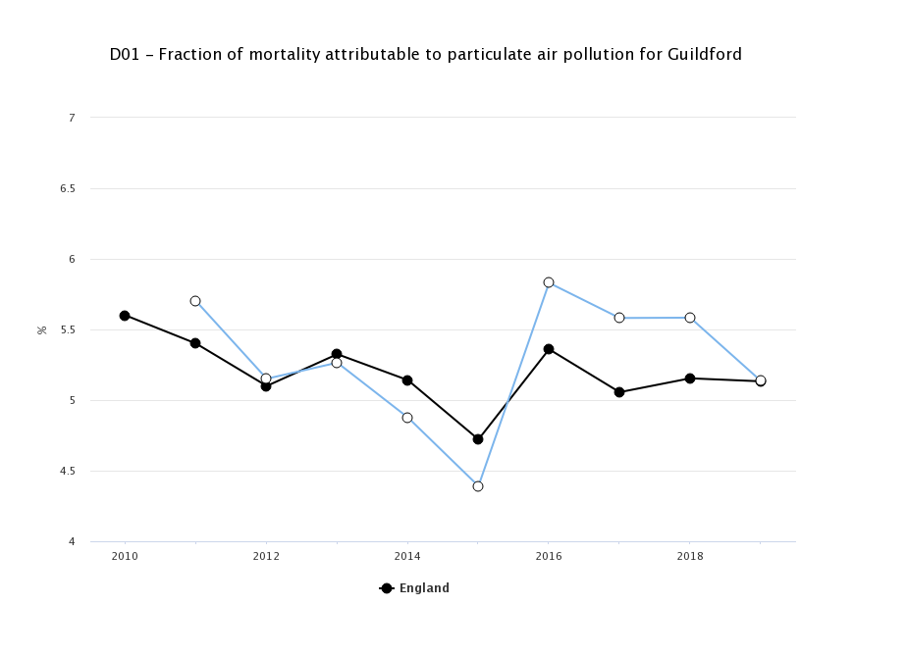

There is currently no monitoring program for PM2.5 in Guildford Borough Council. Guildford Borough Council in 2018 commissioned a detailed air quality modelling together with other Surrey Authorities and a summary was reported in ASR 2020. The report is available to download from our website.
The average modelled concentration for Guildford was <10µg/m³, with the highest concentration of 21-22 µg/m³ modelled at the A3 /M25 junction point. In September 2021, the WHO published updated Air Quality Guidelines. The new Guideline for annual average concentration of PM2.5 is 5µg/m³ . The WHO Air Quality Guidelines are based on the evidence linking concentrations of pollutants in ambient air with adverse effects on health. They are set without reference to achievability. Nevertheless, the new targets for PM2.5 under the Environment Act 2021 are likely to be published, along with new regulatory controls to achieve those targets.
The source apportionment study by CERC showed that up to 70% of the PM2.5 at location near A3 and 85% of the PM2.5 in a rural location (Abinger Hammer) is contributed by the background sources. This suggests that major proportion of PM2.5 level in the borough is contributed by the sources outside the Guildford Borough Council’s authority.
The measures in table 2.2 which are aimed at promoting sustainable mode of transport will inevitably help reduce the emissions of PM_{2.5}.
The Council currently has bylaws (Statutory Nuisance) available to control and regulate garden bonfires. However, some direct legislations to stop bonfire will work better to discourage the residents from burning garden waste. Similarly control of emissions from chimneys are only applicable to the smoke control areas (SCAs) currently. The introduction of Ready to Burn certification scheme through the Air Quality (Domestic Solid Fuel Standards) (England) Regulations 2020, came into force in May 2021 will phase out the use of unseasoned wood and reduce particulate emissions from the domestic wood burning. Although the enforcement of this regulation lies on the Trading Standards, the GBC officers are committed to work as intelligence if a non-compliant trade operates within the Borough.
Environmental Health recommends to the Housing Services to control the type of wood burner installed, fuel used and maintenance schedules to avoid nuisance complaints and to reduce emissions from Council’s rented properties.

Air Quality Monitoring Data and Comparison with Air Quality Objectives and National Compliance
This section sets out the monitoring undertaken within 2021 by Guildford Borough Council and how it compares with the relevant air quality objectives. In addition, monitoring results are presented for a five-year period between 2017 and 2021 to allow monitoring trends to be identified and discussed.

Summary of Monitoring Undertaken

Automatic Monitoring Sites
The Guildford Borough Council do not have any automated monitoring sites in their control within the borough.

Non-Automatic Monitoring Sites
Guildford Borough Council undertook non- automatic (i.e., passive) monitoring of NO₂ at 48 sites during 2021. Table A.1 in Appendix A presents the details of the non-automatic sites.
Maps showing the location of the monitoring sites are provided in Appendix D. Further details on Quality Assurance/Quality Control (QA/QC) for the diffusion tubes, including bias adjustments and any other adjustments applied (e.g., annualisation and/or distance correction), are included in Appendix C.

Individual Pollutants
The air quality monitoring results presented in this section are, where relevant, adjusted for bias, annualisation (where the annual mean data capture is below 75% and greater than 25%), and distance correction. Further details on adjustments are provided in Appendix C.

Nitrogen Dioxide (NO₂)
Table A.2 in Appendix A compare the adjusted monitored NO₂ annual mean concentrations for the past five years (where available) with the air quality objective of 40µg/m³. Note that the concentration data presented represents the concentration at the location of the monitoring site, following the application of bias adjustment and annualisation, as required (i.e., the values are exclusive of any consideration to fall-off with distance adjustment).
For diffusion tubes, the full 2021 dataset of monthly mean values is provided in Appendix B. Note that the concentration data presented in Table B.1 includes distance corrected values, only where relevant.
The Figures A.1- A.4 compares 5 year monitoring data (where available) in the town centre AQMA, Compton AQMA, Shalford AQMA and A3 roadside locations. Figure 2 in the Executive Summary compares 10 year monitoring trend in the urban and rural background locations.
The monitoring locations in town centre area and comparison of past 3 years data indicates the potential presence of hotspots of AQO exceedances. As discussed in section 2.2 (Measure 21), a detailed air quality assessment has since been completed and town centre AQMA declared.
In Compton AQMA, although the annual average for NO₂ was below the AQO, the levels have seen a 10-12% rise from the 2020 monitoring and are within the 10% of the AQO. It is likely that the levels will rise again with the uplifting of covid restrictions.
Similarly, in Shalford AQMA, the monitored levels did not exceed the AQO, however the reduced levels are likely to be due to covid restriction for part of the year. The monitored levels are within 10% of the AQO.
The Shalford and Compton AQMA remains in place and there is no consideration of their revocation.
The monitoring locations on A3 were instated to support the National Highways, air quality work on A3. The data has however, been used to assess the GBCs responsibilities under the LAQM (see section 2.2, bullet point 4). Further monitoring locations were added in 2022 in residential garden and Onslow Infant School.

Appendix A: Monitoring Results
Table A.1 – Details of Non-Automatic Monitoring Sites
Diffusion Tube ID | Site Name | Site Type | X OS Grid Ref (Easting) | Y OS Grid Ref (Northing) | Pollutants Monitored | In AQMA? Which AQMA? | Distance to Relevant Exposure (m) ⁽¹⁾ | Distance to kerb of nearest road (m) ⁽²⁾ | Tube Co-located with a Continuous Analyser? | Tube Height (m)
WTC1 | Walnut Tree Close | Kerbside | 499204 | 149768 | NO2 | No | 1.3 | 1.0 | No | 2.3
GD2 | York Road | Roadside | 499799 | 149934 | NO2 | No | 12.0 | 1.5 | No | 2.6
GD6 | The Chantry | Rural | 500385 | 148342 | NO2 | No | 0.0 | 120.0 | No | 2.0
GD10 | The Garth | Urban Background | 488629 | 150032 | NO2 | No | 0.0 | 12.0 | No | 2.2
GD13 | YMCA | Kerbside | 499305 | 149512 | NO2 | Yes, Air Quality  Management Area (No 3) 2021, Town centre AQMA | 6.0 | 1.5 | No | 2.0
GD16 | Sandfields 2 | Roadside | 499761 | 149914 | NO2 | No | 0.0 | 2.0 | No | 2.5
GD18 | Josephs Road | Urban Background | 499665 | 150720 | NO2 | No | 7.8 | 1.0 | No | 2.4
GD19 | Haydon Place | Kerbside | 499708 | 149909 | NO2 | No | 2.0 | 1.0 | No | 2.4
TC1 | Stoke Road | Kerbside | 499834 | 150113 | NO2 | No | 2.0 | 1.0 | No | 2.4
TC3 | Woodbridge Road | Roadside | 499477 | 150347 | NO2 | No | 0.0 | 6.0 | No | 2.4
TC4 | Stoke Mews | Kerbside | 499822 | 150010 | NO2 | No | 3.3 | 1.7 | No | 2.4
TC5 | Mangles Court, Woodbridge Road | Other | 499486 | 149951 | NO2 | Yes, Air Quality  Management Area (No 3) 2021, Town centre AQMA | 0.0 | 8.0 | No | 2.4
TC6 | Park Street, Guildford | Kerbside | 499299 | 149466 | NO2 | Yes, Air Quality  Management Area (No 3) 2021, Town centre AQMA | 1.5 | 0.5 | No | 2.4
TC7 | 16A Park Street, Guildford | Kerbside | 499308 | 149453 | NO2 | Yes, Air Quality  Management Area (No 3) 2021, Town centre AQMA | 4.0 | 5.0 | No | 2.5
TC8 | 13-21 High Street | Kerbside | 499493 | 149402 | NO2 | Yes, Air Quality  Management Area (No 3) 2021, Town centre AQMA |  | 3.2 | No | 2.5
TC9 | The Mount | Kerbside | 499241 | 149257 | NO2 | No | 0.0 | 0.5 | No | 2.4
TC10 | Castle Hill | Urban Centre | 499694 | 149241 | NO2 | No |  | 0.5 | No | 2.2
C4 | Little Cottage, Compton | Kerbside | 495437 | 147288 | NO2 | Yes, AQMA Order (No. 1) 2018, Compton AQMA | 0.0 | 1.5 | No | 2.6
C9 | Moors Cottage, Compton | Kerbside | 495442 | 147270 | NO2 | Yes, AQMA Order (No. 1) 2018, Compton AQMA | 4.0 | 1.0 | No | 2.5
ASH4 | 29/31 Ash Street, Ash | Kerbside | 488924 | 150326 | NO2 | No | 4.0 | 1.0 | No | 2.3
SH1 | Oppo Sea Horse, Shalford | Kerbside | 500046 | 147604 | NO2 | No | 4.0 | 1.0 | No | 2.4
SH2 | 36 The Street, Shalford | Kerbside | 499978 | 147704 | NO2 | Yes, AQMA Order (No. 2) 2019, Shalford AQMA | 0.0 | 2.2 | No | 2.3
SH3 | Nr Shalford Lane | Kerbside | 500003 | 147670 | NO2 | No | 2.3 | 1.0 | No | 2.4
SH4 | Oppo Bahamia Court | Kerbside | 500086 | 147521 | NO2 | No | 12.0 | 1.0 | No | 2.4
SH5 | Oppo 77 The Street | Kerbside | 500093 | 147473 | NO2 | No | 9.0 | 1.0 | No | 2.4
A281-1 | The Legion | Kerbside | 499624 | 149278 | NO2 | Yes, Air Quality  Management Area (No 3) 2021, Town centre AQMA | 3.0 | 1.0 | No | 2.5
RP4 | Newark Lane, Ripley | Kerbside | 505150 | 156741 | NO2 | No | 0.0 | 0.5 | No | 2.3
RP5 | High Street, Ripley | Kerbside | 505374 | 156883 | NO2 | No | 0.0 | 1.7 | No | 2.4
FRH2 | 38 Farnham Road | Roadside | 499078 | 149414 | NO2 | No | 0.0 | 5.0 | No | 2.0
FRH5 | A31 Farnham Road | Kerbside | 498035 | 149003 | NO2 | No |  | 1.0 | No | 2.4
FRH6 | Dental Surgery | Roadside | 499102 | 149421 | NO2 | Yes, Air Quality  Management Area (No 3) 2021, Town centre AQMA | 0.0 | 6.0 | No | 2.0
PR1 | Wycliffe Buildings, Portsmouth Rd | Kerbside | 499305 | 149168 | NO2 | No | 0.0 | 1.0 | No | 2.1
PR3 | Oppo The Cannon, Portsmouth Rd | Kerbside | 499360 | 149326 | NO2 | Yes, Air Quality  Management Area (No 3) 2021, Town centre AQMA | 2.9 | 2.8 | No | 2.6
SEND3 | Send CoE School | Kerbside | 503080 | 155149 | NO2 | No |  | 2.0 | No | 2.4
SEND4 | 62 Send Barns Lane | Roadside | 502918 | 155341 | NO2 | No | 2.0 | 2.0 | No | 2.4
SEND5 | 84 Send Road | Kerbside | 502536 | 155690 | NO2 | No | 4.0 | 1.3 | No | 2.4
SEND6 | The Pathway, Send | Kerbside | 503665 | 154726 | NO2 | No | 7.0 | 2.3 | No | 2.4
A3-1 | 2 Beechcroft Drive | Other | 496995 | 148902 | NO2 | No | 0.0 | 33.0 | No | 2.0
A3-2 | The Spinneys, Beechcroft Drive | Other | 496976 | 148905 | NO2 | No | 0.0 | 26.0 | No | 2.0
A3-3 | 50 MPH sign, Beechcroft Drive | Roadside | 497041 | 148908 | NO2 | No |  | 7.4 | No | 2.0
A3-4 | Beckingham Road | Roadside | 498133 | 150648 | NO2 | No | 0.0 | 4.0 | No | 2.7
A3-5 | Weston Road | Roadside | 498551 | 150797 | NO2 | No | 6.0 | 19.0 | No | 4.5
A3-6 | Ash Grove | Other | 498217 | 150649 | NO2 | No | 0.0 | 19.5 | No | 2.0
A3-7 | Kendale Court | Other | 498653 | 150790 | NO2 | No | 0.0 | 15.0 | No | 2.4
A3-8 | Noise Barrier, Cathedral Hill Junction | Roadside | 497777 | 149774 | NO2 | No | 19.0 | 7.0 | No | 2.0
A3-9 | Lamp post 513-12 | Kerbside | 497736 | 149590 | NO2 | No | 24.0 | 1.0 | No | 2.5
A3-10 | Raymond Crescent Lamppost, 513-002 | Kerbside | 497876 | 150000 | NO2 | No | 19.0 | 1.0 | No | 2.5
A3-11 | Clearway sign Near HE AMS | Kerbside | 497713 | 149490 | NO2 | No | 19.0 | 1.0 | No | 1.5
Notes:
(1) 0m if the monitoring site is at a location of exposure (e.g. installed on the façade of a residential property).
(2) N/A if not applicable.

Table A.2 – Annual Mean NO₂ Monitoring Results: Non-Automatic Monitoring (µg/m³)
Diffusion Tube ID | X OS Grid Ref (Easting) | Y OS Grid Ref (Northing) | Site Type | Valid Data Capture for Monitoring Period (%) ⁽¹⁾ | Valid Data Capture 2021 (%) ⁽²⁾ | 2017 | 2018 | 2019 | 2020 | 2021
WTC1 | 499204 | 149768 | Kerbside | 100 | 100.0 |  | 28.3 | 28.3 | 18.2 | 19.8
GD2 | 499799 | 149934 | Roadside | 100 | 100.0 | 30.0 | 32.0 | 33.1 | 21.7 | 23.4
GD6 | 500385 | 148342 | Rural | 100 | 100.0 | 10.0 | 13.0 | 10.1 | 8.1 | 10.1
GD10 | 488629 | 150032 | Urban Background | 92.3 | 92.3 | 15.0 | 16.0 | 15.0 | 10.0 | 14.8
GD13 | 499305 | 149512 | Kerbside | 100 | 100.0 | 31.0 | 36.0 | 33.0 | 23.8 | 24.0
GD16 | 499761 | 149914 | Roadside | 100 | 100.0 |  | 36.1 | 38.2 | 25.4 | 29.6
GD18 | 499665 | 150720 | Urban Background | 100 | 100.0 |  |  |  | 14.6 | 17.2
GD19 | 499708 | 149909 | Kerbside | 90.4 | 90.4 |  |  |  | 18.4 | 22.2
TC1 | 499834 | 150113 | Kerbside | 90.4 | 90.4 |  | 35.0 | 32.6 | 22.3 | 24.3
TC3 | 499477 | 150347 | Roadside | 100 | 100.0 |  |  | 30.5 | 21.8 | 25.5
TC4 | 499822 | 150010 | Kerbside | 100 | 100.0 |  |  | 31.8 | 21.0 | 25.9
TC5 | 499486 | 149951 | Other | 100 | 100.0 |  |  |  | 16.0 | 20.5
TC6 | 499299 | 149466 | Kerbside | 100 | 100.0 |  |  |  | 42.7 | 50.5
TC7 | 499308 | 149453 | Kerbside | 92.3 | 92.3 |  |  |  |  | 27.2
TC8 | 499493 | 149402 | Kerbside | 92.3 | 92.3 |  |  |  |  | 34.3
TC9 | 499241 | 149257 | Kerbside | 100 | 67.3 |  |  |  |  | 26.1
TC10 | 499694 | 149241 | Urban Centre | 100 | 57.7 |  |  |  |  | 27.8
C4 | 495437 | 147288 | Kerbside | 100 | 100.0 | 40.0 | 46.0 | 46.0 | 33.3 | 37.3
C9 | 495442 | 147270 | Kerbside | 100 | 100.0 | 42.0 | 44.3 | 44.5 | 31.7 | 35.8
ASH4 | 488924 | 150326 | Kerbside | 92.3 | 92.3 |  |  |  |  | 22.4
SH1 | 500046 | 147604 | Kerbside | 100 | 100.0 | 35.0 | 43.8 | 39.6 | 27.6 | 30.2
SH2 | 499978 | 147704 | Kerbside | 100 | 100.0 |  | 50.1 | 50.0 | 34.8 | 37.1
SH3 | 500003 | 147670 | Kerbside | 100 | 100.0 |  |  |  | 23.5 | 25.0
SH4 | 500086 | 147521 | Kerbside | 100 | 100.0 |  |  |  | 28.4 | 31.5
SH5 | 500093 | 147473 | Kerbside | 100 | 100.0 |  |  |  | 25.4 | 26.2
A281-1 | 499624 | 149278 | Kerbside | 90.4 | 90.4 |  |  |  | 31.0 | 34.7
RP4 | 505150 | 156741 | Kerbside | 100 | 100.0 |  | 32.2 | 33.3 | 22.1 | 25.4
RP5 | 505374 | 156883 | Kerbside | 100 | 100.0 |  |  |  | 20.9 | 25.7
FRH2 | 499078 | 149414 | Roadside | 100 | 100.0 |  | 38.4 | 36.8 | 25.5 | 29.3
FRH5 | 498035 | 149003 | Kerbside | 90.4 | 90.4 |  |  |  | 27.3 | 26.6
FRH6 | 499102 | 149421 | Roadside | 100 | 100.0 |  |  |  | 24.6 | 28.1
PR1 | 499305 | 149168 | Kerbside | 100 | 100.0 |  | 41.2 | 36.1 | 23.7 | 28.4
PR3 | 499360 | 149326 | Kerbside | 100 | 100.0 |  |  | 28.1 | 20.8 | 22.6
SEND3 | 503080 | 155149 | Kerbside | 100 | 100.0 |  |  |  | 13.1 | 15.4
SEND4 | 502918 | 155341 | Roadside | 100 | 100.0 |  |  |  | 15.7 | 19.6
SEND5 | 502536 | 155690 | Kerbside | 100 | 100.0 |  |  |  | 14.3 | 18.2
SEND6 | 503665 | 154726 | Kerbside | 100 | 100.0 |  |  |  | 17.0 | 20.2
A3-1 | 496995 | 148902 | Other | 100 | 100.0 |  |  |  | 13.9 | 15.6
A3-2 | 496976 | 148905 | Other | 100 | 100.0 |  |  |  | 14.5 | 17.2
A3-3 | 497041 | 148908 | Roadside | 90.4 | 90.4 |  |  |  | 19.3 | 20.6
A3-4 | 498133 | 150648 | Roadside | 100 | 100.0 |  |  |  | 23.2 | 35.0
A3-5 | 498551 | 150797 | Roadside | 100 | 100.0 |  |  |  | 34.1 | 41.4
A3-6 | 498217 | 150649 | Other | 100 | 100.0 |  |  |  | 19.0 | 21.7
A3-7 | 498653 | 150790 | Other | 84.6 | 84.6 |  |  |  | 20.7 | 26.1
A3-8 | 497777 | 149774 | Roadside | 82.7 | 82.7 |  |  |  |  | 43.0
A3-9 | 497736 | 149590 | Kerbside | 100 | 100.0 |  |  |  |  | 49.2
A3-10 | 497876 | 150000 | Kerbside | 90.4 | 90.4 |  |  |  |  | 56.2
A3-11 | 497713 | 149490 | Kerbside | 100 | 100.0 |  |  |  |  | 73.1

☒ Annualisation has been conducted where data capture is <75% and >25% in line with LAQM.TG16.
☒ Diffusion tube data has been bias adjusted.
☒ Reported concentrations are those at the location of the monitoring site (bias adjusted and annualised, as required), i.e. prior to any fall-off with distance correction.
Notes:
The annual mean concentrations are presented as µg/m³.
Exceedances of the NO₂ annual mean objective of 40µg/m³ are shown in bold.
NO₂ annual means exceeding 60µg/m³, indicating a potential exceedance of the NO₂ 1-hour mean objective are shown in bold and underlined.
Means for diffusion tubes have been corrected for bias. All means have been “annualised” as per LAQM.TG16 if valid data capture for the full calendar year is less than 75%. See Appendix C for details.
Concentrations are those at the location of monitoring and not those following any fall-off with distance adjustment.
(1) Data capture for the monitoring period, in cases where monitoring was only carried out for part of the year.
(2) Data capture for the full calendar year (e.g. if monitoring was carried out for 6 months, the maximum data capture for the full calendar year is 50%).

Figure A.1 – Trends in Annual Mean NO₂ Concentrations – Town centre

Figure A.2 – Trends in Annual Mean NO₂ Concentrations – Compton AQMA

Figure A.3 – Trends in Annual Mean NO₂ Concentrations – Shalford AQMA

Figure A.4 – Trends in Annual Mean NO₂ Concentrations – A3 Guildford

Appendix B: Full Monthly Diffusion Tube Results for 2021
Table B.1 – NO₂ 2021 Diffusion Tube Results (µg/m³)
DT ID | X OS Grid Ref (Easting) | Y OS Grid Ref (Northing) | Jan | Feb | Mar | Apr | May | Jun | Jul | Aug | Sep | Oct | Nov | Dec | Annual Mean: Raw Data | Annual Mean: Annualised and Bias Adjusted (x0.97) | Annual Mean: Distance Corrected to Nearest Exposure | Comment
WTC1 | 499204 | 149768 | 21.0 | 21.0 | 22.0 | 19.0 | 15.0 | 18.0 | 17.0 | 16.0 | 24.0 | 23.0 | 25.0 | 24.0 | 20.4 | 19.8
GD2 | 499799 | 149934 | 28.0 | 24.0 | 21.0 | 21.0 | 23.0 | 24.0 | 20.0 | 16.0 | 28.0 | 26.0 | 31.0 | 27.0 | 24.1 | 23.4
GD6 | 500385 | 148342 | 11.0 | 11.0 | 10.0 | 9.0 | 9.0 | 10.0 | 8.0 | 14.0 | 12.0 | 8.0 | 13.0 | 10.0 | 10.4 | 10.1
GD10 | 488629 | 150032 |  | 30.0 | 16.0 | 14.0 | 16.0 | 11.0 | 9.0 | 13.0 | 14.0 | 13.0 | 18.0 | 14.0 | 15.3 | 14.8
GD13 | 499305 | 149512 | 26.0 | 28.0 | 27.0 | 29.0 | 28.0 | 26.0 | 24.0 | 19.0 | 22.0 | 20.0 | 27.0 | 21.0 | 24.8 | 24.0
GD16 | 499761 | 149914 | 26.0 | 32.0 | 31.0 | 24.0 | 37.0 | 31.0 | 27.0 | 22.0 | 39.0 | 31.0 | 34.0 | 32.0 | 30.5 | 29.6
GD18 | 499665 | 150720 | 20.0 | 21.0 | 20.0 | 18.0 | 15.0 | 16.0 | 13.0 | 14.0 | 19.0 | 16.0 | 23.0 | 18.0 | 17.8 | 17.2
GD19 | 499708 | 149909 | 24.0 | 28.0 | 26.0 | 24.0 | 21.0 | 22.0 | 18.0 | 15.0 | 27.0 |  | 28.0 | 19.0 | 22.9 | 22.2
TC1 | 499834 | 150113 | 28.0 | 25.0 | 24.0 | 27.0 | 25.0 | 20.0 | 24.0 | 17.0 | 32.0 | 25.0 | 29.0 |  | 25.1 | 24.3
TC3 | 499477 | 150347 | 24.0 | 28.0 | 23.0 | 19.0 | 26.0 | 32.0 | 27.0 | 23.0 | 32.0 | 24.0 | 32.0 | 25.0 | 26.3 | 25.5
TC4 | 499822 | 150010 | 28.0 | 28.0 | 28.0 | 25.0 | 23.0 | 23.0 | 21.0 | 25.0 | 28.0 | 26.0 | 36.0 | 30.0 | 26.8 | 25.9
TC5 | 499486 | 149951 | 23.0 | 23.0 | 24.0 | 19.0 | 21.0 | 19.0 | 20.0 | 15.0 | 23.0 | 22.0 | 26.0 | 18.0 | 21.1 | 20.5
TC6 | 499299 | 149466 | 52.0 | 50.0 | 41.0 | 44.0 | 50.0 | 50.0 | 52.0 | 50.0 | 68.0 | 56.0 | 58.0 | 54.0 | 52.1 | 50.5 | 42.3
TC7 | 499308 | 149453 | 31.0 | 23.0 | 27.0 | 31.0 | 25.0 | 30.0 | 26.0 | 27.0 |  | 25.0 | 37.0 | 27.0 | 28.1 | 27.2
TC8 | 499493 | 149402 | 28.0 | 28.0 | 37.0 | 40.0 |  | 43.0 | 33.0 | 40.0 | 40.0 | 28.0 | 43.0 | 29.0 | 35.4 | 34.3
TC9 | 499241 | 149257 |  |  |  |  | 44.0 | 24.0 | 22.0 | 17.0 | 26.0 | 23.0 | 31.0 | 17.0 | 25.5 | 26.1
TC10 | 499694 | 149241 |  |  |  |  | 37.0 | 39.0 |  | 23.0 | 22.0 | 28.0 | 25.0 | 21.0 | 27.9 | 27.8
C4 | 495437 | 147288 | 35.0 | 32.0 | 40.0 | 41.0 | 41.0 | 41.0 | 41.0 | 27.0 | 49.0 | 39.0 | 41.0 | 35.0 | 38.5 | 37.3
C9 | 495442 | 147270 | 36.0 | 30.0 | 40.0 | 39.0 | 38.0 | 42.0 | 35.0 | 25.0 | 44.0 | 36.0 | 41.0 | 37.0 | 36.9 | 35.8
ASH4 | 488924 | 150326 | 26.0 | 25.0 | 29.0 | 23.0 | 19.0 | 22.0 | 22.0 | 17.0 | 27.0 | 23.0 |  | 21.0 | 23.1 | 22.4
SH1 | 500046 | 147604 | 32.0 | 30.0 | 31.0 | 32.0 | 29.0 | 32.0 | 31.0 | 21.0 | 36.0 | 29.0 | 37.0 | 34.0 | 31.2 | 30.2
SH2 | 499978 | 147704 | 39.0 | 38.0 | 37.0 | 39.0 | 40.0 | 36.0 | 35.0 | 28.0 | 39.0 | 40.0 | 45.0 | 43.0 | 38.3 | 37.1
SH3 | 500003 | 147670 | 28.0 | 26.0 | 27.0 | 29.0 | 26.0 | 26.0 | 24.0 | 20.0 | 29.0 | 24.0 | 28.0 | 22.0 | 25.8 | 25.0
SH4 | 500086 | 147521 | 34.0 | 31.0 | 34.0 | 35.0 | 31.0 | 33.0 | 32.0 | 24.0 | 38.0 | 30.0 | 36.0 | 32.0 | 32.5 | 31.5
SH5 | 500093 | 147473 | 31.0 | 23.0 | 26.0 | 23.0 | 32.0 | 24.0 | 25.0 | 21.0 | 31.0 | 30.0 | 33.0 | 25.0 | 27.0 | 26.2
A281-1 | 499624 | 149278 | 32.0 | 34.0 | 36.0 | 39.0 | 35.0 | 33.0 |  | 26.0 | 43.0 | 31.0 | 44.0 | 40.0 | 35.7 | 34.7
RP4 | 505150 | 156741 | 25.0 | 23.0 | 23.0 | 25.0 | 26.0 | 25.0 | 26.0 | 24.0 | 32.0 | 28.0 | 31.0 | 26.0 | 26.2 | 25.4
RP5 | 505374 | 156883 | 29.0 | 26.0 | 26.0 | 29.0 | 25.0 | 28.0 | 24.0 | 19.0 | 32.0 | 23.0 | 31.0 | 26.0 | 26.5 | 25.7
FRH2 | 499078 | 149414 | 31.0 | 31.0 | 32.0 | 28.0 | 29.0 | 27.0 | 25.0 | 27.0 | 33.0 | 31.0 | 35.0 | 34.0 | 30.3 | 29.3
FRH5 | 498035 | 149003 | 24.0 | 24.0 | 25.0 | 26.0 | 28.0 | 27.0 | 29.0 | 22.0 | 36.0 | 29.0 | 32.0 |  | 27.5 | 26.6
FRH6 | 499102 | 149421 | 30.0 | 28.0 | 26.0 | 30.0 | 26.0 | 33.0 | 27.0 | 24.0 | 34.0 | 29.0 | 30.0 | 31.0 | 29.0 | 28.1
PR1 | 499305 | 149168 | 27.0 | 30.0 | 27.0 | 28.0 | 30.0 | 27.0 | 30.0 | 21.0 | 35.0 | 31.0 | 34.0 | 31.0 | 29.3 | 28.4
PR3 | 499360 | 149326 | 23.0 | 25.0 | 22.0 | 23.0 | 20.0 | 21.0 | 20.0 | 15.0 | 26.0 | 21.0 | 34.0 | 29.0 | 23.3 | 22.6
SEND3 | 503080 | 155149 | 17.0 | 20.0 | 15.0 | 14.0 | 13.0 | 15.0 | 15.0 | 14.0 | 18.0 | 17.0 | 17.0 | 16.0 | 15.9 | 15.4
SEND4 | 502918 | 155341 | 22.0 | 21.0 | 24.0 | 20.0 | 18.0 | 19.0 | 17.0 | 13.0 | 22.0 | 19.0 | 27.0 | 21.0 | 20.3 | 19.6
SEND5 | 502536 | 155690 | 20.0 | 21.0 | 19.0 | 20.0 | 15.0 | 19.0 | 16.0 | 16.0 | 20.0 | 16.0 | 22.0 | 21.0 | 18.8 | 18.2
SEND6 | 503665 | 154726 | 20.0 | 24.0 | 21.0 | 21.0 | 17.0 | 21.0 | 19.0 | 18.0 | 26.0 | 20.0 | 24.0 | 19.0 | 20.8 | 20.2
A3-1 | 496995 | 148902 | 17.0 | 20.0 | 18.0 | 15.0 | 15.0 | 13.0 | 13.0 | 11.0 | 21.0 | 15.0 | 17.0 | 18.0 | 16.1 | 15.6
A3-2 | 496976 | 148905 | 20.0 | 21.0 | 17.0 | 16.0 | 15.0 | 15.0 | 15.0 | 18.0 | 22.0 | 17.0 | 18.0 | 19.0 | 17.8 | 17.2
A3-3 | 497041 | 148908 | 21.0 | 20.0 | 21.0 | 23.0 | 23.0 | 18.0 |  | 16.0 | 26.0 | 20.0 | 20.0 | 26.0 | 21.3 | 20.6
A3-4 | 498133 | 150648 | 32.0 | 43.0 | 36.0 | 31.0 | 38.0 | 29.0 | 32.0 | 32.0 | 41.0 | 45.0 | 36.0 | 38.0 | 36.1 | 35.0
A3-5 | 498551 | 150797 | 39.0 | 36.0 | 41.0 | 45.0 | 45.0 | 41.0 | 40.0 | 30.0 | 53.0 | 48.0 | 52.0 | 42.0 | 42.7 | 41.4 | 38.1
A3-6 | 498217 | 150649 | 24.0 | 21.0 | 28.0 | 27.0 | 20.0 | 23.0 | 18.0 | 17.0 | 20.0 | 20.0 | 28.0 | 23.0 | 22.4 | 21.7
A3-7 | 498653 | 150790 | 25.0 | 26.0 | 28.0 | 24.0 | 26.0 |  | 37.0 | 16.0 |  | 28.0 | 32.0 | 27.0 | 26.9 | 26.1
A3-8 | 497777 | 149774 | 47.0 | 50.0 | 53.0 |  | 36.0 | 47.0 | 37.0 | 34.0 |  | 42.0 | 51.0 | 46.0 | 44.3 | 43.0 | 31.7
A3-9 | 497736 | 149590 | 46.0 | 44.0 | 53.0 | 48.0 | 52.0 | 58.0 | 51.0 | 43.0 | 56.0 | 45.0 | 64.0 | 49.0 | 50.8 | 49.2 | 28.3
A3-10 | 497876 | 150000 | 60.0 | 49.0 | 55.0 | 58.0 | 64.0 | 61.0 | 56.0 | 43.0 | 71.0 | 57.0 | 63.0 |  | 57.9 | 56.2 | 32.5
A3-11 | 497713 | 149490 | 67.0 | 69.0 | 68.0 | 71.0 | 78.0 | 81.0 | 78.0 | 80.0 | 78.0 | 78.0 | 82.0 | 74.0 | 75.3 | 73.1 | 39.2
☒ All erroneous data has been removed from the NO₂ diffusion tube dataset presented in Table B.1.
☒ Annualisation has been conducted where data capture is <75% and >25% in line with LAQM.TG16.

☐ Local bias adjustment factor used.
☒ National bias adjustment factor used.
☒ Where applicable, data has been distance corrected for relevant exposure in the final column.
☒ Guildford Borough Council confirm that all 2021 diffusion tube data has been uploaded to the Diffusion Tube Data Entry System.
Notes:
Exceedances of the NO₂ annual mean objective of 40µg/m³ are shown in bold.
NO₂ annual means exceeding 60µg/m³, indicating a potential exceedance of the NO₂ 1-hour mean objective are shown in bold and underlined.
See Appendix C for details on bias adjustment and annualisation.

Appendix C: Supporting Technical Information / Air Quality Monitoring Data QA/QC

New or Changed Sources Identified Within Guildford Borough During 2021
Guildford Borough has not identified any new sources relating to air quality within the reporting year of 2021.

Additional Air Quality Works Undertaken by Guildford Borough Council During 2021
Guildford Borough Council has not completed any additional works within the reporting year of 2021.

QA/QC of Diffusion Tube Monitoring
The following details relate to the following aspects of non-automatic (i.e. passive) monitoring using diffusion tubes:
- Lambeth Scientific was the supplier used for diffusion tubes within 2020 and the method of preparation, was 20% TEA (triethanolamine) in water;
- Lambeth participates in NO2 Proficiency Testing Scheme (January 2019 – March 2021). AIR NO2 PT forms an integral part of the UK NO2 Network’s QA/QC, and is a useful tool in assessing the analytical performance of those laboratories supplying diffusion tubes to Local Authorities for use in the context of Local Air Quality Management (LAQM). The following summary from the report shows the percentage of samples submitted for the study by Lambeth and subsequently determined to be satisfactory for 2021.

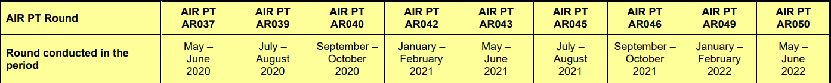
- All the monitoring has been completed in adherence with the 2021 Diffusion Tube Monitoring Calendar. No divergences were necessary.
- DEFRA’s Diffusion tube data processing tool was used for bias adjustment, annualization and fall off with distance calculations

Diffusion Tube Annualisation
The annualisation of data was required for TC9, The Mount and TC10, Castle Hill as the monitoring for these two sites began from May 2021 following the recommendation received from the detailed air quality assessment study for the Guildford town centre AQMA (report reference). Consequently, the data capture for these two sites are less than 75%.
The annualization was carried out using the following four urban background automated monitoring locations, with data obtained from Air Quality England website (https://www.airqualityengland.co.uk/):
- Spelthorne, Sunbury Cross
- London Eltham
- Horley Urban Background
- Hounslow
The annualization has been carried out using the Diffusion Tube Data Processing Tool v2.0 and the summary is provided in the Table C.2.

Diffusion Tube Bias Adjustment Factors
The diffusion tube data presented within the 2022 ASR have been corrected for bias using an adjustment factor. Bias represents the overall tendency of the diffusion tubes to under or over-read relative to the reference chemiluminescence analyser. LAQM.TG16 provides guidance regarding the application of a bias adjustment factor to correct diffusion tube monitoring. Triplicate co-location studies can be used to determine a local bias factor based on the comparison of diffusion tube results with data taken from NO_{x}/NO₂ continuous analysers. Alternatively, the national database of diffusion tube co-location surveys provides bias factors for the relevant laboratory and preparation method.
Guildford Borough Council have applied a national bias adjustment factor of 0.97 to the 2021 monitoring data. A summary of bias adjustment factors used by the Guildford Borough Council over the past five years is presented in Table C.1.
The version 03/22 of the national diffusion tubes bias adjustment factor spreadsheet was used which included 5 studies.
Table C.1 – Bias Adjustment Factor
Monitoring Year | Local or National | If National, Version of National Spreadsheet | Adjustment Factor
2021 | National | V 03/22 | 0.97
2020 | National | V 06/21 | 0.95
2019 | Local | - | 0.92
2018 | National | - | 1.03
2017 | National | - | 0.90

NO₂ Fall-off with Distance from the Road
Wherever possible, monitoring locations are representative of exposure. However, where this is not possible, the NO₂ concentration at the nearest location relevant for exposure has been estimated using the Diffusion Tube Data Processing Tool/NO₂ fall-off with distance calculator available on the LAQM Support website. Where appropriate, non-automatic annual mean NO₂ concentrations corrected for distance are presented in Table B.1.
Most of the monitoring diffusion tube locations in Guildford Borough are located at the relevant receptor location. However, where this was not possible, the tubes are set up as close as possible to the receptor. For diffusion tube sites which have been located in roadside locations with concentrations above 36 μg/m3, the distance adjustment has been calculator using the Diffusion Tube Data Processing Tool V2.0. A local background of 17μg/m3 from 2021 monitoring data for GD18, Josephs Road, which is urban background location in town centre area is used for distance correction.

NO₂ Fall-off with Distance from the Road
Wherever possible, monitoring locations are representative of exposure. However, where this is not possible, the NO₂ concentration at the nearest location relevant for exposure has been estimated using the NO₂ fall-off with distance calculator available on the LAQM Support website. Where appropriate, non-automatic annual mean NO2 concentrations corrected for distance are presented in Table B.1.
The distance correction was required for five locations, TC6 Park Street, A3-5 Weston Road, A3-8 Cathedral Hill Junction, A3-9 Lamppost 513-12, A3-10 Raymond Crescent and A3-11 (on clearway sign, A3).
TC6 is in Guildford Town centre AQMA and is discussed in section 2.2.
A3-5 distance corrected value cannot be accurately relied on because of the following reasons:
- The monitoring location is more than 10m further from the kerb and the receptor is more than 20m further from the kerb.
- The receptor is at an elevation higher than the monitoring location (see the pictures below which shows monitoring location, marked in red in respect to the receptor).
The locations A3-8, 9, 10 and 11 are roadside locations along the A3. Although the distance corrected concentration at the receptor has to be used with caution due to the distance of the receptor from the kerb, the results are discussed in section 2.2.
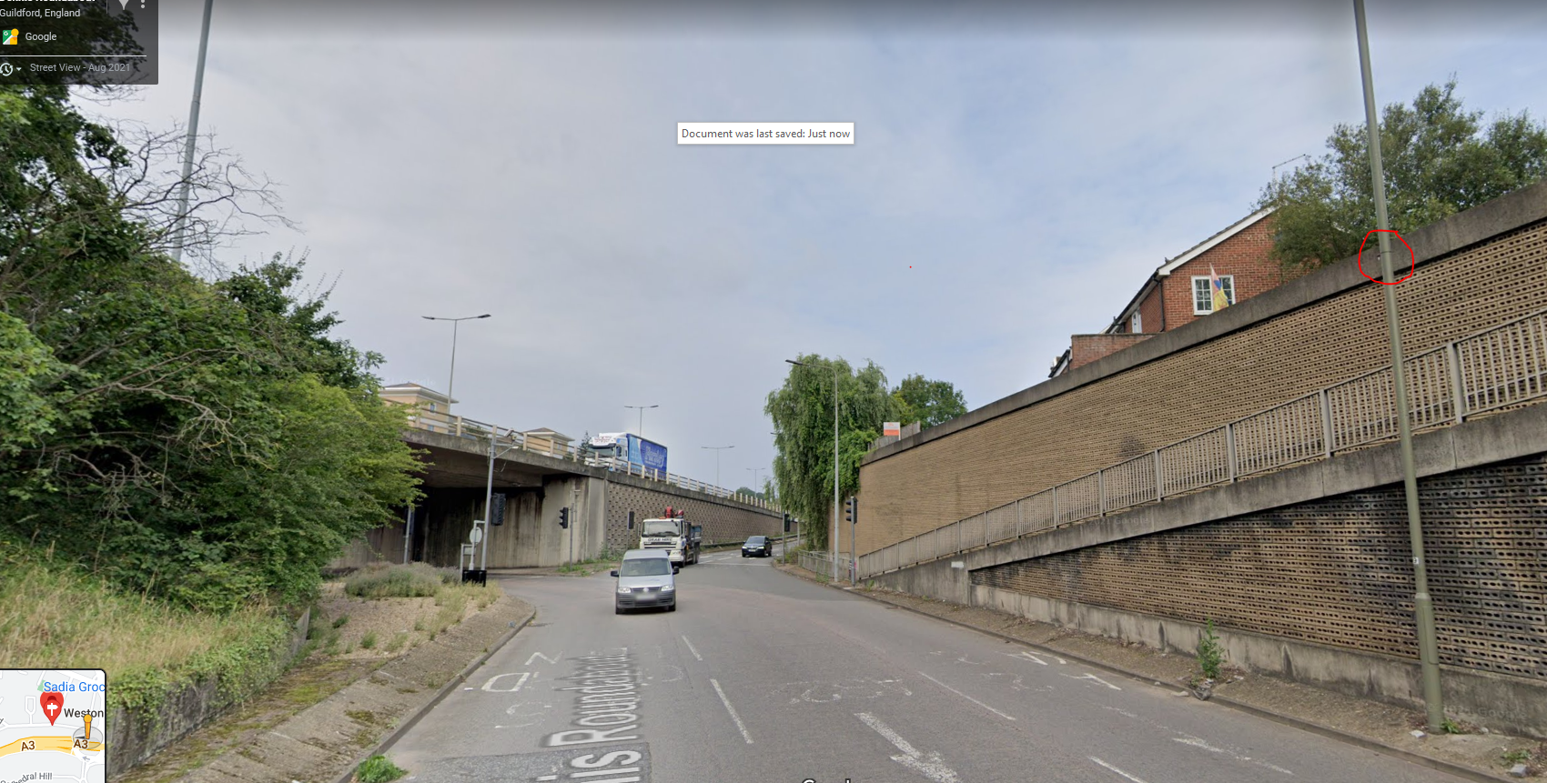
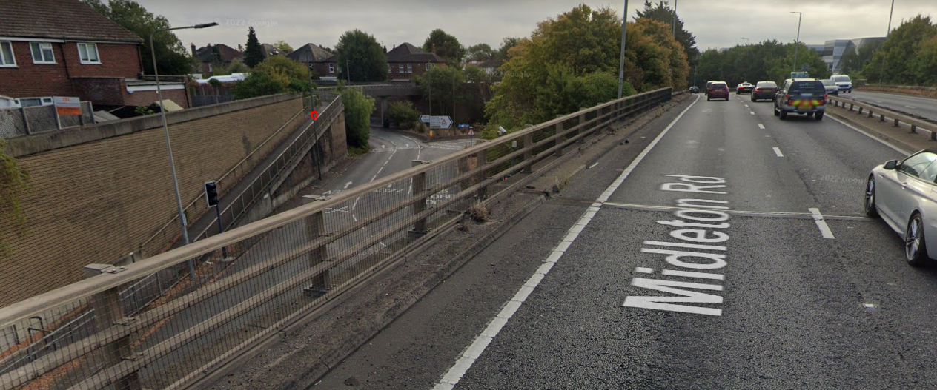

Table C.2 – Annualisation Summary (concentrations presented in µg/m³)
Diffusion Tube ID | Annualisation Factor Spelthorne, Sunbury Cross, Urban Background | Annualisation Factor London Eltham, Suburban | Annualisation Factor Horley, Urban Background | Annualisation Factor Hounslow, Feltham, Urban Background | Average Annualisation Factor | Raw Data Simple Annual Mean (µg/m3) | Annualised Data Simple Annual Mean (µg/m3) | Comments
TC9 | 1.0347 | 1.0803 | 1.0529 | 1.0531 | 1.0552 | 25.5 | 26.9
TC10 | 1.0105 | 1.0647 | 1.0217 | 1.0118 | 1.0272 | 27.9 | 28.6

Table C.3 – NO₂ Fall off With Distance Calculations (concentrations presented in µg/m³)
Site ID | Distance (m): Monitoring Site to Kerb | Distance (m): Receptor to Kerb | Monitored Concentration (Annualised and Bias Adjusted | Background Concentration | Concentration Predicted at Receptor | Comments
TC6 | 0.5 | 2.0 | 50.5 | 17.0 | 42.3 | Predicted concentration at Receptor above AQS objective.
A3-5 | 19.0 | 25.0 | 41.4 | 17.0 | 38.1 | Predicted concentration at Receptor within 10% the AQS objective. Warning: your monitor is more than 10m further from the kerb than your receptor - treat result with caution. Warning: your receptor is more than 20m further from the kerb than your monitor - treat result with caution.
A3-8 | 7.0 | 26.0 | 43.0 | 17.0 | 31.7 | Warning: your receptor is more than 20m further from the kerb than your monitor - treat result with caution.
A3-9 | 1.0 | 25.0 | 49.2 | 17 | 28.3 | Warning: your receptor is more than 20m further from the kerb than your monitor - treat result with caution.
A3-10 | 1.0 | 20.0 | 56.2 | 17 | 32.5
A3-11 | 1.0 | 20.0 | 73.1 | 17.0 | 39.2 | Predicted concentration at Receptor within 10% the AQS objective.

Appendix D: Map(s) of Monitoring Locations and AQMAs
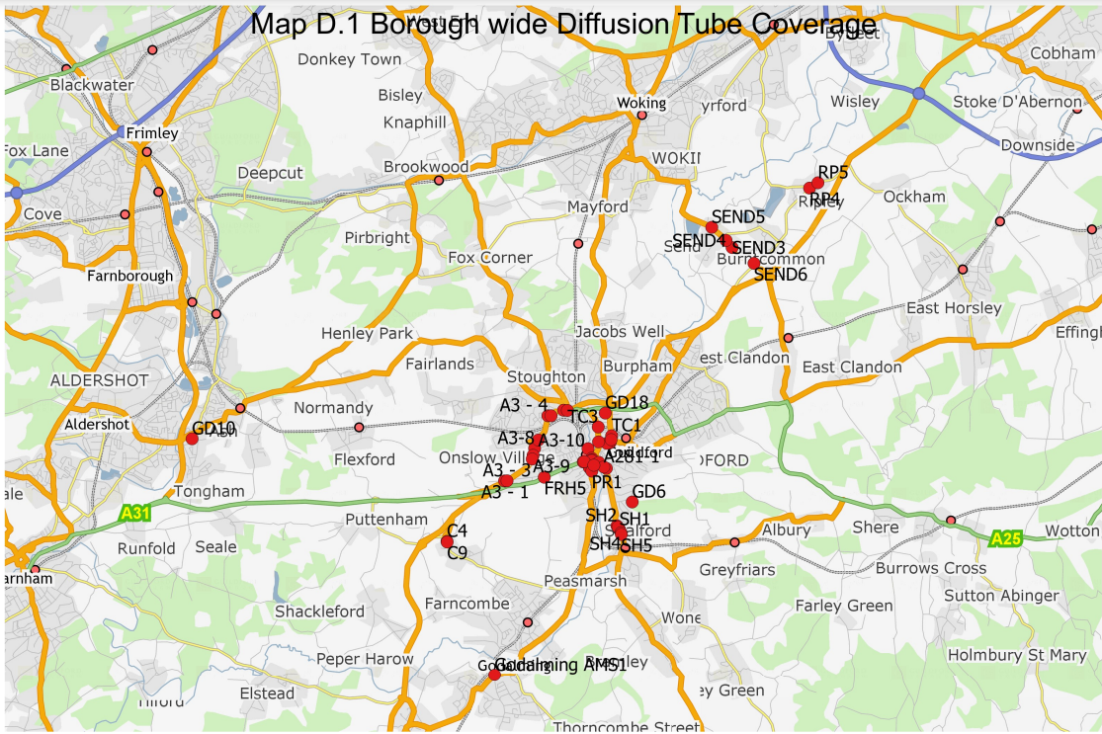
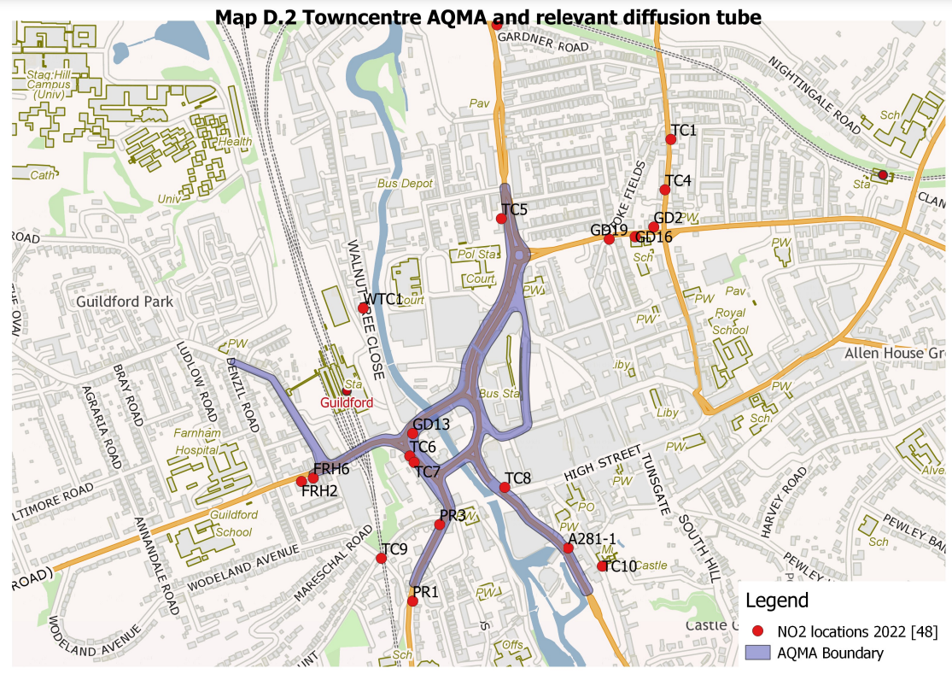
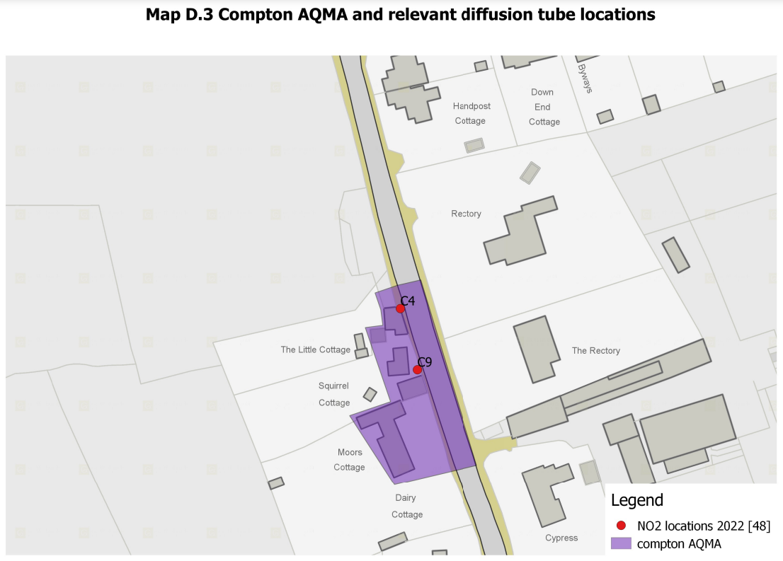
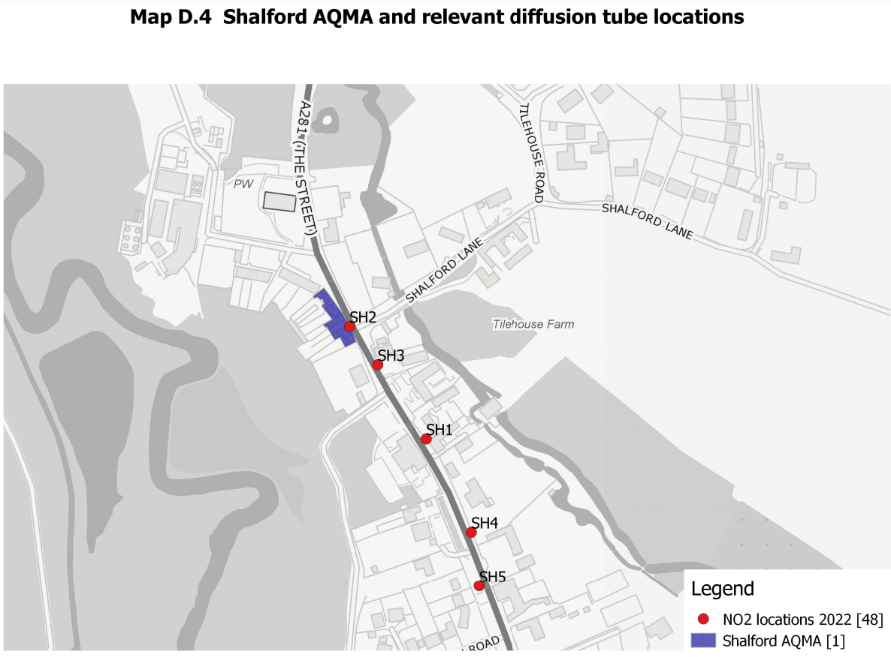
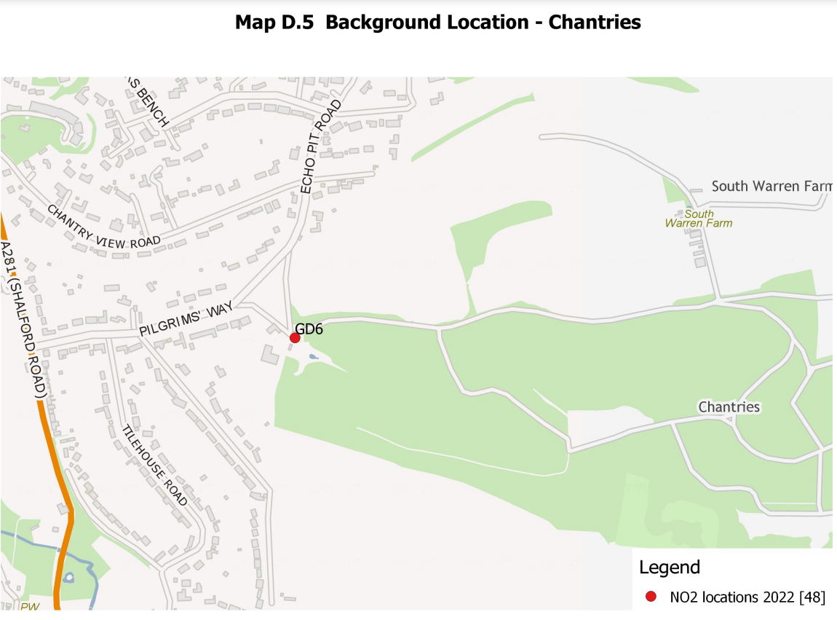
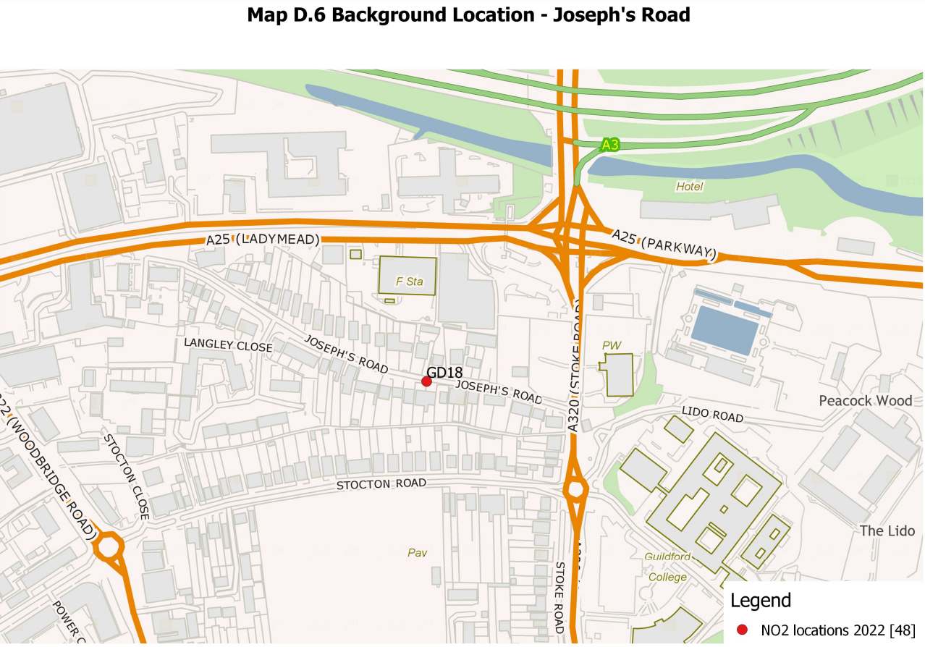
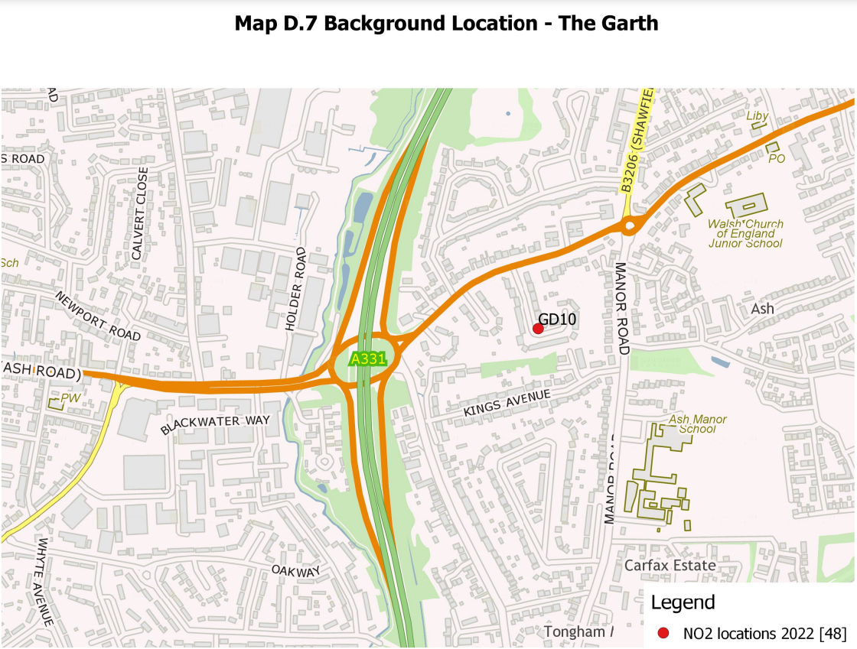
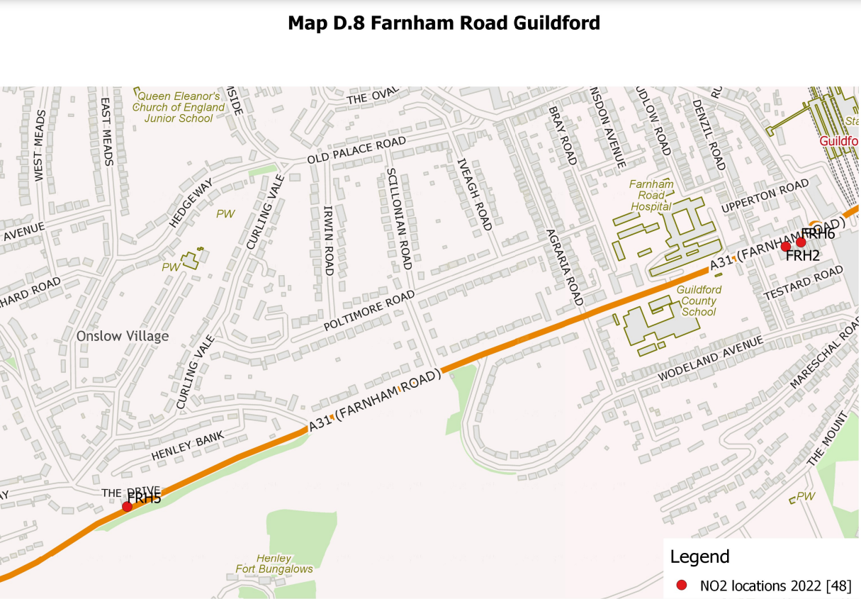
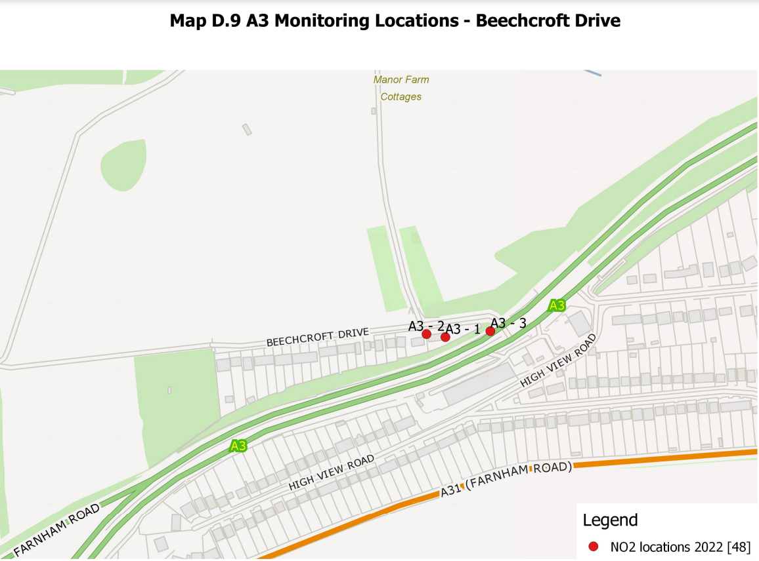
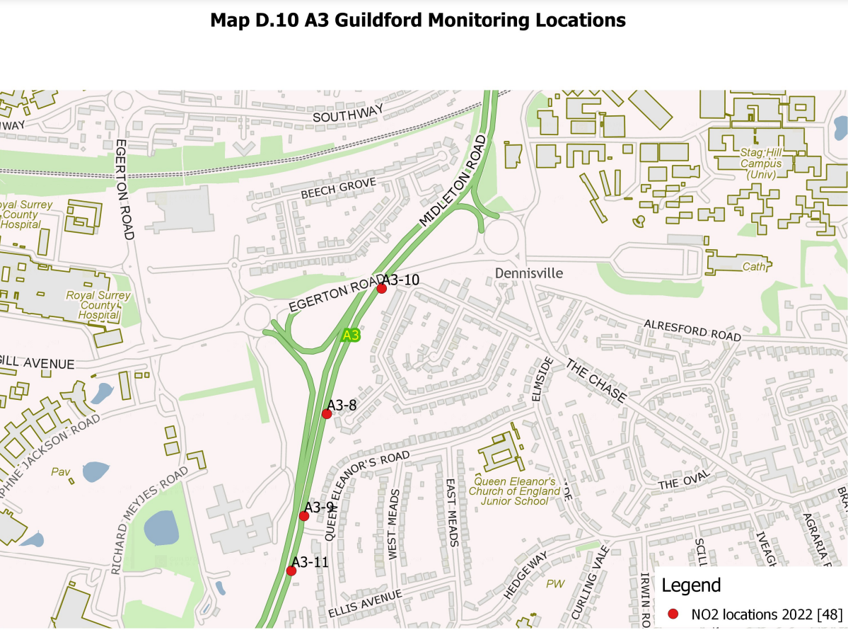
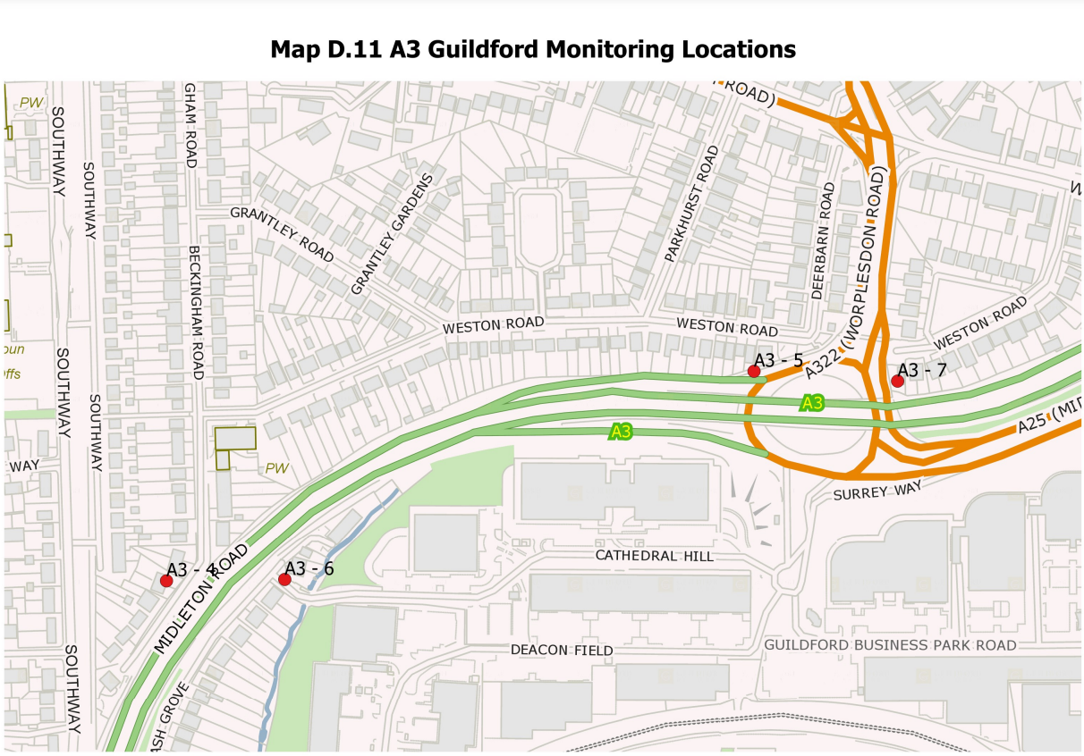
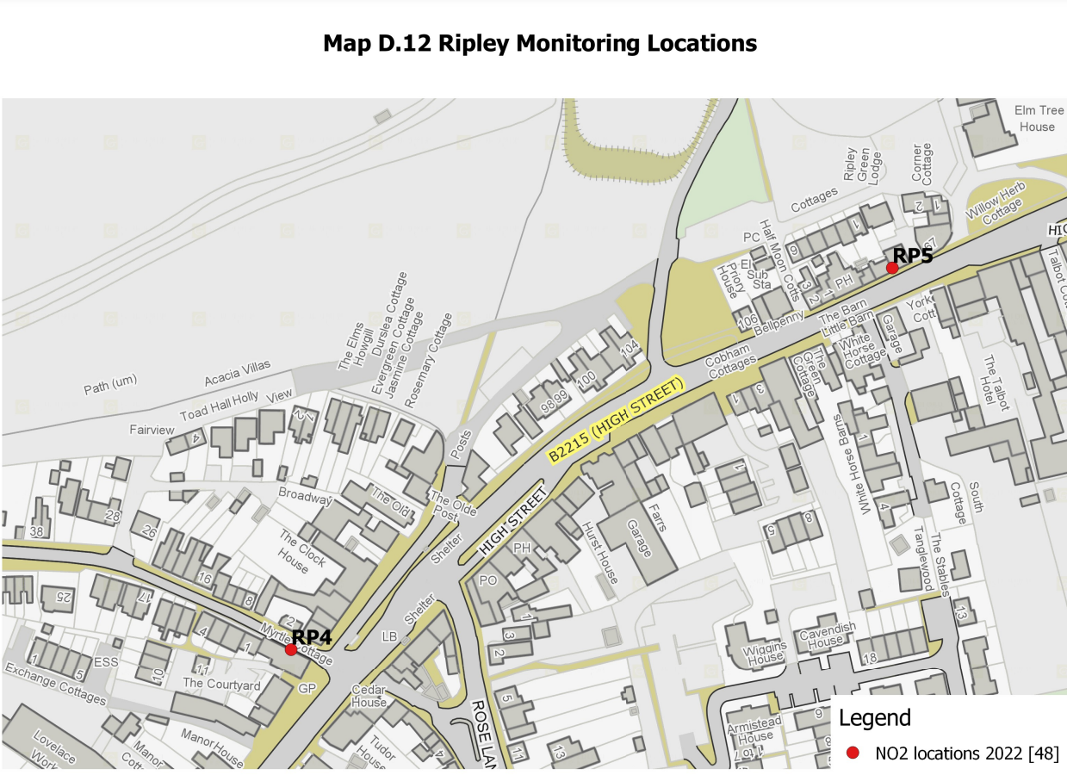
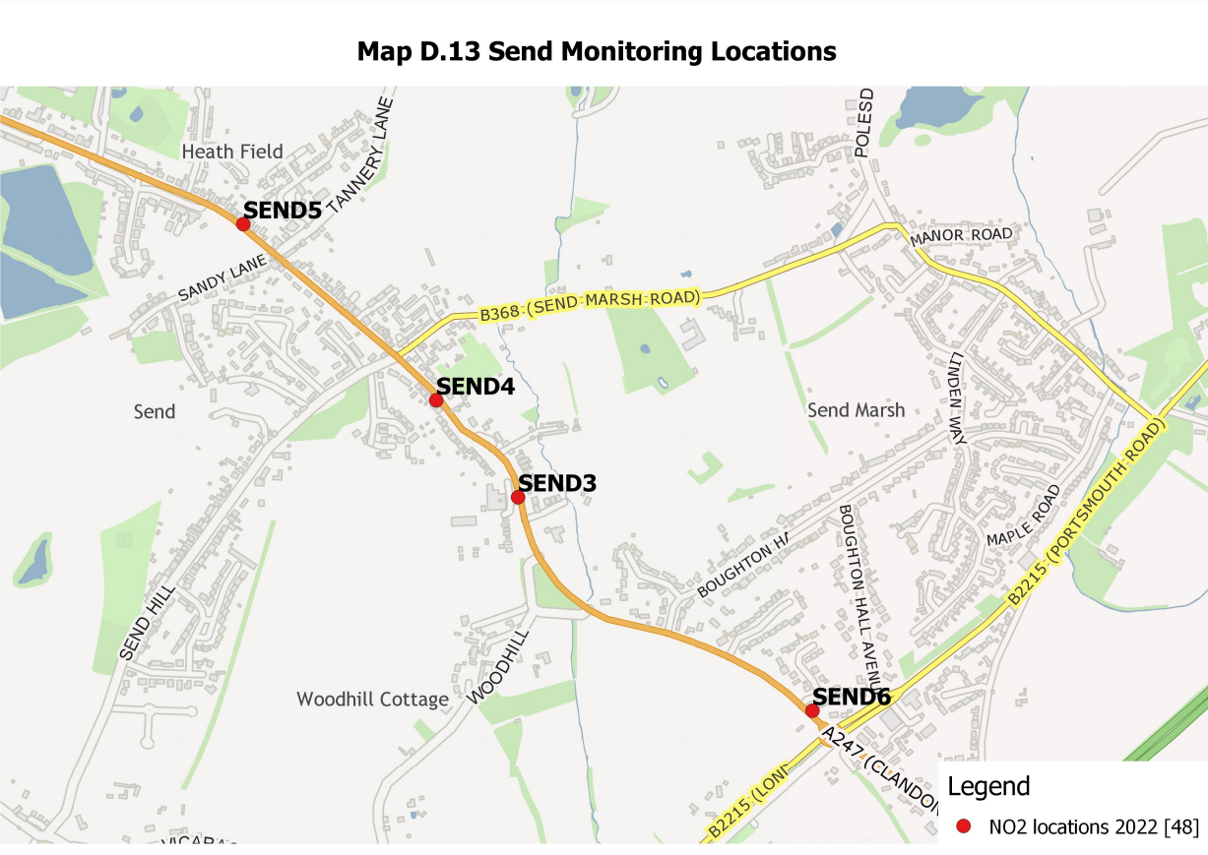

Appendix E: Summary of Air Quality Objectives in England
Table E.1 – Air Quality Objectives in England
Pollutant | Air Quality Objective: Concentration | Air Quality Objective: Measured as
Nitrogen Dioxide (NO₂) | 200µg/m³ not to be exceeded more than 18 times a year | 1-hour mean
Nitrogen Dioxide (NO₂) | 40µg/m³ | Annual mean
Particulate Matter (PM₁₀) | 50µg/m³, not to be exceeded more than 35 times a year | 24-hour mean
Particulate Matter (PM₁₀) | 40µg/m³ | Annual mean
Sulphur Dioxide (SO₂) | 350µg/m³, not to be exceeded more than 24 times a year | 1-hour mean
Sulphur Dioxide (SO₂) | 125µg/m³, not to be exceeded more than 3 times a year | 24-hour mean
Sulphur Dioxide (SO₂) | 266µg/m³, not to be exceeded more than 35 times a year | 15-minute mean

Glossary of Terms
Abbreviation | Description
AQAP | Air Quality Action Plan - A detailed description of measures, outcomes, achievement dates and implementation methods, showing how the local authority intends to achieve air quality limit values’
AQMA | Air Quality Management Area – An area where air pollutant concentrations exceed / are likely to exceed the relevant air quality objectives. AQMAs are declared for specific pollutants and objectives
ASR | Annual Status Report
AQO | Air Quality Objective
Defra | Department for Environment, Food and Rural Affairs
DMRB | Design Manual for Roads and Bridges – Air quality screening tool produced by National Highways
EU | European Union
FDMS | Filter Dynamics Measurement System
LAQM | Local Air Quality Management
NO₂ | Nitrogen Dioxide
NO_{x} | Nitrogen Oxides
PM₁₀ | Airborne particulate matter with an aerodynamic diameter of 10µm or less
PM_{2.5} | Airborne particulate matter with an aerodynamic diameter of 2.5µm or less
QA/QC | Quality Assurance and Quality Control
SO₂ | Sulphur Dioxide

References
- Local Air Quality Management Technical Guidance LAQM.TG16. April 2021. Published by Defra in partnership with the Scottish Government, Welsh Assembly Government and Department of the Environment Northern Ireland.
- Local Air Quality Management Policy Guidance LAQM.PG16. May 2016. Published by Defra in partnership with the Scottish Government, Welsh Assembly Government and Department of the Environment Northern Ireland.
- DEFRA Clean Air Strategy, 2019
- DEFRA, Air Quality PM_{2.5} Targets, Detailed evidence report, May 2022

Public Health England. Air Quality: A Briefing for Directors of Public Health, 2017
Defra. Air quality and social deprivation in the UK: an environmental inequalities analysis, 2006
Defra. Air quality appraisal: damage cost guidance, July 2021
Public Health England. Estimation of costs to the NHS and social care due to the health impacts of air pollution: summary report, May 2018
A3 Guildford Report, Guildford Borough Council, Project Number: 606439884, March 2021, https://www.guildford.gov.uk/article/26606/Working-to-improve-air-quality-on-the-A3-in-Guildford
Defra. Clean Air Strategy, 2019
DfT. The Road to Zero: Next steps towards cleaner road transport and delivering our Industrial Strategy, July 2018
http://www.guildford.gov.uk/carparks
https://fingertips.phe.org.uk/static-reports/public-health-outcomes-framework/at-a-glance/E07000209.html?area-name=Guildford
https://fingertips.phe.org.uk/profile/public-health-outcomes-framework/data#page/4/gid/1000043/pat/102/ati/101/are/E07000209/iid/30101/age/230/sex/4/cat/-1/ctp/-1/cid/4/tbm/1/page-options/tre-ao-0
https://www.guildford.gov.uk/media/32331/Detailed-air-quality-report/pdf/FM1183_Surrey_CERC_Guildford_19Nov19.pdf?m=637296299125670000
9789240034228-eng.pdf (who.int)
WASP – Annual Performance Criteria for NO2 Diffusion Tubes (defra.gov.uk) Summary of Laboratory Performance in AIR NO2 Proficiency Testing Scheme (January 2019 – March 2021).
The units are in microgrammes of pollutant per cubic metre of air (µg/m³).

