ASH PARISH COUNCIL

Minutes of the Meeting of the Council
held in the Ash Centre, Ash Hill Road, Ash
on Wednesday 15 October 2025 which commenced at 18:30

Chair of the Council: Cllr Fiona White A
Vice Chair Cllr Carla Morson
Cllr Philip Bellamy A
Cllr Carl Cookson A
Cllr Mohammad Faisal
Cllr Paul Golding A
Cllr Richard Lucas
Cllr Nigel Manning A
Cllr Michael Moriarty
Cllr Marsha Moseley A
Cllr John Tonks
Cllr Susan Wyeth-Price

Present x Not Present A Apology for Absence

Part I – Public Session

67. To receive Apologies for Absence. (agenda item 1)

Apologies for absence were received from Cllr Fiona White, Cllr Nigel Manning, Cllr Marsha Moseley, Cllr Paul Golding and Cllr Philip Bellamy.

68. Declarations of Interest. (agenda item 2)

Cllr Richard Lucas declared a non-pecuniary declaration of interest on Agenda Item 11, as he is Cllr for Finance, Property and Land Assets at Guildford Borough Council.

69. Confirmation of the Minutes. (agenda item 3)

The minutes of the Meeting of the Parish Council held on Monday 8 September 2025 copies of which have been circulated to members, were confirmed as a true record and will be signed by the Chair of the Council.

70. Chair’s Announcements. (agenda item 4)

The Chair welcomed everyone to the meeting.

Firstly, I’d like to speak regarding what are referred to by Surrey County Council as bus stop improvement works on Ash Church Road. These works will include a new bus shelter with real time travel information, footway widening, lining, bollards and verge works and are due to begin on 27 October for a period of 3 weeks. Temporary lights will be in place at the eastbound bus stop outside Ash Grange school and westbound bus stop outside St Peter’s Church. There will be access to homes and businesses.
This proposal was opposed to by most people in the area and formally objected to by this Council but unfortunately to no avail.

Secondly, I’d like again to mention that we are currently trialling a Police Hub here every Tuesday between 12 and 4pm. I feel I must stress that after years of being told that we need more of a police presence, we now have that and should utilise this service as much as possible. Sadly, I still see many posts relating to either ASB or crimes on Facebook when in fact the best route to take is to actually make a police report via the many options available. If you really want to use Facebook then please do report incidents via the Guildford Beat (Surrey Police) page, not just the community pages. It’s actual reports that count and help resolve the situation. We all have a responsibility to support our community, and this is best done by individuals contacting the police rather than expecting someone else to take action. Remember if you see an incident in progress ring 999.
Thirdly the latest update I have on the Local Government reorganisation is that despite the fact we all believed today was to have been the day we were notified of the outcome of the review; this has now been deferred until the end of October. We’ve been advised that at that point we will receive:
- Information on the number of unitary authorities there are to be
- The draft Structural Changes Order (which will lay out the rules for the set-up of the unitaries and
- An update on the issue of how Woking’s debt situation is to be handled
On a happier note, I’m pleased to be able to say that we have received confirmation of Section 106 monies to come to us for several improvements to be made to Harper’s Recreation Ground. Work will commence on 27th October, and we hope to keep disruption to a minimum.
This evening, we have Steve Bourne and Julie Doherty from Muller Property Group, Robert Shaw from Third Revolution Projects and Samantha Crawly from EQ Care Group with us. At this point I’d like to welcome them and move to agenda item number 5 inviting them to give a short presentation on proposals for the land at Hammersley Drive.
Following this we will move to Item 6 where everyone, Councillors and members of the public, will have the opportunity to ask questions. We do however also have other business to conduct this evening so I will be limiting time to 25 minutes or close to that.
Over to you, Steve, Julie, Samantha and Robert.

71. Muller Property Group, Land at Hammersley Drive. (agenda item 5)

The Chair welcomed Steve Bourne, Technical Director at Muller Property Group and he gave a short presentation to members and residents. Samantha Crawly, CEO of EQ Care Group, then spoke about the ethos of EQ Care Group.

Summary of presentation:
Muller Property Group has acquired land at Hammersley Drive for the development of a care home. While the initial design included 76 rooms, it has since been revised to 70. The facility aims to employ up to 100 local residents and foster strong ties with the community by providing free access to space for local organisations and groups.

72. Adjournment. (agenda item 6)

Members considered adjourning the meeting for a maximum period of 25 minutes, to enable members of the public to raise questions and it was:
Resolved that the meeting be adjourned for a maximum period of twenty-five minutes to enable a public question period to be held (as at Minute Appendix A).

73. Reports of Committees. (agenda item 7)

The following committee reports, copies of which have been circulated were received, considered and the recommendations therein were adopted:

Planning 18 August 2025 Minute Number 24 to 31

74. Monthly Payment List. (agenda item 8)

Members received and approved the monthly payments list giving details of August 2025 payments as at Appendix B.

75. Third Draft Budget and Precept 2026/27. (agenda item 9)

Members considered the third draft of the 2026/2027 budget and continued the discussion on the percentage increase for the Parish precept.

76. Annual Governance & Accountability Return Year Ended 31 March 2025. (agenda item
10)

Members noted the details from the external Auditor’s report.

77. Devolution - Potential Asset Transfer. (agenda item 11)

Members decided they would like to approach Guildford Borough Council (GBC) for potential transfer of assets owned by them in Ash.

78. Drainage Issues in Ash. (agenda item 12)

Cllr Richard Lucas recommended that Guildford Borough Council (GBC) and Surrey County Council (SCC) use S106 monies to fund a drainage survey. Cllr Susan Wyeth-Price advised S106 monies have not been agreed for the Persimmon build by the Chester Bridge. The clerk requested Cllr Susan Wyeth-Price to forward the planning number for further investigation.

Members decided they would like to put a ‘Working Group’ in place. Cllr Susan Wyeth-Price, Cllr Richard Lucas, Cllr Michael Moriarty and Cllr David Shaw (GBC) agreed to set this up, subject to the approval of Cllr Fiona White.

79. Correspondence. (agenda item 13)

There was no correspondence to report.

80. Next Meeting. (agenda item 14)

The next meeting is on Monday 10 November 2025.

The meeting closed at 19:50.

Chairman: __________________________ Date: ________________

AGENDA APPENDIX A

ASH PARISH COUNCIL

LOCAL CODE OF CONDUCT – DISCLOSURE OF INTERESTS

August 2025

DATE OF MEETING | MEMBER | MINUTE REF  & PAGE NO. | TYPE AND NATURE OF INTEREST
PLANNING  18 August 2025 | Ash Parish Council | Min Ref : 25  Page No : 17 | Ash Parish Council are the landlords of the Scout Hut at Harpers Road.

AGENDA APPENDIX B

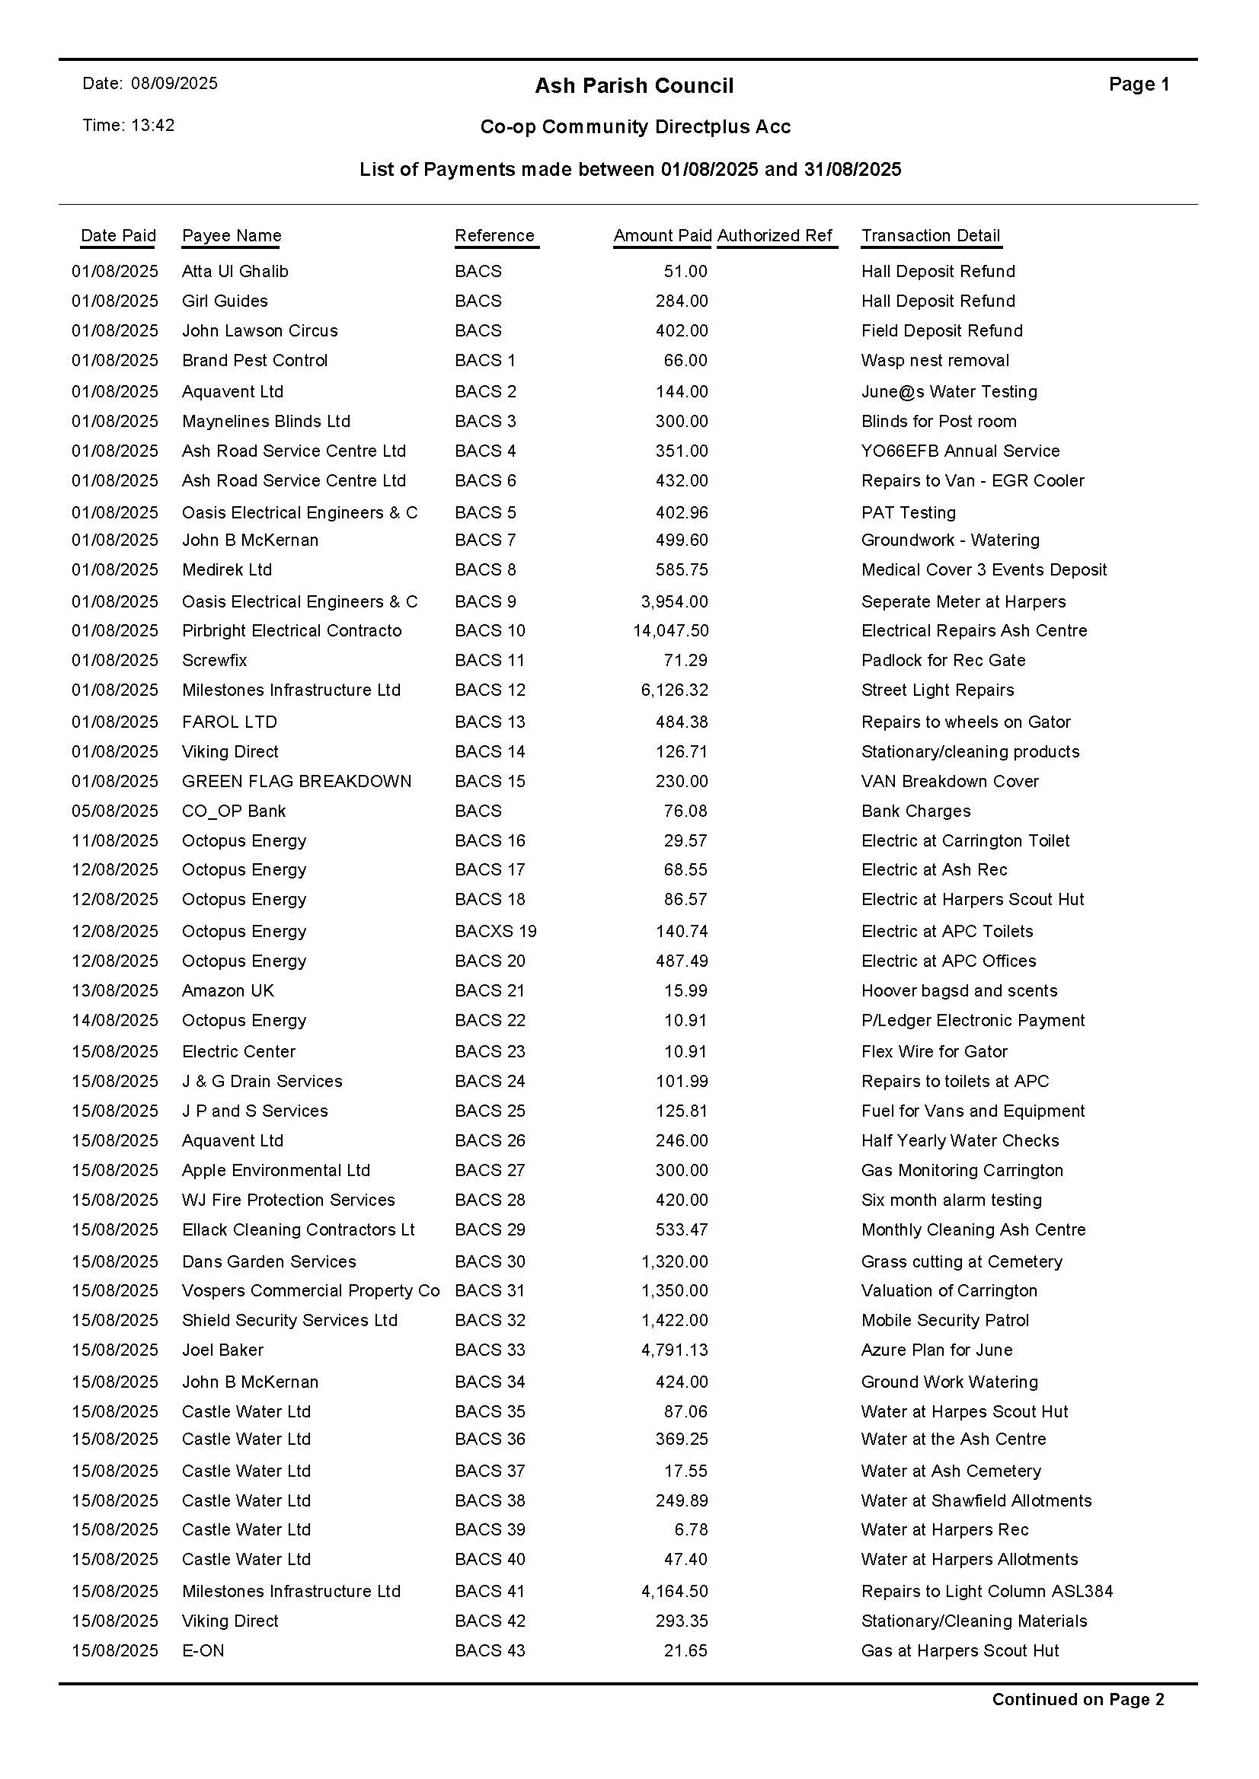

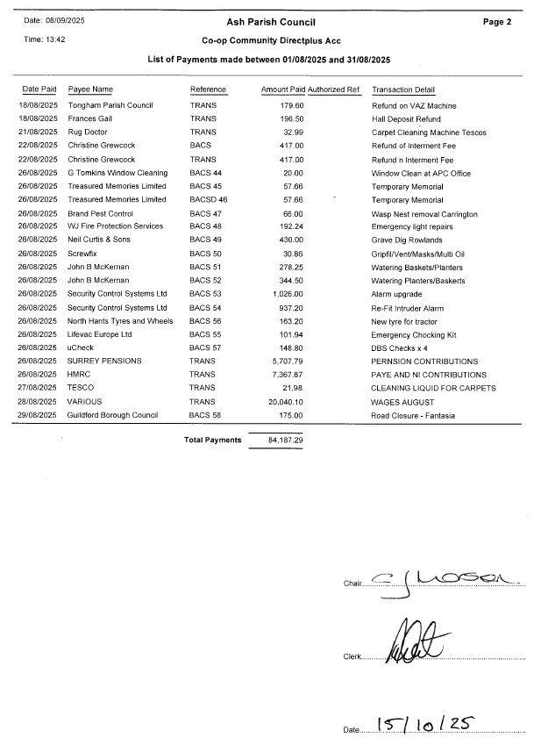

MINUTE APPENDIX A

PUBLIC ADJOURNMENT.

The history of this site and its original intended purpose leaves me feeling dismayed. What guarantees are there that the community will see the benefits from this build?
From our experience of operating care homes, we anticipate that most residents come from within a 3-mile radius of the site. We plan to integrate with the community offering space within the building for local groups and organisations to use for community purposes.

How many parking spaces will there be as parking in this estate is quite tight? The number of local buses is limited and does not go through the estate, and the nearest train station is 1 mile away. In my experience of visiting relatives currently in care homes there is never enough parking at busy times such as Sundays due to staff and visitor parking.
The current design includes 25 parking space (23 normal, 2 disabled and 1 dedicated ambulance car parking space). The care home plans to have a dedicated car / taxi for residents to use for appointments or to be taken to the station. A travel plan will be made to minimise the use of the car park by staff.

Were you aware of the Draft Ash Neighbourhood Plan Regulation 14 which highlights this location, noting its designation for Class C2 Use (residential) and F2 Local Community Use?
Yes, we are aware of the Draft Ash Neighbourhood Plan Regulation 14.

Car Parking spaces are far too few for both visitors and staff. What if the travel plans to minimise the car park use are insufficient, once it’s built the car park can’t be changed and it’s the community who will be stuck with poor design and planning.
The care home would plan to use their taxi to transport residents to places they want to go. The care home will make a travel plan for staff and will always be open to feedback and will make adjustments as we don’t want to cause problems to the local community.

Is this overdevelopment? Is the land big enough for this development, including amenity spaces?
The current design is within CQC regulation in terms of space per resident. The design has placed most of the working / facility rooms in the loft space where light is more limited.

How tall is the building? Raised concerned about insufficient parking. There is no additional parking outside our house, and we are opposite the proposed development. This is a busy area and with the large school, Ash Manor, morning rush hour is particularly busy. How will the addition of up to 100 staff commuting to this location impact travel in this area at busy times?
We will plan shift changes to avoid the busiest times. For example if a shift change begins at 8am we will expect staff to be on site at 7:30am to begin the change. The building will be 3 stories high, similar in scale to the residential apartments adjacent to the site.

I have a relative in a care home; they make facilities available to people in the village. Do you plan to offer this also?
Yes, we want to be part of the community.

How long will it take to build, how are you going to be a considerate constructer? Residents are already annoyed at how long it’s taken to complete snagging of the surrounding sites by the builder.
As part of the planning process, there will be a condition for construction management plan. We estimate a 12 month build once planning is approved.

Will you consider socially funded residents?
Yes, not just local authority funded, health funding also considered.

The care home will require lorries turning up with deliveries, how do you plan to manage this built-up area?
Deliveries are anticipated every 2-3 days, fresh food etc. Within the parking area is a turning area for vehicles. These would not be articulated lorries.

Dementia was mentioned regularly in your presentation are you specialising in this area and do you set aside specific rooms for different needs?
The care home is not specialising in dementia but recognises that many of their residents might have some form of dementia. Upon each application a suitable room will be identified.

Do you anticipate that the residents will have private cars?
There will not be any resident parking, just parking for staff and visitors

When do you plan to start construction?
Subject to the Planning application, we anticipate 13 weeks for planning, then for management plans another 8 weeks, after that it is subject to contractor lead time. Could start in 6 months’ time and be completed in 18 months.

