Advance warning closure notice June/July 2026

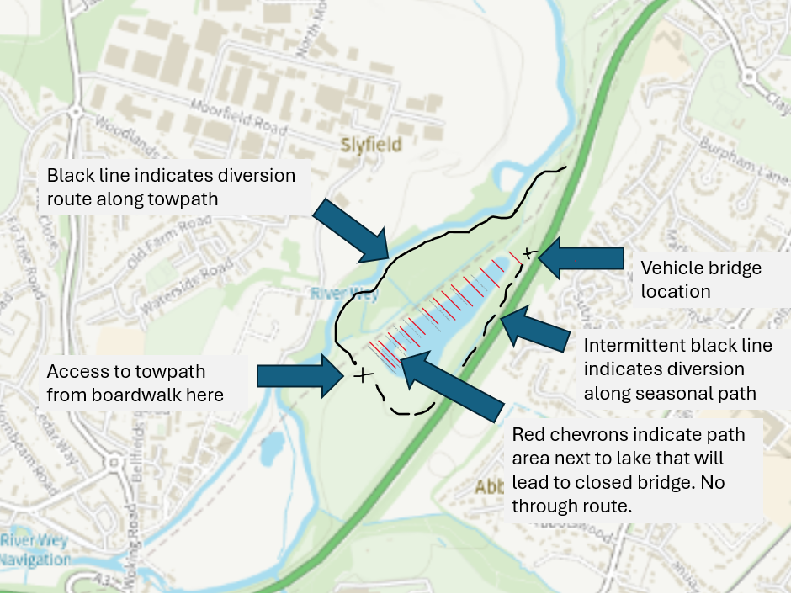
We can be contacted on 01483 505050 or email parks@guildford.gov.uk.

