Riverside Nature Reserve Boardwalk Replacement August 2026
We are upgrading the boardwalk in Riverside Nature Reserve/SANG (suitable alternative natural greenspace). The current boardwalk gives an opportunity to explore the protected fen habitat and creates access for this area of the SANG that otherwise would not be possible due to its wetland features. The site is managed for nature conservation and forms part of the Thames Basin Heath Special Protection Area.
We are replacing with a more durable material for this wetland habitat to preserve this access opportunity for users of the site. We will be replacing the boardwalk with a recycled plastic substitute to preserve access to this natural habitat for years to come. The replacement will take place in August to October 2026. During the replacement works the whole boardwalk area will have no public access.
The new boardwalk will include;
- Complete removal of the previous dead end section that led to the bird hide. By removing this section completely, this will allow us to more effectively manage the willow and scrub to protect the fen habitat characteristics. As part of the new boardwalk we will include a bird screen along the route. This will allow better viewing across the newly improved managed area in anticipation for improved bird watching opportunities.
- The boardwalk will be similar to the current layout but with new materials that will last longer. To improve access, we are widening the width to 1.5m to allow more room. We will keep most of the current passing places and these will be longer with angular access at both ends to allow more room for all users to move.
- Current benches will be kept in their original positions and refurbished.
- There will be some resting perches in some passing places to allow additional points to rest if needed by users.

Current boardwalk

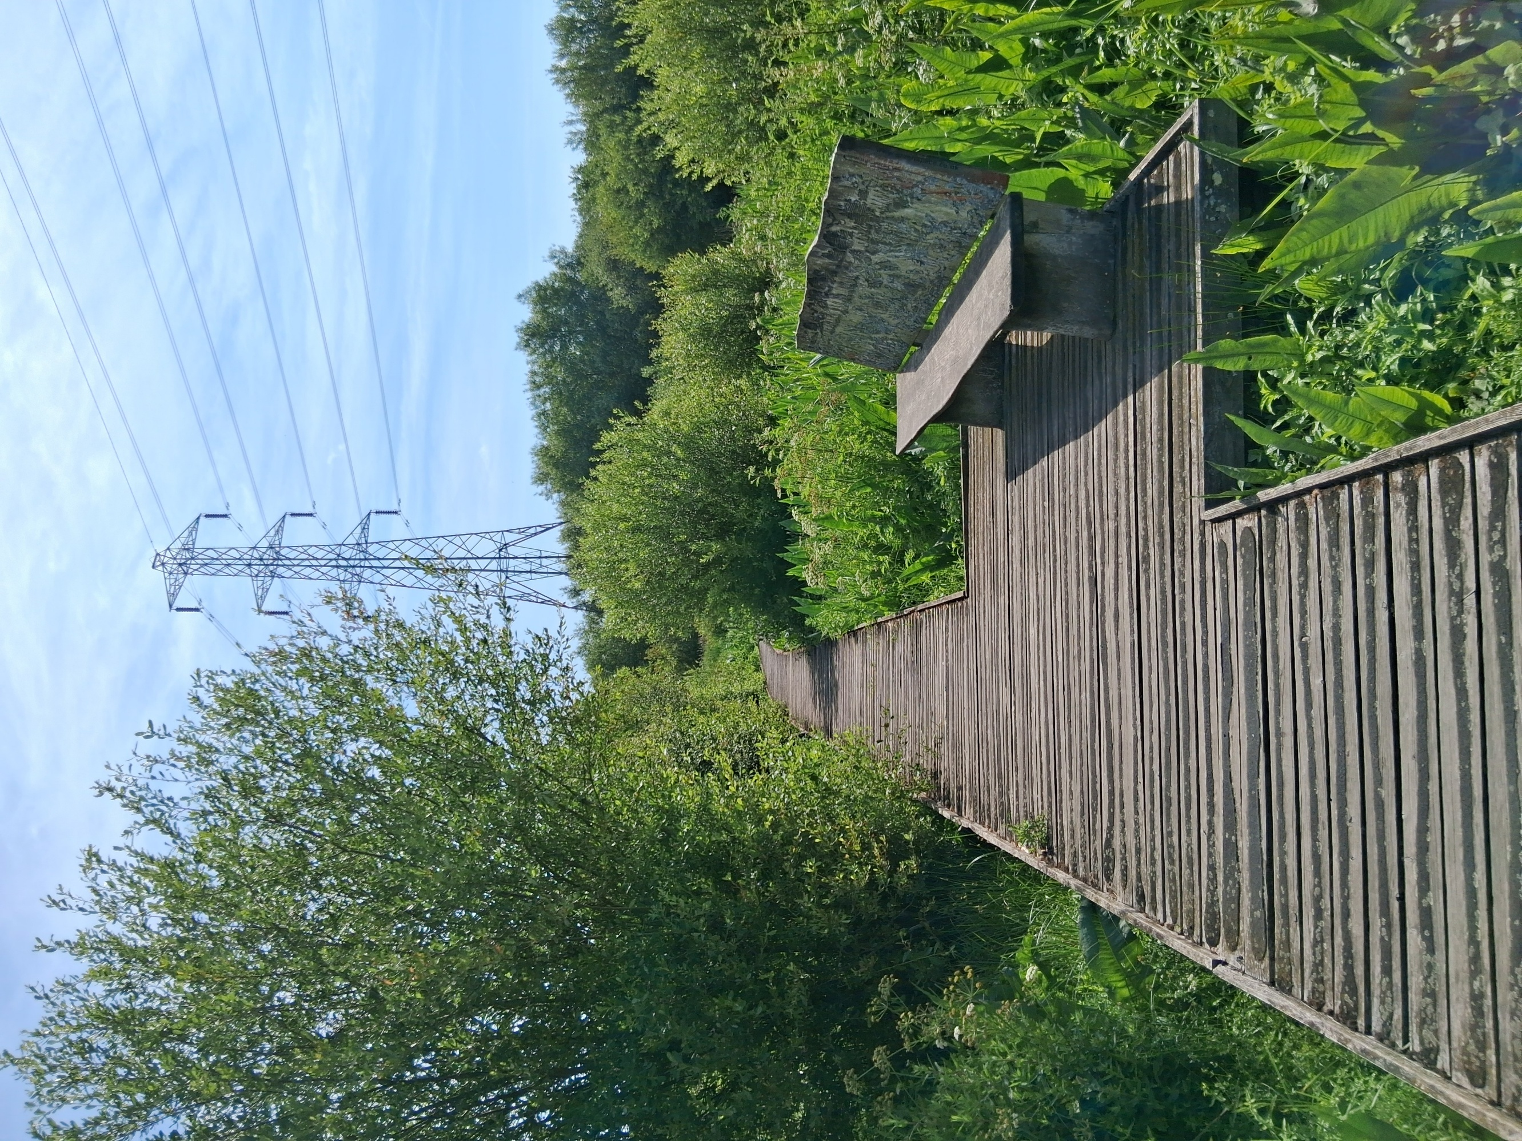

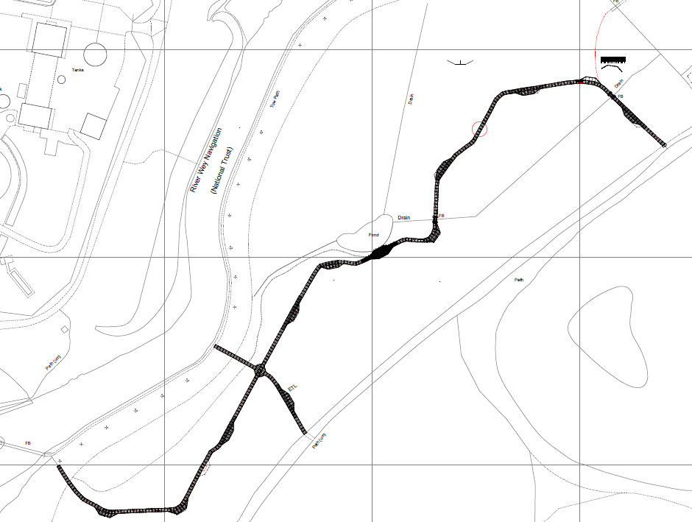

New boardwalk design will be like for like with minor changes and improvements as indicated above and on design drawing.
Location of new bird screen.

Roundabout will be removed.

Size of viewing platform by pond will be increased.

