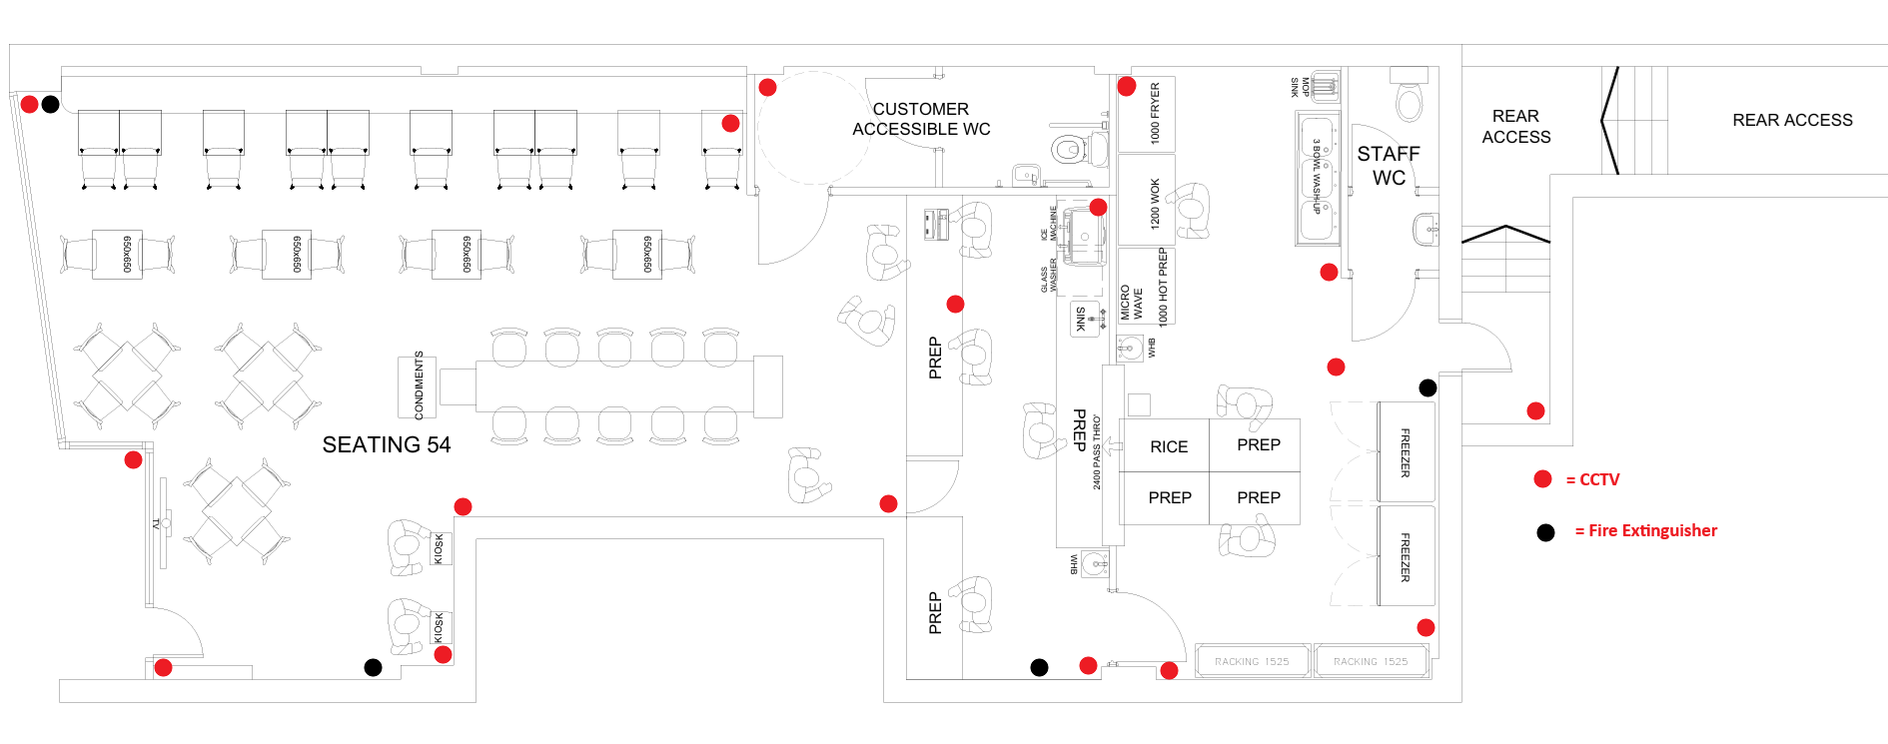
The Sushi Co, Premises Plan

