DONATE A BENCH
Application Form and Information Pack
Thank you for your interest in donating a bench in one of Guildford Borough Council's parks or open spaces.
Donating a bench is a lasting way to celebrate or support one of our valued green spaces.
Please note: benches in parks and open spaces may not display memorial inscriptions or personal identifying information. This includes names, initials, dates of birth and death, and wording such as "In Memory of", "In Loving Memory of", or any similar commemorative message. Plaques should instead contain positive, non-memorial wording, such as a poem, quotation, or other message of personal significance to the individual purchasing the bench.
.

How the process works
- Complete and return this application form.
- We will discuss your preferred location and confirm whether it is suitable.
- We will provide a final quotation.
- Once you have confirmed you are happy to proceed, the bench will be ordered.
- Upon delivery of the bench to our depot, you will be notified and invoiced.
- Installation normally takes approximately 12 to 16 weeks from confirmation of the order.

Please note that bench locations are subject to available space, landscape considerations, maintenance requirements, and future park management needs.

Quick Application Checklist
☐ Applicant details completed
☐ Preferred location provided
☐ Plaque option selected
☐ Inscription wording provided
☐ Terms and conditions accepted

Contact Details
Parks & Countryside Service
Email: parks@guildford.gov.uk

Section 1: Applicant Details

Name: _______________________________________________
Address: __________________________________________________
____________________________________________________
Postcode: _________________________
Telephone: ________________________
Email: _______________________________________________

Section 2: Preferred Location

Preferred Site: __________________________________
Preferred Location within Site: ______________________________________________
______________________________________________________________________
Please attach a map or photograph if available.

Section 3: Plaque Selection

The cost includes a maximum of five lines of text, with a maximum of 36 characters (including spaces between words) per line. You do not have to use all five lines. Included is a proof for you to approve.

Select | Option | Size | Cost + VAT
☐ | Stainless Steel | 228x63mm | £170
☐ | Stainless Steel | 152x63mm | £119
☐ | Cast Bronze | 228x68mm | £198
☐ | Cast Bronze | 152x68mm | £151
☐ | Carved Inscription | 30 characters included then £2.50 per additional letter | £67

Section 4: Plaque Wording

Line 1: _________________________________________
Line 2: _________________________________________
Line 3: _________________________________________
Line 4: _________________________________________
Line 5: _________________________________________

Plaque Examples

Stainless steel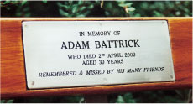 | Cast Bronze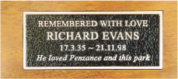 | Carved Inscription 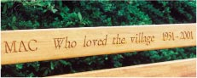

Section 5: Bench Selection
Locations | Bench Type | Cost + VAT
Stoke Park, Stoke Park Gardens, Stoughton Recreation Ground, Sutherland Memorial Park, Stoke Recreation Ground | Georgian  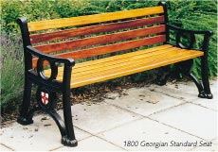 | £777
Kingston Meadows, Onslow Recreation Ground, Racks Close, Castle Grounds* | Cavendish  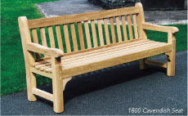 | £1,148
Bellfields Green, Shalford Park, Tilehouse Open Space | Hawthorn  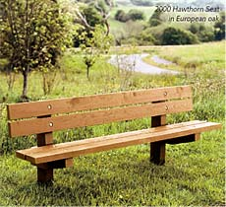 | £670
* Castle Grounds currently has no space for additional benches.

Additional Costs | Bench VAT
Delivery | £95
Installation | £150

Quotation Summary (Office Use)

Bench Cost: __________________
Plaque Cost: _________________
Installation: ________________
Delivery: ___________________
VAT: ________________________
TOTAL: ______________________

Privacy Notice
Guildford Borough Council will only use the personal information supplied on this form to administer and manage your bench donation request, communicate with you about your application and maintain records relating to the donated asset. Information will be processed and retained in accordance with the Council's data protection obligations and retention schedules.

Terms and Conditions
- Applications are subject to Council approval and site suitability.
- The Council reserves the right to propose an alternative location where necessary.
- Prices may change prior to ordering due to supplier increases.
- Full payment is required before installation can be arranged.
- Once installed, benches become the property of Guildford Borough Council.
- Benches remain available for public use and exclusive use cannot be guaranteed.
- Plaque wording is subject to approval and inappropriate wording or logos will not be permitted.
- Additional memorial items attached to benches may be removed without notice.
- The Council will normally retain the bench in the agreed location for a minimum of five years but may relocate it if required for operational, safety or management reasons.
- The Council cannot guarantee protection against vandalism, theft or accidental damage.
- Maintenance is undertaken at the Council's discretion and subject to available resources.
- Where a bench becomes unsafe, obsolete or beyond economical repair, it may be removed without replacement.
- Submission of this form confirms acceptance of these terms and conditions.

Declaration
☐ I have read and accept the terms and conditions.
☐ I confirm the information provided is correct.
Name: __________________________________________
Date: ___________________________________________

