Guildford and Shalford Economic Feasibility Study for Air Quality Improvements
Stage 1: Desktop Review
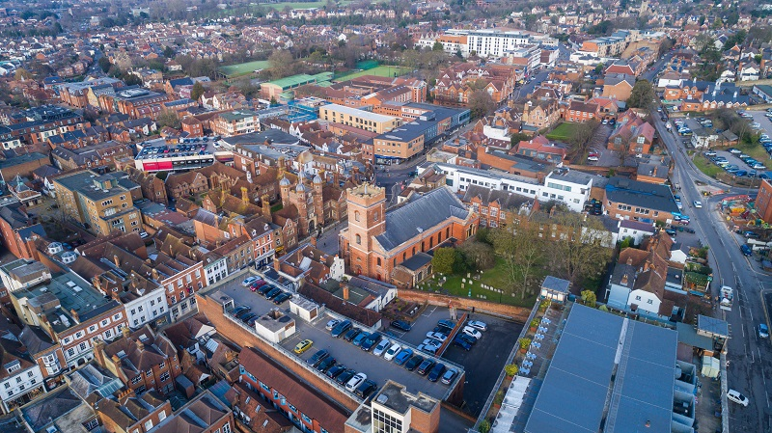
Table of Contents
1 Executive Summary 4
2 Introduction 6
3 Review of Current Situation 8
4 Review of Implemented Schemes 15
5 Case Studies: CAZ/LEZ Implementations Across England 24
6 Case Studies: Non-Charging Clean Air Zones 45
7 Appraising the Costs and Benefits of Improving Air Quality 50
8 Policy Review 52
9 Park and Ride Current Situation 53
10 Next Steps 62
Annex 1 65

Table of Figures
Figure 1 Map of Guildford displaying the Sites of Data Collection 8
Figure . Map of Guildford AQMA and Ward Boundary with 2023 Average Annual NO₂ Emissions 12
Figure Guildford AQMA and Ward Boundary with 2023 Average Average NO₂ Emissions 14
Figure . Park and Rides Routes 54
Figure . Total Passengers by Boarding Time 57
Figure . Average Passenger Numbers by Days of Week 57
Figure . Total Monthly Number of Passengers 58
Figure 8.Pre and Post COVID-19 Total Annual Passengers 59
Figure . Total Passengers by Boarding Time 60
Figure . Average Passenger Numbers by Days of Week 60
Figure . Total Monthly Number of Passengers 61
Figure . Pre Vs Post COVID 19 Total Annual Passengers 61
Figure . Total Passengers by Time-of-Day Comparison 64
Figure . Average Passenger Numbers by Days of Week 65
Figure . Total Monthly Number of Passengers 65
Figure . Pre Vs Post COVID Levels 66
Table of Tables
Table 1. Diesel Compliancy Numbers and Percentage 2022 9
Table 2. ANPR data Cars by fuel type 10
Table 3 Compliancy figures for LGVs 11
Table 4 Comparison between Guildford and the United Kingdom 11
Table 5. Charge and Penalty Structure of Zones in England 17
Table 6 Groups identified through other studies that are likely to be disproportionately impacted by CAZ/LEZ schemes 19
Table 7 Mitigation Measures For Cities Implementing LEZ/CAZ’s in England 21

Executive Summary

Review of Current Situation
Using recent Automatic Number Plate Recognition (ANPR) data, we evaluated levels of vehicle compliance for Vehicles passing through Guildford’s Air Quality Management Area with ULEZ (Ultra Low Emission Zone) standards. As expected, because petrol vehicles can be older and still compliant with ULEZ standards, diesel vehicles were more likely to be non-compliant (non-compliance rates between 11% and 20%) than petrol vehicles (with non-compliance rates ranging between 9 and 17%).and electric vehicles fully meet ULEZ standards. Light goods vehicles (LGVs) showed lower compliance levels, especially among diesel models with the lowest compliancy being below 60%. When compared to national averages, Guildford's compliance was slightly lower, which raises concerns about impacts on local air quality and pollution levels.
For vehicles registered in Guildford, the fleet position was worse with only 68% of cars and 57% of vans are compliant with ULEZ standards. To address this, measures such as vehicle upgrade incentives, public education, and stricter enforcement could help improve compliance and reduce harmful emissions in the area.

Review of Implemented Schemes
This section summarises a review of air quality improvement measures implemented in cities across the UK, focusing on case studies that closely align with Guildford’s context. It examines different types of Clean Air Zones (CAZs) and Low Emission Zones (LEZs) in both England and Scotland, highlighting key differences in enforcement and compliance mechanisms. The analysis primarily draws on English examples due to the distinct approaches between Scottish and English zones, with a focus on how these implementations influence driver and business behaviours, providing relevant lessons for Guildford's proposed measures.

Lessons Learned for Guildford from Case Studies
This section discusses lessons learned from the implementation of Clean Air Zones (CAZs) and Low Emission Zones (LEZs) across UK cities, focusing on how these schemes could inform similar initiatives in Guildford. Key topics covered include the classification of CAZ types, charging structures, enforcement mechanisms, and penalties. The review highlights the benefits and impacts of these schemes, including improved air quality, health outcomes, and the promotion of sustainable transport options. Additionally, it addresses potential challenges, such as public reactions, mitigation strategies, and the need to consider groups disproportionately affected by these measures. The section also outlines exemptions commonly applied in other cities and discusses how these could be relevant to Guildford, while balancing environmental goals with social equity.

The Value of Improving Poor Air Quality
This provides an evaluation of the impact of Clean Air Zones (CAZ), Low Emission Zones (LEZ), and Non-Charging Zones (NEZ) on air quality and public health across various UK cities. It synthesises findings from case studies, highlighting the diverse approaches and economic outcomes associated with each city's strategy. For instance, Greater Manchester's CAZ demonstrates a positive Net Present Value (NPV), indicating a favourable balance of benefits over costs, while Southampton's CAZ shows a more sensitive economic viability depending on assumptions. London's LEZ and ULEZ, however, have proven highly effective, with substantial reductions in NO₂ levels and significant economic benefits. Each case highlights the importance of tailored strategies and comprehensive cost-benefit analyses to ensure successful air quality interventions.

National, Regional and Local Policies/Schemes/Objectives
The proposal's policy review examines a range of local, regional, and national strategies to ensure that Guildford’s proposed Clean Air Zone (CAZ) aligns with existing objectives and supports efforts to reduce air pollution. Key local documents, such as the Guildford Borough Local Plan were considered alongside regional plans like the Surrey Transport Plan and national frameworks such as the UK’s Net Zero Strategy and Clean Air Strategy. This comprehensive analysis highlights policies aimed at improving air quality through initiatives like zero-emission vehicle mandates, sustainable transport infrastructure, and greenhouse gas removals. By integrating these policies into the CAZ planning, the proposal aims to create a coordinated and effective approach to reducing emissions, fostering sustainable travel, and enhancing public health outcomes in Guildford.

Park and Ride Current Situation
This provides an in-depth analysis of the current state and usage of Guildford’s Park and Ride (P&R) services, focusing on the operational performance and passenger trends across key sites, including Artington and Merrow. It evaluates ridership data over time, exploring factors such as peak usage periods, weekday versus weekend patterns, and the impact of the COVID-19 pandemic on overall demand. By comparing pre- and post-pandemic data, this section highlights shifts in commuter behaviour, revealing critical insights into how these services are being utilised and identifying areas for potential improvement. The section also includes a detailed breakdown of ticketing options, operating hours, and service frequencies to provide a comprehensive overview of how these P&R facilities contribute to reducing town centre congestion and promoting sustainable travel within Guildford.

Introduction
Guildford Borough Council commissioned Buro Happold to undertake an economic feasibility study for options to reduce air pollution (and in particular NO₂ emissions) in Guildford and Shalford Air Quality Management areas. This study is a Stage 1 report comprising a desktop review, building upon previous work undertaken to develop the Air Quality Management Areas undertaken by Air Pollution Services (Guildford Town Centre AQMA) and Air Quality Consultants Limited (Shalford AQMA).
This desktop review has the following aims:
            - Review of Current Situation: To establish a rigorous baseline for the current levels of air quality within Guildford and Shalford which will be used to develop the “do-nothing” scenario for future options modelling.

            - Review of Implemented Schemes: Clean Air Zones and Low Emissions Zones have been implemented across several cities in the UK. This review covers both formal and informal interventions to improve air quality, identify costs and benefits from implemented schemes and highlight key learnings to support the development of effective strategies for Guildford and Shalford.

            - Review of Local Development Schemes/Policy: This includes a review of current policies and identification of any proposed schemes that may impact on vehicle movements or provide alternative provisions that will support improving air quality. We have reviewed relevant policy documents including:
- Transport Strategy (Department for Transport, DfT)
- Air Quality Strategy: Framework for Local Authority Delivery 2023 (Department of Environment, Food & Rural Affairs, DEFRA)
- Clean Air Strategy 2019 (DEFRA)
- Clean Air Zone Framework 2022 (DEFRA & DfT)
- Package of Measures Introduced to Improve Air Quality 2022 (DEFRA)
- Net Zero Strategy: Build Back Greener 2021 (Department for Energy Security and Net Zero and Department for Business, Energy and Industrial Strategy)
- Environmental Improvement Plan 2023 (DEFRA)
- Surrey County Council Local Transport Plan 2022 (LTP4) (Surrey County Council, SCC)
- Surrey County Council Air Quality Strategy (SCC)
- Surrey Community Vision 2030 (SCC)
- Surrey 2050 Place Ambition (SCC)
- A New Railway Strategy for Surrey 2021 (SCC)
- Surrey’s Climate Change Strategy 2020 (SCC)
- Surrey County Council Sustainable Modes of Travel to School Strategy (SCC)
- Guildford Air Quality Strategy (GBC)
- Guildford Town Centre Transport Package (TCTP) (GBC)
- Guildford Borough Local Plan: Strategy and Sites 2015-2034 Part 1 and 2 (GBC)
- Shaping Guildford’s Future Masterplan(GBC)
- Local Cycling and Walking Infrastructure Plan (GBC & SCC)
Bus Improvement Plan (GBC)

            - Review of Current Park and Ride Provision: We have obtained key data related to the current park and ride services around Guildford related to demand for services, revenues and costs associated with provision and assessment of socio-economic characteristics of service users.

            - Review of Existing Stakeholder Engagement: We have reviewed existing stakeholder engagement related to air quality improvement options, traffic reduction schemes and/or schemes to encourage modal shift within the past 3 years by Guildford Borough Council. The evidence gathered has been used to map out stakeholders and inform future engagement activities to identify specific needs of community groups and local businesses.

Review of Current Situation

Emission Levels of Vehicles Passing Through Guildford
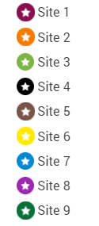
Guildford Borough Council commissioned traffic counts using Automatic Number Plate Recognition (ANPR) technology, the counts were collected across 9 sites, 24 hours a day for the 7 days between 23rd November and 29th November 2022.
Figure 1 Map of Guildford displaying the Sites of Data Collection
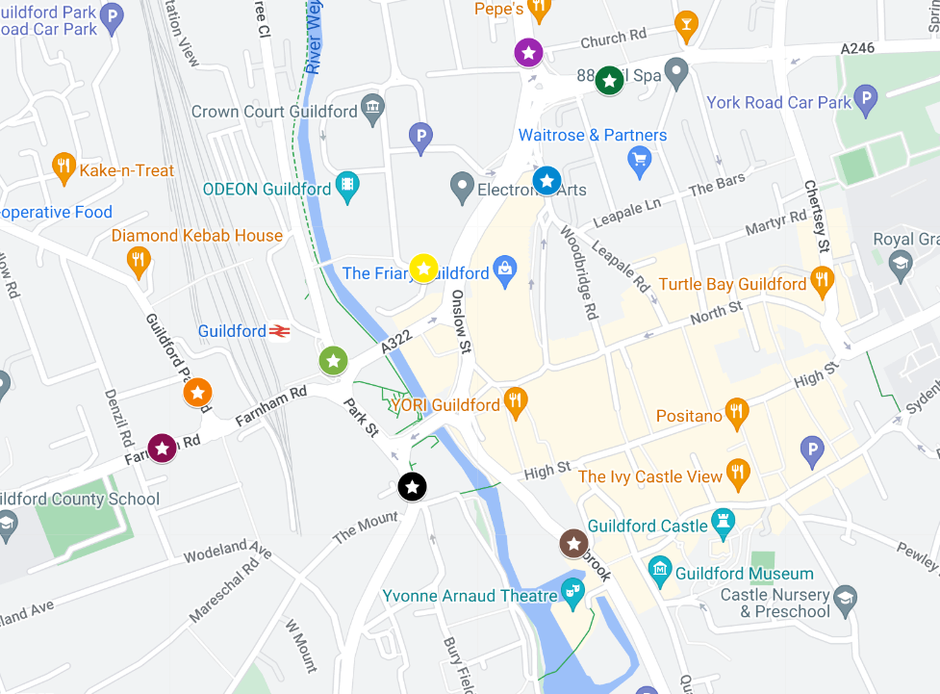

Overview
We compared the Euroclass of vehicles passing through each site to assess levels of compliance to Ultra Low Emission Zone (ULEZ) standards applied elsewhere in the UK i.e. for Petrol vehicles needed to be Euroclass 4 or higher and for diesel vehicles Euroclass 6 (VI for LGVs) or higher.
Across all sites, diesel cars consistently had lower compliance levels than petrol cars (with non-compliance rates ranging between 9 and 17%). This trend is also observed for LGVs (which are far more likely to run on diesel than petrol). Sites 3 and 7, stand out with particularly low compliance rates for diesel LGVs (at 40% and 31% respectively), highlighting site-specific locations that may need targeted interventions.
On November 29, 2022, Site 8 recorded the highest number of non-compliant LGVs, at 311 out of a total of 2,228 LGVs. Similarly, on November 26, 2022, Site 9 had the highest number of non-compliant cars, with 1,040 non-compliant cars out of a total of 5473 cars passing through.

Deep Dive Site Analysis
As around 99% of petrol cars were compliant with ULEZ standards and very few LGVs are fuelled by petrol, we focus on the compliance rates of diesel cars and LGVs in our analysis. For diesel compliancy the following ranges are seen for the sites:
Table 1. Diesel Compliancy Numbers and Percentage 2022
Site | Diesel Cars |  | Diesel LGVs
 | Number of compliant cars | % compliant cars | Number of compliant LGVs | % of compliant LGVs
Site 1 | 2970 - 4136 | 87.14 - 88.82 | 475 - 1710 | 86.27 - 92.40
Site 2 | 2277 - 3769 | 86.13 - 87.33 | 779 - 1631 | 81.22 - 91.54
Site 3 | 866 - 3901 | 79.42 – 84.62 | 58 - 159 | 59.63 – 67.32
Site 4 | 1382 - 2512 | 85.13 - 87.71 | 475 - 1107 | 77.55 – 87.93
Site 5 | 3976 - 4840 | 86.14 – 87.48 | 775- 2271 | 83.91- 89.23
Site 6 | 234- 518 | 85.87 – 90.15 | 33- 1568 | 85.00 – 95.04
Site 7 | 1695 - 2451 | 87.73 - 87.96 | 402- 917 | 66.61- 81.12
Site 8 | 3955 - 4753 | 85.94 - 85.92 | 958 - 2539 | 84.47- 87.99
Site 9 | 4108- 5361 | 85.92 - 87.96 | 618- 1895 | 86.77 – 89.89

Site 4 (Park Street)
Site 4 is where the emissions levels are above target. Overall, diesel cars consistently had lower compliance rates compared to petrol cars, ranging from 85% to 88%. Diesel LGVs showed more variability in compliance, with a notable dip to 78% on 26/11/2022. Petrol LGVs generally maintained high compliance, though they dipped to 80% on 23/11/2022 and 24/11/2022. Despite being the only site over the legal limit of NO₂, it is not the worst site for compliance levels of vehicles passing through. At Site 4, the compliance rates for both cars and LGVs were generally high, with little variation over the observed days. The number of non-compliant cars ranged from 72 to 87, while non-compliant LGVs varied between 10 and 20. Despite these variations, Site 4 consistently showed lower numbers of non-compliant vehicles compared to other sites. For instance, Site 8 recorded a peak of 311 non-compliant LGVs on 29/11/2022, and Site 9 had 1040 non-compliant cars on 26/11/2022.

Analysis of Compliance Rates of Vehicles Registered in Guildford Borough.

Guildford
The latest data available from the Department of Transport showed that 88,014 vehicles (cars and LGVs) were registered within Guildford borough boundaries. We estimated compliance levels based on the date that the vehicle was first registered to standard Ultra Low Emission Zone (ULEZ) restrictions: petrol vehicles registered after 2006 and diesel vehicles registered in 2015 to determine the numbers of locally registered vehicles that would be potentially affected by introducing local ULEZ zones. Overall, 68% of cars registered locally meet ULEZ standards.
Car by fuel type:
Table 2. ANPR data Cars by fuel type
Cars | % of Total Cars by Fuel Type | Number of Cars | Number of Non-Compliant Cars | Compliance Rate (%)
Battery Electric | 2.9 | 2,252 | 0 | 100
Diesel | 26.4 | 20,789 | 11,738 | 43.5
Hybrid Electric | 5.4 | 4,269 | N/A | N/A
Other Fuel Types | 0.01 | 67 | N/A | N/A
Petrol | 63.5 | 50,006 | 6,642 | 86.7
Plug-in Hybrid Electric (combined) | 1.8 | 1,409 | N/A | N/A

The compliance rate of light goods vehicles (LGVs) is significantly lower at 57%.
Table 3 Compliancy figures for LGVs
LGVs | % of Total LGVs | Number of LGVs | Number of non-Complaint LGVs | Compliance Rate (%)
Battery electric | 1.0 | 88 | 0 | 100
Diesel | 93.9 | 8657 | 3714 | 57.1
Other fuel types | 0.2 | 15 | N/A | N/A
Petrol | 4.9 | 458 | 243 | 46.9
Plug-in hybrid electric | 0.04 | 4 | N/A | N/A

Table 4 Comparison between Guildford and the United Kingdom
Overall Comparison | Guildford | UK
Car Compliance (%) | 74.83 | 75.17
LGV Compliance (%) | 54.66 | 62.22

The compliancy rates cover petrol, diesel and battery electric as there is a lack of data on different types of hybrids. The lower compliance rate of vehicles registered in Guildford could have significant implications for local air quality, potentially contributing to increased levels of harmful pollutants like nitrogen oxides (NOx) and particulate matter (PM2.5) and subsequent negative environmental and health impacts. It appears that the compliance rate, at 8% lower than national levels, of LGVs registered in Guildford is especially concerning. For cars, there is a more marginal difference between Guildford and national figures but 1 in 4 cars registered in Guildford are non-compliant to ULEZ standards.

Emission Levels in Guildford’s Air Quality Management Area
NO2 emissions are monitored using diffusion tubes. For context, the UK Government has found that the annual mean concentration of NO2 at the roadside has decreased over time to 21.8 µg/m³ in 2023. However, the annual mean NO2 concentration in 2023 remains higher at roadside sites compared to urban background sites. This is most likely due to substantial emissions of nitrogen oxides from road transport, as the majority of roadside concentrations come from local traffic.
Figure.1 shows the annual average of NO2 pollution in 2023. The location near 18 Park Street has the highest levels of emissions, with an average of 57.2 µg/m³. This is 17 µg/m³ over the legal limit (40 µg/m³), exposure to nitrogen dioxide (NO₂) above this has adverse health effects, particularly for respiratory health, the elderly, and children. Long-term exposure is associated with increased risk of asthma, chronic obstructive pulmonary disease (COPD), and cardiovascular diseases. The concentration of NO₂ emissions exceeding legal limits in specific areas, such as 18 Park Street, highlights environmental inequality. Vulnerable populations passing through this area face disproportionate health risks due to poor air quality.
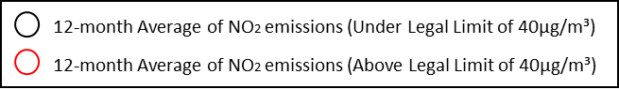
Figure . Map of Guildford AQMA and Ward Boundary with 2023 Annual NO₂ Emissions
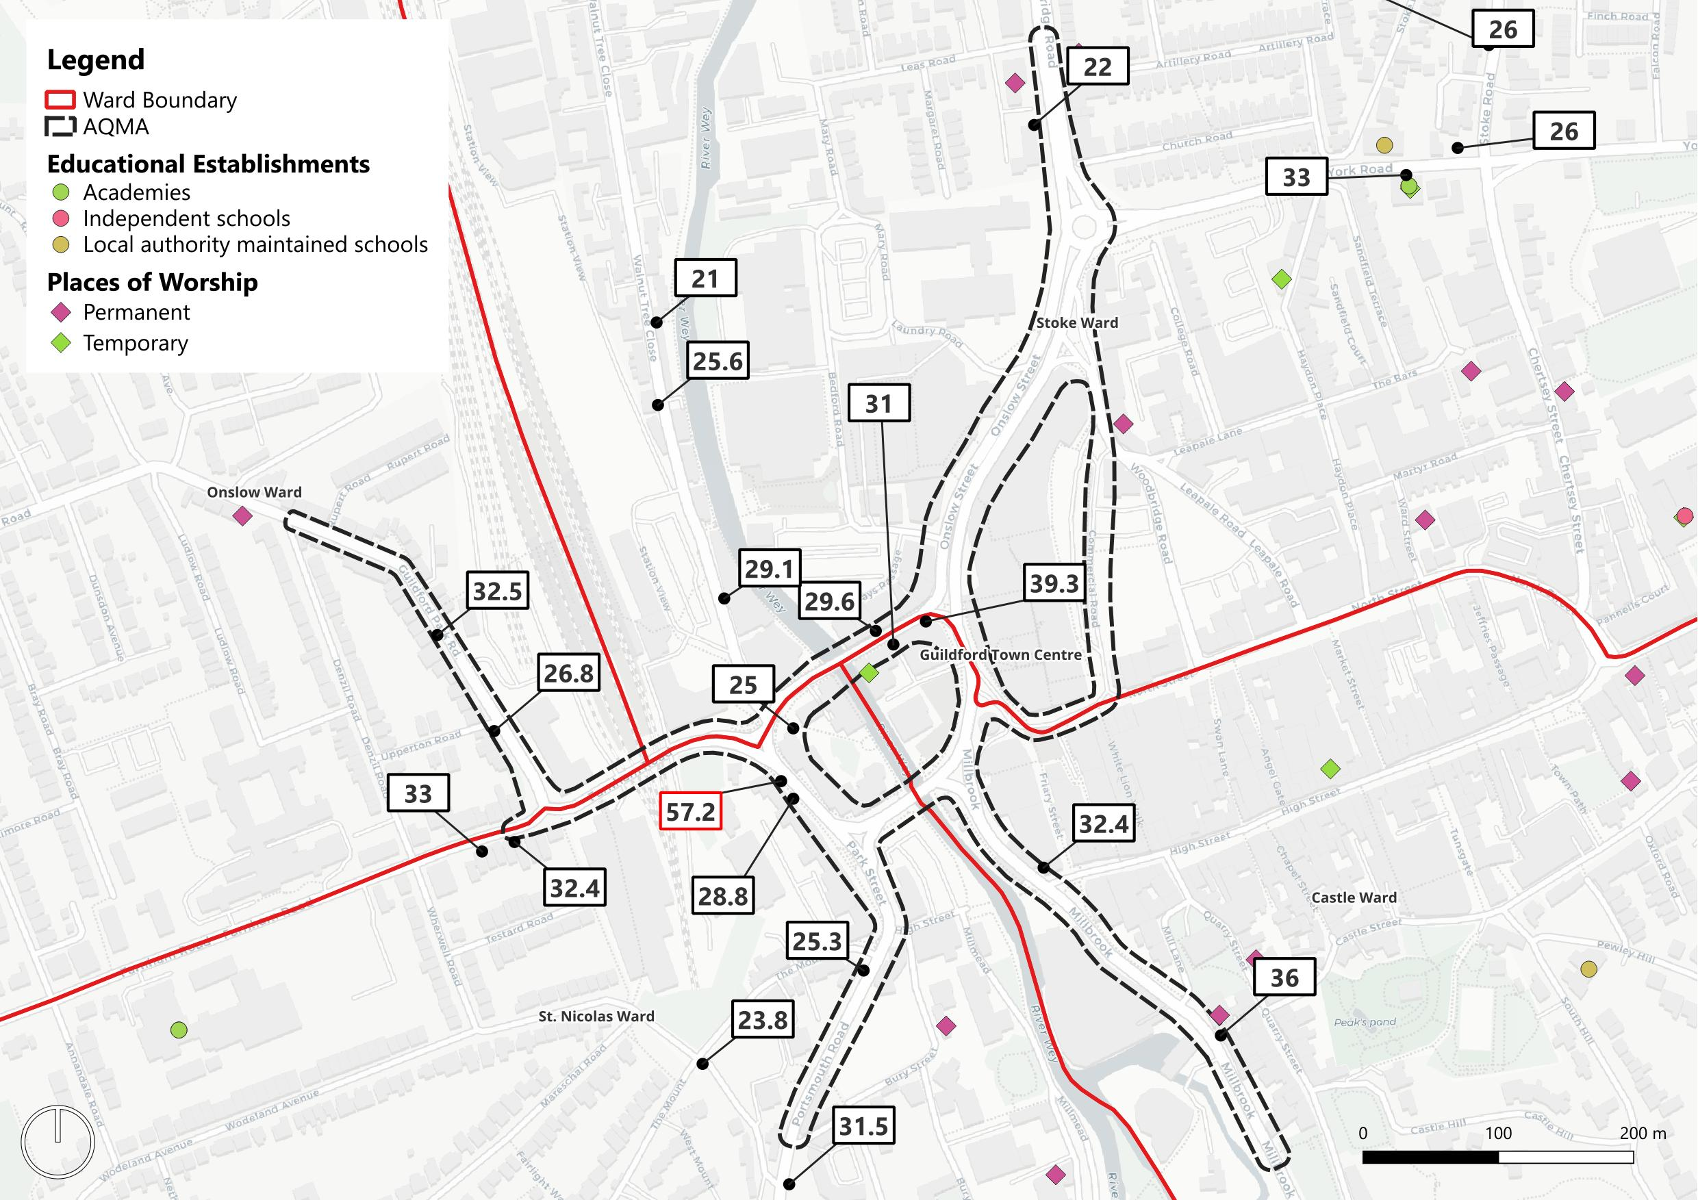

Traffic Congestion
Guildford town centre experiences high levels of traffic congestion, particularly on the gyratory system and key roads such as Park Street, Millbrook, and Onslow Street. The stop-start nature of traffic in these areas exacerbates emissions, as vehicles emit more pollutants when idling or accelerating from a stop.
Source Apportionment
A source apportionment exercise conducted in 2021 revealed that road traffic is the predominant source of NO₂ emissions in Guildford town centre. The contributions from different vehicle types were as follows:
Cars: Major contributors to NO₂ concentrations. (Around 33% of emissions)
Heavy Goods Vehicles (HGVs): Approximately 10% of emissions.
Light Goods Vehicles (LGVs): Approximately 10% of emissions.
Buses/Coaches: Significant contributors, especially on Park Street where they account for 23% of emissions.
Park Street
As seen in Figure.2 Park Street in Guildford is a relatively small street located in the town centre, known for its mix of commercial and residential properties. The street is home to several office buildings, providing convenient access to the town's main transport links, including the Guildford Train Station and the A3 trunk road.

Emission Levels in Shalford’s Air Quality Management Area
Figure Guildford AQMA and Ward Boundary with 2023 Average Average NO₂ Emissions
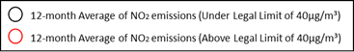
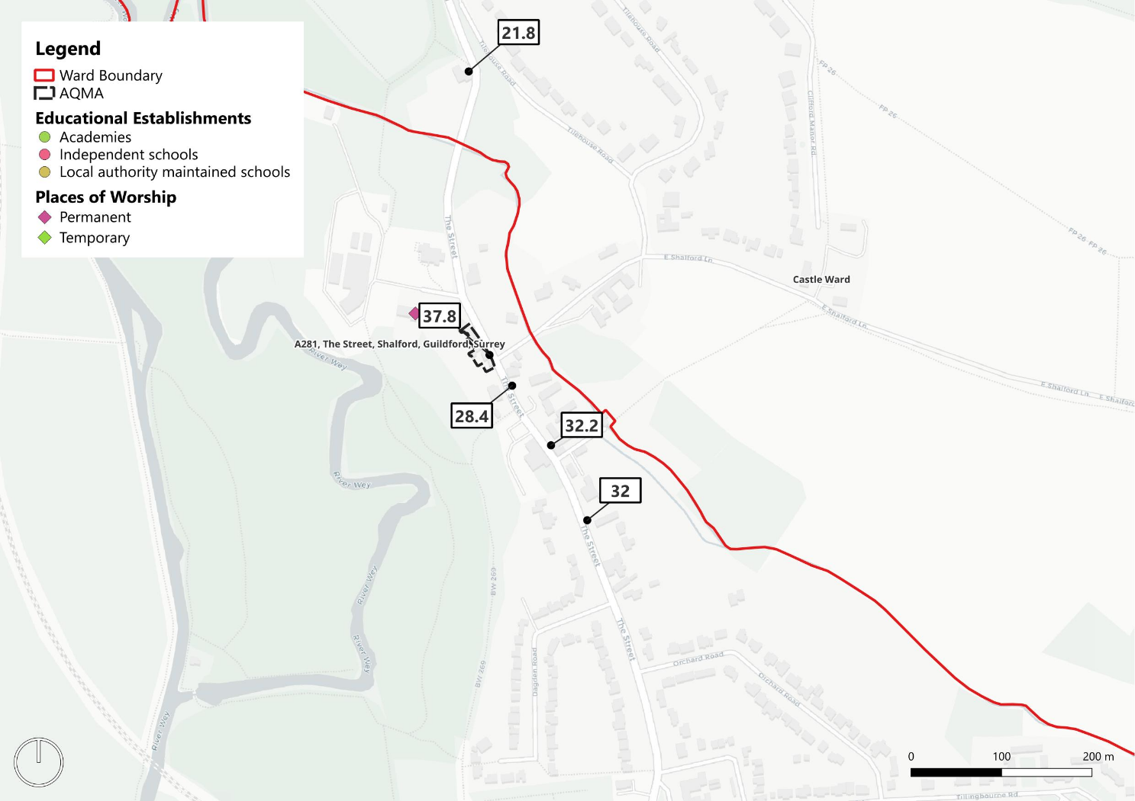

The majority of the locations near Shalford have NO₂ levels below the legal threshold, with the highest reading being 37.8 µg/m³ near the central area. Overall, the data suggests that air quality in this area is generally within legal limits, though certain spots show levels that are approaching the maximum allowable concentration of NO₂, indicating potential areas of concern. The highest level is currently part of an air quality management area. It is important to acknowledge that monitoring began in 2018 and exceeded the Air Quality Objective (AQO) in both 2018 and 2019. The years 2020 and 2021 were impacted by COVID-19. Since then, levels have remained below 40µg/m³, staying within 10% of the objective. In 2023, the annual average dropped below 36µg/m³ for the first time, marking one year of full compliance.

Review of Implemented Schemes
We have undertaken a desktop review of published evidence associated with existing implementations of air quality improvement measures applied in cities in the UK. This section provides case studies from cities selected as being most closely related to Guildford’s situation. The case studies cover implementations of different types of Clean Air Zones and Low Emission Zones.
The Low Emission Zones (LEZs) in Scotland compared to the Clean Air Zones (CAZs) and Low Emission Zones (LEZ) in England have significant differences that make direct comparisons of their impacts challenging due to differences in enforcement and compliance mechanisms. In Scotland, proposed LEZs do not enable non-compliant vehicles to enter the zone for a daily charge, as is applied in England, and instead drivers of non-compliant vehicles entering the zones face immediate fines starting at £60, which can double for repeat offenses. This approach contrasts with the English CAZs, where non-compliant vehicles can enter the zones by paying a daily charge, with fines imposed only if the charge is not paid on time. These structural differences mean that the financial and behavioural impacts on drivers and businesses in Scottish cities are likely to be more stringent and immediate compared to those in English cities. Consequently, this report focuses on lessons learned from schemes implemented in England.

Lessons Learned for Guildford from Implemented Schemes
The implementation of CAZs and LEZs across various cities in the UK has been a significant step towards improving air quality and subsequently public health. While the specific details and approaches may vary, these zones share several commonalities in terms of their objectives, operational mechanisms, and impacts.
Classes of Clean Air Zone
There are four classes of CAZ that have been implemented in England, summarised below:
- Class A: The least stringent, where only certain types of vehicles need to comply with emissions standards or pay a fine.
- Class B: Like Class A, but with additional vehicle types included.
- Class C: Includes buses, coaches, taxis, private hire vehicles, heavy goods vehicles, vans, and minibuses.
- Class D: The most stringent, covering buses, coaches, taxis, private hire vehicles, heavy goods vehicles, vans, minibuses, and cars. Local authorities may also include motorcycles in this class.
Charges and Penalties:
One of the key similarities between CAZs and LEZs is the imposition of charges or penalties for non-compliant vehicles entering the designated zones. These charges are typically based on the vehicle's emission standards, with older, more polluting vehicles being subject to higher fees. Table 1 summarises the wide fee range applied. Similar to many other penalty charges, if a penalty is paid within 14 days, it is reduced by half.
The rationale behind these charges is to incentivize the adoption of cleaner vehicles and discourage the use of older, more polluting ones within the designated areas. However, the specific charge amounts and vehicle categories subject to fees vary across different cities, reflecting local authorities' discretion in tailoring the schemes to their specific needs and circumstances. The fees provide a revenue to the scheme provider to help fund the scheme running costs, mitigation measures, and to support implementation of other transport schemes to encourage cleaner travel including park and ride schemes.
Enforcement and Penalties:
Another common aspect of CAZs and LEZs is the use of Automatic Number Plate Recognition (ANPR) cameras for enforcement purposes. These cameras capture the registration plates of vehicles entering the zones, enabling authorities to identify non-compliant vehicles and issue penalties for non-payment of charges. The penalty amounts and escalation procedures for repeated violations also vary across different cities but generally involve substantial fines to deter non-compliance. If ANPR cameras are not already in use within the area, then the cost of implementing the zone will increase significantly. Any scheme implemented in Guildford would need to model both CapEx and OpEx costs and to what level penalty changes would be a source of revenue to the scheme. This will need to be balanced with public perception and acceptance of the proposed scheme and an analysis to identify and reduce disproportional impacts.

Table 5. Charge and Penalty Structure of Zones in England
City/Zone | Zone Type | Charge for Smaller Non-Compliant Vehicles | Charge for Larger Non-Compliant Vehicles | Penalty Charge
London ULEZ | ULEZ | £12.50 per day for cars, vans, motorcycles | £100 per day for HGVs, buses, coaches | £160 (£80 if paid within 14 days)
London LEZ | LEZ | £100 per day for larger vehicles over 3.5 tonnes | £300 per day for HGVs, buses, coaches | £1,000 (£500 if paid within 14 days)
Bath | Class C CAZ | £9 per day for taxis, vans, LGVs | £100 per day for buses, coaches, HGVs | £120 (£60 if paid within 14 days)
Birmingham | Class D CAZ | £8 per day for cars, taxis, LGVs | £50 per day for HGVs, buses, coaches | £120 (£60 if paid within 14 days)
Bradford | Class C+ CAZ | £7 per day for taxis | £9 per day for vans, LGVs | £50 per day for HGVs, buses, coaches
Bristol | Class D CAZ | £9 per day for cars, taxis, LGVs | £100 per day for HGVs, buses, coaches | £120 (£60 if paid within 14 days)
Newcastle/Gateshead | Class C CAZ | £12.50 per day for taxis, vans, LGVs | £50 per day for HGVs, buses, coaches | £120 (£60 if paid within 14 days)
Portsmouth | Class B CAZ | £10 per day for taxis | £50 per day for HGVs, buses, coaches | £120 (£60 if paid within 14 days)
Sheffield | Class C CAZ | £10 per day for taxis, vans, LGVs | £50 per day for HGVs, buses, coaches | £70 per day for taxis, vans, LGVs and £120 per day for HGVs, buses, coaches
Oxford | Zero Emission Zone | £2-£10 per day for non-zero emission cars/vans (increasing to £4-£20 in 2025) | £2-£10 per day for non-zero emission buses/HGVs (increasing to £4-£20 in 2025) | £60 (£30 if paid within 14 days)

Benefits and Impacts:
Air Quality, Health, Sustainable Modes of Travel
The primary objective of implementing CAZs and LEZs is to improve air quality and reduce harmful emissions, particularly nitrogen oxides (NO_{x}) and particulate matter (PM), which can have detrimental effects on public health. Studies have shown that these zones have been effective in achieving these goals, with cities like London reporting significant reductions in air pollution levels after the introduction of the ULEZ.
Additionally, the implementation of these zones has encouraged the adoption of cleaner vehicles and the transition towards more sustainable modes of transportation, such as public transit, cycling, and walking. This shift not only contributes to improved air quality but also aligns with broader environmental and sustainability goals.
Groups that are may be disproportionately impacted by a CAZ/LEZ
It is critical to undertake impact assessments of potential scheme designs to identify any groups that may be disproportionately impacted through the scheme. Policymakers need to carefully consider appropriate mitigation strategies to ensure that health and economic inequalities are not exacerbated by the implementation of these zones. Targeted support from other implemented schemes has included scrappage schemes, improved public transportation, and inclusive consultation processes to address the specific needs of affected groups.
Some groups are also likely to disproportionately benefit from scheme implementations including those most susceptible to respiratory illnesses and people who do not currently use vehicles as their mode of access to Guildford. Table 2 provides a list of the groups that faced potential disproportionate impact from the zones as identified through analysis undertaken in other cities.

Table 6 Groups identified through other studies that are likely to be disproportionately impacted by CAZ/LEZ schemes
Group | Potential Disproportionate Impact
Low-income communities | More likely to live in areas with poorer air quality and may face increased health risks and/or less likely to afford compliant vehicles and/or daily charges
Ethnic minority groups | More likely to live in areas with poorer air quality and may face increased health risks.
Taxi drivers | May face significant financial burdens to upgrade vehicles
Disabled people including Special Education Needs | May rely more heavily on private vehicles and face challenges with alternative transportation options.
Women | Potentially affected due to caregiving responsibilities or reliance on specific transportation modes
Older people | May have difficulty adapting to new transportation options or affording vehicle upgrades
Gypsies and Travelling Communities | May have difficulty adapting to new transportation options or affording vehicle upgrades
Small and medium enterprises (SMEs) | May struggle with costs of upgrading vehicles or paying daily charges, potentially affecting business viability
Logistics and delivery businesses | May face increased costs for vehicle upgrades or daily charges, potentially affecting operations
Market Traders/Sole Traders | More likely to drive older LGVS and may face significant financial burdens to upgrade vehicles potentially affecting operations
Community Transport Providers | Could face increased operational costs, potentially impacting service delivery to vulnerable populations
Care providers | Could face increased operational costs, potentially impacting service delivery to vulnerable populations
Lower paid workers/night time workers | May face financial burdens to upgrade vehicles and/or have minimal access to alternative modes of transport especially public transport services for night time workers
People able to practice their religion or beliefs | May face financial burdens to upgrade vehicles to be able them to attend their places of worship.

It is important to note that while some groups may face disproportionate impacts, the implementation of CAZs, LEZs, and NEZs is intended to improve air quality and public health for all residents, workers and visitors to an area.
Interaction Between Timing of Implementation, Costs and Benefits Achieved.
One of the critical success factors for Guildford is to reduce the NO₂ to within target levels in the shortest time possible. However, this comes at a potential trade off with the Net Present Value (NPV) of the scheme. If the NPV is positive, the project’s rate of return exceeds the discount rate, making it worth undertaking; if it’s negative, the investment may not be profitable. In policy evaluation, NPV helps assess the economic impact of proposed policies or projects. An alternative option will be aiming to reach within target levels at a certain timeframe which isn’t the shortest time possible. NPV does not include qualitative benefits within the figure, therefore future analysis should try, where possible, to quantify all impacts identified by the scheme design.
Public Response
The public’s response to CAZs and LEZs has been mixed, with both support and opposition from various stakeholders. Proponents argue that these measures are necessary to address the pressing issue of air pollution and its associated health risks, particularly in densely populated urban areas. Supporters also highlight the long-term benefits of improved air quality and the potential for these zones to catalyse broader changes in transportation modal shift and infrastructure.
On the other hand, critics have raised concerns about the financial burden imposed on individuals and businesses, particularly those with non-compliant vehicles who may struggle to afford the charges or the cost of upgrading to compliant vehicles. There have also been concerns about the potential impact on low-income communities and the risk of exacerbating existing inequalities.
Mitigation Measures
To address these concerns, some local authorities have implemented support schemes, such as scrappage programs and financial assistance including for example free local bus travel for a certain period, to help individuals and businesses transition to cleaner vehicles or alternative modes of transportation. However, the effectiveness and adequacy of these support measures has been subject to ongoing debates and evaluations. The wide range of mitigations applied across England is shown in Table 3.

Table 7 Mitigation Measures For Cities Implementing LEZ/CAZ’s in England
Mitigation Measure | Description | Examples
Financial Assistance/Grants | Grants or loans provided to individuals and businesses to help them replace or upgrade non-compliant vehicles with cleaner models that meet the emission standards of the zone. | - London: £160m scrappage scheme for cars, motorcycles, vans, minibuses  - Bristol: £42m package including £1.8m in loans/grants for individuals, £32m for businesses  - Birmingham: £2,000 grants for cars, up to £16,000 for HGVs/coaches  - Bath: Interest-free finance and grants to reduce upgrade costs
Vehicle Retrofit Funding | Funding to help businesses retrofit their existing non-compliant vehicles (e.g. buses, taxis, vans) with approved emission reduction technology to meet the zone standards. | - London: Retrofit funding for black cabs  - Newcastle: Grants up to £16,000 for bus/HGV retrofits
Exemptions/Grace Periods | Temporary exemptions or grace periods granted for certain vehicle types, user groups, or circumstances to allow more time for compliance. | - London: Exemptions until 2025/2027 for disability vehicles  - Bristol: 1-year grace period for residents in the zone  - Birmingham: 2-year exemptions for wheelchair taxis
Public/Active Transport Support | Initiatives to encourage a shift to public transport, walking, cycling as alternatives to driving non-compliant vehicles in the zone. | - Bristol: £5.9m for e-bike loans, cycle training, bus tickets  - Newcastle: Travel Better grants for bikes, public transport  - London: Improved cycle infrastructure and public transport
Targeted Support | Prioritizing support for low-income households, small businesses, specific user groups most impacted by the zones. | - Birmingham: Prioritizing SMEs and self-employed in the zone Prioritizing <£30k earners, Blue Badge holders  - Bath: Prioritizing charities, small businesses in the zone
Mobility Credits | Providing credits/vouchers to use for public transport, car clubs, ride-hailing services as an alternative to owning a non-compliant vehicle. | - London: Mobility credits for car clubs, ride-hailing, cycle hire  - Oxford: Mobility credits for bus, rail, car clubs in zero emission zone
Mitigation Measure | Description | Examples
Scrappage Schemes | Offering incentives to scrap older, higher-polluting vehicles in exchange for discounts on newer, cleaner replacements. | - London: Up to £5,000 for scrapping vans/minibuses  - London: Up to £2,000 for scrapping non-compliant cars  - Bristol: Up to £2,000 for scrapping non-compliant cars
Park & Ride Expansion | Increasing Park and ride facilities on the outskirts of the zone to enable drivers to switch to public transport for the final leg of their journey. | - Bristol: New Park & ride sites and bus services  - Birmingham: Expanded Park & ride at rail stations
Delivery/Freight Consolidation | Establishing urban consolidation centres and promoting sustainable last-mile delivery solutions to reduce freight vehicle movements in the zone. | - London: Construction consolidation centres  - Bristol: Micro-consolidation centres for last-mile delivery
EV Charging Infrastructure | Investing in public charging infrastructure within and around the zone to support the transition to electric vehicles. | - London: Rapid charging hubs and on-street charging points  - Newcastle: Workplace and residential charging funding

Overall, while the implementation of CAZs and LEZs across the UK has faced challenges and varying levels of acceptance, there is a general recognition of the need to address air pollution and its associated health and environmental impacts. As these zones continue to evolve and expand, ongoing monitoring, evaluation, and stakeholder engagement will be crucial to ensure the schemes’ effectiveness, fairness, and alignment with broader sustainability goals.
Exemptions
Several cities offered initial exemption periods for people living and working within the city when schemes were implemented. There is a wide range of exemptions that can be given, either by demographic characteristics of drivers and passengers or by vehicle type. Exemptions provide options to help mitigate the financial and logistical burdens on vulnerable populations and essential services. There are groups of vehicles currently given a national lifetime exemption, these include:
- Agricultural Vehicles: Certain types of agricultural vehicles are exempt.
- Historic Vehicles: Vehicles registered as historic (usually over 40 years old) are exempt.
- Military Vehicles: Vehicles used by the military are exempt.
Furthermore, zones in England have given grace periods for certain vehicles or people such as residents in the zone areas and people with caring responsibilities to minimise socio-economic impact. Examples of these type of exemptions are:
- Disabled Tax Class Vehicles: In London’s ULEZ, vehicles registered under the disabled tax class are granted a grace period, exempting them from charges until 24 October 2027. This temporary exemption provides time for disabled individuals to transition to compliant vehicles reducing financial pressure.
- Light Goods Vehicles in Tyneside: There is a temporary exemption for light goods vehicles in Tyneside (Newcastle and Gateshead) until a specified date, allowing businesses time to upgrade their fleets. with three categories being used to define the type: temporary, lifetime and applied exemptions.
- Emergency Service Fleets: These are normally given grace period to update their fleet to comply with the zone.
Furthermore, exemptions can be applied for or used for one journey. This is with the aim that the wider impacts of the zone are mitigated against. These exemptions include:
- Travel to Hospital Appointments: Birmingham and other cities offer an exemption for a journey to the hospital as a visitor or patient
These exemptions help to reduce the potential disproportionate negative impact of LEZs/CAZs on vulnerable groups and essential services, thereby maintaining a balance between environmental objectives and social equity.
In general, well considered, and localised mitigation measures improve public support for scheme implementation. However, depending on numbers of exemptions applied, there is a risk that they slow down the speed of emission reductions that could otherwise be achieved through the scheme implementation.

Case Studies: CAZ/LEZ Implementations Across England

Birmingham Clean Air Zone
Zone classification |  | Class D
Vehicles affected |  | Buses, coaches, taxis, private hire vehicles, heavy goods vehicles, vans, minibuses, cars excluding motorbikes
Exemptions Given |  | - Residents living within the CAZ (2-year exemption for 1 vehicle per household)  - Low-income workers earning <£30,000/year working in the CAZ (1-year exemption)  - Commercial vehicles registered within the CAZ (1-year exemption, max 2 vehicles)  - Disabled tax class vehicles, historic vehicles, military vehicles, emergency services  - 1-day Vouchers available for journeys/visits to particular hospitals
Charges |  | £8 per day for non-compliant cars, vans and taxis  £50 a day for non-compliant coaches, buses and HGVs
Year of implementation |  | 1st June 2021
Hours of operation |  | 24 hours, 365/6 days a year
Scale of zone |  | 2.96sq miles - The A4540 Middleway Ring Road (excludes the Middleway itself)

Air Pollution Reduction Achieved
Within the first six months of operation, the CAZ reduced nitrogen dioxide (NO₂) levels by an average of 13%. A 2023 study by the University of Birmingham, which adjusted for weather and seasonal effects, estimated an overall reduction of up to 7.3%. In addition to the reduction in NO₂, the proportion of the most polluting vehicles entering the city centre fell from 15.2% in June 2021 to 6.0% in June 2023.

Case for Change
Nearly 2.8 million people are affected by air pollution in the West Midlands, reducing life expectancy by up to 6 months, contributing to 900 premature deaths a year and costing around £860m a year. According to a 2017 study, Birmingham had one of the highest NO₂ levels so the primary objective of the intervention was to reach a level of NO₂ that would be compliant with the EU Limit Value and its breaches of the air quality objective (AQO) for annual mean concentrations of NO₂ (40 μg m³) in the shortest possible time.
Under the Air Standard Regulations, the Council is responsible for ambient air quality and cleaner air. The council undertook an Air Quality Survey in March 2017, From the 1,104 responses to the survey:
- 87% thought air quality is a ‘serious issue’ to be tackled now
- 88% said air quality has a very serious impact on health
- 67% said air quality is an important consideration when making travel choices.
The top three contributors to air pollution were considered by respondents to be (1) congestion, (2) vehicles idling in queues and (3) lorries, vans, and diesel cars. As with the wider UK, the two pollutants of most concern in Birmingham are NO₂ and fine airborne particulate matter, both of which have a significant impact on health.

Costs and Revenues
UK Government Clean Air Fund supported the zone’s funding, by providing £38 million towards mitigation costs and £17.8 million towards implementation costs. The total cost of the scheme was initially estimated at £68.7 million.
Fines have contributed £73.2 million since the clean air zone set up in June 2021 to early 2024. In addition, drivers of non-compliant vehicles, have paid £37.7m through daily charges. In the six months after the launch of the Clean Air Zone the average rate of compliance for all vehicle categories entering the zone increased from 79.8% in June to 88.8% in December 2021.
From the implementation point of 2021 and the same period in 2022, the CAZ generated a profit of £25.604 million according to council figures. In 2023, the city council stated it has reinvested over £52m of net surplus revenues from its CAZ to fund a hydrogen bus trial, upgrade train stations and improve cycling infrastructure.

Distributional Analysis

Micro, Small and Medium Sized Enterprises
The CAZ charges were expected to disproportionately affect small and medium-sized enterprises (SMEs) due to costs associated with upgrading non-compliant vehicles and/or increased business operation costs from paying daily charges. The logistics and transportation sectors, including many small businesses, were anticipated to face higher operational costs for non-compliant vehicles.

Distributional Analysis Appraisal
Prior to implementation, a distributional analysis was conducted, identifying likely groups of people who would be disproportionately impacted by the CAZ. It found that the charge would affect travel costs by car or specialist transport, impacting accessibility to employment, education, places of worship, and recreational facilities. In Sandwell, which has high income deprivation and a high proportion of non-compliant cars, the study stated that residents commuting to Birmingham by car would be significantly impacted. While Birmingham city centre has good bus access from Sandwell, rail access is more limited, especially for those working unsociable hours, therefore restricting alternative transport options.
The CAZ was estimated to have a net negative impact to Birmingham's economy of around £180 million, with SMEs within and near the CAZ experiencing disproportionately more adverse effects. In particular, taxi businesses, required a large investment to make their vehicles compliant, with 90% needing replacements by 2020. In addition, there were limited incentives to upgrade and concerns from taxi businesses that increasingly rigorous legislation means they may need to replace their vehicles twice or multiple times in the future, increasing costs of acquiring vehicles. Van-dependent businesses, especially those with privately-owned vans, were also negatively impacted, though a relatively low proportion entered the CAZ frequently.
To mitigate these impacts, Birmingham Council introduced a series of measures, outlined below:
- Birmingham's Vehicle Scrappage Scheme offers the chance to remove non-compliant vehicles from the road in exchange for a range of grant packages worth up to £4,000 (funded by Government). The scrappage scheme was originally restricted to those working in the zone, however, it was extended in March 2024 to include those living in the zone.
- Three CAZ Privately Hired Vehicles Schemes: Grants of up to £10,000 towards purchase costs, long-term lease, or operating expenses.
- Allocation of £52 million from the Clean Air Zone surplus revenues to improve alternative transport, including hydrogen buses, train station upgrades, improvements to rail stations, Cross-City Bus initiatives, Car Free School Streets expansion, and the next phase of the Birmingham Cycle Revolution (including the Brum Breathes Fund).
- Temporary Exceptions Provided for workers, residents, emergency services vehicles, historic vehicles, driving to medical appointments, school/community transport vehicles and lower-income workers, subject to criteria and for a period of one to two years.
- Birmingham City Council introduced a £5,000 grant for Birmingham-licensed Hackney Carriage Drivers. The Clean Vehicle Retrofit Accreditation Scheme funded specific methods of retrofitting diesel vehicles to ensure reduction in emissions.

Socio-economic impacts
While there are costs associated with the zone, the health benefits lead to positive economic impacts from improved workforce participation, with 216,000 additional hours said to be worked as a result of the zone, and an increase in GVA of £2.7million. In addition, a 5 µg/m³ reduction in NO₂ in Birmingham is estimated to prevent 50 deaths each year and 150 fewer days spent in Birmingham’s hospitals each year.
Advantages
- In 2022, the levels of NO₂ in the CAZ reduced by an average of 17% relative to 2019 (pre-Covid) results. When compared to the 2016 baseline, this is 37%. The number of monitoring locations has also significantly increased since 2016.
- Encouragement of behavioural changes, such as increased use of public transport and adoption of cleaner vehicles, evidenced by the reduction in the proportion of highly pollutant vehicles.
- Financial support and incentives for businesses and residents have enabled many to upgrade to compliant vehicles.
Challenges/Lessons Learnt:
- Mixed results in reducing fine particulate matter (PM_{2.5}), indicating the need for broader measures beyond NO₂ to deal with the wider spectrum of air pollutants
- Ongoing exceedances of NO₂ levels in specific areas, requiring further investigation and targeted interventions

Bath Clean Air Zone
Zone classification |  | Class C
Vehicles affected |  | Buses, coaches, taxis, private hire vehicles, heavy goods vehicles, vans, minibuses, excluding cars, mopeds, and motorbikes
Exemptions Given |  | - Disabled tax class vehicles  - Emergency service vehicles, military vehicles historic vehicles, certain agricultural vehicles  - Temporary exemptions for wheelchair accessible taxis/private hire, community transport (expired March 2023)
Charges |  | £9 per day for non-compliant taxis, private hire vehicles, minibuses, vans, LGVS and campervans  £100 per day for non-compliant buses, coaches, trucks, HGVs and PHGVs
Year of implementation |  | 15th March 2021
Hours of operation |  | 24 hours, 365/6 days a year
Scale of zone |  | 1.2sq miles – Covers the City Centre

Air Pollution Reduction Achieved
Bath and North Somerset Council were asked by Ministerial direction in 2017 to reduce NO₂ levels in the shortest time possible, because the Bath area was consistently exceeding the legal limits for NO₂ pollution, primarily caused by vehicle emissions.
In 2022/2023, the CAZ in Bath reduced the annual mean NO₂ level within the zone by 26%, representing an average reduction of 8.5 μg/m³ and meeting legal standards. The urban area outside the zone has also seen a reduction in annual mean NO₂ concentrations, of 27%, with an average reduction of 7.1 μg/m³. There were 71% fewer non-compliant vehicles driving in the zone by the end of December 2022.

Costs
Government funding covered the entire implementation cost, which included a £9.4m financial assistance scheme to help local businesses and individuals replace or upgrade non-compliant vehicles. The operational costs include maintenance of the Automatic Number Plate Recognition (ANPR) system, signage, and other infrastructure.

Revenue Achieved
Bath and Northeast Somerset received nearly £10m in revenue from the charges between March 2021 and May 2023. This revenue was then reinvested into various transport projects. In 2022, the CAZ generated a net income of £3.3m, which was allocated to support sustainable transport within the wider West of England Combined Authority (WECA) programs.
Distributional Analysis
For a charging Class C CAZ, the following groups could be negatively impacted for reasons of accessibility and affordability:
  - Age
  - Disability
  - Race
  - Residents living outside of the proposed CAZ
  - Businesses
Children and elderly people require access to a range of key amenities (e.g. schools and health facilities), so any change in accessibility could hinder their ability to reach such facilities. Community transport providers who have non-compliant vehicles may be impacted.
To mitigate negative impacts Bath and North Somerset Council introduced a series of measures, outlined below:
- In 2021, the Council secured £500,000 from the Government to support e-cargo bike deliveries in Bath. E-cargo bike couriers provide fast, zero-carbon deliveries for businesses needing to transport small to medium-sized packages over short distances. This method offers an affordable, eco-friendly alternative to van deliveries. The E-Cargo Bath Scheme encouraged businesses in Bath to trial e-cargo bike deliveries to reduce road traffic and demonstrate the cost-efficiencies of sustainable delivery methods compared to their traditional counterparts. By December 2022, 470 businesses were contacted, of which 100 city centre businesses engaged with the CAZ team. Additionally, 200 promotional postcards were delivered to businesses outside the city centre. Despite some interest, overall uptake was low, and the scheme was aborted in early 2023. However, other e-cargo projects are planned locally by WECA.
- By the end of December 2022, Travel Advisors had contacted 2,000 people to inform and guide them through the first stage of the CAZ financial assistance scheme. By the end of 2022, 1,560 vehicles were deemed eligible for funding to upgrade or retrofit, with 900 successfully completed.

Advantages
- Significant Reduction in NO₂ Levels: The CAZ has led to a substantial decrease in NO₂ levels, contributing to improved air quality and public health.
- Financial Support Helped to Mitigate Negative Impacts on Local Businesses and Residents: The council has provided significant financial assistance to help businesses and residents upgrade to compliant vehicles, with over 900 non-compliant vehicles replaced or upgraded by the end of 2022.
Challenges/Lessons Learnt:
- Initial Delays: The implementation faced delays due to the COVID-19 pandemic which impacted on the execution of the extensive public consultation and technical work undertaken.
- Mixed Results: Mixed results in reducing fine particulate matter (PM2.5), indicating the need for broader measures beyond NO₂ to deal with the wider spectrum of air pollutants
- Ongoing Exceedances: Some areas still exceed NO₂ limits, requiring further investigation and targeted interventions.
- Economic Impact: There were concerns voiced from the public about the economic impact on local businesses, particularly those relying on non-compliant vehicles. Which lead to the council providing mitigations through financial assistance and exemptions for certain vehicle categories.
- Traffic Management: Managing traffic flow, especially around Queen Square, was necessary to prevent congestion and ensure the effectiveness of the CAZ.

Portsmouth Clean Air Zone
Zone classification |  | Class B
Vehicles affected |  | Buses, coaches, taxis, private hire vehicles, heavy goods vehicles, minibuses, excluding motorbikes, cars and vans
Exemptions Given |  | - Disabled tax class vehicles  - Historic vehicles, military vehicles, certain agricultural vehicles  - Temporary exemptions for some specialist vehicles like recovery trucks (until March 2025)
Charges |  | £10 per day for non-compliant taxis and private hire vehicles  £50 a day for non-compliant HGVs, buses and coaches
Date of implementation |  | 29 November 2021
Hours of operation |  | 24 hours, 365/6 days a year
Scale of zone |  | 1.16 sq miles - Covers a large portion of the city centre, including areas such as Portsmouth Harbour, Portsea, Landport, and Somers Town.

Air Pollution Reduction Achieved
The CAZ aims to bring NO₂ levels within legal limits (40 µg/m³) as per the Air Quality Standards Regulations 2010. The CAZ has led to a reduction in NO₂ levels, although the exact figures attained vary. Some results indicate certain areas still exceed legal limits, while others state it is too early to determine the impact.
Case for Change
On 5 October 2018, the government published a supplement to the UK Plan, setting out conclusions for each of the 33 ‘third wave’ local authorities, based on Targeted Feasibility Studies undertaken for each of these authorities. The supplement identified eight local authorities with more persistent long-term exceedances including Portsmouth.

Costs and revenues
The implementation costs were supported by government funding, including financial assistance to help local businesses and individuals replace or upgrade non-compliant vehicles. The council has invested in various measures to support the CAZ, such as retrofitting buses and providing grants for vehicle upgrades. It was envisaged that the approved CAZ would be fully funded by DEFRA, covering all costs incurred by the scheme. Some non-charging measures only required policy changes, however, other measures implemented required funding from DEFRA. The total package cost was £16.1 million, 2019 prices, excluding optimism bias.
Distributional Analysis
Central government as described above advised and support the implemented of a CAZ B+ with the plus indicating the non-charging measures that were added alongside the formal zone. These measures included parking measures, changes in traffic measures and revising taxi and private hire policies. Within the analysis the CAZ B+ option was investigated so the effects cannot be isolated to the formal CAZ alone.
The CAZ B+ option was deemed to have a small negative impact (-£132,616) on affordability for businesses, with SMEs experiencing the most of these disbenefits.
The analysis shows a small negative impact across all income groups (£3,206,380), largely as a result of increased parking charges. Based on the relative proportion of dis-benefits against the population in each quintile, there is a slight adverse affordability impact for the most income deprived residents, and a moderate adverse impact for income quintiles 2, with other income groups experiencing a moderate adverse impact.
Some 55% of residents within the Small Area CAZ B are amongst the 20% most income deprived in England and Wales, and 67% have high levels of illness and disability. These groups were stated in the impact assessment to be likely to be disproportionally affected, with potential adverse impacts on employment and education prospects, health, isolation, and social inclusion.
In addition, the proposed cycle routes will improve accessibility.

Socio-economic Impacts
Negative Net Present Value (-£22.6million). The cost of implementing the option is lower (PVC = £25.0million) due to the smaller geographical scale of the option; and positive benefits are derived, primarily from the time, vehicle operating costs, health, journey quality and absenteeism benefits associated with the non-charging options; and the damage cost savings associated with reduced emissions.

Advantages:
- Reduction in NO2 Levels: The CAZ has contributed to a reduction in NO₂ levels, improving air quality and public health.
- Encouragement of Cleaner Vehicles: The scheme has encouraged the adoption of low or zero-emission vehicles, with financial support provided to businesses and residents for vehicle upgrades.
- Traffic Management: Adjustments to traffic signals and other measures have helped reduce congestion and improve traffic flow, contributing to better air quality and improved journey time.
Challenges/Lessons Learnt:
- Mixed Results: Mixed results in reducing fine particulate matter (PM_{2.5}), indicating the need for broader measures beyond NO₂ to deal with the wider spectrum of air pollutants
- Economic Impact: There were concerns about the economic impact on local businesses, particularly those relying on non-compliant vehicles. The council addressed this by providing financial assistance and exemptions for certain vehicle categories
- Implementation Delays: The implementation faced delays due to the COVID-19 pandemic and the need for extensive public consultation and technical work.

Oxford Zero Emission Zone
Vehicles affected |  | All petrol, diesel, and hybrid vehicles incur a daily charge if driven in the zone between 7am and 7pm. The charges vary based on the vehicle's emissions
Exemptions Given |  | - Military vehicles, historic vehicles, emergency services, mobility vehicles  - Temporary discounts for disabled tax vehicles, health/care workers, some businesses (TBD on expansion)
Charges |  | Zero Emission Vehicles (ZEVs): Fully electric vehicles can enter the zone without incurring a charge.  Non-Zero Emission Vehicles: All petrol, diesel, and hybrid vehicles incur a daily charge if driven in the zone between 7am and 7pm. The charges vary based on the vehicle's emissions.  Ultra-low emission vehicles (less than 75g/km CO2): £2 per day, rising to £4 per day from August 2025.  Low emission vehicles (Euro 4 petrol or Euro 6 diesel): £4 per day, rising to £8 per day from August 2025.  All other vehicles: £10 per day, rising to £20 per day from August 2025
Date of implementation |  | 28th February 2022
Hours of operation |  | 7am to 7pm, 365/6 days a year
Scale of zone |  | Sections of the city centre
Air Quality Reduction Achieved
The ZEZ pilot has led to a reduction in NO₂ levels in the pilot area. Specific reductions include:
- Cornmarket Street: 14% reduction (from 21µg/m3 to 18µg/m³)
- St Michael’s Street: 18% reduction (from 17µg/m3 to 14µg/m³)
- New Inn Hall Street: 12% reduction (from 17µg/m3 to 15µg/m³)
Boundary roads around the ZEZ pilot also saw reductions, such as George Street (Magdalen Street side) with a 12% reduction (from 26µg/m³ to 23µg/m³)
Case for Change
As reported in 2020, transport accounted for about 75% of NO₂ pollution in Oxford. Although the city’s air quality had improved significantly in preceding years, there continued to be areas where the national and European legal limit value for NO₂ was exceeded.
Costs and revenues
The estimated capital cost of the ZEZ project is approximately £5.8 million. The costs include the installation of infrastructure such as Automatic Number Plate Recognition (ANPR) cameras, signage, and the development of the online payment system.
The revenue generated from the ZEZ fees is reinvested into various transport projects and initiatives to improve air quality. Specific revenue figures are not detailed in the sources, but the scheme has been quoted as generating significant income from daily charges and fines.
Advantages:
- Reduction in NO₂ Levels: The ZEZ has contributed to a significant reduction in NO₂ levels, improving air quality and public health.
- Encouragement of Cleaner Vehicles: The scheme has encouraged the adoption of low or zero-emission vehicles, with financial support provided to businesses and residents for vehicle upgrades.
- Traffic Management: Adjustments to traffic signals and other measures have helped reduce congestion and improve traffic flow, contributing to better air quality.
Challenges/Lessons Learnt:
- Mixed Results on Air Quality: While NO₂ levels have decreased in some areas, other areas have seen increases, indicating the need for broader measures beyond just targeting NO₂.
- Economic Impact: There were concerns about the economic impact on local businesses, particularly those relying on non-compliant vehicles. The council addressed this by providing financial assistance and exemptions for certain vehicle categories.
- Implementation Delays: The implementation faced delays due to the COVID-19 pandemic and the need for extensive public consultation and technical work.

Clean Air and Low Emission Zones in London

London has two clean air zones: the Low Emission Zone, launched in 2008 which initially applied to lorries, buses and coaches and then extended to vans, minibuses, and specialist heavy vehicles. Overtime the criteria for emissions has increased and has differential charges for NOx and PM emissions per vehicle.

The Ultra Low Emission Zone covers all vehicles and was launched on 8th April 2019 and geographically extended on 29th August 2023 to cover all London Boroughs.

Greater London Low Emission Zone
Vehicles affected | Buses, coaches, taxis, private hire vehicles, heavy goods vehicles, minibuses, motorbikes, cars and vans
Exemptions Given | - Disabled tax class vehicles  - Historic vehicles, military vehicles, certain agricultural vehicles  - Temporary exemptions for some specialist vehicles like recovery trucks (until March 2025)
Charges | Vehicles must meet Euro VI standards to avoid daily charges of £100 to £300, depending on the vehicle type.
Date of implementation | February 4, 2008
Hours of operation | 24 hours, 365/6 days a year
Scale of zone | 1,580 square kilometres, covering all 32 London boroughs and the City of London

Air Quality Reduction Achieved
The LEZ has contributed to a 13% reduction in particulate matter (PM10) between 2008 and 2013 and a significant reduction in NO₂ level
Costs (Implementation and Operation)
The LEZ is part of a broader set of air quality initiatives funded by the Mayor’s Air Quality Fund and other sources. Specific costs for the LEZ are not detailed, but the scheme involves significant investment in infrastructure and enforcement technologies.

Revenue Achieved
The LEZ generates revenue from daily charges and fines for non-compliant vehicles. Specific revenue figures are not detailed, but the scheme contributes to funding further air quality improvements. Despite this when reviewing projections, the LEZ and ULEZ schemes’ financial projections show a decline in income from £501 million in 2022/23 to £5 million in 2025/26. Net proceeds follow a similar trend, decreasing from £162 million to £52 million over the same period. Despite fluctuations, the net operating surplus remains positive, peaking at £239 million in 2024/25.
Socio-Economic/Distributional Analysis
Impact on Non-compliant Owners
- Upon the introduction of the scheme, owners, and operators of non-compliant vans (LGVs), trucks (HGVs), coaches, and minibuses were likely to consider various options to ensure their fleets complied with the scheme. These options included:
    - Paying the charge or risking incurring it
    - Replacing non-compliant vehicles with new compliant ones
    - Replacing non-compliant vehicles with used compliant ones
    - Installing particulate trap abatement equipment on non-compliant vehicles

Adjusting operational procedures to use compliant vehicles in London and redeploying non-compliant vehicles elsewhere
The approach taken by any individual vehicle operator to manage compliance costs depended on several factors, including the number of vehicles in their fleet, the proportion that were non-compliant, the availability of funds for investment in newer vehicles, and the volume of business conducted within London.
An analysis segmented the market into 18 operator types and examined how businesses in each group were likely to respond to the scheme. The average costs for operators to achieve a compliant fleet, either through purchasing new vehicles or retrofitting existing ones, were estimated as follows for each non-compliant vehicle:
- £1,100 to £4,200 for HGV operators
- £1,600 to £1,900 for diesel LGV operators
- £6,200 to £9,500 for bus and coach operators
- £1,400 to £2,500 for minibus operators
Based on these estimates, the total costs associated with making the vehicle fleet compliant, in present value terms over the ten years to 2016, were projected to be approximately £300 million to £470 million.
Overall Cost Absorption
It was estimated that this cost increase might lead to a net reduction in FTE employment of approximately 240 to 430 jobs over the evaluation period (2006/07-2015/16), once the redistribution of driving and hauling jobs from less efficient operators to more efficient ones was considered. Overall, about £200 million to £310 million of the compliance costs were expected to be passed onto the customers of businesses owning affected vehicles. Research into different operator segments indicated that this was most likely for some of the coach markets (tourists and contract hires) and much of the freight market (goods carried by HGVs). About 33% of the scheme's costs were likely to be absorbed by owners of non-compliant vehicles. The locations of these affected vehicles could be identified using registration data available from the DVLA.
However, most of the scheme's costs (67% versus the 33% absorbed by vehicle owners) were expected to be passed on by the owners of non-compliant vehicles to their customers, who would, in turn, pass the costs onto others. These indirect impacts could not be mapped, but it was inferred that a large proportion of these wider impacts would be carried by consumers outside of London. Most affected vehicles that regularly used London’s roads were based outside of London. Only about 40% of vans and about 30% of coaches using London’s roads were owned and kept by individuals or businesses within the capital.
Advantages:
- Significant reduction in particulate matter and NO₂ levels.
- Improved public health, with reductions in respiratory and cardiovascular conditions.
- Encouragement of cleaner vehicle use and sustainable transport options including an acceleration trend for compliance during 2007 as vehicle operators took action ahead of the actual implementation date.
Challenges/Lessons Learnt
- High compliance costs for owners of older, non-compliant vehicles.
- Initial resistance from affected vehicle operators and businesses.
- Continuous need for public engagement and support to improve compliance

Central London Ultra Low Emission Zones
Vehicles affected | Buses, coaches, taxis, private hire vehicles, heavy goods vehicles, minibuses, motorbikes, cars and vans
Exemptions Given | - Disabled tax class vehicles  - Historic vehicles, military vehicles, certain agricultural vehicles  - Temporary exemptions for some specialist vehicles like recovery trucks (until March 2025)
Charges | Vehicles must meet Euro 4 standards for petrol and Euro VI standards for diesel or pay a daily charge of £12.50 for smaller vehicles (cars, motorbikes and vans up to 3.5tonnes) and £100 for larger vehicles.
Date of implementation | April 8th, 2019
Hours of operation | 24 hours a day, every day of the year, except Christmas Day (25 December)
Scale of zone | Central London, initially covering the same area as the Congestion Charge Zone and then extended.

Air Quality Reduction Achieved
The ULEZ has led to a 46% reduction in nitrogen dioxide (NO₂) levels in central London and a 21% reduction in inner London over a four-year period. The expansion to all London boroughs is expected to further reduce NO₂ emissions by 6.9% in outer London

Costs (Implementation and Operation)
The initial setup and operational costs are not explicitly detailed, but the scheme is part of broader air quality initiatives funded by the Mayor’s Air Quality Fund and other sources.
Revenue Achieved
The ULEZ generates significant revenue from daily charges and fines for non-compliant vehicles. In 2022, it raised £224 million a third of which came from penalty charge notices and two thirds from daily charge payments. TfL has used the revenues to cover the capital costs of the implementation of the ULEZ zone and estimate that the ULEZ will stop generating a surplus by 2026-27.
Distributional Impact Assessment
In developing the London-wide ULEZ proposals, TfL considered the potential impacts identified by the ULEZ Scheme IIA (Integrated Impact Assessment), including likely effects on emissions, air quality, and traffic congestion. After the consultation period ended, TfL reviewed the issues raised by respondents, including stakeholders.
Equalities-related impacts (ULEZ expansion)
The identified impacts (those originally noted in the ULEZ Scheme IIA and additional ones identified following consultation) and mitigations are discussed in more detail in section 4, with the exception of impacts and mitigations concerning groups with protected characteristics, summarized below. Additional mitigations were informed by and developed with key stakeholders following the consultation.
The IIA stated that the proposed scheme was expected to contribute to the improvement of health outcomes and reduction of health inequalities for all population groups. Table 4 summarises the key impacts for groups that were predicted to be subject to disproportional impacts.
Table 4. Summary of Groups and Impacts Identified for the London LEZ and ULEZ schemes
Groups | Possible Impacts Identified
Disabled People | - Neutral impact for those qualifying for the Motability scheme and disabled vehicle tax exemption.  - Moderate negative financial impact for those using non-compliant private vehicles, affecting access to employment and medical appointments.  - Minor negative impact for those attending SEN schools using non-compliant vehicles.  - Concerns about safety perceptions and social exclusion.
Sex | - Moderate negative impact on men due to increased LGV operating costs, affecting tradespeople.  - Minor negative impact on men working as PHV drivers.  - Minor negative impact on women taking children to school and relying on charity services.  - Safety concerns for women using non-compliant vehicles.
Race | - Air quality improvements benefit all ethnic groups, with Asian people experiencing the greatest benefit.  - Minor negative impact on Black, Asian, and minority ethnic PHV drivers.  - Minor negative impact on Black, Asian, and minority ethnic NHS workers in lower-paid positions.  - Moderate negative impact on tradespeople from the Gypsy and Traveller Community.
Pregnancy and Maternity | - Moderate negative financial impact on pregnant women or new parents with young children using non-compliant vehicles.  - Limited capacity to change mode due to restricted mobility.
Religion or Belief | - Minor negative financial impact on people of different faiths accessing places of worship using non-compliant vehicles.
Gender Reassignment | - Minor negative impact on perceptions of safety for trans people using non-compliant vehicles.
Sexual Orientation | - Minor negative impact on perceptions of safety for LGBT+ people using non-compliant vehicles.
Other Impacts | - Minor negative impact on refugees, asylum seekers, and homeless people relying on charity services using non-compliant vehicles.
Deprivation | - Moderate negative financial impact on low-income individuals using non-compliant vehicles to access employment or opportunities.  - Minor negative impact on low-income people living near the ULEZ boundary.  - Increased costs for families on low incomes providing SEN travel.

Benefits to Surrounding Areas
Data and studies surrounding the implementation in London has shown that air pollution has not got worse in surrounding areas due to traffic diversion. Instead, the use of cleaner vehicles extends beyond the zones, benefiting nearby regions as well. In London, the inner ULEZ has accelerated air quality improvements on boundary roads. Overall, these zones encourage the use of less polluting vehicles, leading to widespread environmental and public health benefits, including reduced respiratory and cardiovascular issues.

Advantages:
- Significant reduction in particulate matter and NO₂ levels.
- Improved public health, with reductions in respiratory and cardiovascular conditions.
- Encouragement of cleaner vehicle use and sustainable transport options.

Challenges/Lessons Learnt
- High compliance costs for owners of older, non-compliant vehicles.
- Initial resistance from affected vehicle operators and businesses.
- Continuous need for public engagement and support to ensure compliance and acceptance

Shoreditch Ultra-Low Emission Neighbourhood
Vehicles affected | The scheme bans all petrol and diesel cars within these roads during peak hours (7 am-10 am and 4 pm-7 pm). Only vehicles emitting less than 75g/km of CO₂ are allowed.
Year of implementation | 3 September 2018
Hours of operation | Peak Hours
Scale of zone | Approximately 0.6 square miles covering nine designated roads: Old Street, Blackall Street, Cowper Street, Paul Street, Tabernacle Street, Ravey Street, Singer Street, Willow Street, Charlotte Road, and Rivington Street.
Air Quality Reduction Achieved:
Initial reports indicate a significant reduction in NO₂ levels, with a 20% decrease in nitrogen dioxide concentrations within the first year of implementation
Costs (Implementation and Operation)
The Mayor’s Air Quality Fund (MAQF) allocated £20 million for various projects, including the Shoreditch ULEN. Specific costs for Shoreditch are not detailed, but the overall funding supports infrastructure improvements and enforcement technologies like ANPR cameras
Revenue Achieved
Revenue data specific to Shoreditch LEN is not available. However, fines for non-compliant vehicles can reach up to £100 per violation, contributing to ongoing enforcement costs.
Advantages
- Improved air quality and reduced noise pollution.
- Enhanced health and wellbeing of local communities.
- Encouragement of sustainable transport modes like walking and cycling
Challenges/Lessons Learnt
- Enforcement and compliance monitoring require significant investment in technology and ongoing enforcement operations.
- Initial resistance from local businesses and residents due to restricted vehicle access.
- Continuous public engagement and education are crucial for the scheme's success.

Advantages
- Improved air quality and reduced noise pollution.
- Enhanced health and wellbeing of local communities.
- Encouragement of sustainable transport modes like walking and cycling
Challenges/Lessons Learnt
- Enforcement and compliance monitoring require significant investment in technology and ongoing maintenance.
- Initial resistance from local businesses and residents due to restricted vehicle access.
- Continuous public engagement and education are crucial for the scheme's success.

Greenwich West Ultra-Low Emission Neighbourhood

Vehicles affected | The scheme bans all petrol and diesel cars within these roads
Year of implementation | 2021
Hours of operation | The LEN operates 24 hours a day, 7 days a week, including weekends
Scale of zone | The LEN covers key areas within the Greenwich West and Peninsula wards. Approximately 0.8 square miles
Air Quality Reduction Achieved: The LEN has contributed to a reduction in NO2 levels by approximately 15% within the first two years of implementation.
Costs (Implementation and Operation): The project received £2 million in match-funding from the Mayor of London, covering infrastructure improvements and operational costs.
Revenue Achieved: Specific revenue data for the Greenwich LEN is not available. However, the scheme's focus on promoting electric vehicles and reducing emissions indirectly supports local economic activities by improving public health and reducing healthcare costs.
Advantages
- Significant improvement in air quality and reduction in traffic-related emissions.
- Promotion of sustainable transport options, including walking and cycling.
- Enhanced community engagement and support for environmental initiatives.

Challenges/Lessons Learnt
- High initial costs for infrastructure development and technology implementation.
- Need for continuous monitoring and adaptation of measures to ensure effectiveness.
- Importance of community involvement and feedback in shaping and sustaining the scheme.

Case Studies: Non-Charging Clean Air Zones
Non-charging clean air zones (CAZs) are zones where vehicles aren’t charged when they enter the zone, regardless of their emission levels. This method focuses on other measures to improve air quality, such as enhancing public transport, promoting cycling and walking, and improving traffic flow. Non-charging CAZs provide a flexible approach to managing air quality without administrative burden of collecting charges and enforcing penalties. A non-charging zones avoids placing any potential financial burden on residents and businesses, particularly those with non-compliant vehicles, while still aiming to improve air quality. Regarding public acceptance, non-charging zones reduce opposition and make it easier to implement.
Cities such as Derby and Liverpool are both non-charging CAZs, city councils are given the option on how to implement a CAZ, Liverpool and Derby ran public consultations to choose the implementation route of their CAZ, both city’s consultations reflected the public’s understanding the need for addressing air pollution but expressed concern for the economic burden of a charging zone. In Liverpool, the city council has promoted active travel and implemented an engine idling charge to reduce unnecessary vehicle emissions. And in Derby, they implemented various traffic management schemes which were introduced to manage the flow of traffic and reduce congestion on the busier parts of the city.
Both non-charging and charging CAZs aim to reduce air pollution but use different strategies to achieve this goal. Charging zones use financial incentives to discourage high-emissions vehicles, while non-charging zones rely on infrastructure improvements and public awareness.

Liverpool City Centre
Location Overview:
Liverpool City has a population of just under 500,000 people. 40% of Liverpool’s households do not own a car; 40% own 1 car, and 20% own 2 or more cars. In 2020, it was reported that 1,040 deaths a year in the city are related to air-pollution. Because of this and other factors, the City Council implemented a Smoke Control Area (SCA). The SCA aims to reduce the harmful effects of smoke and improve air quality, which is crucial for public health and the environment. The SCA was implemented in February 2015, as part of broader efforts to improve air quality and reduce pollution in the city. The city council held multiple rounds of public consultations in 2014, 2016 and 2018, allowing residents and businesses to provide feedback on the proposed policies and modifications. Additionally, in 2021 the city council launched a 6-week public consultation to invite all stakeholders to have their final say on the city’s 15-year Local Plan.
The annual mean concentration of PM_{2.5} in Liverpool City Centre has been a concern with recent data recording concentration levels ranging between 7-10µg/m³. While this is below the UK limit of 25µg/m³, it still exceeds the World Health Organisation’s guideline of 5 µg/m³ . Nitrogen Dioxide (NO2), levels in Liverpool average at 30 µg/m³, which is below the UK limit of 40 µg/m³ ,. The Liverpool Smoke Control Area strategy is part of a broader Liverpool Tobacco Control Strategy 2024-2030. This involves reducing smoking prevalence and creating smoke-free environments.
Why were they asked to set up a Control Air Zone
Liverpool was instructed by the government to set up a Clean Air Zone (CAZ) to address high levels of nitrogen dioxide (NO₂) pollution. The aim was to bring NO₂ levels within legal limits as quickly as possible, given the significant health risks associated with prolonged exposure to this pollutant. The Smoke Control Area initiative was part of a broader strategy to address significant health inequalities and preventable illnesses by smoking and air pollution.
Charging vs Non-Charging Control Air Zones
Liverpool considered both charging and non-charging options for their Clean Air Zone. Ultimately, the council decided against a charging zone due to concerns about the economic impact on residents and businesses, especially given the current economic climate. Instead, they opted for non-charging measures to improve air quality. The city council conducted public consultation to gather feedback on proposed air pollution reduction measures, including public meetings, surveys and online platforms to ensure broad participation from residents and businesses. The feedback was mixed, many residents supported the measures, recognizing the health benefits and the need to address air pollution. However, there were concerns on the economic impact, particularly from businesses worried about the potential costs and disruptions, residents critiqued the timing given the post COVID-19 economic recovery, a local commented saying that there were “8,500 Liverpool businesses were "in significant distress".
What options did they consider?
Liverpool City Council considered various options, including different types of charging Clean Air Zones (CAZ) ranging from Class A to D, which would affect different categories of vehicles. They also looked at non-charging measures such as traffic management, promoting public transport, and encouraging the use of low-emission vehicles.
Why didn't they set up a charging zone?
The decision not to implement a charging zone was influenced by several factors, including the potential economic burden on residents and businesses, the effectiveness of non-charging measures, and the experiences of other cities with similar schemes. Additionally, it was determined that a charging zone would not address all areas of high pollution effectively and there were other routes to cleaner air such as traffic management.
What non-charging policies did they implement?
Liverpool implemented several non-charging policies including traffic management and bus stop location reviews. The city council implemented a £47 million program of roadworks which aimed to reduce congestion and improve air quality by enhancing traffic flow and encouraging the use of public transport. The city “Let’s Clear the Air Liverpool” initiative provides local advice and solutions for air pollution, alongside a monitoring program which measures a arrange of air pollutants and provides regular updates on air quality. Alongside these policies, Liverpool City Council has taken steps to address engine idling. While there isn’t a specific idling charge, they have implemented measures to reduce idling, such as public awareness campaigns and encouraging drivers to switch off their engines when stationary. The Council also has the authority to issue Fixed Penalty Notices (FPNs) for idling under existing UK laws.
How Successful has it been?
So far, the plan has been deemed as successful: monitoring data shows that NO₂ concentrations have decreased by 20% in key areas of the city centre. The annual mean concentration of PM_{2.5} has also seen a reduction, recent data indicates that PM_{2.5} levels have dropped to around 7.7 µg/m³, which although below the UK limit is still above the WHO’s guidelines of 5µg/m³.

Derby’s Solutions to Improving Air Quality
Location Overview:
Derby City Council has two declared Air Quality Management Areas (AQMAs) because of exceedances in the annual mean nitrogen dioxide (NO₂) objective, predominantly due to road traffic emissions. Derby has an average of 1.3 cars per household. This high number of vehicles contributes significantly to air pollution, making the implementation of a Smoke Free Area essential to improving air quality and public health. The annual mean concentration of PM_{2.5} in Derby was around 10 µg/m³, which meets the World Health Organization (WHO) guideline but still poses health risks. In 2015, Derby City Council was identified by DEFRA, along with four other cities (outside London), to take early action to improve roadside nitrogen dioxide (NO₂) emissions. In 2021, Derby recorded an annual mean NO2 concentration of 42 µg/m³. This indicates significant pollution from road traffic. In Derby, it is estimated that long-term exposure to air pollution contributes to around 5.6% of all deaths. By improving air quality, Derby can reduce healthcare costs and improve public health.
Why Were they asked to Set Up a Control Air Zone?
Derby was identified as one of several local authorities needing air quality measures due to exceedances in nitrogen dioxide (NO₂) levels, primarily from road traffic emissions. This was based on the national air quality model predicting exceedances of the EU Limit Value for NO₂.
Charging vs. Non-charging Control Air Zone
Derby chose not to implement a charging clean air zone, choosing to focus on other measures to improve air quality such as SCAs and action plans to reduce nitrogen dioxide levels. This decision was made to avoid the economic impact on residents and businesses that a charging zone might have caused. Derby City Council conducted extensive public consultations to gather resident’s views on the proposed CAZ. The consultations revealed mixed opinions, with some residents and businesses expressing concerns about the potential economic impact of a charging zone.
What Options did they Consider?
Derby considered several options, including both charging and non-charging measures. The options included traffic management schemes, promoting sustainable transport, and implementing active travel schemes.
Why didn’t they Set Up a Charging Zone?
The decision against a Charging Zone was influenced by concerns over the economic impact on residents and businesses. The council believed that non-charging measures could achieve the required air quality improvements without the financial burden on the community. Negative impacts of charging were noted as the possibility of increased costs for commuters, particularly burdensome for low-income households and potential negative impacts on local businesses, due to reduced foot traffic as customers avoid areas with charges leading to decreased sales – affecting the local economy.
What non-charging Zone policies did they implement?
Derby implemented several non-charging measures, such as traffic management schemes around Stafford Street, promoting sustainable transport, and active travel initiatives. The traffic management schemes were introduced to manage the flow of traffic and reduce congestion around Stafford Street in Derby. The measures include changing the road layouts and road signal timings to improve traffic flow and reduce emissions. These schemes were implemented in the Summer of 2018 (July 30th – September 24th). The full business case for these measures was submitted on March 26th, 2019, and the implementation of the schemes took place shortly after. These measures aimed to reduce NO2 levels without imposing charges on vehicle users.
How successful has it been?
The Derby Air Quality Annual Status Report 2022 indicates that there has been some improvement in air quality. Specifically, the report notes a general decrease in nitrogen dioxide (NO2) concentrations across Derby in 2021 compared to 2020. However, it also mentions that the levels are still higher than those recorded in 2020, which were unusually low due to the national restrictions during the COVID-19 pandemic. SCAs have shown a decrease by up to 20% in PM2.5. As of 2022, only one of the 67 sites, at Nottingham Road in Derby City Centre, recorded above the government limit 40µg/m3 at 41.1 µg/m3 in 2022, although this was following a gradual decrease over the past 5 years (except for 2020 – due to COVID-19 having an emissions decrease).

Relevance to Guildford
Non-charging zones have been successful in various case studies, showing a reduction in harmful air pollutants such as Nitrogen Dioxide and PM2.5.
Both Derby and Liverpool held public consultations regarding different proposals to tackling air pollution. From these public consultations both cities faced similar reactions, which was an understanding of the need to tackle air pollution, although both case studies’ feedback sessions opposed the implementation of charging zones, citing financial burdens on stakeholders, including local businesses and residents. Non-charging zones provide local authorities a more flexible approach to Clean Air Zones. If local stakeholders oppose the charging CAZ, there are several effective non-charging policy implementations such as traffic management, engine idling fines and the promotion of more sustainable transport such as active transport and public transport.
Reflecting on other case studies, for Guildford: additional considerations include highlighting the potential health benefits for residents, such as reduces respiratory issues and overall improved public health. Discussing the potential economic benefits of cleaner air, such as increased tourism and a more attractive environment for local businesses, is also important. Emphasising the importance of ongoing community engagement ensures that the implemented measures have broad support from stakeholders and are effective. Comparing Guildford’s specific needs and characteristics with those of Derby and Liverpool can provide a tailored approach.

Appraising the Costs and Benefits of Improving Air Quality
The implementation of CAZ, LEZ and NEZ across various UK cities has been a significant step towards improving air quality and public health. This section summarises findings from case studies highlighting the results of any cost benefit analysis undertaken. Each city has approached the challenge differently, resulting in varied economic outcomes and impacts on air quality and so are not directly comparable with each other.
Greater Manchester CAZ
In Greater Manchester, the CAZ proposal includes multiple phases, starting with a Category B CAZ and extending to a Category C CAZ. The economic case for this intervention was developed to assess the total air quality benefits, wider social and economic impacts, and value for money. The Cost-Benefit Analysis (CBA) model used in Greater Manchester quantifies economic benefits to individuals and businesses, including health benefits, vehicle upgrade costs, and changes in travel behaviour. The analysis also considers the distributional impacts to identify disproportionately negatively impacted communities and businesses and provide mitigations to minimise these impacts. The CBA indicated that the CAZ would achieve compliance with air quality standards by 2024, three years earlier than without intervention. The Net Present Value (NPV) of the CAZ was positive, suggesting that the benefits outweigh the costs, making it a viable investment for improving air quality and public health. The investment-led plan, which avoids charging, is projected to meet legal limits for nitrogen dioxide by 2025, with a significant investment in zero-emission buses and cleaner taxis.
Southampton CAZ
Southampton’s CAZ proposal included both charging and non-charging options. The economic appraisal focused on the sensitivity of the NPV to various assumptions, such as behavioural responses, implementation costs, and vehicle growth. The analysis used a WebTAG-based model to assess the costs and benefits of different CAZ measures. Sensitivity tests were conducted to evaluate the robustness of the results under different scenarios. The NPV of the non-charging CAZ was found to be very close to zero, indicating that the measure’s economic viability is highly sensitive to the assumptions made. The charging CAZ, however, showed a more robust positive NPV, suggesting that it would be more effective in delivering economic and environmental benefits.
Bradford Clean Air Plan
Bradford’s Clean Air Plan included a Category C CAZ with additional measures and exemptions. The economic case was developed using a CBA model that incorporated local data on industrial sources, train services, and domestic heating. The CBA weighed the health benefits from reduced pollution against the costs of vehicle upgrades and infrastructure. The analysis also included a distributional analysis to ensure equitable impacts across different societal groups. The CBA forecasted a negative NPV of -£11.2 million for the CAZ C plus additional measures, indicating that the costs outweigh the benefits. This result highlights the importance of carefully considering local context and specific measures to ensure economic viability.
Sheffield and Rotherham Clean Air Plan
The Sheffield & Rotherham Clean Air Plan proposed a CAZ with various incentives and revenue mechanisms. The economic appraisal included a detailed cost-benefit analysis with sensitivity testing. The CBA considered multiple factors, including behavioural responses, implementation costs, and damage costs. Sensitivity tests were conducted to evaluate the impact of different assumptions on the NPV. The NPV of the CAZ was found to be -£34.1 million, with a Benefit-Cost Ratio (BCR) of 0.65. This negative NPV suggests that the proposed measures may not be economically viable under the central case assumptions. However, the sensitivity analysis indicated that certain scenarios could improve the economic outlook.
London LEZ/ULEZ
In London, the introduction of the LEZ and subsequent ULEZ has had a significant impact on air quality and public health. The London Low Emission Zone (LEZ) was introduced in 2008 and focused on reducing particulate matter emitted from diesel-engine vehicles. The economic benefits of the LEZ have been substantial, with health improvements estimated to be worth £26 million in the first year of introduction alone, and just under £100 million in total based on the net improvement to the vehicle fleet. The ULEZ, introduced in 2019, has further reduced nitrogen dioxide (NO2) levels by 18.4% in Central London compared to pre-ULEZ levels. The combined LEZ and ULEZ schemes have generated cost savings of over £963 million in Greater London, highlighting the significant economic and health benefits of these measures.

Policy Review
We have reviewed key local, regional, and national policies and strategies to ensure the proposed options for a clean air zone in Guildford are coherent, as well as establishing baseline knowledge of any schemes that may impact vehicle movements or provide alternative provisions to support reducing air quality. As part of which, we have identified the relevant policies and measures. The full policy review can be found in Annex 1. Based on this work, the CAZ initiative is a strategic response to the pressing need for improved air quality, underpinned by a range of existing and emerging policies, plans, and proposed schemes. The CAZ initiative is not an isolated effort but is integrally linked with national, regional, and local policies that share the common goal of reducing emissions and improving public health.
- At the national level, the CAZ supports the Net Zero Strategy by facilitating the transition to zero-emission vehicles and promoting active travel. It aligns with the Clean Air Strategy 2019 by addressing key pollutants such as NO2, and by implementing measures that protect public health and biodiversity.
- Regionally, the CAZ complements the Surrey County Council Local Transport Plan 2022 (LTP4) by promoting sustainable transport modes and reducing reliance on high-emission vehicles. It also supports the Surrey County Council Air Quality Strategy by targeting areas with high NO2 levels and enhancing electric vehicle infrastructure.
- Locally, the CAZ integrates with the Guildford Borough Local Plan encouraging sustainable transport, reducing traffic congestion, and improving air quality. The CAZ’s focus on reducing vehicle emissions and promoting active travel directly contributes to the goals of these local policies.
- The CAZ initiative is not just about achieving compliance with air quality standards but is a proactive measure to enhance the quality of life for the residents of Guildford Borough. It is a comprehensive approach that addresses the sources of air pollution, promotes cleaner modes of transport, and fosters a culture of environmental responsibility. Therefore, the implementation of the Clean Air Zone in Guildford is a pivotal step towards achieving the borough’s mission of creating a healthier, more sustainable environment. By supporting and enhancing existing policies, the CAZ not only addresses immediate air quality concerns but also paves the way for long-term environmental and public health benefits. The CAZ initiative is a clear demonstration of Guildford Borough’s commitment to its residents and to the broader goal of environmental sustainability. It is a model of how local authorities can take decisive action to improve air quality, and it sets a strong precedent for other local authorities to follow.

Park and Ride Current Situation

Park and Ride Sites
There are currently 2 operational park and ride sites in Guildford:
    - Artington (Bus 200)
    - Merrow (Bus 300)
The Spectrum and Onslow Park and ride site are currently suspended.
There is no charge to park at the Artington and Merrow sites but there is a fee for the bus that travels to Guildford town centre.
Figure . Park and Rides Routes
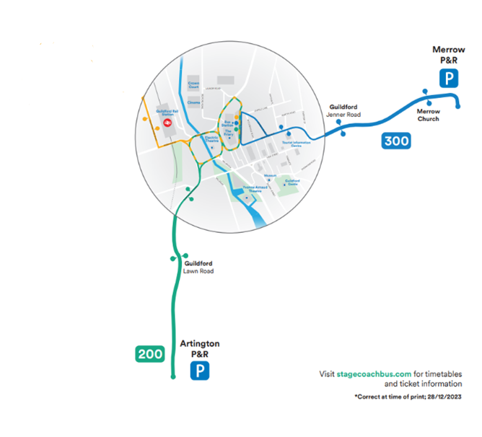
Ticket Options
Adult single tickets:
    - £1.60 at Artington and Merrow sites
Day tickets (DayRider for all 3 sites):
    - £3 from driver or Stagecoach app
    - Up to 2 children under 16 travels free with an adult
    - Additional children pay 75p
Concessionary fares:
    - Senior bus pass holders pay £1.50 day return
    - Disabled pass holders travel free after 9:30am weekdays, or pay £1.50 before 9:30am
    - Weekly ticket: £12 MegaRider for 7 days
Monthly tickets:
    - £42 for 28-day MegaRider
    - £36 for MegaRider Xtra (recurring monthly payment)
Operating Hours
Artington (Bus 200):
    - Mon-Sat: 7:35am - 7:35pm
    - Buses up to every 20 mins
    - Extra stops on Portsmouth Road
- Merrow (Bus 300):
    - Mon-Sat: First bus 7:50am, last bus 7:30pm
    - Buses every 30 mins daytime, 20 mins peak times
    - Extra stops on North Street and Epsom Road

Usage of Guildford’s Park and Ride and Surrounding
Unless specified, Post-COVID analysis uses data from 1st April 2023 to 22nd June 2024, while pre-COVID data from April 2018 to April 2019.

Park and Ride Usage Analysis

Introduction
This study examines the Park and Ride usage at two sites: Artington and Merrow. It begins with an analysis of Artington, followed by an analysis of Merrow, and concludes with a comparison between the two.

Artington

Time:

Peak boarding time for the Park and Ride service was between 08:00 and 08:59, with a total of 14,179 passengers during this period. In contrast, the least popular boarding time was between 19:00 and 19:59, with only 572 passengers recorded.

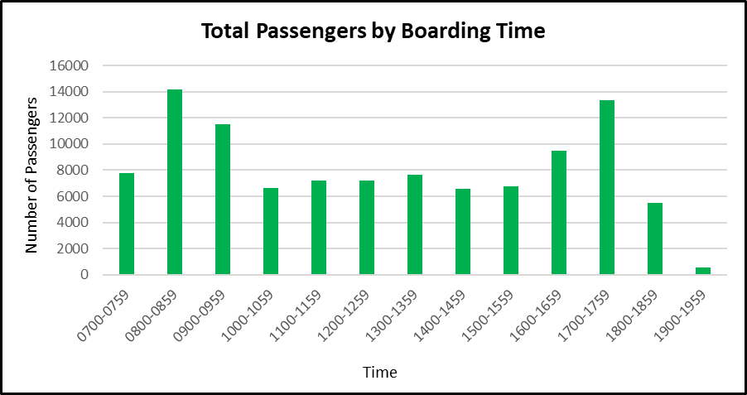
Figure . Total Passengers by Boarding Time

Day of Week:

Tuesdays recorded the highest number of passengers, with a daily average of 327. In contrast, Saturdays saw the lowest daily average, with only 191 passengers. This suggests a notable difference in passenger usage patterns throughout the week, with Tuesday buses being approximately 72% more popular than Saturdays.
Figure . Average Passenger Numbers by Days of Week
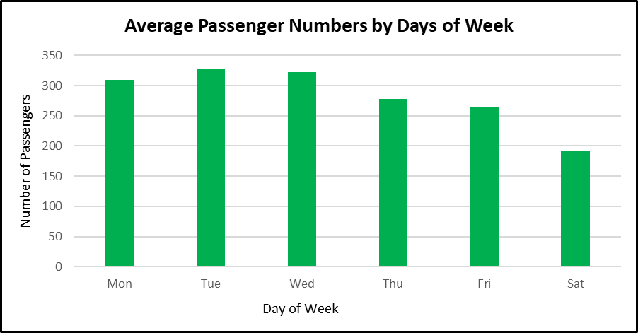

Monthly:

For the period from April 2023 to March 2024, the average number of passengers per month was 7,179. November emerged as the busiest month, with a total of 8,110 passengers, closely followed by December with 7,985 passengers. In contrast, September recorded the lowest passenger count, with 6,330 passengers.

Figure . Total Monthly Number of Passengers

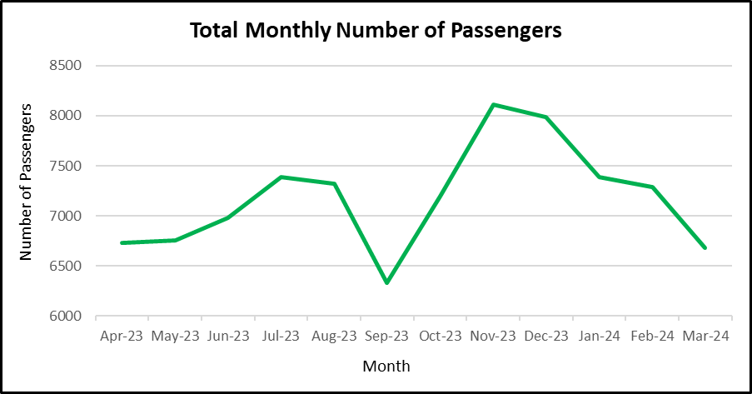

Pre vs Post Covid:

Comparing passenger data from April 2018 to April 2019 (pre-COVID) with April 2023 to April 2024 (post-COVID) reveals a significant shift in demand for the Park and Ride service at Artington. The pre-COVID period saw a total of 284,773 passengers, whereas the post-COVID period recorded only 86,150 passengers, indicating a steep 70% decline in usage. This substantial decrease suggests a potential decline in public confidence in using the service, as well as a shift towards alternative travel behaviours, possibly influenced by the lasting effects of the pandemic on commuting patterns and public transportation preferences.

Figure 8.Pre and Post COVID-19 Total Annual Passengers

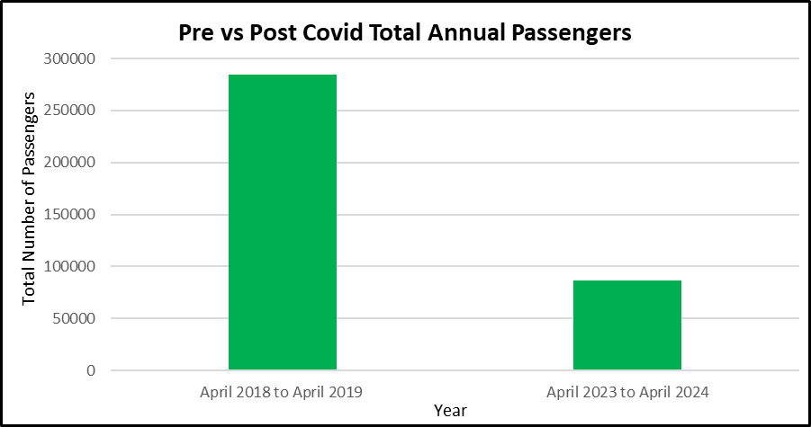

Merrow

Time:

The peak boarding time for the Park and Ride service was between 10:00 and 10:59, with a total of 12,723 passengers during this period. In contrast, the least popular boarding time was between 19:00 and 19:59, with only 763 passengers recorded.
Figure . Total Passengers by Boarding Time

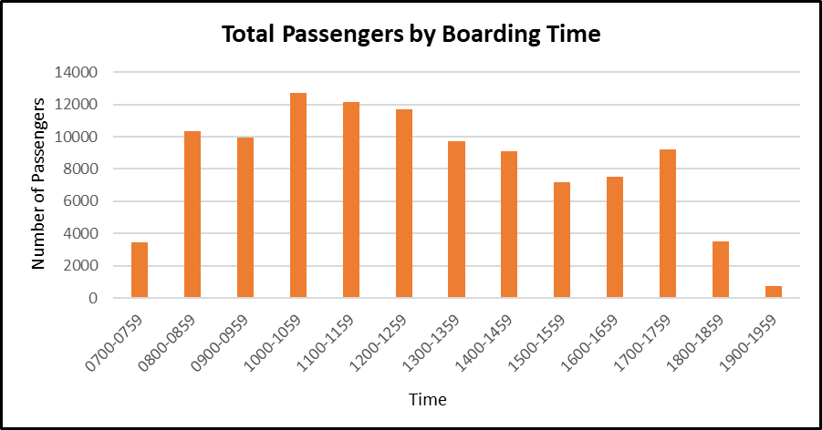

Day of Week:

Wednesdays recorded the highest number of passengers, with a daily average of 321. In contrast, Saturdays saw the lowest average, with only 242 passengers per day. This suggests a notable difference in passenger usage patterns throughout the week, with Wednesday’s buses being approximately 32% more popular than Saturdays.
Figure . Average Passenger Numbers by Days of Week

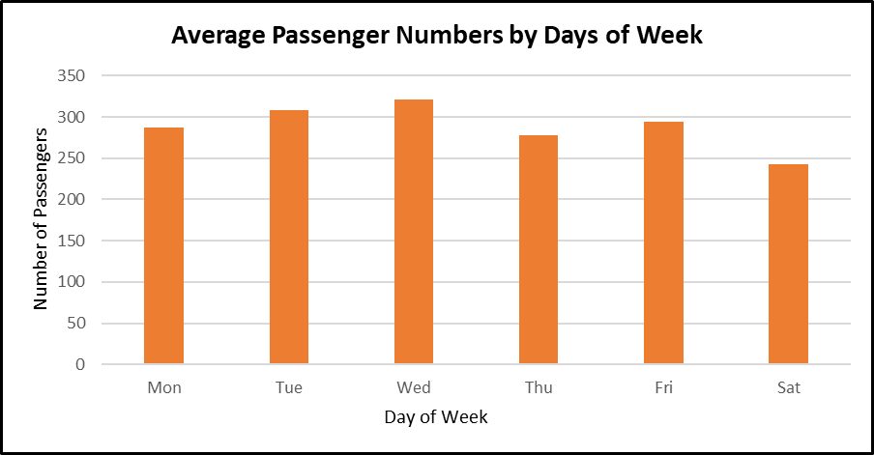

Monthly:
For the period from April 2023 to March 2024, the average number of passengers per month was 7,303. December emerged as the busiest month, with a total of 8,530 passengers, closely followed by November with 8,116 passengers. In contrast, April 2023 recorded the lowest passenger count, with 6,670 passengers.

Figure . Total Monthly Number of Passengers
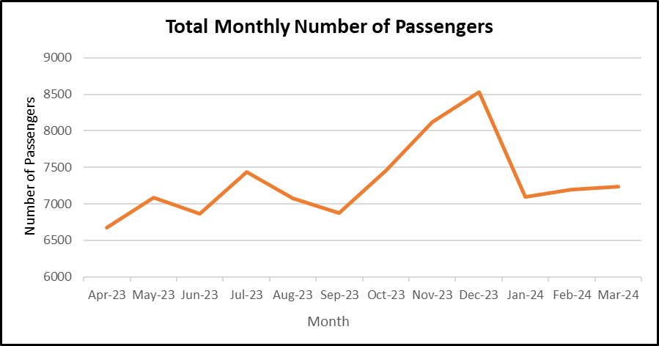

Pre vs Post Covid:

An analysis of passenger data comparing April 2018 to April 2019 (pre-COVID) with April 2023 to April 2024 (post-COVID) highlights a notable decrease in demand for the Park and Ride service at Merrow. During the pre-COVID year, the total number of passengers reached 194,179, whereas the post-COVID year saw a reduction to 87,638 passengers, marking a 55% decline. This reduction in usage points to a possible shift in travel habits and a decrease in reliance on the Park and Ride service, likely influenced by changes in commuter behaviour and concerns related to public transportation following the pandemic.
Figure . Pre Vs Post COVID 19 Total Annual Passengers

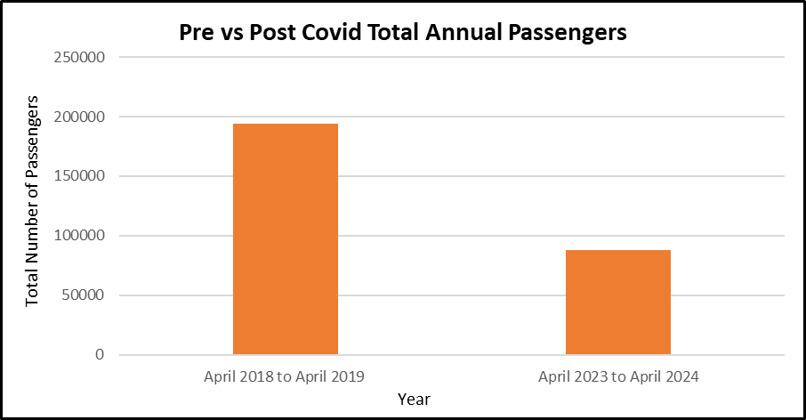

Comparison Study between the Park and Rides

Time:

Merrow served 2,748 more passengers than Artington during the analysed period of 1st April 2023 to 22nd June 2024, representing approximately a 2.63% higher passenger volume. This modest difference suggests that both locations have similar overall demand, with Merrow slightly leading in total usage.

Morning Commute (07:00-09:59):
Artington saw 9,796 more passengers during the morning commute period, a 41.37% higher volume than Merrow. This significant difference suggests that Artington is more heavily utilised during the traditional morning rush hours, possibly due to its location, connectivity, or user demographics that favour earlier travel times.

Midday Period (10:00-14:59):
Merrow served 20,045 more passengers during the midday period; a substantial 56.74% increase compared to Artington. This suggests that Merrow has significantly higher midday demand, likely driven by a diverse range of passengers, including non-commuters such as shoppers, tourists, or those with flexible schedules.

Afternoon/Evening Commute (15:00-19:59):
Artington saw 7,501 more passengers during the afternoon and evening commute, a 26.64% higher volume compared to Merrow. The stronger evening demand at Artington could indicate that it serves a larger commuter population returning home after traditional work hours.

Late Evening (19:00-19:59):
Merrow had 191 more passengers in the late evening period, 33.39% higher than Artington. Despite both locations showing a sharp decline in evening passengers, this slight edge for Merrow might suggest a different passenger profile with potential demand for later travel. The higher demand for Park and Ride travel at Merrow in the late evening could be due to a different passenger profile, such as those with late shifts or evening commitments. Additionally, Merrow might offer more convenient late evening services and be closer to active destinations like entertainment venues or restaurants.

Figure . Total Passengers by Time-of-Day Comparison

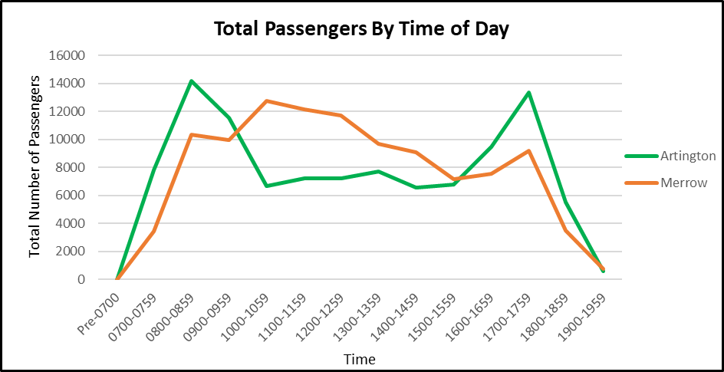

Day of Week:

A key observation is that Artington and Merrow exhibit distinct weekday patterns typical of commuter hubs. While both services peak mid-week, Merrow reaches its highest average on Wednesdays (321 passengers), whereas Artington peaks slightly earlier on Tuesdays (327 passengers). This slight shift could indicate that Artington’s users might start their week with a stronger need for commuting, tapering off slightly towards the end of the week, possibly due to a higher tendency for remote working or flexible schedules later in the week. Merrow, by contrast, maintains a more consistent flow of passengers through mid-week.

The transition from weekdays to weekends presents another interesting comparative insight. Artington sees a sharp decline in passenger numbers from its weekday peak on Tuesday (327 passengers) to Saturday (191 passengers), a 41.74% drop. This steep reduction highlights its strong focus on weekday commuters, with much less weekend activity, likely due to reduced work-related travel on Saturdays. In contrast, Merrow experiences a smaller drop from Wednesday’s peak (320.58 passengers) to Saturday (242.22 passengers), only a 24.43% decrease. This more moderate decline suggests that Merrow maintains a broader appeal throughout the week, including on weekends.

Figure . Average Passenger Numbers by Days of Week

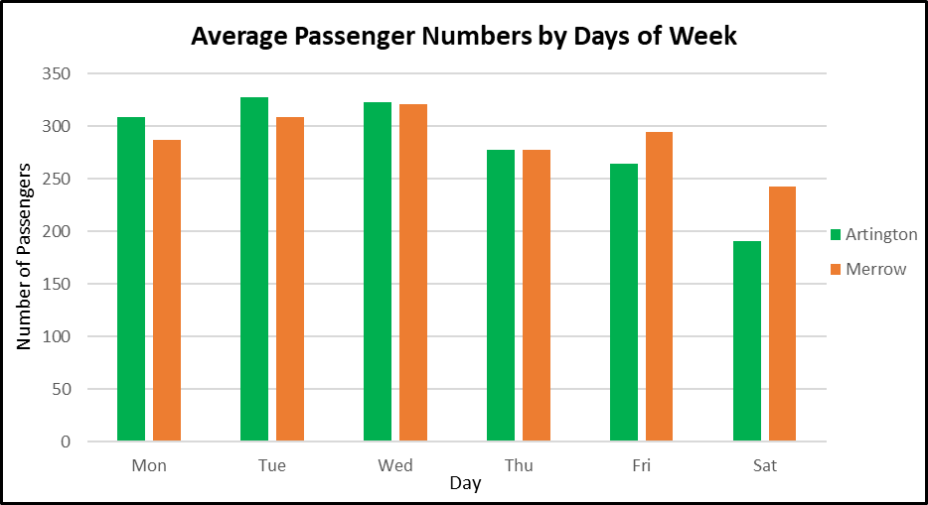

Monthly:

The monthly passenger data for Artington and Merrow from April 2023 to March 2024 reveals some trends and differences in passenger behaviour across these two locations. Merrow consistently leads with the highest average monthly passenger count of 7,303, slightly ahead of Artington at 7,179. This marginal difference suggests that both locations are similarly popular, though Merrow exhibits slightly stronger overall performance, particularly in the latter half of the year, peaking in December with 8,530 passengers—the highest monthly figure across both Artington and Merrow. In contrast, Artington’s highest monthly total was 8,110 passengers in November, slightly below Merrow’s peak, indicating a slightly less pronounced seasonal increase during the winter months.
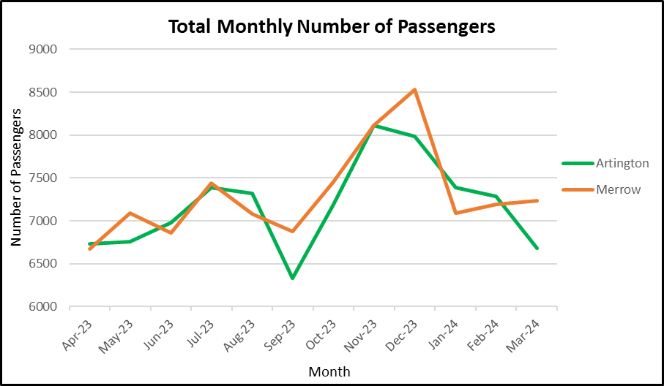
Figure . Total Monthly Number of Passengers

Pre vs Post Covid Levels:

The comparison of pre- and post-COVID passenger levels at Artington and Merrow clearly illustrates the substantial impact the pandemic has had on these services. While both locations have experienced sharp declines, Artington’s nearly 70% reduction highlights a particular vulnerability in its user base, likely tied to commuting patterns that have not fully recovered. In contrast, Merrow’s 55% decline, though still significant, suggests a more stable or diversified user base.
Figure . Pre Vs Post COVID Levels

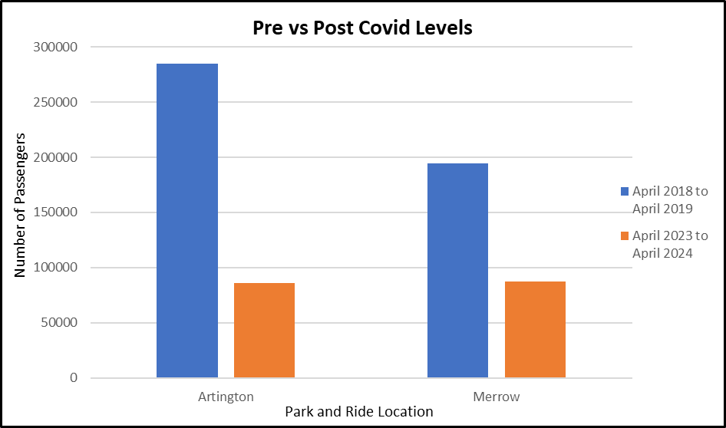

Next Steps
The analysis within this report highlights that Guildford has the opportunity to improve air quality by specifically designing interventions that tackle the worse polluting vehicles. For locally registered vehicles, only 54.66% of LGVs are compliant to ULEZ standards, significantly lower than the national level (62.22%) and one in four cars registered in Guildford are non-compliant to ULEZ standards. As of March 2024, there were 11,738 diesel cars, 6,642 petrol cars and 3,714 diesel LGVs that were non-compliant to ULEZ standards registered in the Guildford Borough Council area.
For traffic passing through Guildford’s Air Quality Management Area, there were generally higher levels of compliant vehicles with between 86% and 89% of diesel cars and 60% to 93% of diesel vans estimated to be compliant to ULEZ standards.
Our desk based review has shown that by targeting emission reduction schemes, significant improvements can be made to local air quality in relatively short periods of times and that Clean Air Zones have been successfully deployed throughout the UK.
This implies that focussing efforts on reducing non-compliant diesel vans passing through Guildford centre will have more immediate effects on reducing harmful emissions.
The next stages of the study will focus on the following activities to further inform potential interventions by Guildford Borough Council:

            - Stakeholder Engagement
We will discuss with Guilford Borough Council to identify any existing stakeholder engagement that may have been undertaken to date on air quality improvement options, traffic reduction schemes and/or schemes to encourage modal shift within the past 3 years. We will review key findings to identify specific needs of local groups and businesses.

We will map out and prioritise engagement with key stakeholders, including local authorities, residents, and businesses, to gather input and ensure the proposed measures meet community needs and expectations. This will help develop indicators and measurements of the feasibility, viability and affordability of each option as well as provide insight into developing measurements on progress for the proposed interventions. We will build upon existing stakeholder engagement which we will review as part of the desk top analysis.
Deliverables:
• Stakeholder Workshop 1: Long-List Confirmation and Input into Short-List
• Stakeholder Workshop 2: Feedback on Short-List Option Appraisal

            - Option Assessment

Stage 1: Long List Appraisal
Objectives and Scope: Using the results of this desk top study, we will identify and confirm with the wider project team the aims, scope and objectives of the proposed interventions. We will seek to align objectives with relevant local, regional and national environmental, social, and economic goals.
Long-List Appraisal: We will compile a comprehensive long list of existing options aimed at improving air quality within Guildford Town Centre. This will build on the work reported by Guildford Borough Council in the “Guildford Town Centre: Air Quality Action Plan.” We will develop the economics perspective and identify if this has any marked impacts to the existing scoring of options. We will work in collaboration with the wider project team to compile integrated options that may link some or several of the existing proposals into holistic interventions. E.g. combining electric scooter hire and electric bicycle hire into a single option for delivery.

Deliverables
- Long list of options for future appraisal

Stage 2: Establishing the Baseline and Counterfactual

Working in collaboration with the air quality and traffic consultants and using the information collected within this report as the baseline, we will develop a counter-factual that applies current policies and trend forecasts to account for expected changes within population, traffic levels and fleet composition.
Deliverables
- Baseline and counterfactual
Stage 3: Establishing the Short-list Options
Appraising the Long list: We will enhance the work already completed in Guildford’s Air Quality Action Plan to include economic input into the scorings. The measures will then be ranked based on their performance in the Multi Criteria Analysis, facilitating the identification of the most promising interventions.
• Sift and Shortlist: Use the critical success factors established to sift through options, focusing on feasibility, effectiveness, and alignment with objectives.
• Stakeholder Workshop 2: Confirming the shortlist

Deliverables
- Short-list Options

Stage 4. Appraise Short-List Options
• Develop Appraisal Criteria: Criteria will include economic (cost-benefit analysis), environmental (impact on air quality), and social (effects on communities and businesses)
• Assess Costs and Benefits: Utilizing the aforementioned data, a cost-benefit analysis will be conducted to evaluate the economic impacts of the shortlisted options, including potential CAZ/LEZ implications. This analysis will encompass the benefits and disbenefits for both communities and businesses. Predictions on emission reductions and air quality improvements will be obtained from the existing consultants. We will apply the NHS Rapid Health Impact Assessment Tool to determine health impacts, we will apply standard models for determining environmental impacts and calculate the monetary value associated with any carbon reductions identified and how this supports wider Guildford Borough Council’s aims for reducing carbon as stated in your climate emergency declaration.

We anticipate that high-level costs data will be provided by Surrey County Council and Guildford Borough Council for both the Capital costs (CAPEX) and Operational costs (OPEX). In the absence of this data being available as we anticipate, we will be able to calculate some benchmarking figures to use within the study for an additional fee. We will quantify the costs (implementation, enforcement, compliance) and benefits (health, social, environmental and economic) for each option.

• Environmental Impacts: Environmental impacts, whether positive or negative, will also be assessed for each shortlisted scheme.

• Strategic Environmental Assessment: Previous LEZ implementations have applied a Strategic Environmental Assessment (SEA), we will discuss with Guildford Borough Council if they already have an in-house staff member who has experience and skills to undertake this assessment. If not, we will for an additional fee, identify options for screening out the SEA Directive and if that is deemed as not possible/desirable, undertake a full SEA.

• Risk and Uncertainty Analysis: Identify risks and uncertainties associated with each option and assess their potential impact.

Deliverable: Costs and Benefits of the Short-List Options

Stage 5. Develop Outline Business Case

Cost-Benefit Analysis (CBA): Use CBA to evaluate the net economic value of each shortlisted option, comparing the present value of benefits to costs. We will also look at the net social value of each option.

Deliverable: Best Value for Money Recommendation

Stage 6: Final Recommendations and Reporting
Traffic Management Implications: Working with Surrey County Council’s transport modelling team, we will explicitly assess the effects implementations will have on traffic management and provide recommendations for the management of traffic and policies to minimise the impacts that may occur from the recommended final option.
Recommendations: Based on the shortlisted measures, we develop a set of actionable recommendations for the economic feasibility study. These recommendations are designed to guide decision-making and implementation, providing a clear pathway towards achieving the desired outcomes for Guildford Town Centre. The recommendations will be consistent with relevant national guidance and local policies and plans.

Deliverable: Final Report and Presentation

Annex 1
- Transport Strategy (Department for Transport, DfT)
- Air Quality Strategy: Framework for Local Authority Delivery 2023 (Department of Environment, Food & Rural Affairs, DEFRA)
- Clean Air Strategy 2019 (DEFRA)
- Clean Air Zone Framework 2022 (DEFRA & DfT)
- Package of Measures Introduced to Improve Air Quality 2022 (DEFRA)
- Net Zero Strategy: Build Back Greener 2021 (Department for Energy Security and Net Zero and Department for Business, Energy and Industrial Strategy)
- Environmental Improvement Plan 2023 (DEFRA)
- Surrey County Council Local Transport Plan 2022 (LTP4) (Surrey County Council, SCC)
- Surrey County Council Air Quality Strategy (SCC)
- Surrey Community Vision 2030 (SCC)
- Surrey 2050 Place Ambition (SCC)
- A New Railway Strategy for Surrey 2021 (SCC)
- Surrey’s Climate Change Strategy 2020 (SCC)
- Surrey County Council Sustainable Modes of Travel to School Strategy (SCC)
- Guildford Air Quality Strategy (GBC)
- Guildford Town Centre Transport Package (TCTP) (GBC)
- Guildford Borough Local Plan: Strategy and Sites 2015-2034 Part 1 and 2 (GBC)
- Shaping Guildford’s Future Masterplan(GBC)
- Local Cycling and Walking Infrastructure Plan (GBC & SCC)
- Bus Improvement Plan (GBC)

1. National Policy Context

1.1. Transport Strategy
The government’s transport strategy is centred around the goal of achieving net-zero emissions by 2050. The strategy is designed not only to meet environmental targets but also to improve public health, create jobs, and foster economic growth through green technology advancements.
"We want to be a world leader in green technologies, and encourage more sustainable travel choices."
Key Objectives are to:
- End the sale of new petrol and diesel cars and vans from 2030: By 2035, all new cars and vans must be zero emission at the tailpipe. This will become more feasible via the implementation of a zero-emission vehicle (ZEV) mandate from 2024, setting annual targets for manufacturers.
- Infrastructure for Electric Vehicles (EVs): The UK is taking significant strides to ensure a reliable and accessible charging infrastructure for electric vehicles (EVs). This involves publishing an EV infrastructure strategy that clearly delineates the roles of the public and private sectors in its rollout. Furthermore, the UK government has committed an additional £620 million to support the EV transition, with a particular focus on enhancing local on-street residential charging facilities.
- Zero Emission Vehicle Supply Chain: This focuses on building a competitive zero-emission vehicle supply chain, thereby positioning the automotive sector at the forefront of the transition to net-zero. This approach ensures that the UK remains a key player in the global shift towards sustainable transportation.
- Public Transport, Cycling, and Walking: This is geared towards increasing the share of journeys taken by sustainable modes of transport. This involves an investment of over £12 billion in local transport systems and an additional £2 billion in cycling and walking infrastructure. The ultimate aim is for half of all journeys in towns and cities to be undertaken by cycling or walking by 2030. This comprehensive approach underscores the UK’s commitment to promoting sustainable and active travel options.
Given that in 2019, transport accounted for 23% of UK greenhouse gas emissions, the strategy comprehensively addresses this significant contributor to climate change. It covers various aspects of transport, with clear commitments and substantial investments. The aim is to reduce emissions, foster a sustainable, healthier, and more efficient transport system, and ultimately drive a significant reduction in the UK’s overall greenhouse gas emissions.

1.2 Air Quality Strategy: Framework for Local Authority Delivery 2023
This framework guides local authorities in England on how to improve air quality. It outlines their roles, responsibilities, and the actions they are expected to take. The strategy is underpinned by the Environment Act 1995 and the Environment Act 2021, and it sets legally-binding targets for pollutants like PM2.5 and nitrogen oxides. The document emphasises the importance of collaboration between local authorities, the Environment Agency, and National Highways, and it also provides enforcement measures for non-compliance. The strategy focuses on reducing pollutants that have significant impacts on public health and biodiversity, such as fine particulate matter (PM2.5), nitrogen oxides (NOx), and ammonia.

Main Objectives are to:
- Plan Reforms Helping to Deliver on Air Quality: This involves developing and implementing strategic plans that aim to improve air quality. These plans may include measures to reduce emissions from various sources, such as industrial processes, road transport, and domestic heating. The reforms could also involve updating existing policies or introducing new ones that are more effective in achieving air quality targets.
- Build Capacity in Local Councils Through Training, Guidance, and Knowledge Sharing: This objective focuses on enhancing the ability of local councils to effectively manage air quality. This could be achieved through various means, such as providing training programs for council staff, offering guidance on best practices for air quality management, and facilitating the sharing of knowledge and experiences among different councils.
- Raise Awareness Within Local Communities of Air Quality Impacts and How to Reduce Them: This involves educating the public about the health and environmental impacts of poor air quality and promoting actions that individuals can take to reduce their contribution to air pollution. This could be done through public awareness campaigns, educational programs in schools, and community events.
- Boost Active Travel and Public Transport to Improve Air Quality: Promoting active travel (such as walking and cycling) and the use of public transport can significantly reduce emissions from private vehicles, thereby improving air quality. This could involve improving infrastructure for active travel, providing incentives for using public transport, and implementing measures to make public transport more attractive, such as reducing fares or improving service quality.
The Air Quality Strategy is a critical component of public health, economic growth, biodiversity, and the UK’s net zero targets. Poor air quality, the largest environmental health risk, necessitates interventions that consider exposure disparities. Economically, reducing air pollution, even with high upfront costs, has proven benefits, including a potential 0.8% average GDP increase in Europe for every 1 μg/m3 reduction in PM2.5 concentrations. Biodiversity is also at stake, with poor air quality contributing to the decline of sensitive habitats, which are crucial for achieving the UK’s net zero targets. Lastly, while some measures to reduce greenhouse gases may conflict with improving air quality, these interactions warrant careful consideration. Therefore, a comprehensive and balanced approach is essential in implementing the Air Quality Strategy.

1.3 Clean Air Strategy 2019
The UK’s 2019 Clean Air Strategy is a comprehensive plan aimed at improving air quality across the nation. The strategy focuses on tackling all sources of air pollution to make the air healthier to breathe, protect nature, and boost the economy. It includes measures to collect better data for air quality, reduce emissions from transport, homes, and address air pollution at all levels of leadership. The strategy also complements three other UK government strategies: the Industrial Strategy, the Clean Growth Strategy, and the 25 Year Environment Plan. Key focuses include:

1.3.1 Nation’s Health
Public Health England (PHE) has identified air pollution as a top priority for action. Conditions, especially respiratory are exacerbated by exposure to polluted air. For instance, ‘’recent research commission by Public Health England has found that the health and social care costs of air pollution (PM2.5 and NO2) in England could reach £5.3 billion by 2035.’’
Key Objectives are to:
- Promote Active Travel: Encourage less use of vehicles and more walking, cycling, or public transport, especially for short journeys. This not only reduces emissions but also offers health benefits that outweigh the risks of roadside exposure to air pollution.
- Adopt Cleaner Vehicles: Advocate for the switch to less polluting models such as electric vehicles, and encourage turning off engines when parked or waiting in traffic for long periods.
- Choose Quieter Routes: Promote the selection of quieter routes when walking or cycling to reduce exposure to air pollution.
- Reduce Deliveries: Encourage grouping of online purchases to reduce the number of deliveries needed, thereby reducing emissions.
- Set Ambitious Targets: The government’s action plan aims to reduce people’s exposure to air pollution by setting an ambitious long-term target, following the WHO’s annual mean guideline limit of 10 µg/m3 of PM2.5.

1.3.2 Nation’s Environment
Clean, green and healthy environments in urban and rural areas are an essential component of progress, not a barrier to economic development. The strategy acknowledges the previous misconception that pollution was simply a price to pay for economic development. The measures put into place regulatory controls to improve the way that cumulative impact of nitrogen deposition on natural habitats is controlled. The measures being put into place were expected to protect an additional 200,000 hectares of natural habitat from excessive nitrogen deposition.

1.3.3. Action
Key Objectives are to:
- Spend nearly £1.5 billion supporting the take-up of ultra-low emission vehicles.
- Invest £2 million to support the uptake of e-cargo bikes in order to make last mile delivery more sustainable and to reduce vehicle emissions .
- Invest up to £246 million in the design, development and manufacture of electric batteries through the Faraday Challenge.
- Launch a £19.6 million ‘Clean Air: Analysis and Solutions’ research programme, to be delivered in partnership with UKRI.

1.4 Clean Air Zone Framework 2022
The framework sets out the principles for the operation of clean air zones in England. It provides the expected approach to be taken by local authorities when implementing a clean air zone (CAZ). These zones have been introduced with a focus on tackling NO2 concentrations in areas which are breaching legal limits. Regarding the vehicles, fully electric or hydrogen fuel cell vehicles will not be charged for entering or moving through a clean air zone. Exempted vehicles also include: hybrid vehicles that otherwise do not meet the euro standard/ age requirements for their type and plug-in hybrid vehicles which are geo-fenced to operate in electric only mode within the zone.
1.5 Package of Measures Introduced to Improve Air Quality 2022
A series of actions was announced to improve air quality under the Environment Act. Environment Minister Steve Double, said: “These changes – delivered by our Environment Act - provide a strengthened framework for local councils to meet their air quality objectives, and will ensure that communities are protected sooner with real improvements to the air we breathe.”
Key Objectives are to:
- Improve Collaboration: Encourage National Highways to work with local authorities to improve air quality. National Highways is to become the first designated “Relevant Public Authority”, placing a legal requirement on it to collaborate with local councils to deliver air quality standards and objectives.
- Strengthen Guidance: Strengthen Local Air Quality Guidance under the Environment Act, and update technical guidance to support local air quality action.
- Implement Clear Action Plans: Introduce a new requirement for local Air Quality Action Plans to include a timeline of clear actions that ensure Air Quality Objectives (pollution concentration limits) are met and air quality standards improve in local areas.
- Declare Air Quality Management Areas: Require an Air Quality Management Area to be declared within 12 months of identifying an exceedance of the air quality objectives, ensuring that local councils develop Air Quality Actions Plans more quickly.
- Produce Air Quality Action Plans: Mandate local authorities to produce an Air Quality Action Plan within 18 months of declaring an Air Quality Management Area.
- Increase Local Council Compliance: Implement a new reminder and warning alert system to increase local council compliance with reporting on actions they are taking to improve air quality.

1.6. Net Zero Strategy: Build Back Greener 2021
‘’We will meet the global climate emergency but not with panicked, short-term or self-destructive measures as some have urged. Instead we will unleash the unique creative power of capitalism to drive the innovation that will bring down the costs of going green.’’
The UK’s Net Zero Strategy is a comprehensive plan aimed at achieving a carbon-neutral economy by 2050. This strategy is underpinned by several key policies related to power, buildings, transport and greenhouse gas removal. These policies represent a bold and ambitious approach to tackling climate change and transitioning to a sustainable economy. They will require significant investment and societal change, but the potential benefits in terms of reduced emissions, improved air quality, and new green jobs are substantial. Key policy areas include:

1.7. Environmental Improvement Plan 2023
The government’s 2023 Environmental Improvement Plan revises the 25-year environment plan. The second goal, ‘Clean Air’, addresses domestic, industrial, and agricultural air pollution, providing targets and recommendations for monitoring air quality.
Main Objectives are to:
- Challenge Councils: Improve air quality quickly with clear guidance, funding, and tools.
- Reduce Ammonia Emissions: Extend environmental permit conditions to dairy and intensive farms.
- Improve Communication: Enhance how the government communicates air quality information.
- Support Zero Emission Vehicles: Provide grants and generous tax rates to support the transition.
- Tackle Domestic Emissions: Continue efforts to reduce emissions from domestic sources.
Methods to Achieve Goals:
- Clean Air Zones: Facilitate the rollout of Clean Air Zones by local councils.
- Regional Air Quality Zones: Re-align zones with local government boundaries for coordinated action.
- Support Zero Emission Vehicles: Continue to support the transition away from petrol and diesel cars.
Sub-Target 2: Driving Effective Local Action
- Air Quality Grant Scheme: Allocated £30 million to community projects tackling air pollution.
- Local Authority Collaboration: Reforms to the Local Air Quality Management Framework.
- Air Quality Hub: Share best practices and success stories among local authorities.
- Funding: Over £883 million to develop and implement local NO2 reduction plans.
- Clean Air Zones: Introduced in Bath, Birmingham, Bradford, Bristol, Portsmouth, and Tyneside, with a future zone in Sheffield.
Sub-Target 5: Reducing Emissions from Transport
- National Highways Collaboration: Work with local authorities to reduce exceedances.
- Funding Measures: Junction improvements and vehicle upgrades to improve air quality.
Support Zero Emission Vehicles: Commitments to end the sale of new petrol and diesel cars and vans by 2030, and non-zero emission heavy goods vehicles by 2040.

1.8. Greenhouse Gas Removals
The Greenhouse Gas Removals (GGR) policy area focuses on compensating for residual emissions from sectors that are difficult to fully decarbonise by 2050, such as industry, agriculture, and aviation. This involves deploying engineered methods to actively remove greenhouse gases from the atmosphere. The government has set an ambitious target to deploy at least 5 million tonnes (Mt) of CO2 per year in engineered removals by 2030, supported by significant investments in research, development, and market incentives.
"Developing a robust approach to the Monitoring, Reporting and Verification (MRV) of negative emissions is essential to the deployment of GGRs at scale."
Key Objectives are to:
- Deploy Engineered Removals: Set the ambition to deploy at least 5 MtCO2/year of engineered removals by 2030, aligning with assessments from the Climate Change Committee (CCC) and the National Infrastructure Commission. While this primarily targets carbon dioxide, the reduction of overall greenhouse gases can complement efforts to improve air quality by addressing other pollutants indirectly.
- Boost Innovation Funding: Deliver £100 million in innovation funding for Direct Air Carbon Capture and Storage (DACCS) and other greenhouse gas removal technologies. Advancing these technologies can support cleaner air by removing CO2 from the atmosphere, which is often co-emitted with nitrogen dioxide (NO2) from combustion processes.
- Enhance Regulatory Oversight: Investigate options for regulatory oversight to ensure robust monitoring, reporting, and verification (MRV) of GGRs. This follows recommendations from a BEIS-led MRV Task & Finish Group, which emphasised the importance of transparency and accuracy in carbon removal claims. Effective MRV can ensure that GGR efforts are genuinely reducing pollutants that affect air quality, such as NO2.
The government's strategy for greenhouse gas removals emphasises deploying advanced technologies to remove CO2 from the atmosphere, supported by significant innovation funding and market development. While the primary focus is on CO2, the reduction of overall greenhouse gases can have complementary benefits for air quality by addressing pollutants like nitrogen dioxide (NO2) that are often associated with CO2 emissions. Key objectives include establishing a robust regulatory framework, integrating GGRs into the UK ETS, and ensuring these efforts support broader clean air and transport strategies. These initiatives are critical for achieving net-zero emissions and enhancing air quality, particularly in urban areas impacted by transport emissions.

2. Regional Policy Context
2.1. Surrey County Council Local Transport Plan 2022 (LTP4)
Surrey’s fourth Local Transport Plan (LTP4), adopted on 12 July 2022, outlines a ten-year vision for a transformed transport network, with a focus on significantly reducing carbon emissions in line with Surrey’s net-zero commitment by 2050. The LTP4 aims to foster sustainable growth, well-connected communities, and improve air quality, enhancing the quality of life for all residents. It proposes measures aligned with three principles: avoiding unnecessary travel, shifting to sustainable transport modes, and improving vehicle and road efficiency. These measures, which encompass the promotion of electric vehicles, enhancement of public transport, and introduction of shared transport options, are strategically designed to mitigate carbon emissions and enhance air quality. Key Policy areas include:
2.1.1. Public and Shared Transport
‘’To provide high-quality, reliable, affordable, and joined up public, shared and demand responsive transport, supported by accessible and easy to use travel information and booking systems.’’
The two policy areas, ‘Demand Management for Cars’ and ‘Demand Management for Goods Vehicles’, further reinforce this strategy. They aim to increase the demand for public transport, thereby decreasing dependence on high-emission cars. In areas where public transport may not be as feasible, the alternative is to promote Electric Vehicles (EVs). This approach seamlessly aligns with Policy 1.2.2.1.2.
Key Objectives are to:
- Enhancing Journey Time Reliability: By improving the reliability of journey times, it can attract a larger number of individuals and commuters to consider public transport as a viable alternative.
- Boosting Accessibility and Safety: Collaborating with districts and boroughs to build upon previous efforts aimed at enhancing bus accessibility and safety will encourage a broader spectrum of passengers to use public transport. This is particularly beneficial for women, children, and individuals with disabilities who require special access.
- Simplifying Ticketing and Fares: This aims to review and develop fare structures and introduce multimodal ticketing, which allows passengers to purchase tickets for a single journey across various types of transport. This initiative builds upon the successful implementation of ACORN tickets in North Surrey and integrated ticketing in Woking and Guildford.
2.1.2. Promoting Zero Emission Vehicles
‘’To improve emissions intensity and energy efficiency of vehicles and operational efficiency of roads through technology improvements.’’
Key Objectives are to:
- Strategise and Facilitate Charging Infrastructure: By strategically planning and enabling well-situated charging facilities for EVs, it can bolster the swift transition to Zero Emission Vehicles (ZEVs) and EVs, thereby reducing overall nitrous oxide emissions.
- Promote EV Car Clubs: The county council is committed to fostering the growth of EV car club fleets. By offering car sharing or rentals on a more pay-per-use basis, it incentivises a decrease in ownership of high-emission vehicles.
2.1.3. Supporting Behaviour Change
To promote ‘’awareness campaigns and other activities to encourage walking, cycling and use of public transport and zero emission vehicles (ZEVs).’’
Key Objectives are to:
- Adopt Technology and Incentives: Technology offers a plethora of opportunities to shape behaviour. For example, smartphone apps can incentivise specific travel behaviours with digital rewards.
- Promote Behavioural Change: Implement a range of strategies to influence various community sectors, building on the success of our travel awareness campaigns over the past two decades, including Travel SMART. Targeted campaigns could, for instance, raise awareness among those travelling to key destinations like workplaces or retail centres, emphasising the available travel options.
Therefore, the LTP4 is a strategic blueprint for transforming Surrey’s transport network, aiming for net-zero carbon emissions and sustainable growth. It aligns with the principles of a Clean Air Zone (CAZ), promoting cleaner transport modes and reducing reliance on high-emission vehicles. The LTP4’s ‘Avoid, Shift, Improve’ principles resonate with the CAZ’s approach, fostering a shift to more sustainable transport modes and improving vehicle and road efficiency. Thus, the LTP4 and a CAZ can collaboratively achieve these shared objectives.

2.2. Surrey County Council Air Quality Strategy
This strategy is part of the LTP4, focusing on reducing emissions from transport that are harmful to health and working with partners to achieve legal compliance for local air quality. One of the key initiatives under this strategy is the Electric Towns and Cities Initiative (ETCI), which supports the legal requirement for National Highways to ensure that the limit value for nitrogen dioxide (NO2) concentrations across the strategic road network is met in the shortest timescales possible. The stretch of the A3 running through Guildford has been identified as a priority area for action, having a mean annual NO2 level of more than double the legal limit.
Key Objectives are to:
- Reduce emissions from transport that are harmful to health.
- Achieve legal compliance for local air quality.
- Support the Electric Towns and Cities Initiative (ETCI) to ensure that the limit value for nitrogen dioxide (NO2) concentrations across the strategic road network is met in the shortest timescales possible.
- Identify priority areas for action, such as the stretch of the A3 running through Guildford.
- Work together with businesses and communities to find effective solutions to reduce emissions.

2.3. Surrey Community Vision 2030
Surrey County Council conducted extensive engagement with residents, communities, and partners across the county to formulate a vision for Surrey by 2030. The collective insights from these discussions have shaped a consensus-driven vision for the future of Surrey. With 41.5% of residents expressing dissatisfaction with the management of road congestion and 39.5% unhappy with vehicle parking, these issues are clearly a high priority for Surrey. Therefore, it is crucial to explore and implement robust alternatives that not only improve these statistics but also contribute to cleaner air and overall enhancement of the area.
The vision acknowledges the need for sustainable transport and reducing congestion, which aligns with the goals of improving air quality and reducing dissatisfaction with road congestion and parking.
Key Objectives are to:
- Ensure children and young people are safe and feel safe.
- Encourage healthy lifestyle and make good choices about their wellbeing.
- Promote green communities where people and organisations embrace their environmental responsibilities.
- Make journeys across the county easier, more predictable and safer.
- Create well-connected communities with effective infrastructure that grow sustainably.
2.4 Surrey 2050 Place Ambition
Surrey’s 2050 Place Ambition is a collective, long-term vision set by Surrey County Council in collaboration with local authorities and strategic partners. The ambition aims to support and manage growth in a way that addresses the challenges associated with climate change and the existing and future infrastructure deficit. It seeks to enable Surrey’s economy to grow sustainably while improving the overall quality of the environment and well-being of residents.
2.4.1. Priority Theme 1: Address the Climate Emergency
Key Objectives are to:
- Reduce Transport Emissions: With 46% of Surrey’s emissions coming from the transport sector, there’s an urgent need for action to respond to the climate emergency. The target is a 60% reduction in transport emissions by 2035.
- Implement Policies to Reduce Carbon Emissions: These include planning for place, promoting digital connectivity, encouraging active travel/personal mobility, improving public/shared transport, managing demand for cars and goods vehicles, managing network efficiency, and promoting zero-emission vehicles.
- Integrate Climate Change Considerations: Ensure that climate change considerations are central to the Place Ambition, to support the integrity and resilience of the natural environment and communities.
- Adapt the Built Environment: Promote sustainable design and construction principles, achieve water efficiency standards, maximise energy efficiency, integrate renewable and smart energy technologies, and ensure new development takes account of flood risk.
- Collaborate to Address the Climate Emergency: Continue to work together to address the climate emergency through supporting the delivery of planning policies that are compatible with net-zero targets, exploring the scope to align low carbon planning policies across Surrey, developing guidance documents to promote climate compatible development, and exploring the potential for carbon offset funding.
2.4.2. Priority Theme 2: Improve Connectivity within Surrey and Between Key Hubs
Key Objectives are to:
- Adapt to the impact of more “hybrid working”: This is likely to mean less frequent commuting and more emphasis on creating places where people’s daily needs can be met within a short walk or cycle.
- Invest in Active Travel and New Transport Technologies: Aims to create neighbourhoods that support a low carbon economy.
- Build on an Infrastructure Investment Strategy: Develop a coherent long-term infrastructure investment strategy through the Surrey Infrastructure Plan (SIP).
- Improve Rail Connectivity: Improve rail connectivity between Surrey’s main towns and other key economic centres including London by securing investment in the North Downs Line, capacity improvements at Woking and Southern Rail access from Heathrow Airport to Surrey and beyond.
- Improve Stations: Focus on improving stations within Surrey so they benefit communities and support sustainable local economic growth.
- Advance a Bus Service Improvement Plan for Surrey: Enhance the quality of bus services through investing in infrastructure to allow faster journeys by bus, improving the coverage of the network, providing more coordinated bus services which integrate with other transport modes and improving service frequencies, reliability, fares and customer experience.
- Increase Walking/Cycling Uptake: Increase walking/cycling uptake through implementing Local Cycling and Walking Infrastructure Plans (LCWIPs) across Surrey to link urban and rural built-up areas and public transport connections.
2.4.3. Priority Theme 3: Enhance the Place Offer of Surrey’s Towns and Urban Areas
Key Objectives are to:
- Enhance the Built Environment: Ensure all new developments and redevelopments recognise local character, contribute positively to urban areas, and focus on creating pleasant, safe, and attractive streets.
- Maximise Natural Capital: Improve the quality and accessibility of green and blue infrastructure within and between urban areas, contributing to ‘clean’ growth.
- Improve Connectivity: Focus transport investment on active travel and public transport to enhance mobility and accessibility within and between urban areas.
- Promote Healthy and Inclusive Places: Enhance walkability, connectivity, and access to natural environments to improve residents’ well-being and safety.
2.4.4. Priority Theme 4: Maximise the Benefits of Collaboration for Sustainable Development
Key Objectives are to:
- Invest in Infrastructure: Address existing infrastructure deficiencies and support new development through strategic infrastructure and investment. This includes new communities and areas where there are opportunities to maximise the value of strategic economic assets such as transport hubs, universities, or strategic employment locations.
- Promote Collaboration: Encourage joint consideration of issues by partners on a wider geographical basis, especially where impacts cross administrative boundaries. This may require new collaborative working arrangements to be set up.
- Focus on Investment: Focus investment, such as in infrastructure, to unlock sites and improve movement and connectivity between key hubs and along strategic movement corridors.
- Protect Strategically Important Land: Protect strategically important land and premises where appropriate, including within town centres that are well served by public transport.
2.5. A New Railway Strategy for Surrey 2021
This strategy aims to ‘reduce the number of car journeys on our roads and to support our climate change agenda’ and is designed to reflect current operations of the rail network, government investment programmes and the objectives within Surrey’s 2023 Community Vision and 2050 Place Ambition. It sets out the county’s rail infrastructure priorities and considers future scenarios to help residents and businesses respond to changing demands.
Key Objectives are to:
- Reduce Car Dependency: By improving rail services and infrastructure, the strategy can help reduce the number of car journeys, thereby reducing emissions and improving air quality.
- Promote Sustainable Travel: The strategy promotes sustainable travel behaviours, encouraging residents to use public transport instead of private vehicles.
- Improving Public Health: By reducing emissions from transport, the strategy contributes to improving air quality, which has significant benefits for public health.
2.6. Bus Service Improvement Plan
This plan aims to enhance bus services across Surrey to reduce car journeys, support climate change initiatives, and improve public transport accessibility. It aligns with the county’s broader goals outlined in the 2023 Community Vision and 2050 Place Ambition, focusing on sustainable and efficient public transport solutions.
Key Objectives are to:
- Reduce Car Dependency:
  - Enhanced Bus Services: Improving the frequency and reliability of bus services to make them a viable alternative to car travel.
  - Zero Emission Buses: Investment in zero-emission buses and minibuses to reduce pollution.
- Promote Sustainable Travel:
  - Public Awareness Campaigns: Promoting the benefits of using public transport to encourage a shift from private car use.
  - Enhanced Bus Services: Making bus services more frequent and reliable to encourage their use over private vehicles.
- Improve Public Health:
  - Zero Emission Buses: Reducing emissions from transport to improve air quality.
  - Public Awareness Campaigns: Educating the public on the health benefits of reduced emissions and increased public transport use.
- Enhance Accessibility:
  - Infrastructure Improvements: Upgrading bus stops and routes to support efficient and comfortable travel for all residents.
  - Enhanced Bus Services: Ensuring bus services are reliable and accessible to everyone, including those with mobility challenges.
2.7 Local Cycling and Walking Infrastructure Plan
This plan aims to develop a comprehensive walking and cycling network across Guildford to reduce car journeys, support climate change initiatives, and improve public health. It aligns with the broader goals of the Cycling and Walking Investment Strategy (CWIS) and Surrey’s 2023 Community Vision and 2050 Place Ambition.
Key Objectives and Relevant Policies:
- Reduce Car Dependency:
  - Prioritised Cycle Routes: Implementing high-priority cycle routes in phases to encourage cycling as a primary mode of transport.
  - Core Walking Zones: Establishing core walking zones to make walking a more attractive option for short journeys.
- Promote Sustainable Travel:
  - Public Awareness Campaigns: Educating residents on the benefits of walking and cycling to encourage a shift from private car use.
  - Integrated Transport Networks: Creating seamless connections between cycling, walking, and public transport networks.
- Improve Public Health:
  - Safe and Accessible Infrastructure: Ensuring that walking and cycling routes are safe and accessible for all, reducing the risk of accidents and promoting physical activity.
  - Air Quality Improvements: Reducing emissions by encouraging more people to walk and cycle, thereby improving air quality.
- Enhance Accessibility:
  - Infrastructure Improvements: Upgrading paths, crossings, and signage to make walking and cycling more convenient and accessible for everyone, including those with disabilities.
  - Community Engagement: Involving local communities in the planning and implementation process to ensure the infrastructure meets their needs.
- Support Economic Growth:
  - Developer Contributions: Using the LCWIP to seek contributions from developers for walking and cycling infrastructure.
  - Economic Benefits: Highlighting the economic benefits of a well-connected walking and cycling network, such as increased foot traffic to local businesses.

2.6. Surrey’s Climate Change Strategy 2020
The shared ambition of Surrey’s 12 local authorities is that residents live in clean, safe, and green communities, where people and organisations embrace their environmental responsibilities.
Their ambition statement for Transport and Air Quality: ‘’Deliver and promote an integrated, accessible, affordable and reliable public and active (walking or cycling) transport system across the County, thereby reducing journeys and improving local air quality for improved health and wellbeing of our residents.’’
Currently, 46% of Surrey's emissions come from the transport sector. Therefore, this strategy aims for a 60% emission reduction in the Transport Sector by 2035 against BAU as a minimum.
Key Objectives are to:
- Strategic Priority 1 (SP1) - Prioritise investment in place-based development that creates well-connected communities close to high quality places, spaces and services to reduce the number and length of car journeys for all residents.
- Strategic Priority 2 (SP2) - Invest in initiatives and infrastructure to increase the uptake of walking, cycling and public transport, alongside schemes to reduce reliance on the car for example ultra-low emission zones, pedestrianisation and car-free zones.
- Strategic Priority 3 (SP3) - Invest in and support the development of the infrastructure required to support the move to zero emission vehicles for journeys that cannot be made on foot, by bicycle or public transport.

2.7. Surrey County Council Sustainable Modes of Travel to School Strategy
The strategy's implementation is guided by three fundamental themes that align with the LTP4 Strategy principles. Recognising that school transportation is inevitable, the objective is to transform and enhance travel related to schools. SMOTSS is focused on ‘‘building children’s confidence in their ability to travel to school actively, safely and eventually independently, as well as providing them with the knowledge needed to make sustainable choices.’’
Key Objectives are to:
- Promote Active Travel: Encouraging walking and cycling reduces vehicle emissions, directly improving air quality.
- Improve Education and Awareness: Training and educating students and parents about sustainable travel fosters long-term behavioural changes.
- Boost Health and Well-being: Aims to improve public health by reducing air pollution and promoting active lifestyles.

3. Local Policy Context 3.2. Guildford Air Quality Strategy
The Guildford Borough Air Quality Strategy aims to address and improve air quality within the borough by implementing practical measures and promoting collaborative efforts. This strategy outlines actions to reduce air pollutants such as Nitrogen Dioxide (NO2) and Particulate Matter (PM) and integrates various policies and initiatives to enhance public health, economic development, and overall quality of life. Key policy areas include:
3.2.1. Air Quality Monitoring and Assessments
Focus is to "maintain and where necessary expand our nitrogen dioxide passive diffusion tube monitoring network". This ensures compliance with national standards and provide accurate data for future actions.
Key Objectives are to:
- Provide Comprehensive Monitoring: Expanding the monitoring network allows detailed assessment of air quality across the borough, crucial for identifying areas needing intervention.
- Ensure Data-Driven Actions: Reliable data supports the development and implementation of targeted measures to improve air quality in specific areas.
3.2.2. Reducing Vehicle Emissions
Aims to minimise emissions from vehicles through various initiatives, including promoting the use of electric vehicles and reducing idling.
Key Objectives are to:
- Enhance Electric Vehicle Infrastructure: Promotes the installation of EV charging points, supporting the transition to zero-emission vehicles.
- Promote Anti-Idling Campaigns: Reduces unnecessary emissions from idling vehicles, especially in high-traffic areas.
3.2.3. Planning Framework
Integrate air quality considerations into the planning process to ensure new developments contribute positively to air quality improvements, taking into account any relevant findings within air quality investigations or modelling.
Key Objectives are to:
- Improve Development Controls: Ensures that new developments incorporate features that reduce emissions and promote sustainable transport.
- Promote Pre-Application Guidance: Provides developers with guidelines on how to address air quality issues from the outset.
3.2.4 Public Information and Awareness
"Work with the community through public health awareness to achieve behavioural change to lower emissions and reduce exposure to air pollution."
Key Objectives are to:
- Encourage Community Engagement: Educates the public on the benefits of sustainable transport and the health impacts of air pollution.
- Advance Behavioural Change Campaigns: Encourages individuals to adopt practices that reduce emissions, such as using public transport, walking, or cycling.
In summary, the Guildford Borough Air Quality Strategy embodies robust measures for air quality monitoring, emission reduction, sustainable transport promotion, and community engagement. It bolsters monitoring, facilitates the shift to electric vehicles, advocates for active and public transport, and mandates air-friendly new developments. Aligned with Clean Air Zone objectives, these policies target emission hotspots and champion sustainable practices, enhancing Guildford’s air quality and public health.
3.4. Guildford Borough Local Plan: Strategy and Sites 2015-2034
The Guildford Local Plan outlines the framework for development and land use within Guildford Borough, emphasising sustainable development, climate change mitigation, and enhancing the quality of life for residents. The plan integrates various policies aimed at balancing economic growth, social development, and environmental conservation. Key elements include sustainable design and construction, the promotion of renewable energy, and the development of sustainable transport systems. Key Policies include:
3.4.1. Policy D2: Climate Change, Sustainable Design, Construction, and Energy
This policy aims to mitigate climate change by promoting sustainable design and construction practices, reducing carbon emissions, and encouraging the use of renewable energy sources. It operates under the principle that “achieving sustainable development means that plans should secure net gains within economic, social, and environmental objectives”. This highlights the holistic approach of the policy in addressing the multifaceted challenge of climate change.
Key Objectives are to:
- Support zero-carbon developments and retrofitting existing buildings for energy efficiency.
- Encourage the use of landform, layout, building orientation, and landscaping to reduce energy consumption.
- Promote measures that enable sustainable lifestyles for the occupants of new development buildings, including electric car charging points, supporting the transition to low-emission vehicles.
3.4.2. Policy ID3: Sustainable Transport for New Developments
This Policy, building upon the NPPF, aims to foster an integrated, accessible, and safe transport system. It highlights the importance of sustainable transport modes such as walking, cycling, and public transport. The policy integrates the concept of ‘Sustainable Movement Corridors’, viewing them as part of the broader transport network rather than a standalone feature. Recognising the environmental and congestion impacts of heavy reliance on private vehicles, the policy states that “measures designed to encourage people to make sustainable travel choices can assist with reducing these impacts”. These strategies, together, aim to reduce reliance on private vehicles, thereby promoting environmental sustainability and enhancing the quality of urban life.
Key Objectives are to:
- Implement an Integrated Transport System: By prioritising walking, cycling, and public transport, new developments can contribute to a reduction in vehicle emissions, which is a key aspect of maintaining a clean air zone.
- Maximise Sustainable Transport: Providing high-quality walking and cycling routes not only promotes healthier lifestyles but also reduces the reliance on vehicles, thereby contributing to cleaner air.
- Control Vehicular Parking: By managing off-street parking and potentially implementing maximum parking standards for certain areas, we can discourage excessive use of private vehicles and promote cleaner air.
- Promote Car Club Support: Supporting car clubs can lead to shared vehicle usage, reducing the number of vehicles on the road and thus contributing to a cleaner air zone.
Therefore, in the Guildford Local Plan, key policies such as D2 and ID3 are central to sustainable development and carbon reduction. They foster energy efficiency, sustainable transport, and renewable energy use, key to implementing a clean air zone. By reducing vehicular emissions, promoting electric vehicles, and improving public transport, these policies align with clean air zone goals to enhance air quality and public health.
3.5 Guildford Borough Local Plan Part 2: Strategy and Sites 2015-2034
The Guildford Local Plan: Part 2, focuses on development management policies. These policies are consistent with and build upon the strategic policies from the first part and will help in determining planning applications. Key elements include sustainable design and construction, the promotion of renewable energy, and the development of sustainable transport systems.
- Policy P9 - Air Quality and Air Quality Management Areas: This policy directly addresses air quality, which is a primary concern for CAZ and LEZ developments.
- Policy D14 - Sustainable and Low Impact Development: This policy promotes sustainable development practices, which are crucial for reducing emissions.
- Policy D16 - Carbon Emissions from Buildings: This policy focuses on reducing carbon emissions, aligning with the goals of CAZ and LEZ.
- Policy D17 - Renewable and Low Carbon Energy Generation and Storage: This policy supports the use of renewable energy, which can help reduce overall emissions in the area.
3.5. Shaping Guildford’s Future Masterplan
The "Shaping Guildford’s Future" Masterplan is a comprehensive framework aimed at revitalising Guildford town centre through sustainable development, enhanced infrastructure, and improved public spaces. The masterplan focuses on creating a vibrant, economically resilient, and environmentally sustainable town centre, addressing key issues such as flooding, transportation, and urban greening. It aims to deliver new homes, jobs, and community facilities while promoting health, well-being, and sustainability. Key areas include:
3.5.1. Policy SM1: Sustainable Transport Initiatives
Develop a sustainable transport system that reduces car dependency, promotes active travel, and enhances public transport. Policy TM1 (Traffic Reduction Strategies) builds upon this to provide ‘’comprehensive traffic management strategies aimed at reducing congestion and improving the flow of traffic within the town centre."
Key Objectives are to:
- Create a Modal Shift: Encourages walking, cycling, and public transport, reducing vehicle emissions.
- Improve Traffic Management: Strategies to reduce traffic congestion and improve air quality.
3.5.2. Policy CE1: Community and Stakeholder Engagement
The creation of the masterplan was a joint venture, incorporating extensive interaction with the community and stakeholders to ensure alignment with public goals and secure broad-based endorsement. This approach guaranteed that the masterplan encapsulates the shared vision and priorities of Guildford’s residents. For example, active public engagement revealed that 76% of participants advocated for less car traffic in the town centre, providing a compelling rationale for introducing a clean air zone to foster change.
Key Objectives are to:
- Ensure Public Support: Involves the community in decision-making processes, ensuring that initiatives meet public needs and gain widespread support.
- Increase Education and Awareness: Raises awareness about the benefits of sustainable transport and air quality improvement measures.
"The masterplan has been shaped by extensive engagement with the community and key stakeholders, reflecting the collective vision and priorities of Guildford’s residents."
Therefore, the Masterplan is a visionary framework that integrates sustainable transport and economic development to create a vibrant and sustainable town centre. Extensive community and stakeholder engagement have shaped the masterplan, ensuring broad support and alignment with local needs. Key policies such as Sustainable Transport Initiatives (SM1) are crucial for implementing a Clean Air Zone, contributing to improved air quality and public health in Guildford.

Department of Transport DVLA data collected in March 2024
The data does not specify whether the diesel or petrol part of engine is compliant/meets the required emission standards, so the compliancy rate is unknown.
The data does not specify whether the diesel or petrol part of engine is compliant/meets the required emission standards, so the compliancy rate is unknown.
The data does not specify whether the diesel or petrol part of engine is compliant/meets the required emission standards, so the compliancy rate is unknown.
The data does not specify whether the diesel or petrol part of engine is compliant/meets the required emission standards, so the compliancy rate is unknown.
Find out how we monitor air quality and pollution - Guildford Borough Council (Raw NO₂ 2023 data)
https://www.gov.uk/government/statistics/air-quality-statistics/ntrogen-dioxide#:~:text=The%20annual%20mean%20concentration%20of%20NO2%20at%20urban%20background%20sites,%C2%B5g%2Fm3%20each%20year.
https://www.who.int/publications/i/item/9789241516666
https://www.eea.europa.eu/publications/air-quality-in-europe-2020
https://www.guildford.gov.uk/article/21335/Find-out-about-Guildford-air-quality-management-areas?ccp=true
https://www.guildfordsociety.org.uk/Air_Pollution_Report_Central_Guildford.pdf
https://www.guildford.gov.uk/article/21335/Find-out-about-Guildford-air-quality-management-areas?ccp=true
https://maps.guildford.gov.uk/atSoloMap_planning.html
Find out how we monitor air quality and pollution - Guildford Borough Council (Raw NO₂ 2023 data)
https://www.bbc.co.uk/news/uk-england-london-67288327#:~:text=Cleaner%20air%20in%20London%20brought%20about%20by%20the,savings%20of%20more%20than%20%C2%A3963m%20in%20Greater%20London.
https://www.sciencedirect.com/science/article/pii/S136192092200147X
https://content.tfl.gov.uk/health-impact-assessment.pdf
https://consult.defra.gov.uk/airquality/implementation-ofcazs/supporting_documents/161012%20%20CAZ%20Impact%20Assessment%20%20FINAL%20consultation.pdf
https://www.ncbi.nlm.nih.gov/pmc/articles/PMC8255006/
https://www.cundall.com/ideas/blog/clean-air-zones-and-air-quality-assessments-what-you-need-to-know
https://assets.publishing.service.gov.uk/media/5a759352ed915d506ee7fe2b/Impact_Assessment_-_on_line.pdf
NPV is a metric used to evaluate the profitability of a project or investment. It represents the difference between the present value of expected cash flows and the initial investment.
https://www.brumbreathes.co.uk/news/article/94/clean_air_zone_interim_report_provides_evidence_of_impact_on_air_pollution
https://www.birmingham.gov.uk/news/article/1114/clean_air_zone_sees_city_centre_air_quality_improve_in_its_first_year
https://www.birmingham.ac.uk/news/2023/clean-air-zone-reduces-air-pollution-levels-in-birmingham-study
https://www.brumbreathes.co.uk/news/article/104/birminghams_clean_air_zone_continues_to_help_improve_air_quality_in_the_city_centre
Birmingham Clean Air Zone: Objectives, Challenges and Opportunities – City-REDI Blog (bham.ac.uk)
https://www.birminghambeheard.org.uk/economy/birmingham-air-quality/
https://www.rac.co.uk/drive/advice/emissions/the-birmingham-clean-air-zone-what-you-need-to-know/
https://www.birminghammail.co.uk/news/midlands-news/birmingham-clean-air-zone-drivers-28803709
Clean Air Zone Six Month Report - Brum Breathes
https://www.birminghamworld.uk/news/birmingham-clean-air-zone-profits-city-council-3991993
https://www.fleetnews.co.uk/news/environment/2023/08/23/uk-clean-air-and-low-emission-zones-net-local-authorities-418m#:~:text=Birmingham%20City%20Council%20says%20it,stations%20and%20improve%20cycling%20infrastructure.
https://www.birmingham.gov.uk/downloads/file/11354/e3_-_distributional_impact_appraisal_report_rev_22
https://www.brumbreathes.co.uk/info/30/financial-incentives-1/54/clean-air-zone-vehicle-scrappage-scheme#:~:text=Birmingham's%20Vehicle%20Scrappage%20Scheme%20offers,worth%20up%20to%20%C2%A34%2C000.
https://www.brumbreathes.co.uk/info/30/financial-incentives-1/2/clean-air-zone-1/3
https://cities-today.com/birmingham-launches-fund-backed-by-clean-air-zone-revenue/
https://www.brumbreathes.co.uk/homepage/13/exemptions
https://www.cbi.org.uk/articles/cleaner-air-in-cities-benefits-health-and-the-economy/
https://link.springer.com/article/10.1007/s10640-023-00794-2.
https://s40026.pcdn.co/wp-content/uploads/Clean-Air-Fund_Birmingham-1.pdf
https://newsroom.bathnes.gov.uk/news/air-quality-bath-continues-improve
https://www.bbc.co.uk/news/uk-england-somerset-66608299
https://beta.bathnes.gov.uk/sites/default/files/2020-10/appendix_i_674726.br_.042.br_.fbc-21_project_costs.pdf
https://beta.bathnes.gov.uk/sites/default/files/2020-10/674726.br_.042.fbc_-_bath_clean_air_plan_fbc.pdf
https://beta.bathnes.gov.uk/sites/default/files/2020-10/appendix_i_674726.br_.042.br_.fbc-21_project_costs.pdf
https://beta.bathnes.gov.uk/sites/default/files/jsna/Clean%20Air%20Zone%20Equality%20Impact%20Assessment%20-%20July%202022.pdf
https://beta.bathnes.gov.uk/sites/default/files/3049.CAZ_.Main%20Report_FINAL.pdf
final_asr_bnes_2023.pdf (bathnes.gov.uk)
final_asr_bnes_2023.pdf (bathnes.gov.uk)
https://www.bbc.co.uk/news/uk-england-hampshire-67569728
https://www.bbc.co.uk/news/uk-england-hampshire-63943993
https://assets.publishing.service.gov.uk/government/uploads/system/uploads/attachment_data/file/915958/air-quality-no2-plan-supplement.pdf
https://www.portsmouth.gov.uk/wp-content/uploads/2020/04/env-aq-air-quality-plan-outline-business-case.pdf
https://www.portsmouth.gov.uk/wp-content/uploads/2020/04/env-aq-air-quality-plan-outline-business-case.pdf
https://www.portsmouth.gov.uk/wp-content/uploads/2020/04/env-aq-air-quality-plan-outline-business-case.pdf
https://www.oxford.gov.uk/news/article/201/new-data-shows-that-air-pollution-levels-across-oxford-saw-overall-improvement-during-2022
https://www.oxfordshire.gov.uk/sites/default/files/file/roads-and-transport-connecting-oxfordshire/ZEZ_update_Jan2020.pdf)
https://www.bbc.co.uk/news/uk-england-oxfordshire-68349612
https://www.alumni.ox.ac.uk/article/oxfords-zero-emission-zone-begins
https://www.oxfordshire.gov.uk/residents/roads-and-transport/oxford-zero-emission-zone-zez
https://news.sky.com/story/londons-low-emission-zones-have-improved-air-quality-study-suggests-12998637
https://www.bbc.co.uk/news/uk-england-london-67288327
https://content.tfl.gov.uk/economic-impact-assessment-non-technical-summary.pdf
https://content.tfl.gov.uk/economic-impact-assessment-non-technical-summary.pdf
https://www.london.gov.uk/programmes-strategies/environment-and-climate-change/environment-and-climate-change-publications/inner-london-ultra-low-emission-zone-expansion-one-year-report
https://tfl.gov.uk/corporate/about-tfl/air-quality#:~:text=The%20Ultra%20Low%20Emission%20Zone&text=It%20has%20also%20helped%20to,year%20report%20(February%202023).
https://www.london.gov.uk/sites/default/files/2023-09/In-vehicle%20exposure%20to%20traffic%20and%20road-generated%20air%20pollution.pdf
ULEZ: Charges and fines raised nine-figure sum in 2022 - BBC News
https://cleanair.london/app/uploads/CAL-526_Jacobs_London wide_ULEZ_Integrated_Impact_Assessment_ULEZ_Scheme_IIA_2_170522.pdf
https://www.sciencedirect.com/science/article/abs/pii/S136192091300059X
https://www.loadsofvans.com/blog/new-ultra-low-emission-neighbourhoods-in-force-in-east-london
https://www.loadsofvans.com/blog/new-ultra-low-emission-neighbourhoods-in-force-in-east-london
https://www.royalgreenwich.gov.uk/info/200205/pollution_and_noise/1945/low_emission_neighbourhood
https://www.royalgreenwich.gov.uk/info/200205/pollution_and_noise/1945/low_emission_neighbourhood
Liverpool Census Reports - Liverpool City Council
Liverpool drivers could be charged under Clean Air Zone plans - Liverpool Echo
Liverpool City Smoke Controlled Zone - data.gov.uk
Final public consultation launches on Liverpool's local plan - Liverpool Express
Article Detail (c40knowledgehub.org)
Liverpool Air Quality Index (AQI) and United Kingdom Air Pollution | IQAir
East England towns and cities 'have illegal NO2 levels' - BBC News
Liverpool moves closer to clean air zone congestion charge - BBC News
Plan to make Liverpool 'smoke-free' by 2030 approved - BBC News
https://www.bbc.com/news/uk-england-merseyside-51226192
Let's Clear The Air Liverpool | If we all work together, we can make a difference (letscleartheairliverpool.co.uk)
Air Quality Annual Status Report 2023 (derby.gov.uk)
Derby Air Quality Index (AQI) and United Kingdom Air Pollution | IQAir
Derby air quality map | IQAir
Air quality - Derby City Council
derby-asr-2018.pdf
Councils clash over England's smallest clean air charge zone plan - BBC News
Derby Air Quality Annual Status Report 2022
Derby Air Quality Annual Status Report 2022
Smoke control area enforcement by local authorities in England - GOV.UK (www.gov.uk)
Air Quality Annual Status Report 2023 (derby.gov.uk)
https://www.bath.ac.uk/announcements/low-emission-zones-improve-air-quality-health-and-peoples-well-being-new-ipr-policy-brief/#:~:text=The%20ULEZ%20has%20had%20an,levels%20(2016%2D18).

